Write the words.
1
1 the hair of an animal f ..... .....
2 very long front teeth on some animals t ..... ..... ..... .....
3 covers the body of a person or an animal s ..... ..... .....
4 the nose of an elephant t ..... ..... ..... .....
5 a long, hard body part on the head of some animals h ..... ..... .....
Complete the animal facts with the words below.
2

poisonous | harmless | exotic | protected | species | invasive | endangered
There are about 950,000 ..................................... of insects on Earth.
There are only about 2,500 Bengal tigers in the wild,
so they are an ..................................... animal.
The whale shark is the world’s largest fish, but it only eats small fish and it’s ..................................... to humans.
The grey squirrel is an ..................................... animal in England because it comes from America and it causes damage to the land.
The king cobra is the world’s longest and most ..................................... snake. One bite can kill a person
in under 15 minutes.
It’s illegal to hurt or kill ..................................... animals.
We must keep them safe.

Bearded dragons aren’t ordinary reptiles. They’re
quite ..................................... , but people often keep them
as pets.

Animal Facts

1

2

3

4

5

6

7
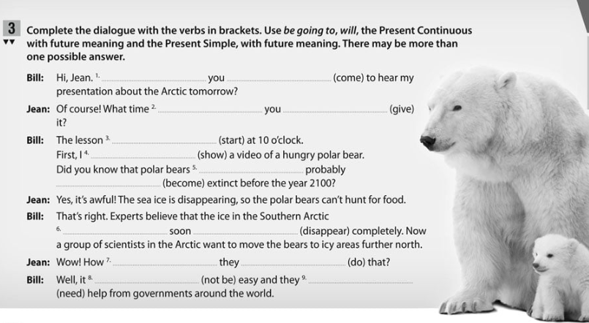

Write questions (Escribe preguntas) about a rainforest jeep tour with the verbs in brackets. Use be going to, will and the Present Simple or Present Continuous with future meaning. Then match the questions to the answers.
4

No olvides tener la explicación del futuro delante
1 What time .................................... the tour .................................... (end)?
2 .................................... the driver .................................... (be) our tour guide?
3 How long .................................... the drive to the rainforest .................................... (take)?
4 What animals .................................... we probably .................................... (see) on the tour?
5 When .................................... we .................................... (leave) for the rainforest?
..... a Tigers, monkeys and more.
..... b In ten minutes.
..... c At 2.00 pm.
..... d About three hours.
..... e Yes, he is.
Which topic (tema) is each sentence about? Match the topics to the sentences.
5

A. Homeless People | B. The Mayor | C. A Traffic Jam
D. Residential Areas | E. Poverty
..... 1 Nearly half of the people in the world live on under £2 a day.
..... 2 In August, 2010, people spent five days in their cars on a motorway in China.
..... 3 Millions of people around the world live on the streets.
..... 4 Some parts of the city have got many homes but no shops.
..... 5 Hilmar Moore was the most important person in Richmond, Texas, for over 63 years!
Complete the mini-dialogues with the words above each. There are more words than you need.
6

job opportunities | disadvantage | advantage
1 A: What is a big ..................................... of living in the city?
B: There are more ..................................... , so it’s a better place to work.

speed limit | motorway | traffic jam
2 A: How long does it take to drive to London on the ..................................... ?
B: It usually takes about 30 minutes, but don’t drive over the ..................................... .

open spaces | urban farms | suburbs
3 A: Why do you prefer living in the ..................................... ?
B: Because there are more ..................................... than in the city, so it’s quieter.

graffiti | homeless | mayor
4 A: What did the ..................................... promise to do?
B: He’s going to remove all the ..................................... on the buildings in the city centre.

disadvantage | advantage | crowded
5 A: What is the biggest ..................................... of living in the city?
B: Sometimes, it feels ..................................... because there are so many people.

ANSWERS


