1 Find five verbs in the puzzle. Then copy and complete the sentences with the verbs you found.
d | i | s | a | g | r | e | e | t
b | v | l | y | l | d | l | p | w
h | r | l | p | e | k | j | t | p
e | m | i | p | n | t | e | t | j
a | p | q | n | d | j | y | e | q
r | t | m | t | g | d | k | v | p
1 He’s speaking quietly. I can’t .............................................. him.
2 I .............................................. with Mike. I think he’s wrong.
3 I haven’t got a calculator. Can you .............................................. me yours?
4 Luke and his brother .............................................. a football to school every day.
5 People usually .............................................. their clothes in their bedroom.

2 Finish the sentences in a way that they make sense. Termina las oraciones de un modo en el que tengan sentido.
1 You can collect __________________________________________________________________.
2 ________________________________________________________because she finished her project.
3 My dad repaired _______________________ so now ___________________________________.
4 When you sell something, you ______________________________________________________.
5 You can donate _______________________________ to ________________________________.

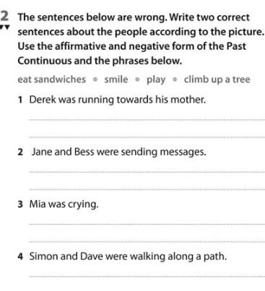

(Las oraciones son incorrectas, escribe dos frases correctas para cada persona usando los 4 verbos/frases)

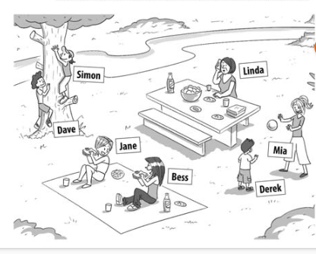

Read the text, copy and complete exercises 1 and 2.




ANSWERS

Ex 1: Hear, Disagree, Lend, Bring, Keep – In That Order In The Sentences.

Ex 2: These are possible ideas

1 You can collect RUBBISH FROM THE FLOOR.
2 She went out with her friends because she finished her project.
3 My dad repaired our TV so now WE AE WATCHING OUR FAVOURITE PROGRAMME.
4 When you sell something, you get money from other people.
5 You can donate your old clothes to charity.

EX.3:

Derek wasn’t running towards his mother.
He was playing with Mia.
He wasn’t eating sandwiches.

Jane and Bess weren’t sending messages.
They were eating sandwiches.
They weren’t playing

Mia wasn’t crying.
She was playing a ball game with Derek
She wasn’t eating sandwiches.

Simon and Dave weren’t walking along a path.
They were climbing a tree.




