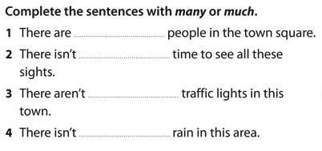
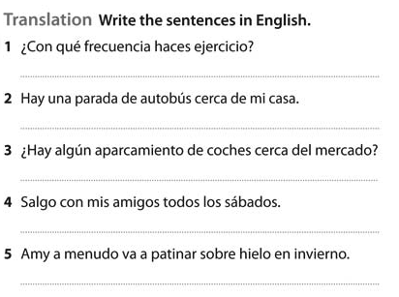
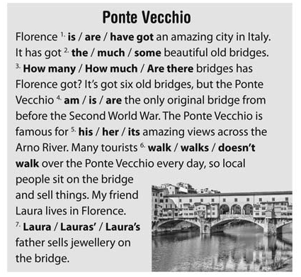
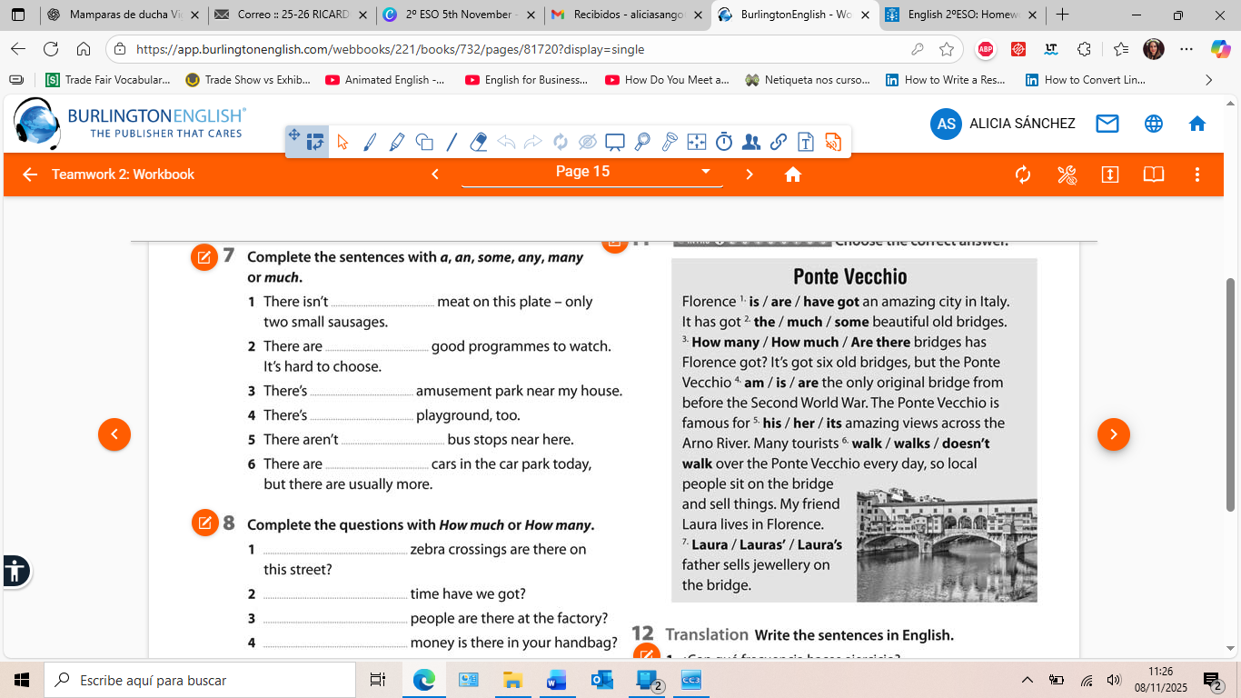
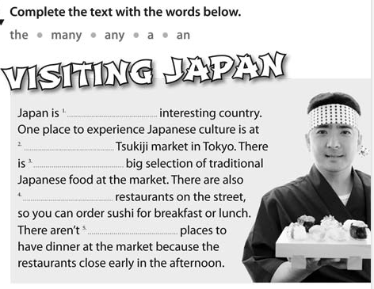
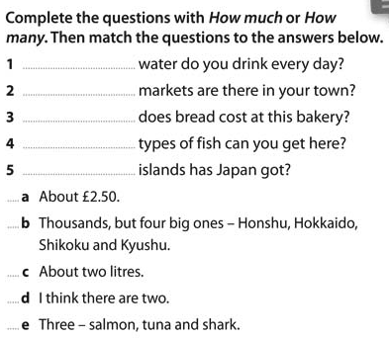

Answers:
Exercise 1:
- Many
- Much
- Much
- Much
Exercise 2:
- How much wáter…?
- How many markets…?
- How much does bread…?
- How many types…?
- How many islands…?
1c, 2d, 3a, 4e, 5b
Exercise 3 : Visiting Japan
- An
- The
- A
- Many
- Any
Exercise 4:
- Any/much
- Some
- An
- A
- Many/any
- some

Exercise 5:
- How many
- How much
- How many
- How much

PONTE VECCHIO
- Is
- Some
- How many
- Is
- Its
- Walk
- Laura’s father

TRANSLATION:
- How often do you exercise?
- There is a bus stop near my house.
- ¿Is there any car park near the market?
- I go out with my friends every Saturday.
- I often go ice-skating in winter.

