Grammar
Choose the correct answer.
1

1 Tim’s next to the window. Can you see her / them / him?
2 Have you got any / some / a sugar?
3 There were / There weren’t / Were there any clothes in the dryer.
4 Where is the brush? I can’t find him / them / it.
5 There is / Is there / There isn’t a pillow on the bed?
6 I have got a / some / an orange shirt.
7 We’re lost. Can you help us / ours / it?
8 I ate a hamburger right now / tomorrow / yesterday.
9 Look at a / the / some moon!
10 There were / There weren’t / Were there some clowns in the hospital.
Complete the sentences with the verbs below. Use the Present Simple.
2

not drive | not believe | finish | study | ride | enjoy
1 I usually ................................................... the school concerts. They’re fun.
2 We ................................................... his story because he isn’t always honest.
3 Jane ...................................................a car. She isn’t old enough.
4 ..................................... the students ..................................... French every day?
5 Our lesson ................................................... at 12.00 on Tuesdays.
6 Greg ................................................... his bicycle to school?
Write questions using the present simple and adverbs of frequency and answer them. (Use different frequency adverbs).
3

Example: What does your best friend usually do every morning?
Answer: My best friend usually leaves home and goes to school every morning.

- _____________________________________________________?
_____________________________________________________
- _____________________________________________________?
_____________________________________________________
- _____________________________________________________?
_____________________________________________________
- _____________________________________________________?
_____________________________________________________
- _____________________________________________________?
_____________________________________________________

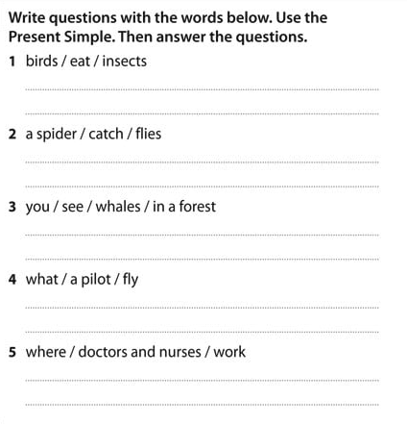

Vocabulary
Match the words to the pictures.
1

1 rock 4 jeep 7 tree
2 lorry 5 toothbrush 8 bridge
3 painter 6 calculator 9 keyboard
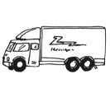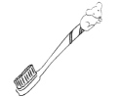
a
b
c
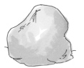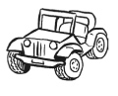
d
e
f
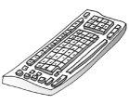
g
h
i
Complete the chart with the words below. Then add two more words to each category.
2

scooter | sky | nurse | factory | husband | ferry | grass | mechanic | market | niece
playground | pilot | star | parents | tram
Places | Family | Jobs | Transport | Nature

ANSWERS:

GRAMMAR

Exercise 1:
- Him
- Any
- There weren’t
- It
- Is there…?
- An Orange shirt
- Us
- Yesterday
- The
- There were
Exercise 2:

- I usually enjoy
- We don’t believe
- Jane doesn’t drive
- Do the students study…?
- Our lesson finishes
- Does Greg ride his bicycle to school?
Exercise 3:

This activity is open, it depends on the student.

Exercise 4:

- Do birds eat insects? Yes, they do. They eat insects.
- Does a spider catch flies? Yes, it does. A spider catches flies.
- Do you see whales in a forest? No, you don’t. You see whales in the sea.
- What does a pilot fly? A pilot flies aeroplanes or helicopters.
- Where do doctors and nurses work? Doctors and nurses work at a hospital.
VOCABULARY

Exercise 1:

- D, 2. A, 3 E, 4. F, 5 B, 6 C, 7 I, 8 G, 9 H

Exercise 2:

Places: factory, market, playground.
Family: husband, niece, parents
Jobs: nurse, mechanic, pilot
Transport: scooter, ferry, tram
Nature: sky, grass, star

