Grammar
Choose the correct answer.
1

1 Tim’s next to the window. Can you see her / them / him?
2 Have you got any / some / a sugar?
3 There were / There weren’t / Were there any clothes in the dryer.
4 Where is the brush? I can’t find him / them / it.
5 There is / Is there / There isn’t a pillow on the bed?
6 I have got a / some / an orange shirt.
7 We’re lost. Can you help us / ours / it?
8 I ate a hamburger right now / tomorrow / yesterday.
9 Look at a / the / some moon!
10 There were / There weren’t / Were there some clowns in the hospital.
Complete the sentences with the verbs below. Use the Present Simple.
2

not drive | not believe | finish | study | ride | enjoy
1 I usually ................................................... the school concerts. They’re fun.
2 We ................................................... his story because he isn’t always honest.
3 Jane ...................................................a car. She isn’t old enough.
4 ..................................... the students ..................................... French every day?
5 Our lesson ................................................... at 12.00 on Tuesdays.
6 Greg ................................................... his bicycle to school?
Write questions using the present simple and adverbs of frequency and answer them. (Use different frequency adverbs).
3

Example: What does your best friend usually do every morning?
Answer: My best friend usually leaves home and goes to school every morning.

- _____________________________________________________?
_____________________________________________________
- _____________________________________________________?
_____________________________________________________
- _____________________________________________________?
_____________________________________________________
- _____________________________________________________?
_____________________________________________________
- _____________________________________________________?
_____________________________________________________

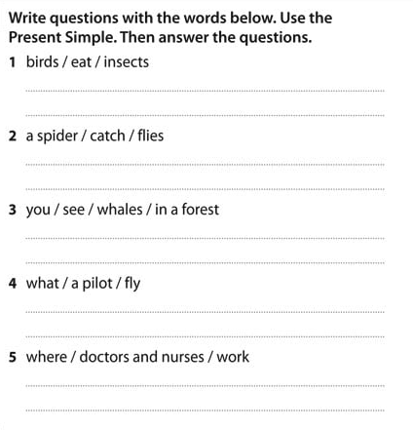

Vocabulary
Match the words to the pictures.
1

1 rock 4 jeep 7 tree
2 lorry 5 toothbrush 8 bridge
3 painter 6 calculator 9 keyboard
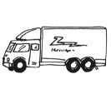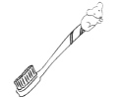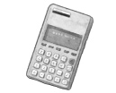
a
b
c
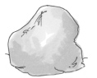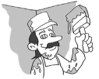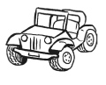
d
e
f
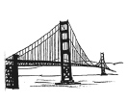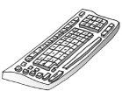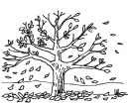
g
h
i
Complete the chart with the words below. Then add two more words to each category.
2

scooter | sky | nurse | factory | husband | ferry | grass | mechanic | market | niece
playground | pilot | star | parents | tram
Places | Family | Jobs | Transport | Nature

