Zero Conditional Form
1) If I (wake up) late, I (be) late for work.

2) If my husband (cook) , he (burn) the food.

3) If Julie (not/wear) a hat, she (get) sunstroke.

4) If children (not/eat) well, they (not/be) healthy.

5) If you (mix) water and electricity, you (get) a shock.

6) If people (eat) too many sweets, they (get) fat.

7) If you (smoke) , you (get) yellow fingers.

8) If children (play) outside, they (not/get) overweight.

9) If you (heat) ice, it (melt).

10) If I (speak) to John, he (get) annoyed.

11) I (feel) good the next day if I (go) to bed early.

12) Lots of people (come) if Jenny (have) a party.

13) She (buy) expensive clothes if she (go) shopping.

14) My daughter (pass) her exams if she (work) hard.

15) David (be) sick if he (drink) milk.

16) The river (freeze) if it (be) very cold.

17) I (like) to visit the museums if I (be) in a new city.

18) I (cycle) to work if the weather (be) fine.

19) My flatmate (clean) really well if she (clean) the house.

20) Everybody (be) grumpy if it (rain) a lot.
21) If you (to mix) red and green, you (to get) brown.

22) If you (to drop) a glass on the floor (to drop), it (to break).

23) If babies (to be) hungry, they (to cry).

24) When you (to add) sugar, the sauce (to taste) sweet.

25) Water (to boil) if you (to heat) it to 100 °C.

26) Plants (to die) if they (not/to get) enough water.

27) If you (to put) water in the freezer, it (to become) ice.

28) When the sun (to rise), the street lights (to go out).

29) When you (to heat) ice, it (to melt).

30) He always (to take) his umbrella when it (to rain).

FIRST Conditional Type
- You (PAY) a higher insurance if you buy a sports car.
- You (BE ABLE) to see better if you turn on the lamp.
- If they (NOT GET) up early, they can't go jogging.
- If you (NOT PUT) too much sugar in your coffee, you won't put on too much weight.
- If he continues to work hard he (BE) the best in his class.
- If Johnny plays in the mud he (GET) dirty.
- He (HAVE) sore eyes if he spends too much time on the computer.
- If she (NOT USE) light colours the picture will be too dark.
- If you (NOT WRITE) a letter to Santa Claus, you won't get any presents.
- If Tom gets back earlier he (TELL) you about it.
- If I (BE) right, they won't be able to pay back all the money.
- She (HAVE) to drive on the left side of the road when she goes to Britain.
- You (HAVE) to work harder if you want to pass the exam.
- You will be tired if you (NOT GO) to bed soon.
- If he (FIND) a good job he will be able to pay all his bills.
- If you sell more than you did last year you (EARN) more money.
- If the report is not on my desk by tomorrow you (BE) in big trouble.
- If you (NOT DO) anything bad, you won't get into trouble.
- If you take my advice you (NOT HAVE) any problems.
- I'll call you only if I (THINK) there's a problem.
- If the plan (SUCCEED) you will make a big profit.
- If I read this manual I (NOT MAKE) any mistakes.
- If he comes before ten we (MEET) him at the station.
- If you (EAT) an apple every day, you will stay healthy.
- If I (to study), I (to pass) the exams.
- If the sun (to shine), we (to walk) into town.
- If he (to have) a temperature, he (to see) the doctor.
- If my friends (to come), I (to be) very happy.
- If she (to earn) a lot of money, she (to fly) to New York.
- If we (to travel) to London, we (to visit) the museums.
- If you (to wear) sandals in the mountains, you (to slip) on the rocks.
- If Rita (to forget) her homework, the teacher (to give) her a low mark.
- If they (to go) to the disco, they (to listen) to loud music.
- If you (to wait) a minute, I (to ask) my parents.
- If it (to rain), the children (not/to go) for a walk.
- If she (not/to read) the novel, she (not/to pass) the literature test.
- If I (not/to argue) with my father, he (to lend) me his motorbike.
- If we (to take) the bus, we (not/to arrive) in time.
- If Dick (not/to buy) the book, his friends (to be) angry with him.
- If Tom (not/to tidy up) his room, Victoria (not/to help) him with the muffins.
- If the boys (not/to play) football, the girls (not/to come) to the football pitch.
- If you (to eat) too much junk food, you (not/to lose) weight.
- If I (not/to make) breakfast tomorrow morning, my girlfriend (not/to love) me anymore.
- If they (not/to hurry), they (not/to catch) the train.

SECOND Conditional Type
- I very happy if he got the job. (NOT BE)
- If my brother here he would go fishing with me. (BE)
- If she had her guitar with her she us one of her favourite songs. (SING)
- If I the lottery I would stop working. (WIN)
- If we caught the earlier train we there on time. (ARRIVE)
- You would get a better job if you from university. (GRADUATE)
- If we weren't so hungry we to have some food. (NOT GO)
- You more work done if you planned your day better. (GET)
- Your English would improve if you more. (READ)
- What if you found a purse on the pavement? (YOU DO)
- Jonathan more fun if he went to parties more often. (HAVE)
- If the rain we could go for a walk. (STOP)
- If the tent were any smaller one of us (HAVE) to sleep outside.
- If her hair were black she (LOOK) completely different.
- If we (HAVE) enough money we would stay in a hotel.
- If my brother (BE) a foot taller he would be a great basketball player.
- If I had a good teacher I (BE) good at maths.
- If I lived in Canada I (SPEAK) English fluently.
- If you (NOT LIVE) so far away I would visit you more often.
- If he were asked to drive the car he (NOT REFUSE).
- If they locked the door nobody (BREAK) into their house.
- If he (NOT WASTE) so much time he would go to the university.
- If they (GIVE) everybody a present they would run out of money.
- They (CELEBRATE) their honeymoon in Asia if they could afford it.
- I (NOT LIKE) it very much if they gave Mark the job.
- I wouldn't get so angry with you if you (GET) more work done.
- What would you do if you (HIT) a parked car in the street?
- If I knew how it worked I (TELL) you what to do.
- You (BE) smarter if you graduated from the university.
- If I (WIN) in the lottery I would give up working.
- If we (CATCH) the nine o'clock train we would get there on time.
- What (YOU DO) if you found a one hundred dollar note on the sidewalk?
- If John (BE) here, he would prepare a meal.
- It would be nice if the rain (STOP).
- I (SING) a song if I had my guitar here.
- If he were a young man he (BE ABLE) to walk faster.

THIRD Conditional Type
- I'd have told you the news earlier if I (SEE) you.
- I (HELP) you if you had told me there was a problem.
- I (BUY) a bigger model if I had been able to afford it.
- I wouldn't have met Tom if I (STAY) at home.
- If he hadn't fallen asleep while driving he (NOT CRASH) his car.
- If we (HAVE) enough money we would have gone to the concert.
- I wouldn't have lost my job if I (NOT BE) late for work.
- If the wind hadn't been so strong the bridge (NOT COLLAPSE)
- I (PHONE) Sally if I hadn't forgotten her number.
- If you had come earlier, you (SEE) the famous actor.
- If my alarm clock (RING) I would have been on time.
- If I had seen Mary I (TELL) her.
- If Mary had been free yesterday I (INVITE) her.
- If the weather (BE) miserable what would you have done ?
- If you hadn't called I (NOT KNOW) about the meeting.
- If she had received an invitation she (JOIN) us.
- If it (NOT RAIN) yesterday we would have gone on a picnic.
- You would have done it if you (TRY).
- He (NOT BE) so surprised if he had gone to their last meeting.
- If I had bought some fresh food I (NOT HAVE) to eat canned food for breakfast,
- The constructors (BUILD) the road if they had had enough tools.
- The author would have finished the book he he (NOT FALL) seriously ill.
- The car engine (WORK) if the mechanic had done his job properly.
- He would have taken the job if he (FIND) the offer acceptable.
- I (TELL) you the news if I had seen you sooner.
- I would have bought the larger model if I (BE ABLE) to afford it.
- I would never have believed it would be possible if I (NOT SEE) it with my own eyes,
- If we (HAVE) enough money we would have gone to the concert.
- If he (NOT FALL) asleep he would not have crashed his car.
- I (PHONE) Sally if I hadn't forgotten her phone number.
- If the wind hadn't been so strong the bridge (NOT COLLAPSE).
- If you (COME) earlier you would have seen a famous actor.
- If my alarm clock had rung I (ARRIVE) on time.
- If I had seen Mary I (TELL) her.
- If they (NOT PASS) the exam their teacher would have been sad.
- If it had rained yesterday , (YOU STAY) at home ?

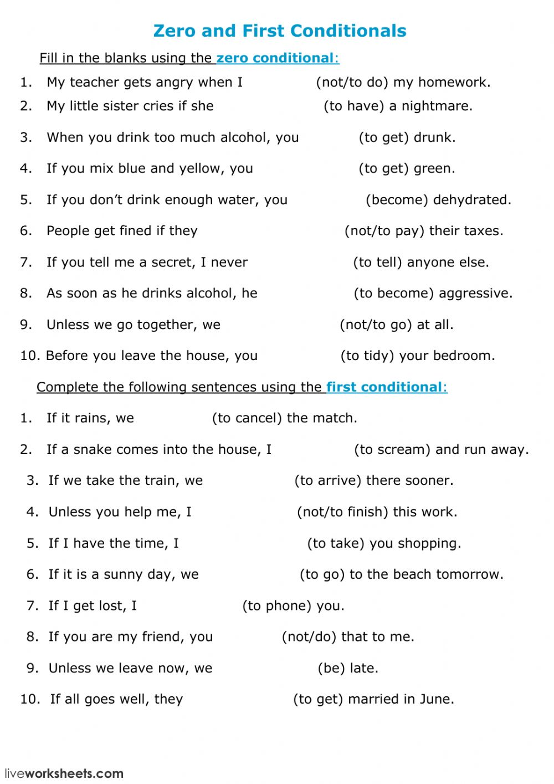

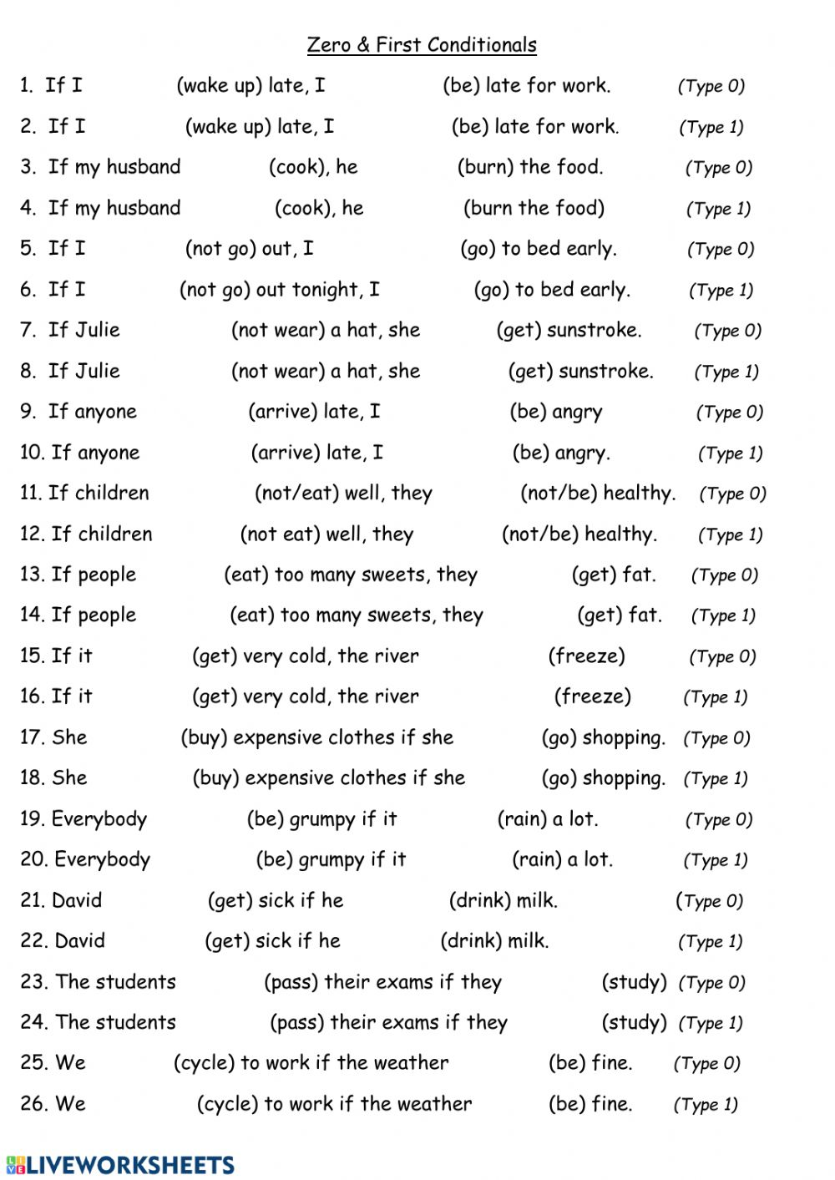

Mixture

- If John does not leave now he (MISS) his train.
- She (NOT HELP) me if I was in trouble.
- If he (BE) more careful he wouldn't have got caught.
- They (MAKE) up a lie if they had thought it would help me.
- Your dog would not be so fat if you (NOT FEED) it so often.
- If the weather (BE) fine tomorrow we will go to the beach.
- She (WORRY) if I told her the truth.
- If I (HAVE) to hold a speech I would be pretty nervous.
- If the trip hadn't been so expensive I (MAKE) a reservation.
- I (INVITE) you to a drink if I pass my English test.
- He will be really disappointed if you (NOT TELL) him the truth.
- If you had had the money (YOU LEND) it to me ?
- The teacher will be angry with you if you you your homework (NOT DO).
- If he me what was wrong, I could help him (TELL).
- If you hadn't watered the flowers they (DIE).
- I if I had time (COME).
- He will play tennis if the weather good (BE).
- If I I would have come earlier (KNOW).
- I wouldn't say it if I you (BE).
- If she wears a necklace her dress better (LOOK)
- The children can stay up late if they good (BE).
- We would die if the plane (CRASH).
- If I found a wallet on the street I it to the owner (RETURN).
- If I offered a loan I would accept it. (BE)
- If you ask the policeman he you how to get to the station (TELL).
- You healthier if you ate less junk food. (BE)
- The police into the warehouse , if there hadn't been any gunshots. (NOT BREAK)
- If I $1,000 I could afford to repair my house (HAVE)
- If the movie more than 3 hours I won't be able to sit through it. (LAST)
- If I for a walk this morning I would have seen that broken tree. (GO)
- If he time he will call his parents (HAVE).
- If it the match will be cancelled (RAIN)
- If you had studied more you the exam (NOT FAIL).
- I would lend you my scooter if you to be careful with it. (PROMISE)
- If you had had the money, it to me? ( YOU LEND)
- He would have gone to work last week if he ill (NOT FALL).

