1. Types of Computer Software

Vocabulary Preparation
Match each word or phrase with its correct definition.
Word / Phrase | Definition
1. System software | a) Programs that perform tasks for the user, such as writing or designing
2. Utility software | b) Programs that manage and support computer systems and hardware
3. Application software | c) Tools that keep the computer safe and running well
4. Operating system | d) Software that controls how hardware and other programs work together
5. System management programs | e) Operating systems, database, network, and security software
6. System development programs | f) Software that helps programmers write and test new code
7. Application-specific programs | g) Programs designed for a particular business or professional task
8. General-purpose programs | h) Programs used for common user activities like writing or browsing

Reading: Types of Computer Software

Computer software is the part of a computer system that contains encoded information or computer instructions. It tells the hardware what to do and how to do it. Computer software can be divided into three main types: system software, utility software, and application software.

1. System Software
Its main function is to manage and support computer systems and networks. It controls the basic operations of a computer, such as how it displays information on the screen and how the keyboard works.
Common examples of system software are Microsoft Windows, Apple macOS, and Linux. These are called operating systems, and they are part of a group known as system management programs, which include:
- Operating systems (Windows, macOS, Linux)
- Network and database systems
- Security monitors and virus control software
Another important group inside system software is system development programs, which help programmers create or maintain software. These include:
- Language translators (such as compilers and interpreters)
- Programming editors
- Development tools used to write, test, and debug code.
When you turn on your computer, the operating system is loaded into RAM and starts communicating with all the components. It makes sure that the hardware and the software can work together.

2. Utility Software
Utility software is a type of system software that performs specific maintenance tasks to keep the computer running efficiently.
There are many types of utility programs. Some examples are:
- Security programs, such as antivirus software, which scan and remove viruses or malware.
- Optimisation tools, which help clean up the system, defragment disks, and compress files to save space.

3. Application Software
Application software (or simply applications) includes all the programs that perform information processing tasks for the user.
They are designed to help people do specific work or personal activities, such as writing a document, creating a presentation, or playing a game.
There are two main categories:
- General-purpose application programs, such as word processors, spreadsheets, web browsers, and graphics editors.
Examples: Microsoft Word, Excel, Google Chrome, Adobe Photoshop.
- Application-specific programs, which are designed for particular professional or business tasks, like accounting systems, hospital management software, or CAD (Computer-Aided Design) programs.

1. Comprehension Questions.
1.1. Write T (True) or F (False) and correct the false sentences.
- ___ Utility software is used to design buildings or products.
- ___ System software includes operating systems and security tools.
- ___ Application software controls the computer hardware directly.
- ___ Utility software always runs in the background.
- ___ A word processor is an example of system software.
- ___ Language translators are part of system development programs.

1.2. Answer in 1–2 sentences using your own words.
- What is the main function of system software?

- Name two examples of utility software and explain their purpose.

- What are general-purpose application programs? Give two examples.

- What do application-specific programs do?

Mind Map Activity

Use the information from the reading to complete the mind map below.
You can draw it in your notebook or on a poster.
Under each branch, add: Definition / Function, examples, subtypes (if any).

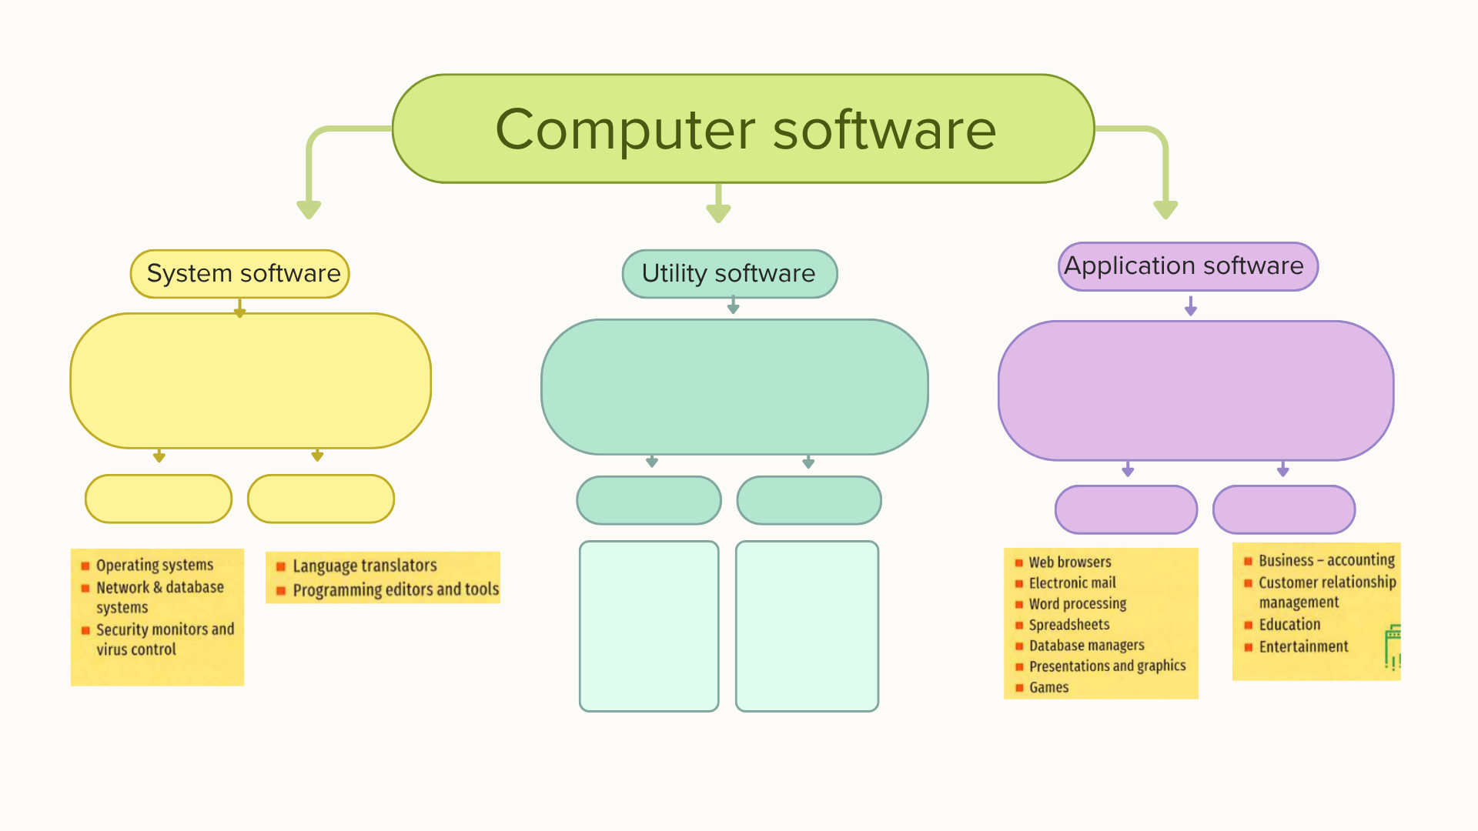

Grammar: Comparatives & Superlatives review

1. Complete the Sentences
Students complete sentences about software using the correct comparative or superlative form of the adjective in parentheses.
- Windows 11 is ______ (modern) than Windows 7.
- Zoom is ______ (popular) than Skype nowadays.
- Photoshop is ______ (complex) than Paint.
- Linux is ______ (safe) than other operating systems.
- Google Chrome is ______ (fast) browser on my computer.
- Word is ______ (useful) program for writing documents.
- Spotify is ______ (good) than listening to radio online.
- Dropbox is ______ (practical) way to share files.
2. Complete the chart with the missing comparative and superlative form:
Adjective | Comparative | Superlative
fast | faster | ______
easy | ______ | the easiest
expensive | more expensive | ______
good | ______ | the best
bad | ______ | the worst
modern | ______ | the most modern
useful | more useful | ______
safe | ______ | the safest
big | ______ | the biggest
powerful | more powerful | ______

3. Fill in the blacks with the right adjective (comparative or superlative) from the word bank.

Word bank: good, easy, fast, expensive, good, useful, safe, popular, powerful, bad
- Photoshop is ______ image editor for designers.
- Linux is ______ than Windows because it has fewer viruses.
- This version of AutoCAD is ______ than the old one.
- Microsoft Word is ______ program for writing reports.
- Windows 11 is ______ than Windows 10.
- Dropbox is ______ way to share files than email.
- Spotify is ______ music app today.
- Some people think macOS is ______ than Windows.
- Chrome is ______ browser on my computer.
- This old antivirus is ______ than the new one.

