Life Skills
Definition: Life skills can be defined as abilities that enable humans to deal effectively with demands and challenges of life. They may be called psychosocial skills, as they are psychological in nature and include thinking and behavioural processes. Other define them as behavioural, cognitive, or interpersonal skills that enable individuals to succeed in various areas of life.
In 1999 WHO identified six key or basic areas:
- Communication and interpersonal skills.
- Decision making and problem solving
- Creative thinking and critical thinking
- Self-awareness and empathy emotional intelligence
- Assertiveness and equanimity or self-control.
- Resilience and ability to cope with problems.

They classified these skills:

- Soft skills: are personal habits and traits that shape how you work, on your own and with others
Accepting
Adaptability
Ambitious
Analysis
Analytical thinking
Assertiveness
Attentive
Attitude
Calm
Commitment
Communication
Competitiveness
Confidence
Conflict resolution
Creative thinking
Creativity
Criticism
Critical thinking
Curiosity
Customer service mindset
Decision making
Delegation
Dependability
Detail-oriented
Diligent
Discipline
Eagerness/Willingness to learn
Emotional management/intelligent
Empathy
Ethical
Flexibility
Friendliness
Honesty
Hospitality
Influencing
Innovation
Listening
Mediation
Motivation
Negotiation
Open minded
Optimistic
Organization
Perseverant
Persuasion
Prioritization
Problem solving
Professional
Public speaking (presentation)
Punctuality
Questioning
Rapport building
Reliability
Research
Resilience
Respectfulness
Responsibility
Results oriented
Self-assessment
Self-awareness
Self-management
Stress management
Taking criticism
Team building/work
Tolerance
Time management
Trainable

- Hard skills: are technical knowledge or training that you have gained through any life experience, including in your career or education.
Accounting and tools
Adobe software suite
Administration
Advanced bookkeeping
Advocacy
Android
Auditing and forecasting
Automotive services
AP style
Big data analysis
Bilingual or multilingual
Blogging and CMS
Brand management
Budgeting
Building
Business intelligence
Carpentry
Clinical & health
Cloud apps and solutions
Computer literacy
Content management systems
Conversion testing
Copywriting
Cost saving analysis
Cyber security protocols
Database analysis & management
Data mining
Data warehousing
Digital printing
Driving
Electricity
Engineering
Environment Clean-up
Farming
Financial reporting
Fine arts
Foreign languages
Gardening
Google analytics or other
Graphic design
HTML/CSS
Human resources
Inference algorithms
Infographics
IOS, Linux, Unix, Windows
IT troubleshooting
Investigation
Laboratory
Java development
Marketing
Mathematics
Medical coring
Microsoft Office or other suite
Mobile development
Music
Network architecture & viability research
Network security
Marketing campaign management
Office administration
Paid online traffic
Photo editing
Plumbing
Poetry
Process improvement and optimization
Programming and coding languages
Project management
Public speaking & relations
Publicity & publishing
Quality assurance and testing
Research
Sales
Schedule Management
SEO/SEM marketing
Software development
Software QA
Social media
Specialized knowledge
Statistical analysis
Storage systems and management
Tangible
Taxation
Telecommunication
Technical writing and documentation
User interface design
UX/UI design
Visual arts
Vulnerability analysis
Web architecture
Website design
Word processing

But at the same time they add this types:
- Personal skills
- Interpersonal skills
- Leadership skills
- Writing skills
- Numeracy skills
- Presentation skills
- Learning skills
- Parenting skills

Around 2017 there were a redesign to clarify, and add
- Thinking skills
- Social skills
- Emotional skills
But maintaining the types they were mention above.
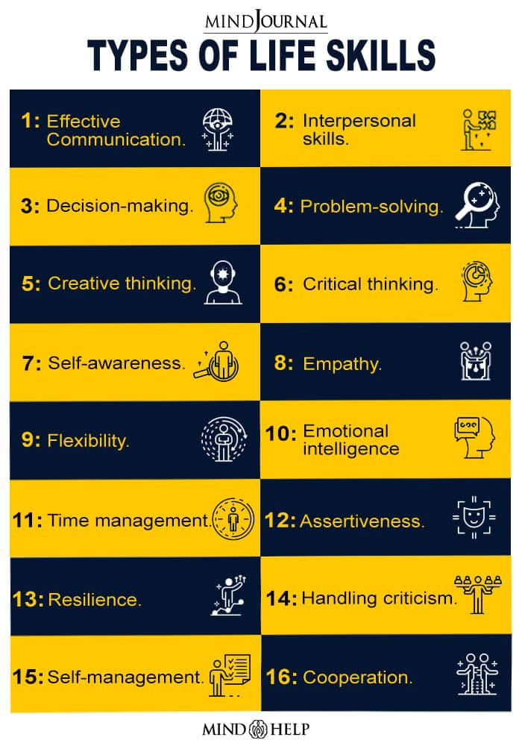

The mental well-being of people shows how positively and adaptively they can behave when interacting with others, with their cultures, and with their environments. An individual can learn to deal with difficult challenges effectively with the help of life skills or psychosocial competency. The term is used for describing a bunch of basic social, cognitive, and interpersonal capabilities 1 acquired through direct life experiences or learning. These skills are mostly based on certain executive functions and enable individuals to effectively handle issues that they encounter in their everyday life. Among this group of essential skills, certain capabilities are specially designed for performing better in a working environment and some provide extremely crucial knowledge about dealing with every situation effectively, interacting with others, identifying and processing emotions. A 2012 study 2 has shown that people can educate the youth about various health-related issues with the help of different life skill approaches. A 2010 research paper 3 has reported that education about these skills can prevent school dropout cases and violence among young people.

1. Effective Communication
It refers to the process of exchanging knowledge, ideas, perspectives, information, thoughts in the best possible manner. One can communicate both verbally and non-verbally. Effective communication is more about listening than talking, it is more than just exchanging information. It does not only help one to understand the words the other person is saying but also the emotions the speaker is trying to convey. A 2010 research paper has described communication as an art and process of creating and sharing ideas. Effective communication depends largely on the richness of these ideas. Communication is all about expressing one’s desires, feelings, needs, and also fears. It is not a very difficult thing to do, but communicating effectively sets an individual apart from the rest of other people. Effective communication requires learning certain important aspects such as – Literacy Good presentation skill Public speaking Written communication Body language Nonverbal communication Active listening skill It doesn’t matter whether someone is communicating with his/her family, friends, colleagues, or clients, learning these skills can deepen both personal and professional connections. Excessive stress, lack of focus, out-of-control emotions, negative and inconsistent body language may create barriers to effective communication. This skill also provides knowledge about the difference between face-to-face communication, digital communication, and phone communication.

2. Interpersonal skills
Interpersonal relationships refer to the strong association between people based on inference, love, solidarity, common business interactions, and other social commitments. These relationships can be of great importance for one’s mental and social well-being. Such skills involve qualities and behaviours that people exhibit while communicating with others. Lack of interpersonal skills often leads to conflicts with people and makes it critical to be good at getting along with others. A 2004 research paper 4 explained that one has to work conscientiously to develop this competence by doing the right things repeatedly until they become ingrained. Good interpersonal skills add smoothness and pleasantness to the normal regular interactions. It allows people to build better and long-lasting relationships both personally and professionally. Interpersonal skills include certain other significant life skills also as most of the important skills are interlinked with each other. Interpersonal skills consist of: Nonverbal and verbal communication Conflict management Leadership skills Good listening skills Empathy Teamwork Positive Attitude

3. Decision-making
Making good decisions is a skill that people must learn. This skill is not something with which people are innately born. Decision making skill is a step-by-step process that one can ascertain from different life experiences. In a simple sense, it is about selecting one course of action from several alternatives. It is one of the skills that are essential both in and out of the workplace. According to research 5 , it is extremely important to understand the environment, its limitations, opportunities, and the possibilities for change for making beneficial decisions. One needs to make decisions that can be well-implemented on a personal and organizational level. Firm decision-making requires a certain level of intellect and confidence. It also helps one to avoid any situations that may lead to second-guessing. These skills include a few other skills such as – Time management Creative thinking Prioritization Problem-solving Logical reasoning.

4. Problem-solving
Problem-solving is a soft skill that can’t be learned through education or training. Studies have explained that the process of problem-solving refers to a process of resolving a known difficulty. It requires quick identification and understanding of the issue and implementation of a solution. Stressful situations and unresolved significant problems can have consequences for health. The primary step to solve a problem is to identify it and determine the root that causes it. Finding and implementing multiple solutions can lead to various opportunities. Problem-solving skill helps one to evaluate situations and divide them into manageable facts. This skill is not an impossible challenge rather it discovers certain strengths and capabilities in people that they might never have known before. Problem-solving skill includes certain other important skills as well that are: Active listening Brainstorming Creative thinking Prioritizing Teamwork Time management

5. Creative thinking
Thinking creatively consists of four components, namely fluency, flexibility, elaboration & originality. Thinking creatively adds value to people’s lives and makes them more confident and reliable. A 2008 research paper 6 explained that this skill requires some risk-taking as there is a chance that people may make mistakes or not come up with an answer at all. One needs to be prepared to cope with the resultant risk and confusion. The ability of employees to think creatively makes an organization and department more productive. This skill is not limited to only artists, anyone can nurture and develop it. One can be a creative thinker by developing creative courage, adopting leadership qualities, listening to feedback and utilizing those in work, considering the obvious solution, brainstorming other solutions, and apply those.

6. Critical thinking
A 2007 study has described critical thinking as a type of skilful and responsible thinking that is conducive to good judgment. It takes significant time, enough practice, and a lot of patience to be a critical thinker. In a simple sense, critical thinking refers to the ability to analyze information and make a reasonable judgment. A critical thinker is capable of recognizing the factors that influence values, the media, and peer pressure. He/she can draw meaningful conclusions from a bunch of information. One has to be an active learner and not a passive recipient of information to adopt this skill. Being objective is an essential quality to be a successful critical thinker. Another quality of critical thinkers is that they work in groups but solve problems independently. Some significant steps to be a successful critical thinker include – Identifying the problem Investigating the opinions and arguments Evaluating information factually Being open-minded Communicating the findings and outcomes

7. Self-awareness
Most people tend to believe that they are self-aware while true self-awareness is an exceptionally rare quality. Self-awareness refers to the capability of focusing on oneself and how an individual’s actions, emotions, thoughts, feelings align or not align with the internal standard. According to a 2016 research paper 8 , the concept of self-awareness is generally related to positive psychological well-being. This skill makes people more confident and creative, helps them to make better decisions, build healthy relationships, and interact more effectively. This skill often includes – Interpersonal skills Effective communication skills The skill of developing empathy

8. Empathy
According to a recent study, empathy is described as the emotional appreciation of another person’s feelings. This study states that empathy plays a key role in the understanding of people’s feelings, sufferings, and behaviours with a significant link to compassion. This skill involves other’s perspectives, enabling prosocial and helping behaviour that comes from within a person. It requires immense patience to express genuine concern for another person and help them to solve their issues. The process of communication becomes one-way traffic without empathy. Empathy development in people makes them more cooperative and helps them to connect with others and make moral decisions. Read More About Empathy Here.

9. Flexibility
It’s a kind of thinking skill that makes people improvise, adapt to new situations, and shift strategies to achieve success. As the world is constantly and rapidly changing, adjustment and adaptation are extremely important for success. Thus, the most essential characteristic a person requires to have is flexibility. It helps develop a mindset of readiness, reduces unnecessary stress, and exposes new experiences. Flexibility includes certain important aspects as well. They are: Open-mindedness Assertiveness Creative thinking Adaptability

10. Emotional intelligence
A 2009 research paper has suggested that emotional intelligence refers to the capability of identifying, accessing, and managing the emotions of one’s self, of others, and of groups. The development of emotional intelligence helps an individual to become more productive and successful at what he/she does and helps others become more productive and successful too. Being academically brilliant is not enough for people to achieve success in life, one needs to adopt this skill to manage stress and emotions. Emotional intelligence is often associated with four attributes such as – Social and self-awareness Maintaining relationships Self-management Read More About Emotional Intelligence Here.

11. Time management
A 2011 study has mentioned that proper time management skill always results in contentment and satisfaction in daily life. The ability to manage time effectively is extremely crucial for people. Proficiency in this skill leads to improved efficiency and productivity. These skills create an extremely positive impact on personal and professional life. It also helps one to eliminate excessive stress, offers extra time, introduces more beneficial opportunities, and provides the ability to realize the goals. A person’s happiness depends on how he/she manages the time beneficially. Read More About Time management Here.

12. Assertiveness
Assertiveness refers to the ability to stand up for oneself and protect their and other people’s rights in a positive and effective way. But it doesn’t include any kind of aggressive or insulting behaviour. This skill helps a person to put across his/her perspective across without letting down others or becoming upset with themselves. Studies 10 suggested that it allows people to have meaningful and productive communication in their personal life and at the workplace. This skill is related to the following – Self-control Honesty Accountability Openness

13. Resilience
A 2013 research paper 11 has defined resilience as a successful adaptation that relies on effective responses to environmental challenges and ultimate resistance to the deleterious effects of stress. In a simple sense, resilience refers to something that offers people the psychological strength to deal with stress and hardship. Resilient people are more likely to handle adversity and develop their lives after a struggle. This skill helps one to face life’s difficulties effectively instead of falling into despair and adapting certain unhealthy coping strategies.

14. Handling criticism
People need to accept the fact that nobody is perfect and at times they can make mistakes. However, it is essential to accept constructive criticism positively. One can develop and improve professionally only by feedback and criticism. These specific skills include – Good communication skills Listening skills Self-awareness Desire for improvement

15. Self-management
The definition of self-management has its roots in the emotional intelligence theory in which the capability may also be referred to as self-regulation. Self-management is considered to be people’s ability to manage their behaviours, emotions, thoughts in a conscious and productive way. Research has suggested that self-Management involves doing something different now in order to accomplish a goal later. Strong self-management skill teaches one to act according to different situations. It makes people understand their personal responsibility in different aspects of life. These specific skills include few significant attributes such as – Time management Self-motivation Accountability Stress management Goal setting

16. Cooperation
One needs to get along with others in life. The skill to cooperate is very important in life as our communal development relies on our ability to collaborate as a family unit, work as a team, and as contributing members of society. It is also important in the workplace as employees have to perform in other collaborative settings. Cooperation skill requires a person to improve: Conflict management skills Empathy Emotional intelligence Teamwork Interpersonal skills Decision making Flexibility Creative and critical thinking Communication skills Problem-solving Leadership skills

The interpersonal capabilities termed ‘life skills’ help people to understand their strengths, weaknesses, and even the opportunities available for them. Life skills contribute hugely to the basic education process that includes gender equality, democracy, quality and equality of education system, child care and protection, the importance of peace, the quality of life, good citizenship, and the value of lifelong learning. Thus, it is extremely important to learn these skills to adapt to all circumstances and succeed in the renaissance and prosperity of society.

Read more here: https://mind.help/topic/life-skills/types/

Personal skills

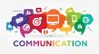
Communication
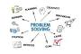
Problem solving

Leadership

Critical thinking

Time management
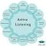
Active listening

Teamwork
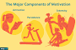
Motivation
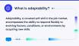
Adaptability

Creativity

Interpersonal communication

Collaboration
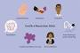
Conflict resolution
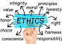
Ethics

Attention to detail

Computer skills

Management skills
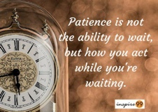
Patience
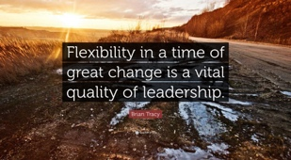
Flexibility
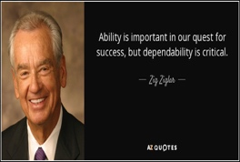
Dependability
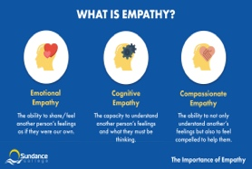
Empathy
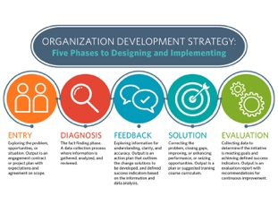
Organization
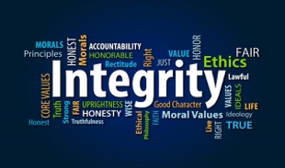
Integrity
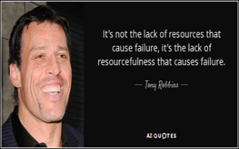
Resourcefulness

Types of Interpersonal Skills
Interpersonal skills include verbal and nonverbal communication, the ability to handle conflict, teamwork, empathy, listening, and a positive attitude. Being flexible and positive, able to listen, and communicating well are important criteria for success at work.
Communication
One of the most important interpersonal skills in any job is communication. Whether you work in IT, customer service, construction, or any other industry, you will need to be able to communicate clearly and effectively with others both verbally and in writing. Some jobs also require skills in effective public speaking.
- Nonverbal communication
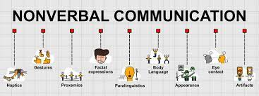
- Public speaking
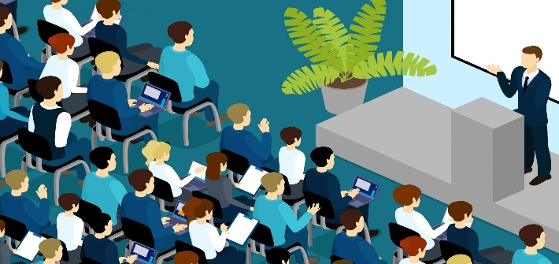
- Verbal communication
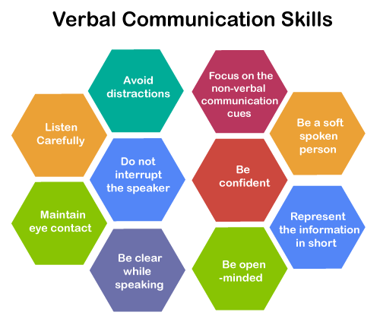
Conflict Management
Whether you are a manager or an employee, you will likely need to resolve conflictsat some point in your job. This might involve solving an issue between two staff members, between yourself and a colleague, or between a client and your company. You will need to be able to listen fairly to both sides and use creative problem-solving to arrive at a solution.
- Conflict resolution
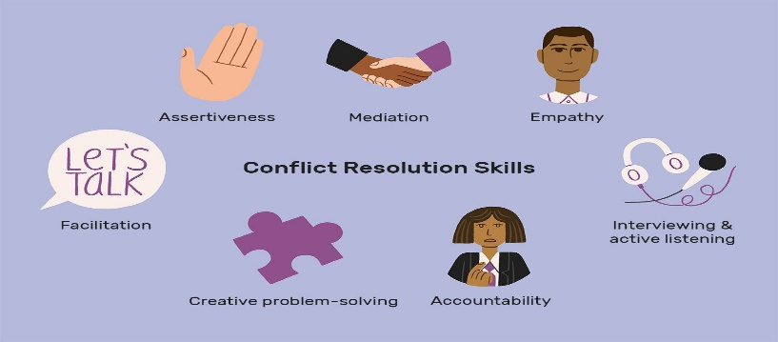
- Constructive criticism
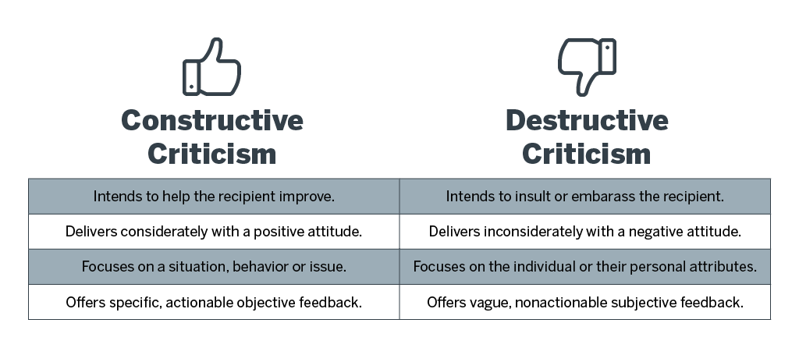
- Counselling & guidance
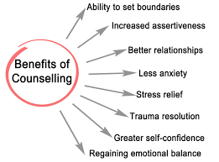
- Mediating
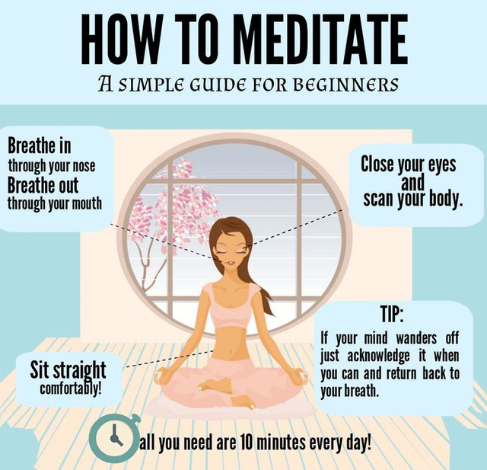
- Problem-solving
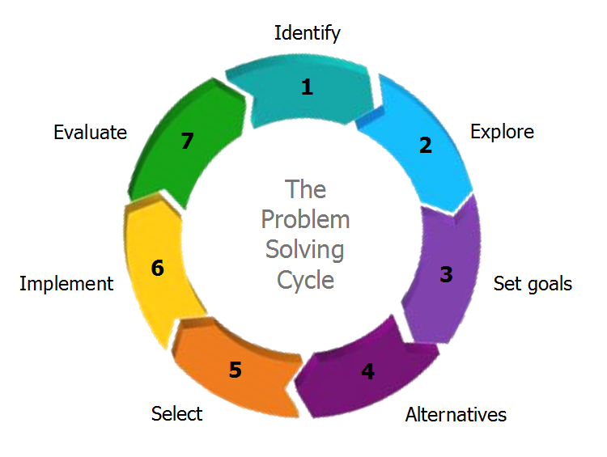
Empathy
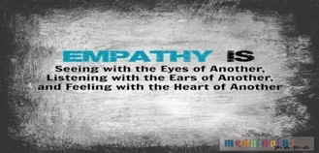
Part of being a good manager, employee, or colleague is the ability to understand and show empathy to others. If a customer or colleague calls with a complaint, for example, you will need to listen thoughtfully to the person’s concerns and express compassion for their issue. Empathy is an important skill that will help you get along with everyone in the workplace.
- Caring
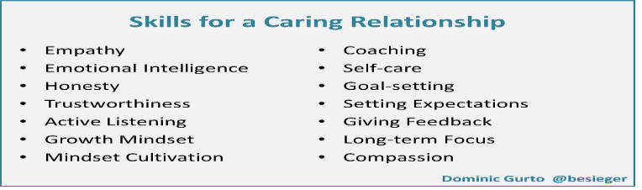
- Compassion
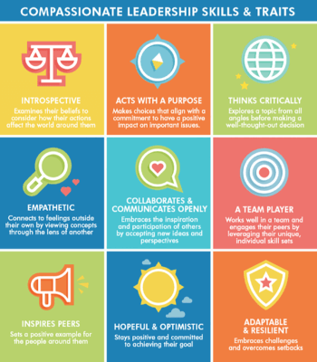
- Diplomacy
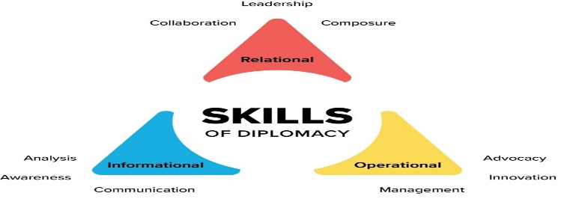
- Diversity
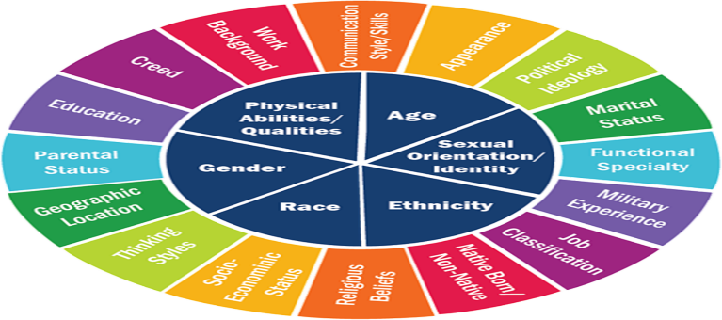
- Helping others
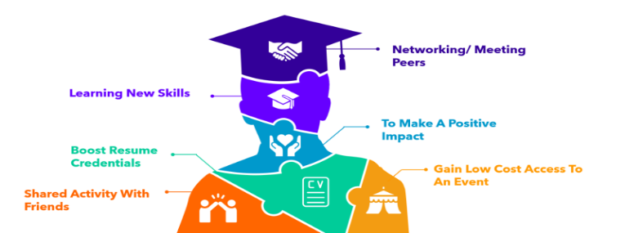
- Kindness
- Patience
- Respect
- Sensitivity
- Sympathy
Leadership
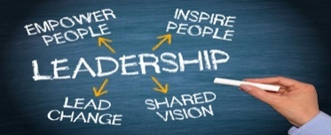
Even if you are not a manager, it is important to have some leadership experience and ability. Leadership requires being able to motivate and encourage others and help a team achieve success. It is a responsibility not power.
- Encouraging
- Inspiring trust
- Instructing
- Management
- Mentoring
- Motivation
- Positive reinforcement
Listening
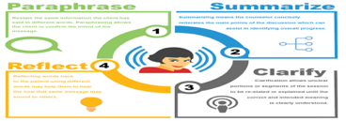
Listening is a skill that goes hand in hand with good communication. While you need to be able to express your own ideas, you also need to thoughtfully listen to the ideas of others. This will help your clients, employers, colleagues, and employees feel respected and valued. Listening is not understanding the words of the question asked, listening is understanding why the question was asked in the first place.
- Active listening
- Curiosity
- Focus
- Inquiry
Negotiation
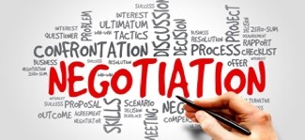
Negotiation is an important skill for many positions. Depending on the specific job, it might involve creating formal agreements (or contracts) between clients or helping colleagues solve a problem and determine a solution. To be a good negotiator, you must be able to listen to others, use creative problem solving, and arrive at an outcome that satisfies everyone.
- Negotiating
- Persuasion
- Research
Positive Attitude
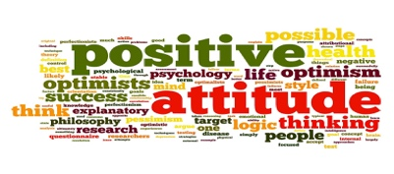
Employers want to hire employees who make the office a brighter place. They want people with a friendly, positive demeanor. This doesn’t mean you have to be the most social person in the office, but you must be willing to develop some sort of a positive rapport with your colleagues.
- Behavioural skills
- Developing rapport
- Friendliness
- Humour
- Networking
- Social skills
Teamwork
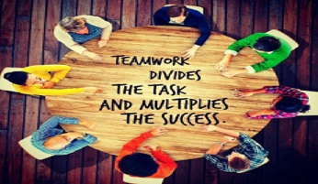
Even if your job involves a lot of independent work, you still need to be able to collaborate with others. Teamwork involves several of the skills already mentioned: you need to be able to listen to others, communicate your own goals, motivate your team, and resolve any conflicts that may arise.
- Collaboration
- Group facilitating
- Team building
- Teamwork

Leadership skills

Active listening
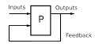
Feedback

Delegation

Conflict management
Creativity
Problem solving
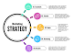
Strategy
Time management
Adaptability
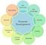
Develop situational awareness
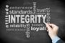
Integrity
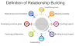
Relationship building

Team building
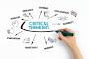
Critical thinking
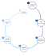
Decision-making
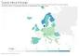
Trust

Communication skills
Empathy
Communication
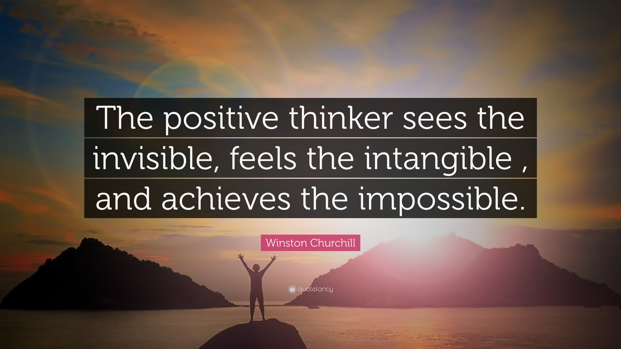
Positivity
Reliability
Flexibility
Responsibility
Vision

Writing skills
In the workplace, writing skills examples include:
- Grammar.
- Vocabulary.
- Spelling.
- Sentence construction.
- Structure.
- Research and accuracy.
- Clarity.
- Persuasiveness.
- Documenting a process for someone else to learn it
- Summarizing a meeting in an email for all attendees
- Sharing a team update in Slack
- Crafting a mass email to send to prospective customers
- Communicating with a client via email to get action on next steps
- Creating a presentation to share your findings with your team
- Drafting a list of questions to a client to learn more about their needs
- Explaining an unfamiliar concept or term to a stakeholder

Here are common scenarios when you’ll use writing skills during your job—even if you don’t think your role has anything to do with writing.

Emailing: “Most professionals have to craft business emails,” says Muse career coach Tara Goodfellow, owner of Athena Consultants. Emails might be how you update your team on a project, request information from a colleague, or follow up on a meeting with clear next steps. And in some instances, an email is how you make your first impression on a new person.

Communicating with co-workers: Whether it’s via email, Slack, another messaging app, or Google Doc, you’ll want your co-workers to know what you’re talking about without adding yet another meeting to the calendar.

Documenting procedures: Written records can be particularly helpful when you’re trying to standardize how your team or company handles recurring tasks or training new co-workers to take these on. “Clearly writing and documenting new procedures can allow for future consistency and improved quality control,” Smith says, even if you’re not available to meet with and explain the processes to each new person taking them on.

Crafting sales pitches: For example, if you’re an account executive reaching out to a prospect via email or LinkedIn, “A well-written sales pitch to a critical client will increase your credibility and help you land the new client,” Smith says.

Reporting on the results and/or progress of your work
Creating copy for a website or product
Making notes on code
Creating reports, contracts, or official documents
Giving feedback on others’ work
Putting together newsletters, emails, social media posts, and other marketing materials
Delegating work to others asynchronously
Taking notes on a meeting, appointment, training, or other live event
Content writing
Copywriting
Editing the written work of others
Creating a presentation
Making recommendations to management or clients
Updating project management software or customer relationship management software to track progress and make notes
Crafting job descriptions
Outlining roadmaps, timelines, or future plans for yourself or your team.

Numeracy Skills
Numeracy skills can include a wide range of abilities to understand and anlyze information, Here are some main numeracy skills that you may regularly use in a work environment
- Basic knowledge of numbers
- Calculation skills
- Budgeting
- Interpreting mathematical information
- Understanding the relationships between numbers
- Understanding trends
- Measurements and data analysis
How to improve numeracy skills
Strong numeracy skills can be learned and improved upon with time, effort and patience. Here are the basic steps you can use to strengthen your own math skills.
- Determine what skills you need.
Identify what numeracy skills are important for your career. If you need to better understand big data and interpret it to make decisions within your company, you need to be good at understanding figures. If you are a salesperson, you need to be able to quickly calculate your commission so you don’t lower the price too much on a product you are selling. Rather than trying to improve all your numeracy skills at once, identify one or two areas you need in your current role or one you are pursuing.
- Find a training course to fit your needs.
Look for math courses online or offline that help you improve specific skills. Some courses are offered for weeks at a time and can help you substantially improve your competency and confidence.
- Practice

Presentation skills definition

Language
Eye
Structure presentations effectively
Audience engagement
Practice
Storytelling
Know your audience
Breathe
Delivery
Leadership
Active listening
Public speaking
Understanding your audience
Use a visual aid
Voice projection
Arrive early
Confidence
Pause
Practicing and rehearsing your presentation
Research
Time management
Verbal communication
Attend other presentations
Avoid filler words

Learning skills

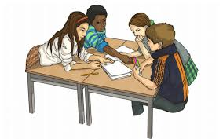
Collaboration
Creativity

Critical thinking
Problem solving
Learning skills
Communication
Active listening
Managing time

Reading

Writing
Adaptability
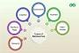
Allocating resources

Information management

Innovation
Leadership
Resolving conflicts
Team building
Curiosity

Parenting skills

Be a good role model
Crisis management
Communication
Dedicate time to your kids
Education
Encourage autonomy
Patience
Unconditional love
Be flexible
Calmly expressing feelings
Consistency
Control your emotions
Creativity
Empathy
Life skills
Love
Love and Affection
Relationship skills
Safety
Set boundaries
Stress management
Child
What are positive parenting skills?
Communicate openly

Here are Epstein’s 10 most important parenting skills.
- Love and affection, including unconditional love, physical affection, praise, and quality time together
- Stress management, through regulating your own nervous system as well as your child’s—including practicing and teaching effective ways to relax and express emotions in a healthy way
- Relationship skills, including showing respect and care for others even in conflict
- Encouraging autonomy and independence by treating your child with respect and high regard and supporting body autonomy, consent, and self-reliance
- Prioritizing education and learning, by allowing your child to explore their curiosities, as well as providing appropriate educational opportunities for them
- Modelling life skills, like financial and future planning
- Behaviour management, through extensive use of positive reinforcement rather than punishment or other punitive measures
- Supporting health, including both physical and mental health practices for yourself and your child
- Spirituality, which may look like a respect for nature, a connection to something bigger than oneself, or a compassionate religion
- Ensuring your child’s safety, including mental, physical, and emotional safety, by being aware of their activities, behaviours, mental health, and friendships

In-Demand Interpersonal Skills to Highlight
Preparing for a job interview, working on a promotion, or customizing your resume or cover letter? These are some of the most sought-after interpersonal skills. Look for ways to weave some of these keywords into your application materials or conversation.

- Active listening
- Behavioural
- Caring
- Collaboration
- Comforting
- Communication
- Conflict management
- Conflict resolution
- Consulting
- Constructive criticism
- Counselling
- Creative thinking
- Customer service
- Developing rapport
- Diplomacy
- Diversity
- Encouraging
- Flexibility
- Group facilitating
- Helping others
- Humour
- Inquiry
- Inspiring trust
- Instructing
- Interviewing
- Leadership
- Listening
- Mediating
- Mentoring
- Motivation
- Negotiating
- Networking
- Nonverbal communication
- Patience
- Persuasion
- Positive reinforcement
- Problem-solving
- Public speaking
- Relationship management
- Respect
- Responsibility
- Sensitivity
- Social skills
- Sympathy
- Teamwork
- Tolerance
- Verbal communication

