We’re Going To Be Friends

https://www.youtube.com/watch?v=az8UDe6UQGQ
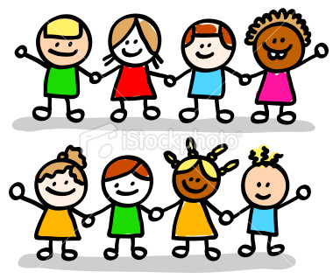
…………….(season) is here, hear the yell
Back to school, ……………. (verb) the bell
Brand new ……………. (clothes), walking blues
Climb the fence, books and ……………….. (classroom object)
I can tell that we're going to be friends
I can tell that we're going to be friends

Walk with me, Susie Lee
Through the …………… (place in town) and by the tree
We will rest upon the ground
And look at all the ………………. (small animals) we found
Safely …………. (verb) to school without a sound
Safely …………. (verb) to school without a sound

Here we are, no one else
We walked to school all by ourselves
There's dirt on our ……………. (school clothes)
From chasing all the ants and worms
We clean up and now it's time to learn
We clean up and now it's time to learn

Numbers, letters, learn to spell
Nouns and books and show and tell
At playtime we will throw the …………. (game)
Back to class, through the …………… (part of school)
Teacher marks our height against the wall
Teacher marks our height against the wall

We don't notice any time pass
We don't notice anything
We sit side by side in every class
………….. (job) thinks that I sound funny
But she likes the way you ………….. (verb)

Tonight I'll dream while I'm in …………… (furniture)
When silly thoughts go through my …………….. (part of the body)
About the bugs and ……………. (=ABC)
And when I wake tomorow I'll bet
That you and I will ………… (verb) together again
I can tell that we're going to be friends
I can tell that we're going to be friends

