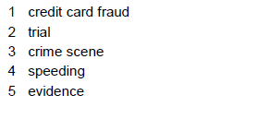
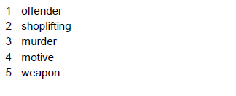
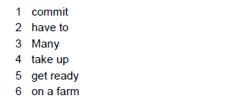
EXERCICIOS ALUMNO 1 EN OPENOFFICE

GRAMMAR

1.
Had, hidden, arrived
Hadn’t seen
Had eaten, arrived
Discovered, had stolen
Robbed

2.

3.

4.

PART 2. READING

1.

2.

