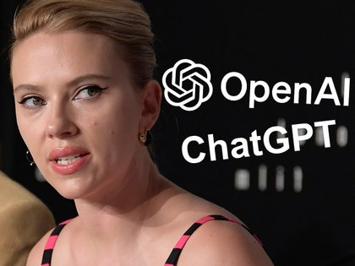
SCARLETT JOHANSSON “SHOCKED” BY AI CHATBOX IMITATION
Vocabulary
Turn down (phrasal verb): rechazar
Eerily (adv.): siniestramente, de forma espeluznante
Tie into: fit in with, be related to, encajar
Amid: in the middle of ; it sets the stage for the location of an action or within a certain environment.
Amid has two main meanings. The first is “in the middle of; surrounded by; among.” For example:
John looked for his friend amid the crowd.
Mary built a cabin amid the pine trees.
This first sense of amid generally expresses a kind of physical relationship.
The second meaning of amid is “during, in or throughout the course of.” For instance:
We welcomed her optimism amid the crisis.
Roosevelt took office amid the Great Depression.
The couple checked in on their elderly parents amid reports a huge blizzard was coming their way.

This second sense of amid can show a relationship between things in time or convey the idea that something is taking place against the backdrop or background of something else.

Rampant (adj.): uncontrolled, growing without control; desenfrenado, descontrolado
Safeguard: protective measures (amparo, custodia, salvaguardia)
Hire (vb.): contratar
Synonyms: take on, recruit
Antonyms: fire, dismiss, sack , make sb redundant
Comforting (adj.): tranquilizante, reconfortante
Sample (vb.): tomar muestras de
Chatbot (n.): the term was coined in the 90s by Micheal Maudlin from the terms chatter and robot.
A chatbot is a a computer program that simulates interactive human conversation, usually over the internet.

COLLOCATIONS
- Draw comparisons: establecer comparaciones
- Strike a deal: alcanzar un acuerdo
- Strike a balance: lograr un equilibrio
- Strike a bargain: ponerse de acuerdo
Careful with the past tense and the past participle of the verb STRIKE (STRUCK/STRUCK)
PRONUNCIATION
Debute (vb.): /ˈdeɪbjuː/
Safeguard: /ˈseɪfgɑː^{r}d/ the “U” is silent
SUGGESTED ANSWERS
Question 1
a) False: “The actress said she had previously turned down an approach by the company to voice its new chatbot”.
b) True: “Set in the near future, 2013 film ‘Her’ sees Joaquin Phoenix fall in love with his device’s operating system, which is voiced by Ms. Johansson”.
c) False: “The actress, who has been nominated for two Academy Awards,…”
d) True: “This issue ties into broader concerns, as OpenAI has been battling various legal challenges to how it uses copyrighted information available online”.

Question 2 (Key ideas)
a) Scarlett Johansson was shocked because OpenAI released a chatbot with a voice that sounded very much like hers, even though she had already refused their offer to use her voice. She also felt angry, especially because the voice was very similar to the one she used in the 2013 movie 'Her.'
b) In response to Johansson’s concerns, OpenAI said it would take away the chatbot’s voice that sounded like hers. The company also said that the voice was not supposed to be a copy of her voice.
c) Dan Stein thinks that using someone’s voice without their permission is very intrusive, especially now when many people don’t trust AI and are worried about the harm it could cause. He also warned that this could lead to serious problems with copyright and consent in the industry.

Question 3
a) statement
b) (to) turn down
c) broader
d) (to) hire

Question 4
4.1) A) ‘Sure, I could use a break!’
4.2) C) ‘Was it about robots taking over the world?’
4.3) A) lend a hand with

