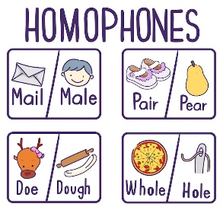
Student’s name: ___________________________________________________ Date: _________2026

 | # 1st word | Meaning | #2nd word | Meaning | #3rd word | Meaning | Pronunciation
Slide #1 | Tear  /ˈtɪə^{r}/ | Lágrima | Tear /ˈtɛə^{r}/ | Rasgar |  |  | Homographs
Slide #2 | Vain | Vanidoso, superficial; vano | Vein | vena | Vane | veleta | /'veɪn/
Slide #3 | Key | Llave | Quay | Embarcadero, muelle, atracadero |  |  | /ˈkiː/
Slide #4 | Buy | comprar | By | escrito por | Bye | Adiós | /ˈbaɪ/
Slide #5 | Cent | céntimo | Scent | olor, perfume, aroma | Sent (past tense of send) | enviar | /ˈsɛnt/
Slide #6 | Road | carretera | Rowed the past tense is pronounced with a /d/ sound because vowels are voiced | remó | Rode (past tense of ride) | Montar en, ir en | /ˈrəʊd/
Slide #7 | Plain | Planicie, llanura | Plane | Avión |  |  | /ˈpleɪn/
Slide #8 | Weak | Débil | Week | Semana |  |  | /ˈwiːk/
Slide #9 | Waist | Cintura | Waste | Desperdicios, deshechos |  |  | /ˈweɪst/
Slide #10 | Leak | Gotera, fuga, filtración | Leek | Puerro |  |  | /ˈliːk/
Slide #11 | Rain | Lluvia; llover | Rein | riendas | Reign | Reinado , mandato | /ˈreɪn/
Slide #12 | Beach | Playa | Beech | Haya (árbol) |  |  | /ˈbiːtʃ/
Slide #13 | Sew | Coser | Sow | Plantar | So | Así que, por tanto | /ˈsəʊ/
Slide #14 | Pray | rezar | Prey | Presa |  |  | /ˈpreɪ/

