UNIT 1 POP-UP QUIZ: CRIME

Name: _______________ Surnames: ______________________________________ Date: 21/10/2025

Exercise 1: Write an opinion essay on the topic below. Make sure you double-check your writing before handing it in. (140 words)
Some people believe that the best way to reduce crime is to focus on preventing it rather than punishing criminals. To what extent do you agree or disagree with this statement?

Taken from: Writing Task 2 Sample Essays: Crime Prevention Vs Punishment - Band-specific Examples And Analysis » IETLS.NET
Criteria | 0.75 | 0.5 | 0.25 | 0
Contido e extensión: O alumnado aborda adecuadamente o tema proposto. O obxectivo e a extensión da tarefa son os requiridos. Non se repiten ideas. Demóstrase madurez e autonomía comunicativas
Riqueza e control do vocabulario. Preséntase un uso flexible e correcto dun léxico rico e variado axeitado para o tema proposto segundo o nivel requirido.
Corrección gramatical, ortografía e puntuación: O alumnado ten un repertorio básico de elementos lingüísticos e de estratexias que lle permiten abordar o tema con comodidade. Non comete erros gramaticais básicos. Hai poucos erros ortográficos e empréganse correctamente os signos de puntuación
Cohesión e coherencia: O alumnado utiliza adecuadamente os conectores e demais medios de cohesión. Ademais, é capaz de organizar as súas ideas para redactar un texto coherente e ben estruturado.

Exercise #2: fill in the gaps with the right word or words so that the text makes sense. [12x0.25 each-3p]
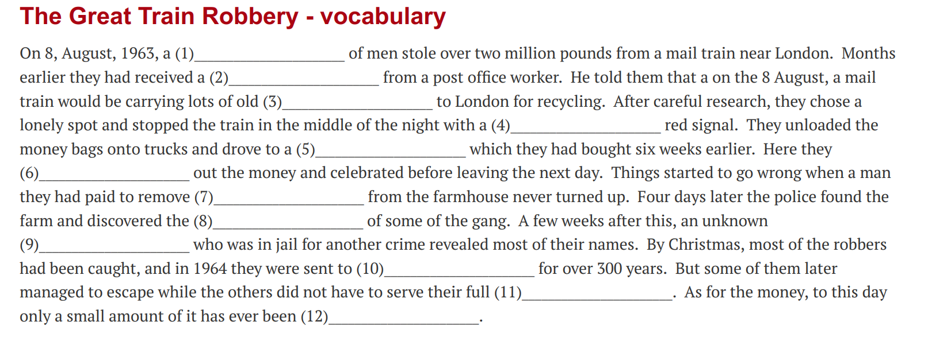

Exercise #3: Rephrase the following sentences so that they mean the same as the original ones. [4p]

1. He understood little about the situation.
_________________________________________________________________________________________

2. My neighbour seldom leaves his house so early.
_________________________________________________________________________________________

3. It's possible that the burglars got into the building by forcing open a fire exit.
GAINED
The burglars may _____________by forcing open a fire exit.

4. She feels that her parents don’t value all the things she does for them.
GRANTED
She hates ____________________________________ by her parents.

Exercise #4: Complete each sentence with a type of offender.[4p]

1. The_____________________ created realistic banknotes at home and tried to use them to buy jewellery.
2. A ____________________________ smashed all the windows of a parked car.
3. The _________________________ attacked a man as he was leaving a pub, leaving him with six broken ribs.
4. A _________________________ was charged with importing marijuana and selling it in his local area.
5. The _______________________illegally diverted money from the company's accounts for years.
6.The _______________________threatened the shop owners with violence unless they paid him.
7.The _______________________was driving home after drinking and killed a pedestrian.
8.The _______________________kept calling up a colleague and verbally abusing her, causing her mental distress.

Exercise #5: PRONUNCIATION. [3p]
- Which past ending is pronounced differently? apologized misused raised raced
- Which pairs of words do NOT have the same vowel sound: pair- pear fair -fare beer-tear (vb.) billed-build
- Underline the silent consonant in these words: cupboard Wednesday dumb honour

Exercise #6: Write a few lines about what surprised you most of all the things Abha told you about India, the school system, the religions and the food. [2p]

