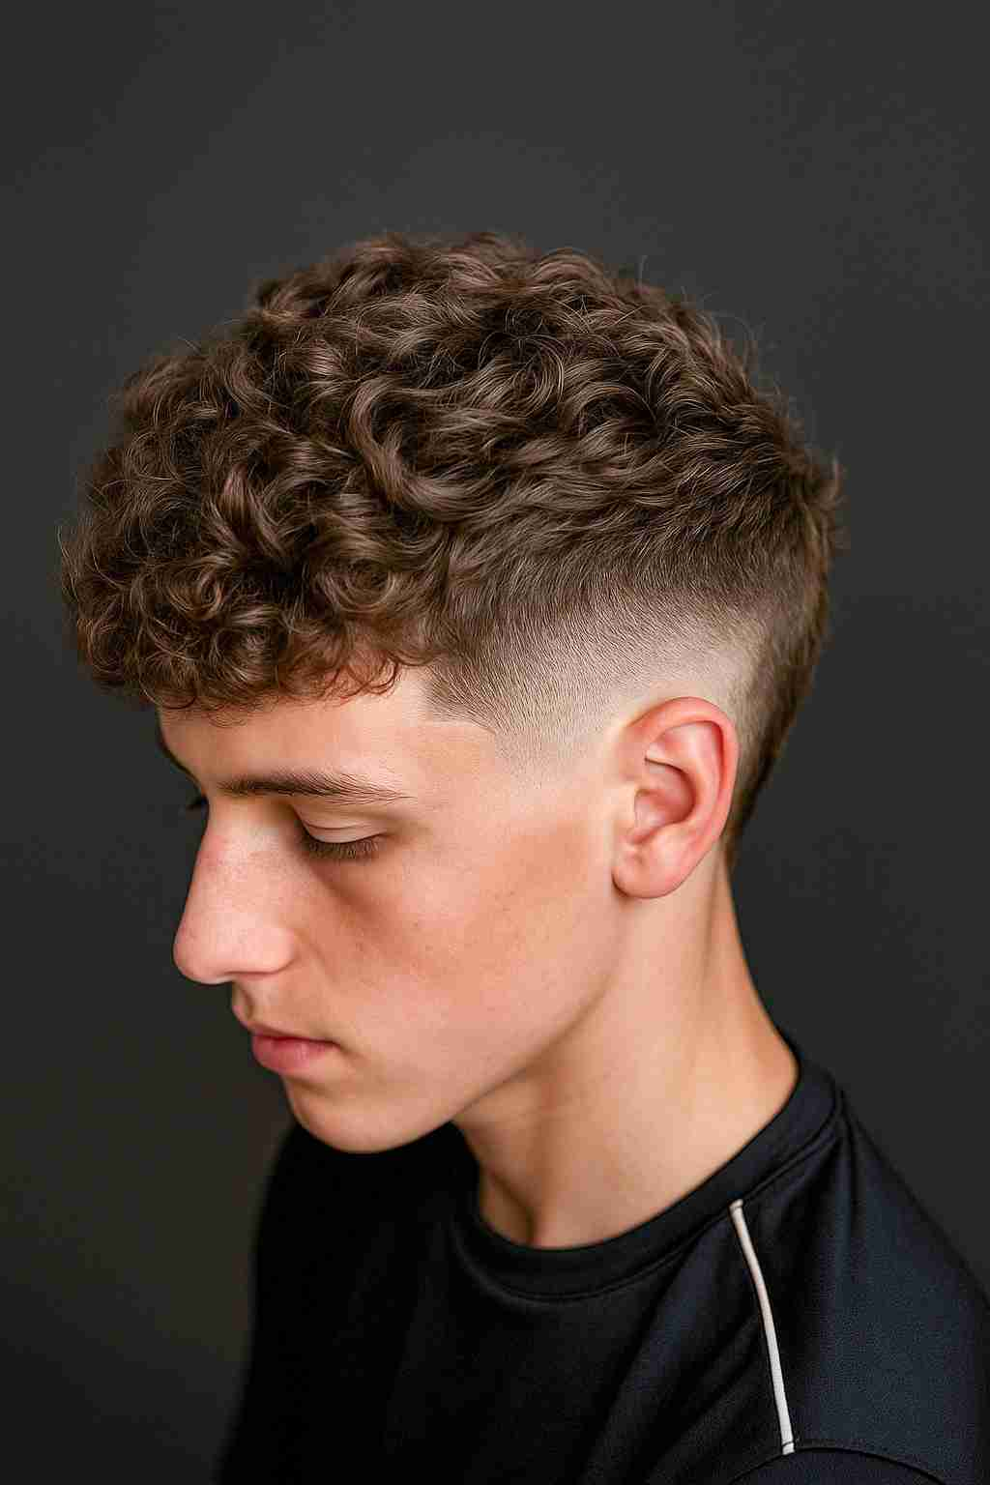
- The Skin Fade
The skin fade continues to dominate as one of the most requested men’s cuts. This clean style offers a seamless (continuo) transition from shaved sides to longer length on top. In 2025, expect to see more personalized variations:
- Low Skin Fades for a subtle, office-friendly finish
- High Fades for bold contrast and sharper definition
- Drop Fades that curve naturally around the head shape
Skin fades work well with nearly every hair type and can be combined with many other styles, from quiffs(tupé) to pompadours.

2️. Textured Crops & Messy Layers
The messy textured look is ideal for men who want a more relaxed style. Using layering and point-cutting techniques, we create movement and volume without looking too ‘done.’
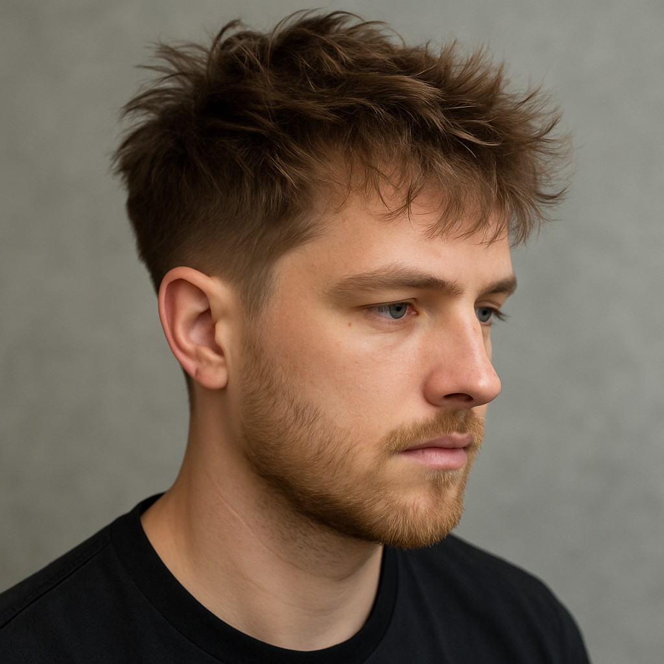
Perfect for:
- Wavy or slightly curly hair
- Low-maintenance clients
- Casual and professional settings
Texturizing products like matte clay or sea salt spray help maintain the style daily.

3️.The Quiff
The quiff remains one of the most adaptable men’s hairstyles for 2025. With short faded sides and longer hair brushed upwards and back, it creates height, shape, and balance.
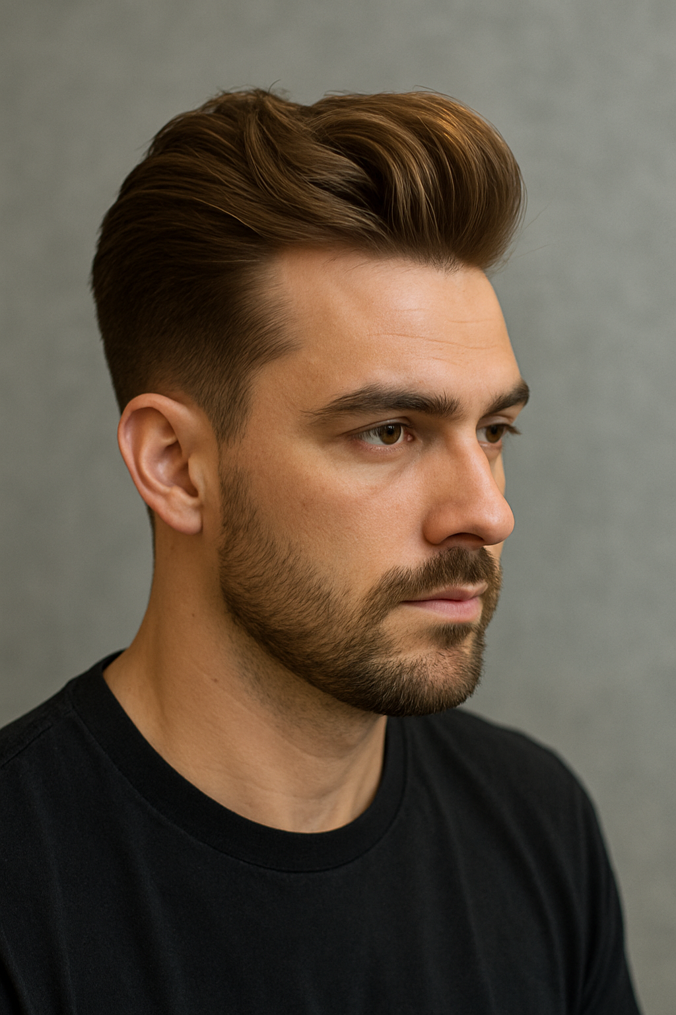
We’re seeing:
- Disconnected Quiffs for sharper contrast
- Natural Quiffs with softer texture and less product
- Slicked (engominado) Quiffs for formal occasions
Great for men who want versatile styling options.

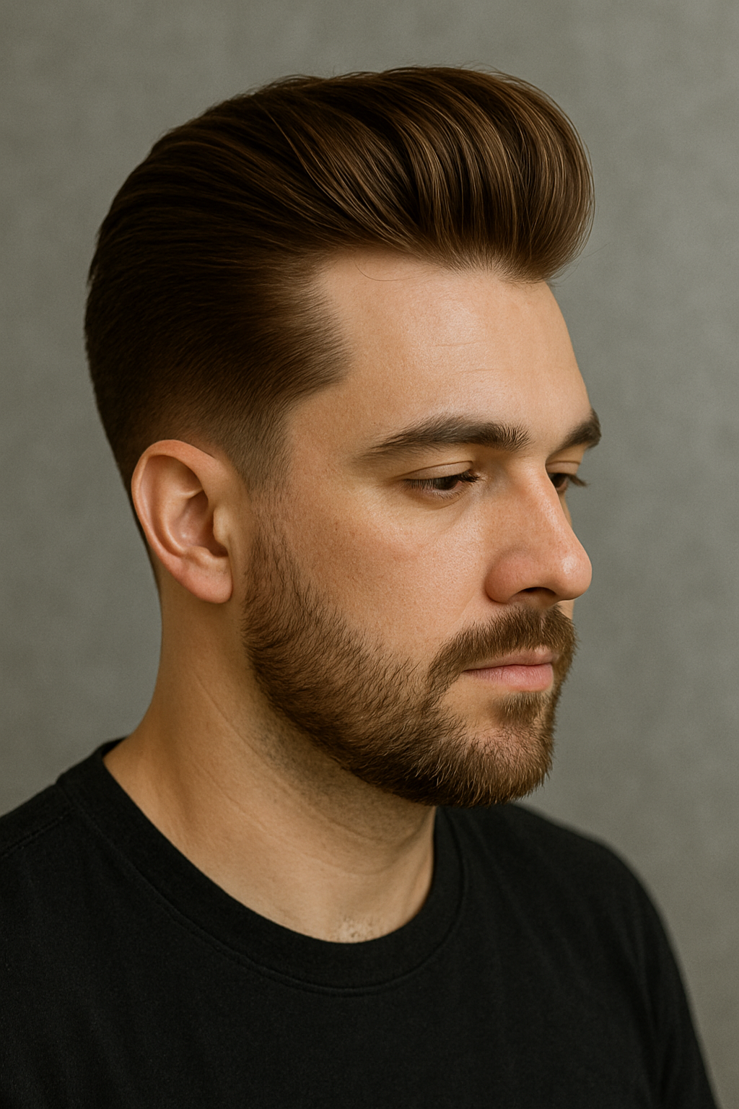
4️. The Pompadour
Inspired by vintage rock ‘n’ roll, the modern pompadour is sleeker and more structured. Using pomade or gel, the top section is styled up and back with maximum volume.

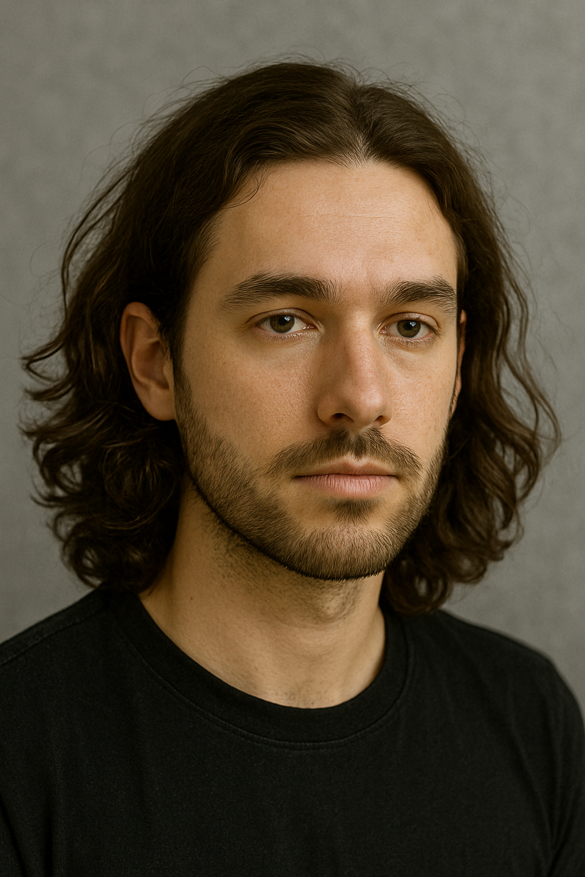
5️. Long Hair with Waves
More men are embracing longer styles. Waves and longer layers offer versatility while maintaining a natural, effortless appearance.
This works for:
- Naturally wavy hair types
- Men willing to invest in proper conditioning and trims
- Professional or creative industries
Long hair requires regular maintenance, but offers endless styling flexibility — from man buns to loose, flowing waves.

6️. Men’s Perms
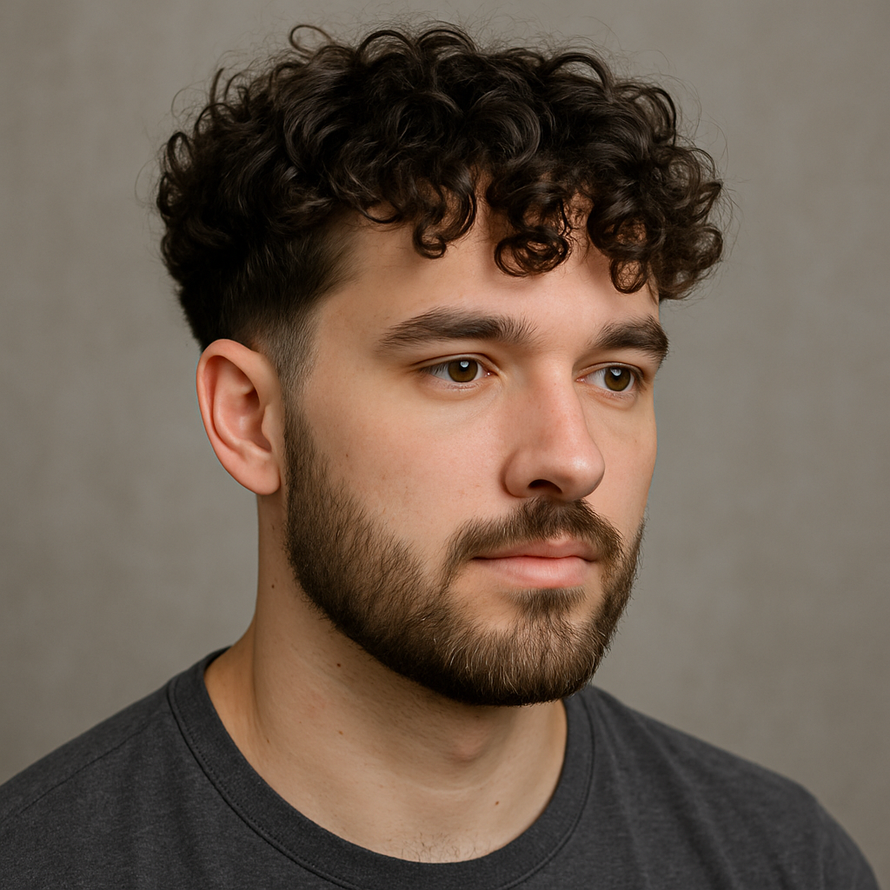
One of the fastest-growing trends is men’s perms. From loose beachy waves to tighter curls, perms can completely transform straight or flat hair into textured, dynamic styles.
Modern perming techniques are gentler, more natural, and fully customizable to each client.

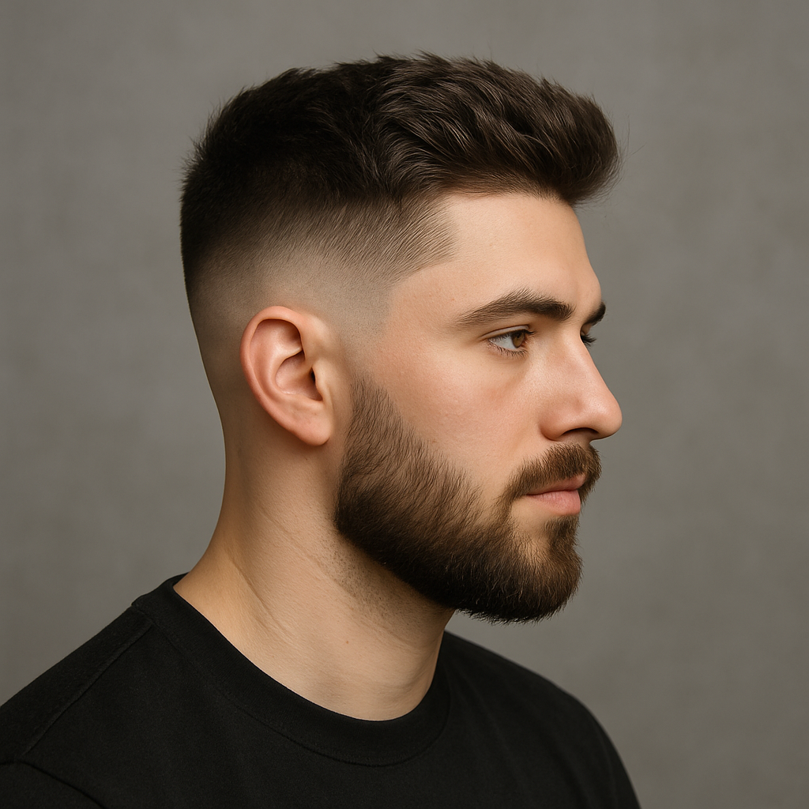
7️. Fades & Grades
Fade haircuts remain a foundation(base) for many modern men’s styles. Whether it’s a low, mid, or high fade — precision clipper work ensures a clean, blended finish that complements any head shape or face structure.

