VÍDEOS PECOCA
https://www.youtube.com/watch?v=vP6R5WUJswU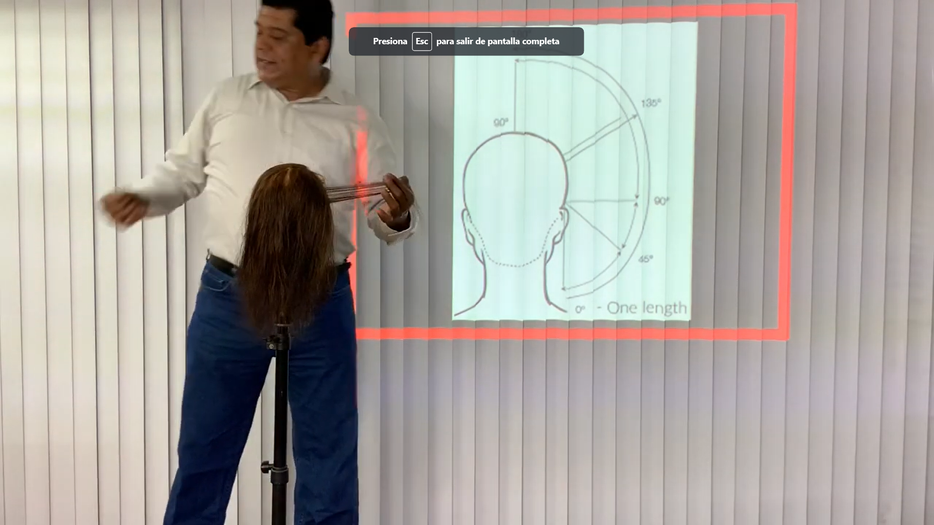

https://www.youtube.com/watch?v=27A8DW18xsE
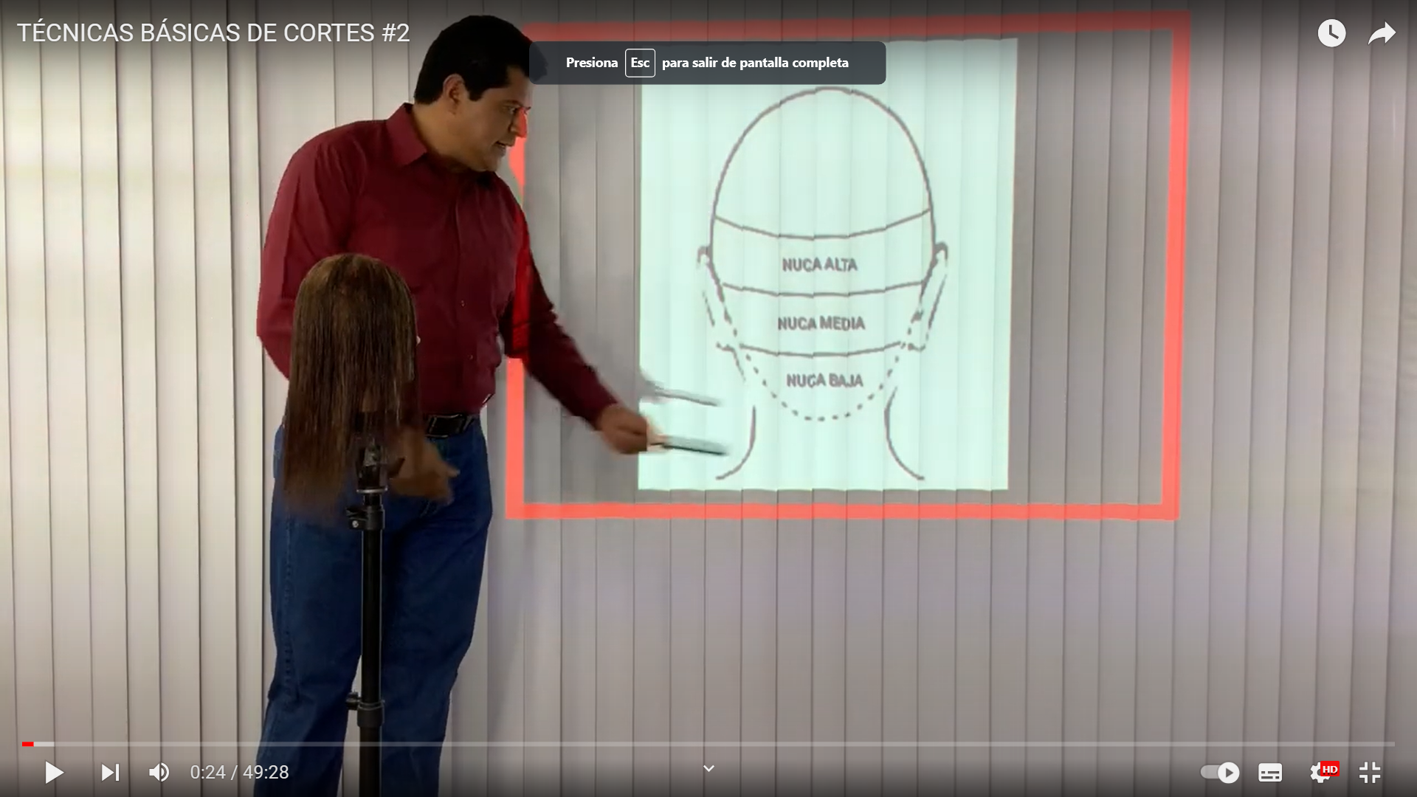
https://www.youtube.com/watch?v=fju-cUuxUOs

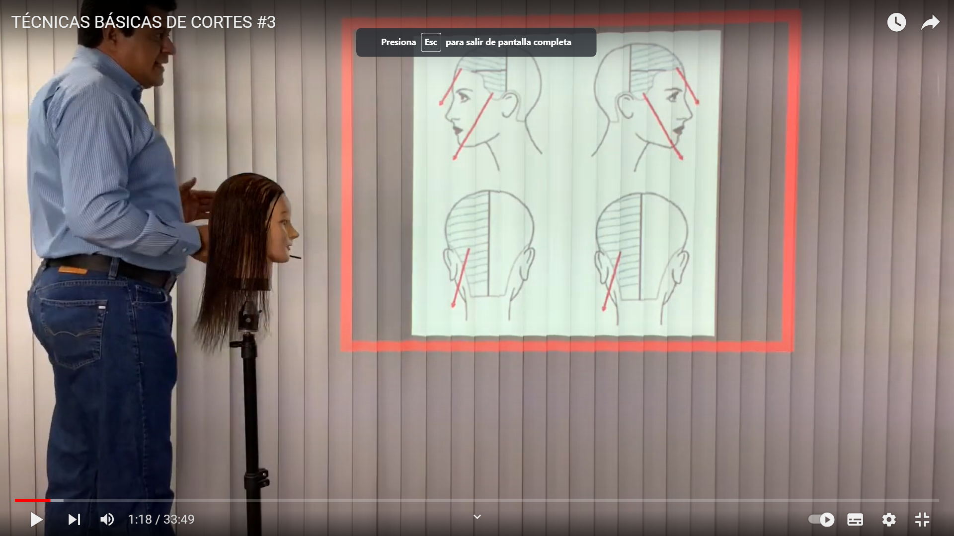

https://www.youtube.com/watch?v=IttZo8BG83s

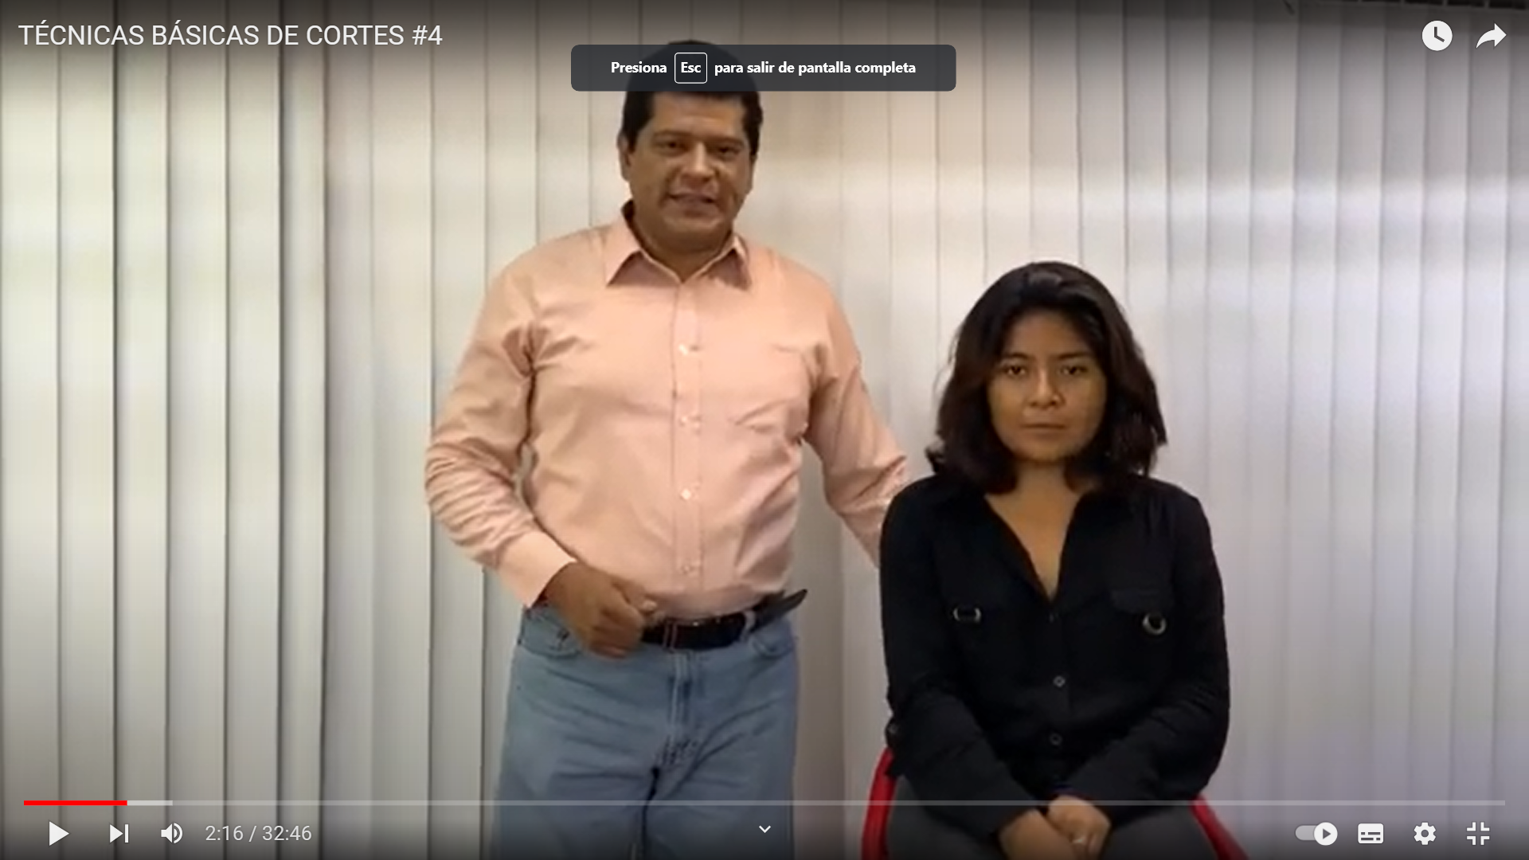

https://www.youtube.com/watch?v=W24kNL2E4N4
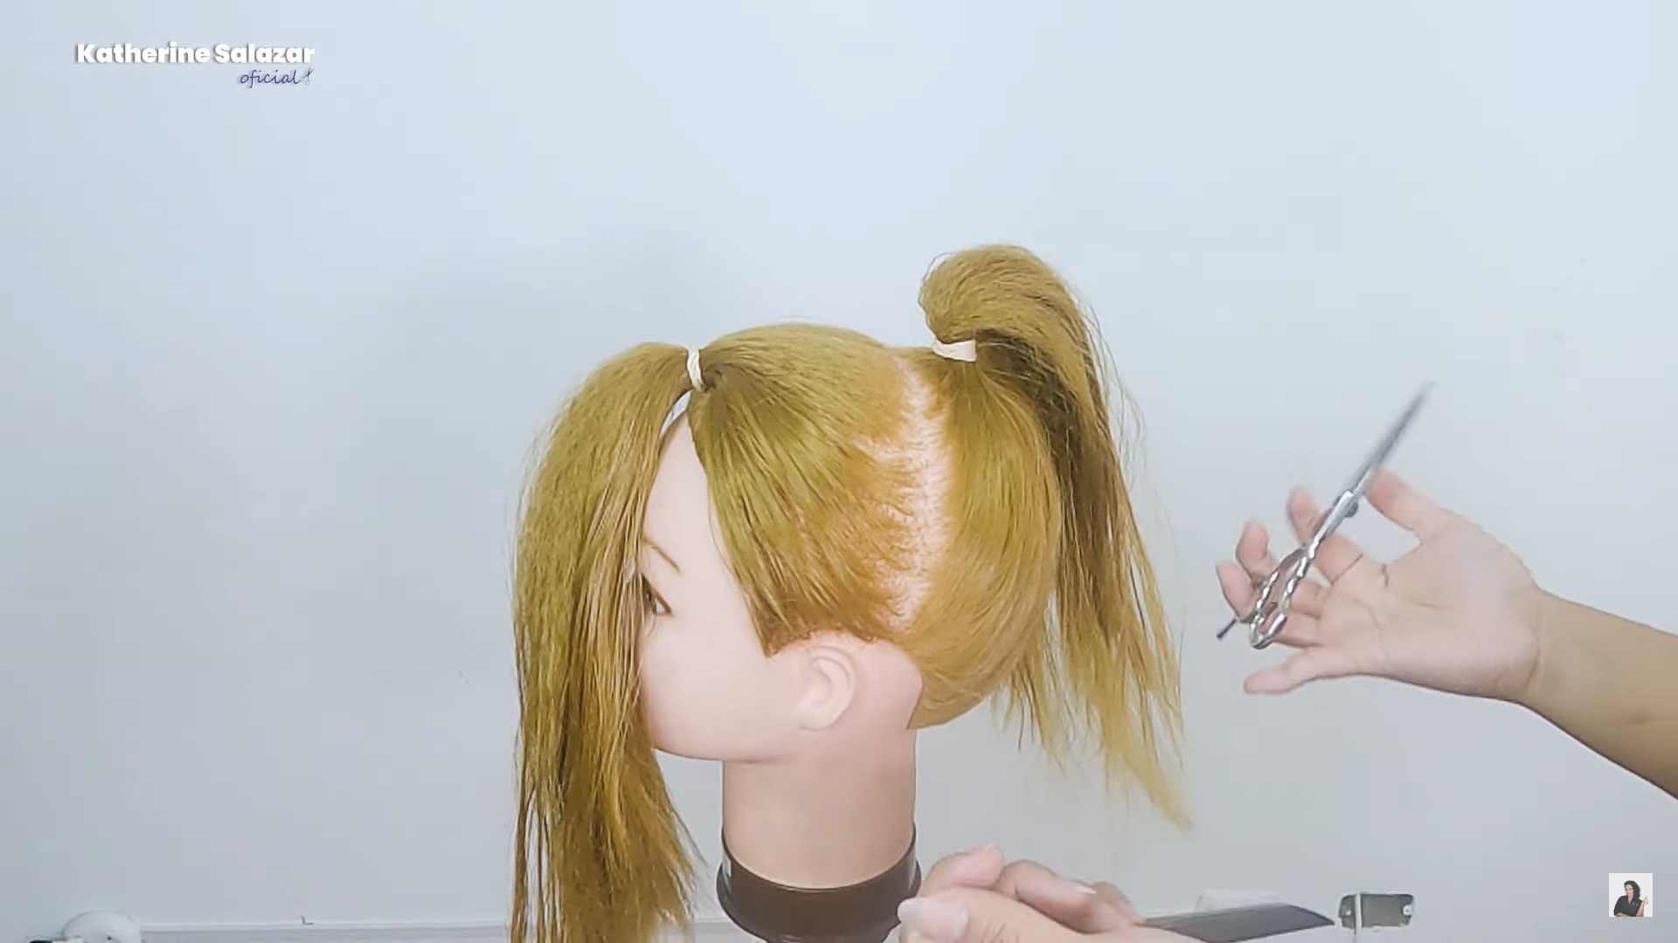

https://www.youtube.com/watch?v=6p7Hk6oeRms


https://www.youtube.com/shorts/71ja4f6Y_Sc
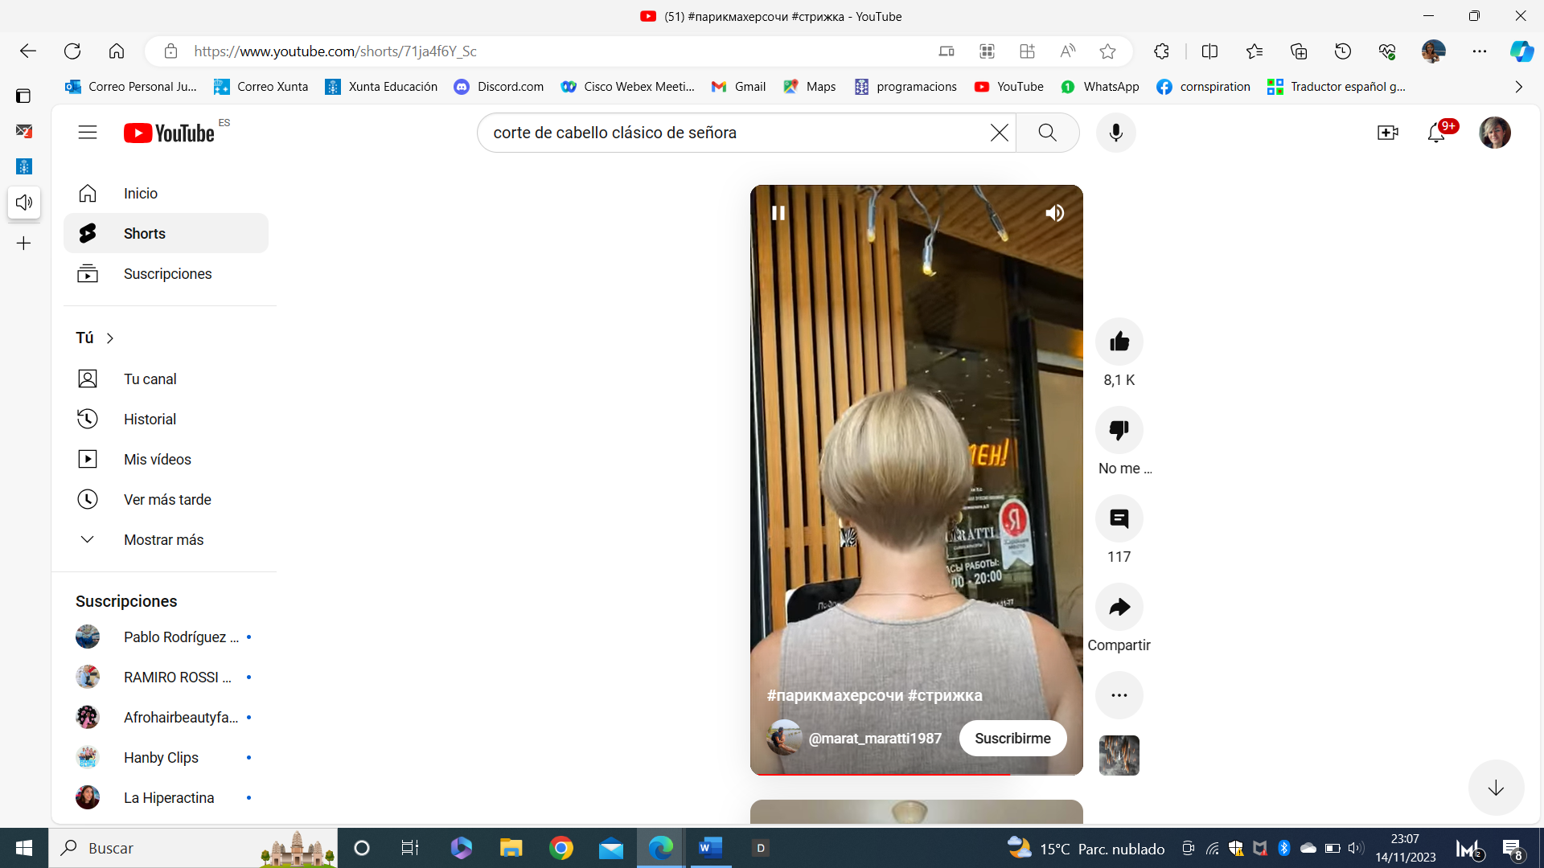

https://www.youtube.com/watch?v=FJm2WLR_4Uo
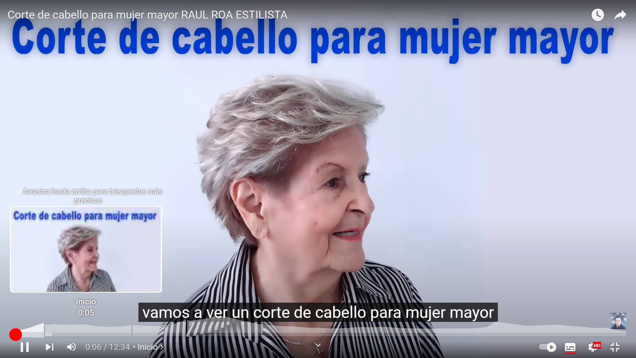

https://www.youtube.com/watch?v=NOIHcKLsq-c



https://www.youtube.com/watch?v=dKTc0216Dw0
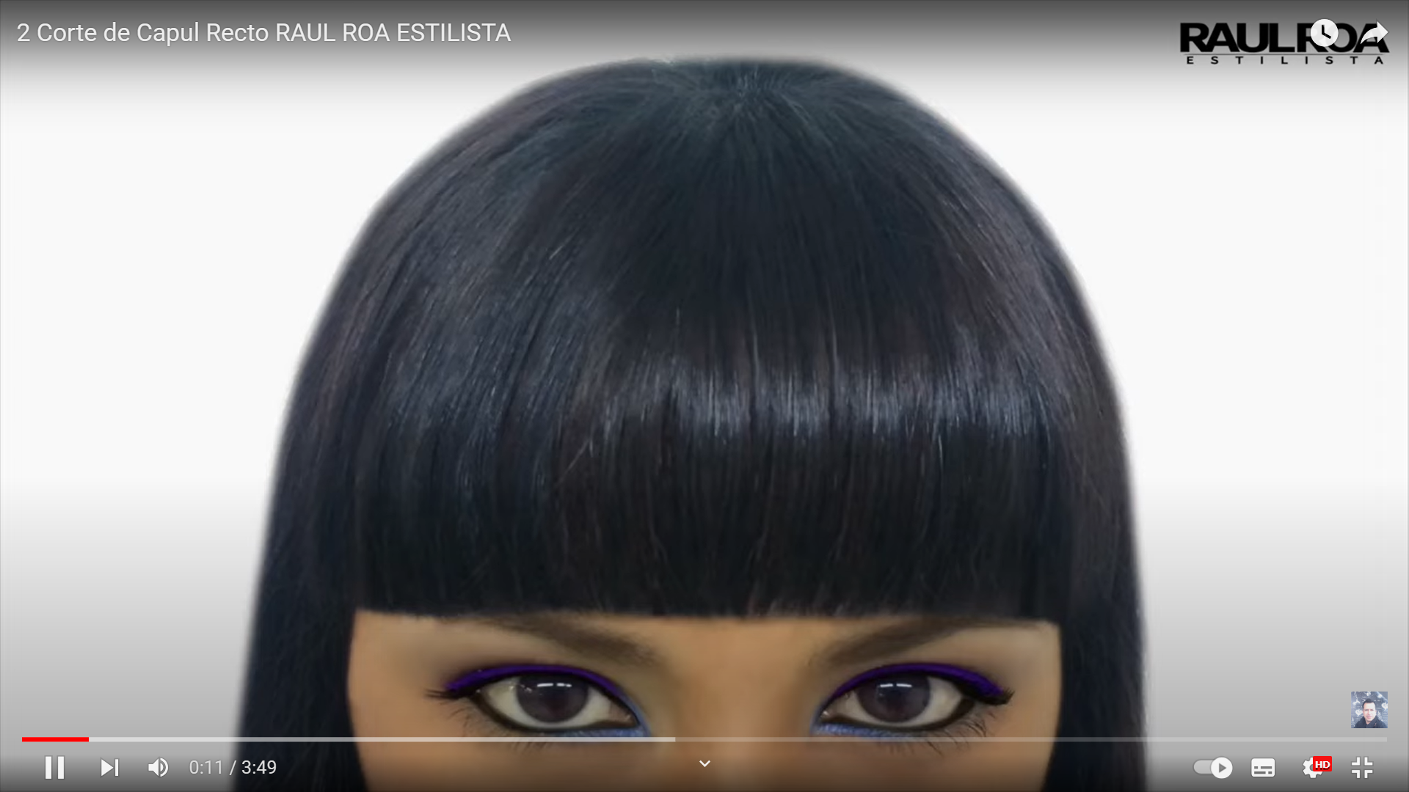

https://www.youtube.com/watch?v=Y2CpWSALzTo
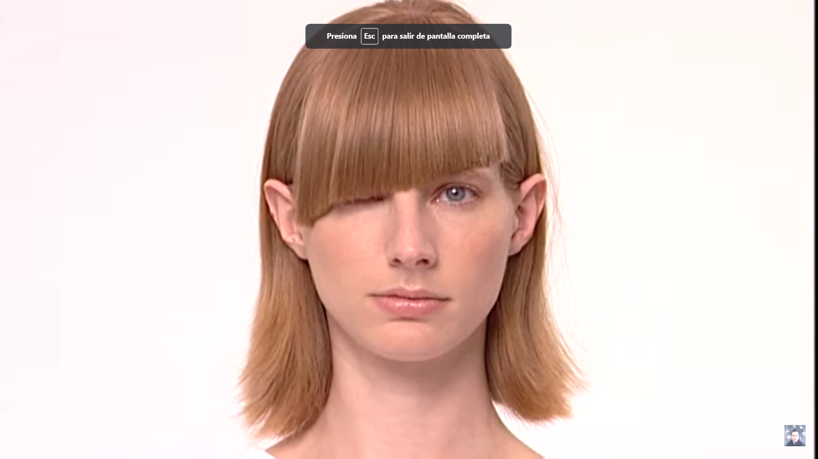

https://www.youtube.com/watch?v=zoS0a6BjNWA
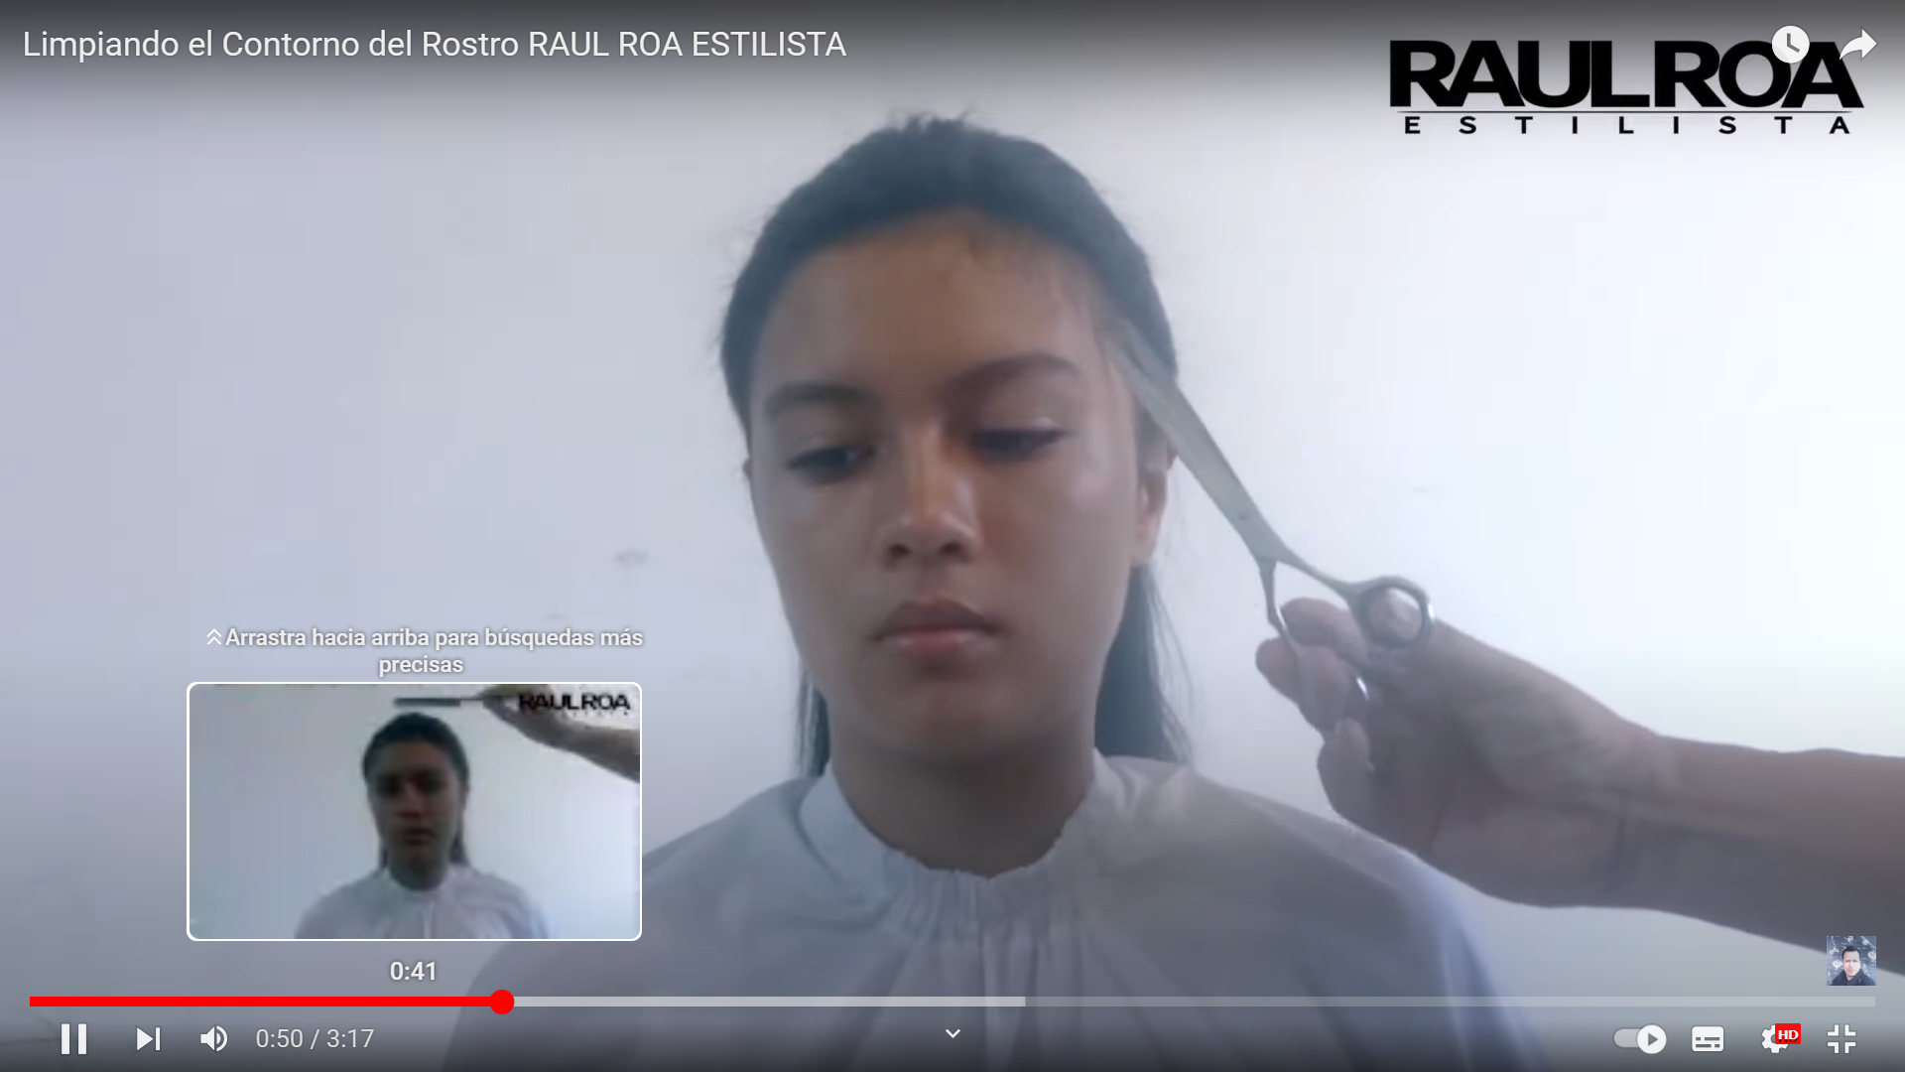

https://www.youtube.com/watch?v=GyXjuIbfyS8
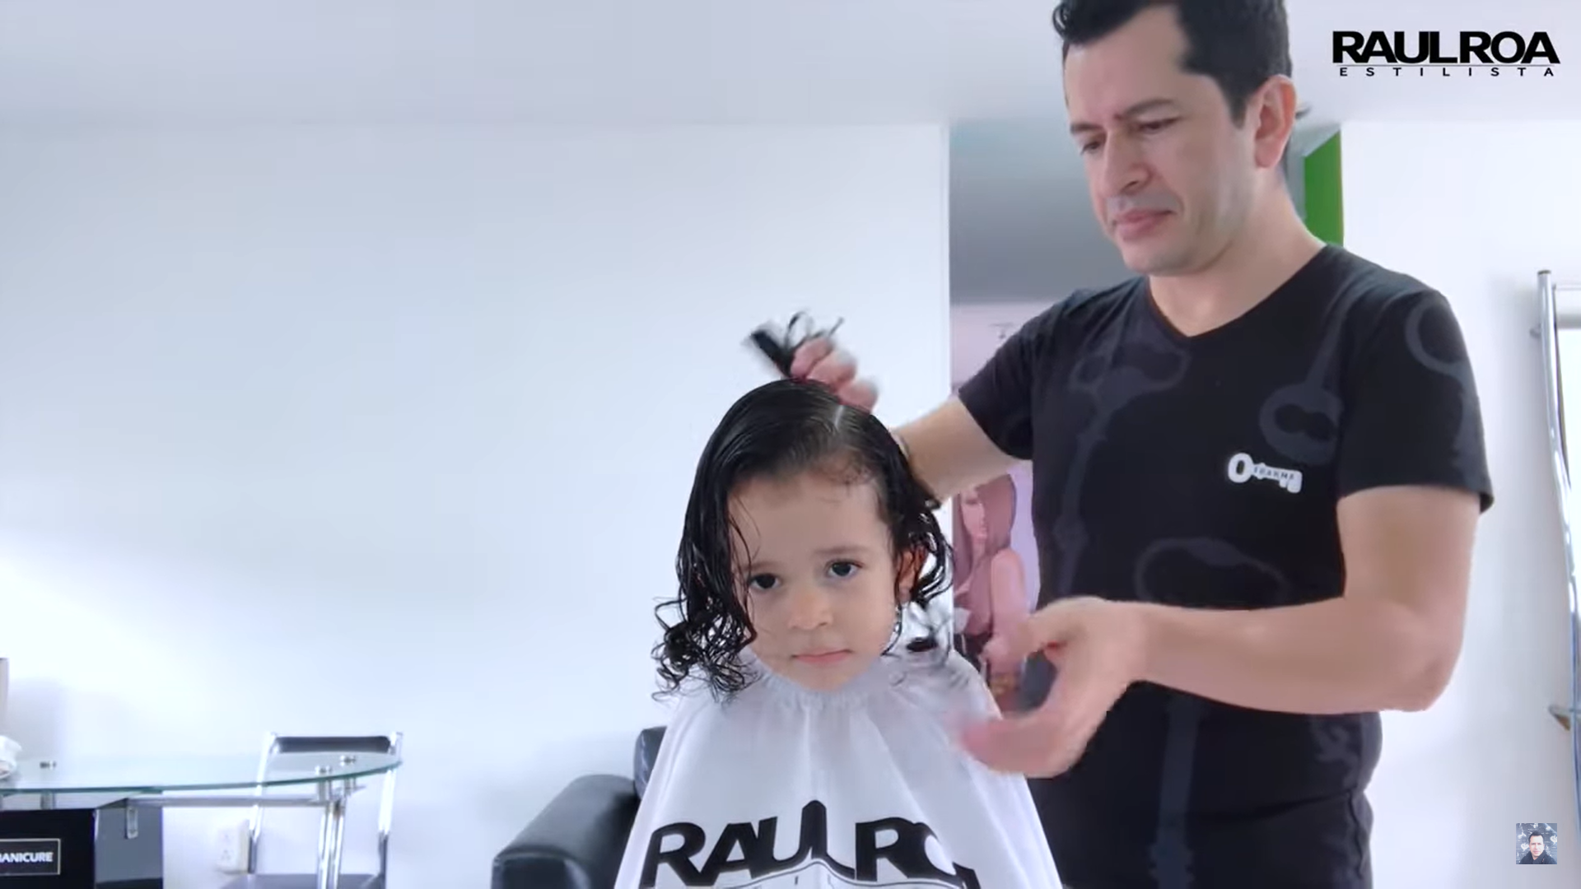

https://www.youtube.com/watch?v=3J5x7SZHoss
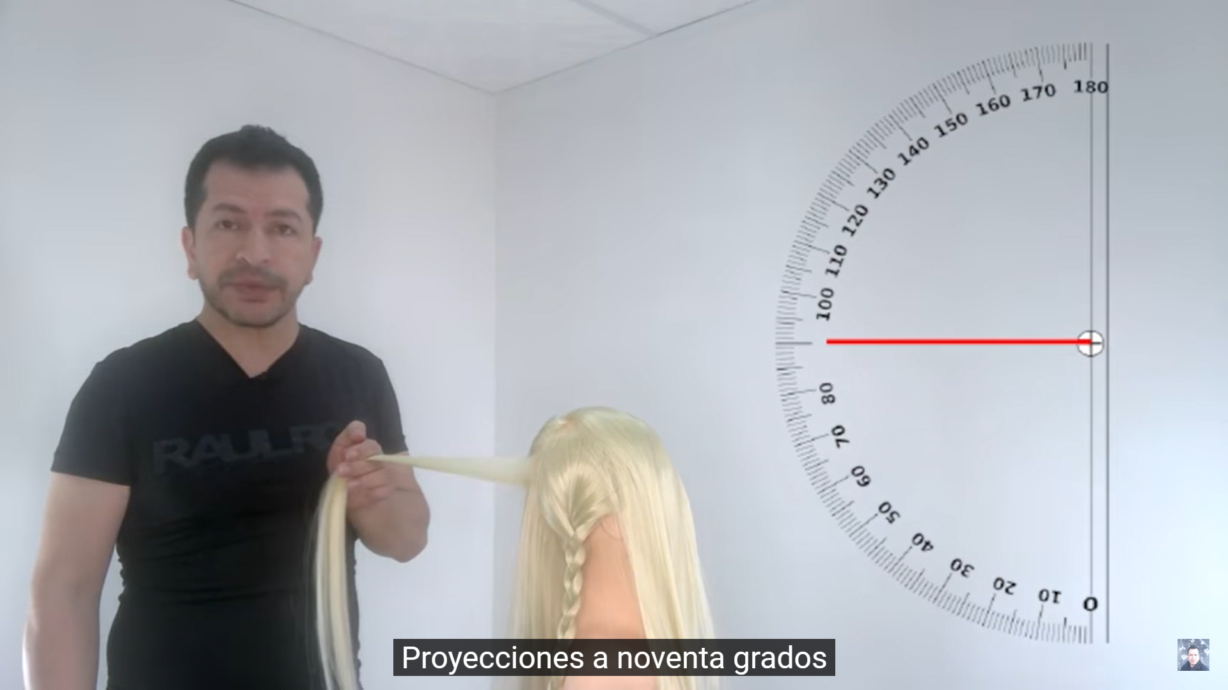

https://www.youtube.com/watch?v=SDIetkNjGQw
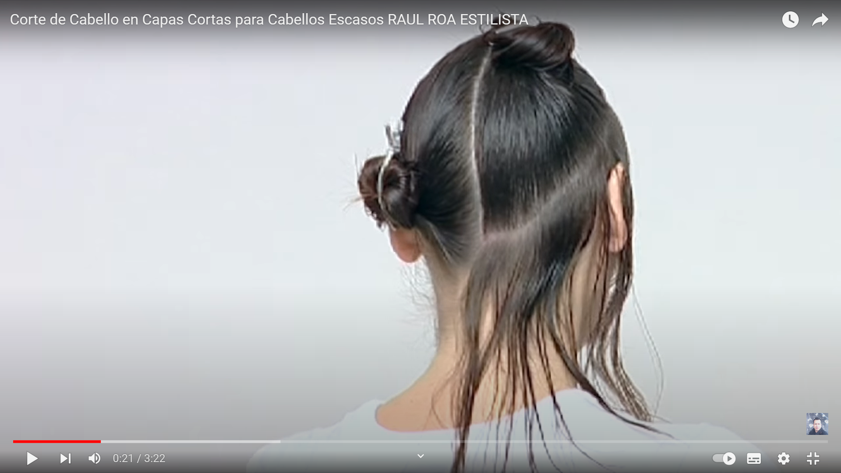

https://www.youtube.com/watch?v=yEPzKMWEuG4
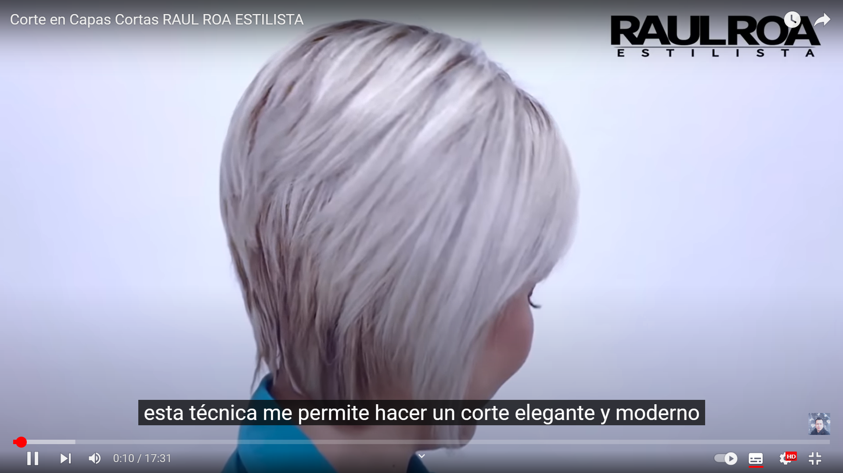

https://www.youtube.com/watch?v=AK8AbZiIRm4&list=TLPQMTQxMTIwMjOQ8AuDSk_ccA&index=2
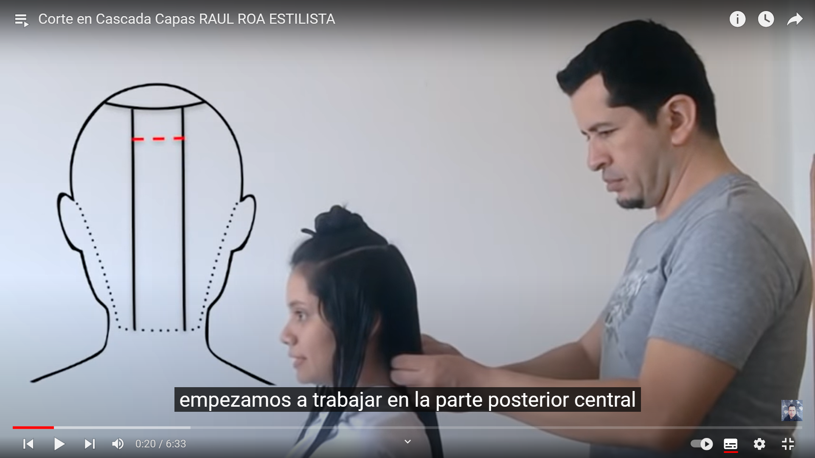

https://www.youtube.com/watch?v=nQsqj2sPlcs
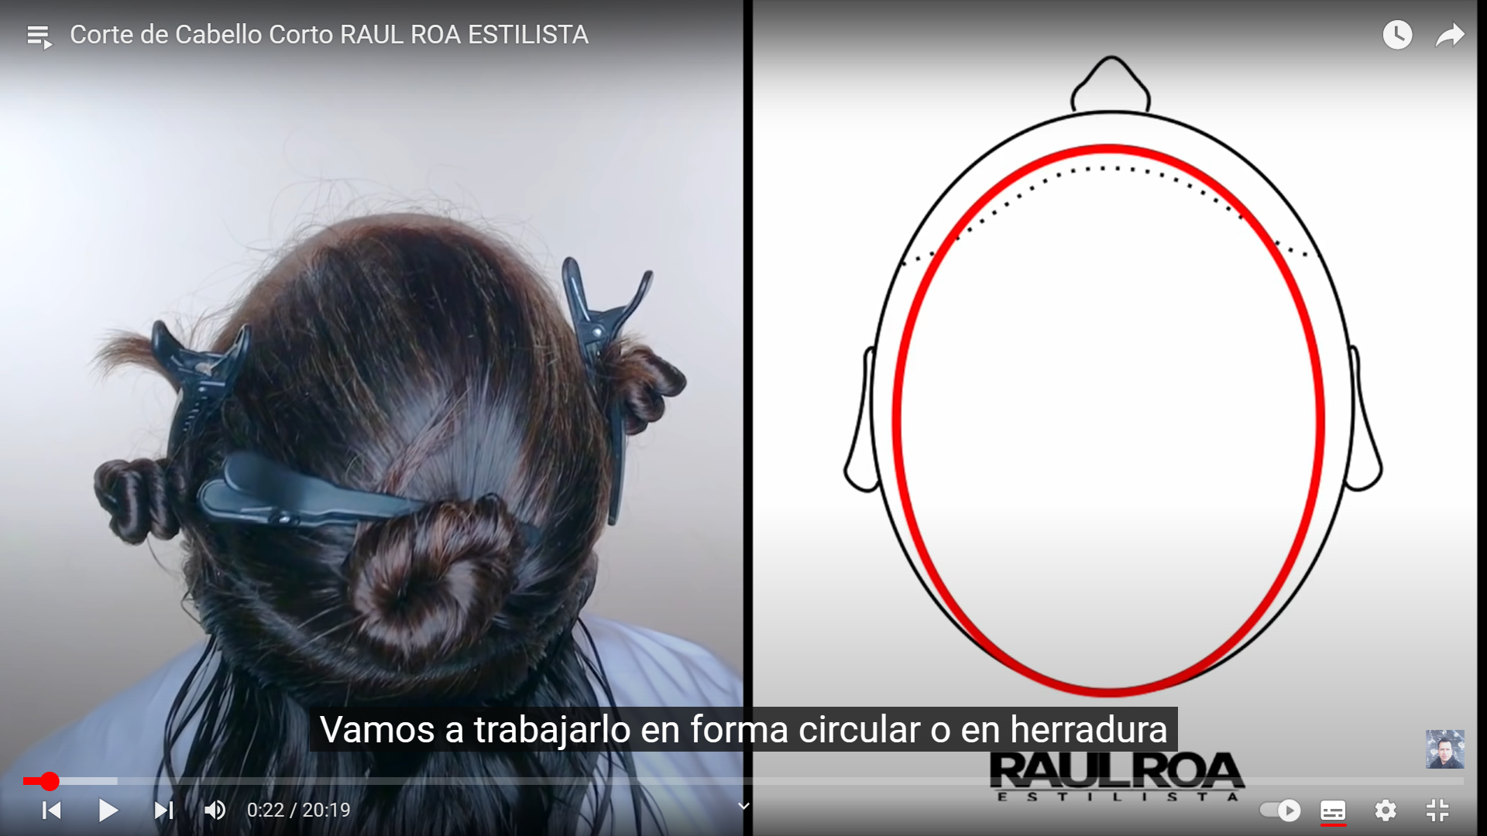

https://www.youtube.com/watch?v=DKhb9LD00j8
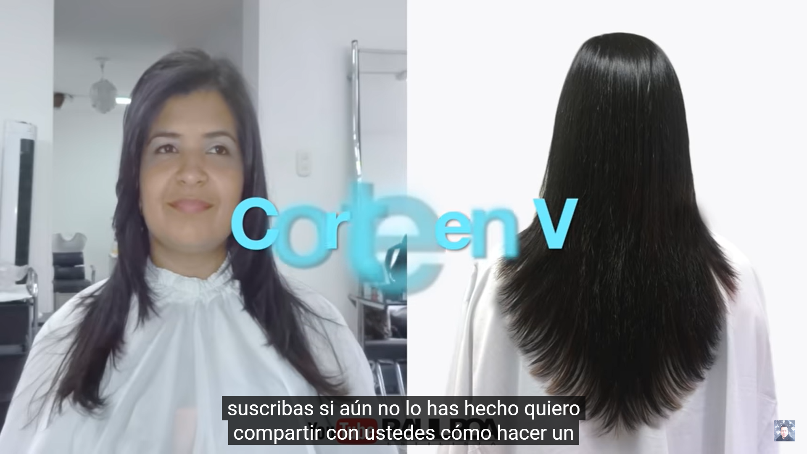

https://www.youtube.com/watch?v=H-465k_faSU&t=5s
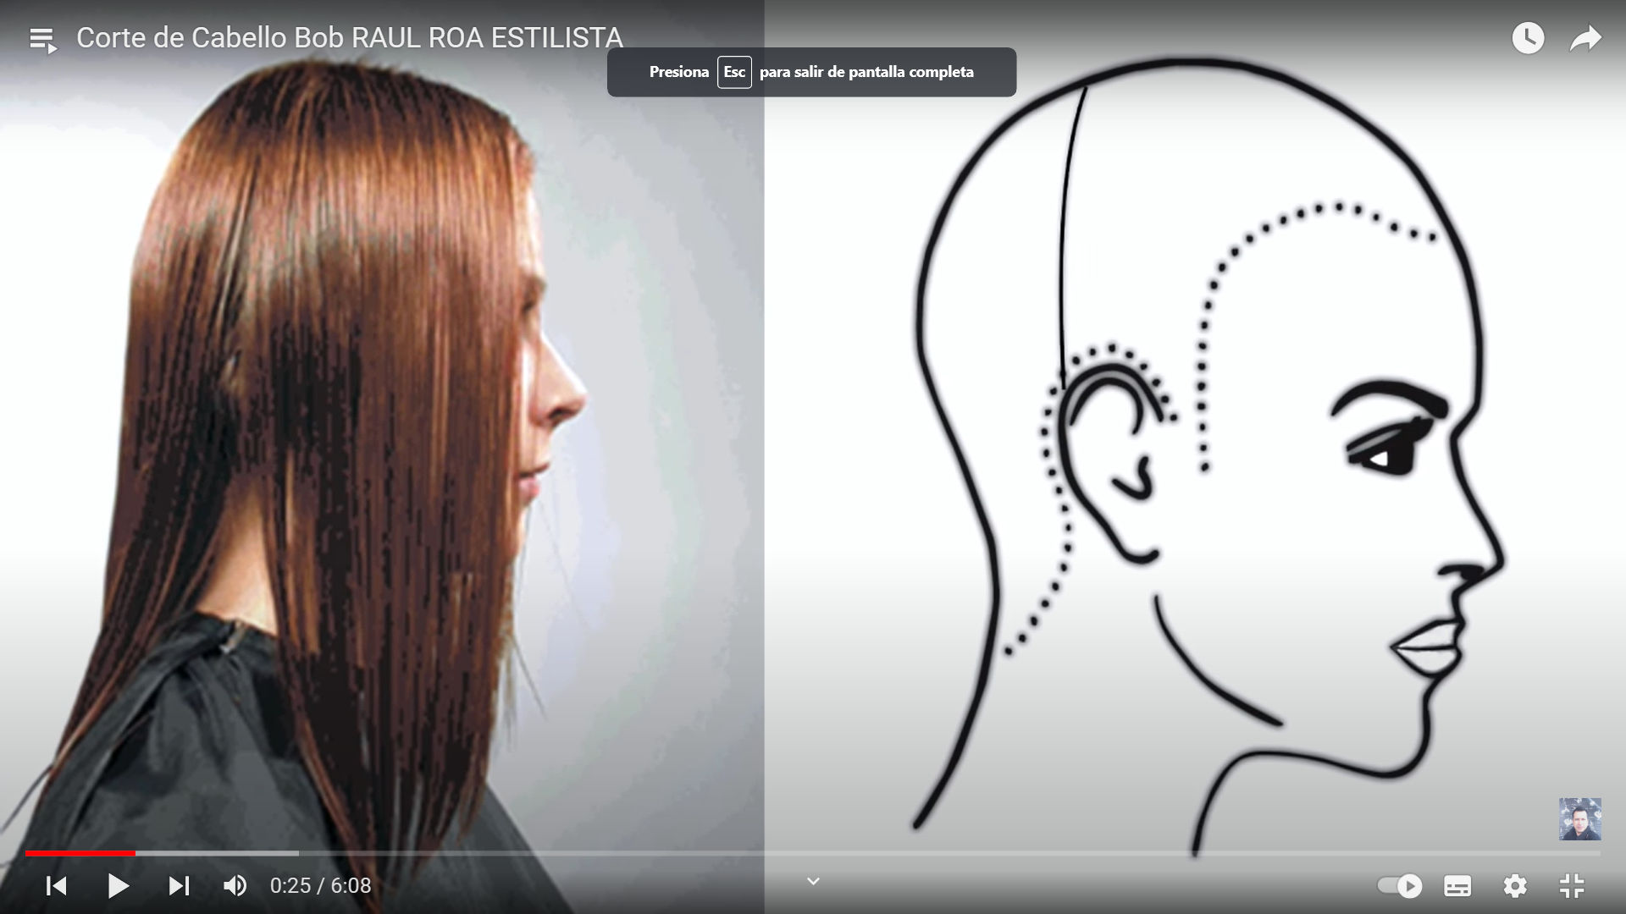

https://www.youtube.com/watch?v=xNqRo3h0Zco


https://www.youtube.com/watch?v=DU4vnFpqaRo


https://www.youtube.com/watch?v=BVuFdhKJ8lI
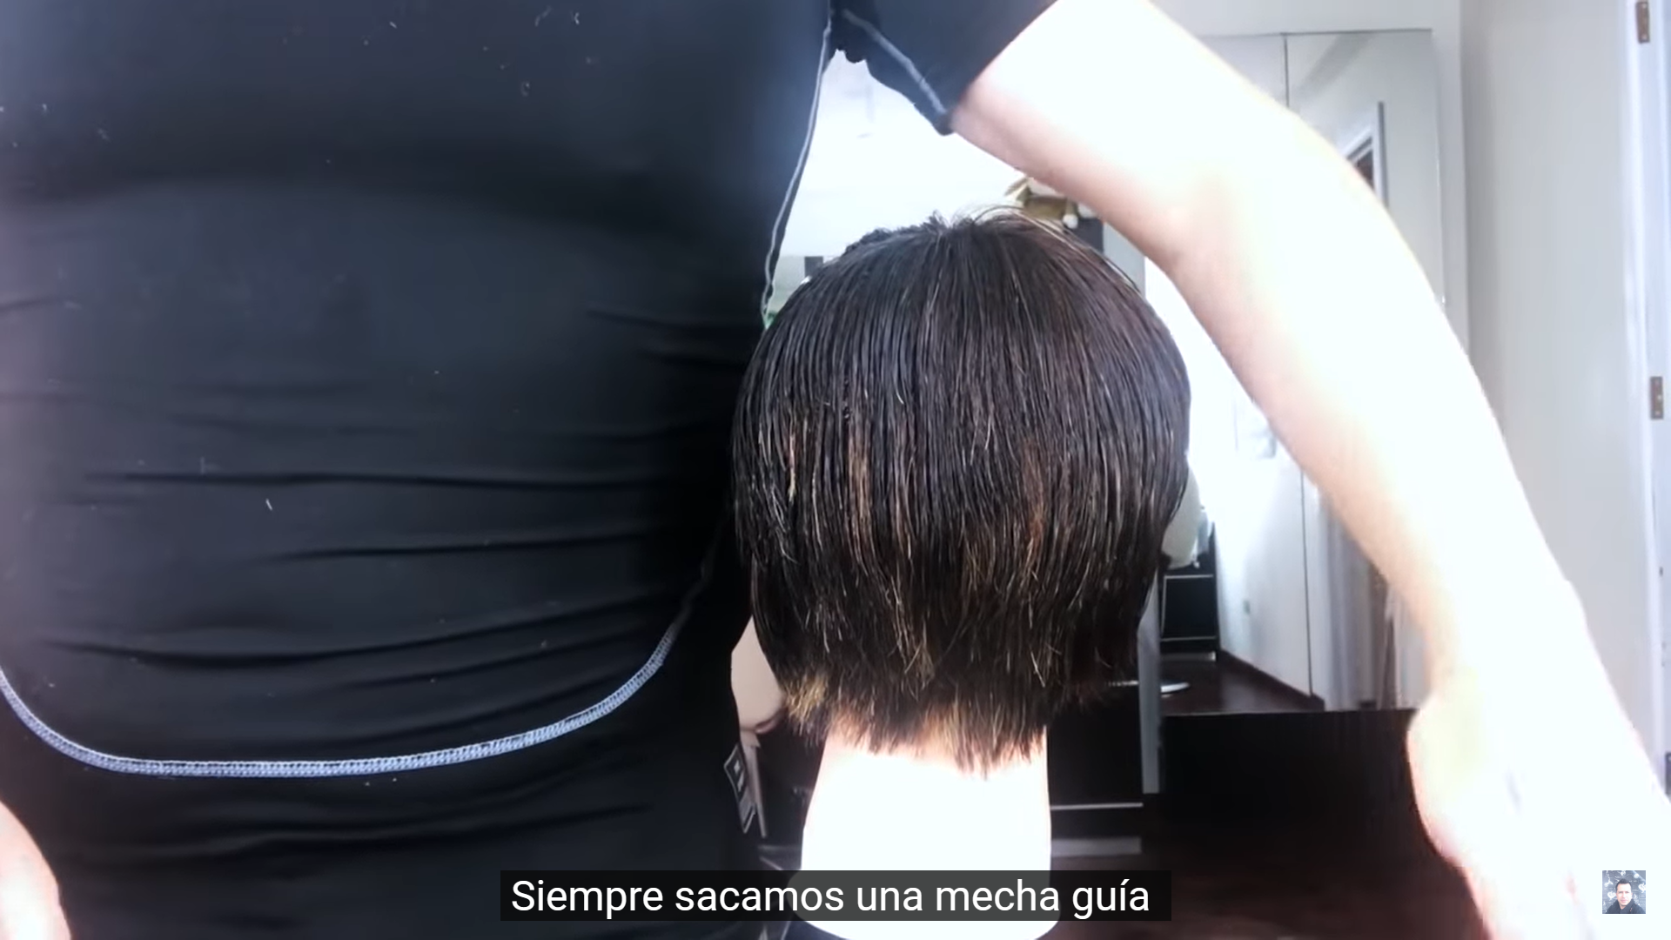

https://www.youtube.com/watch?v=kxOu7DeZgT0


https://www.youtube.com/watch?v=kn2m8sPsmRk
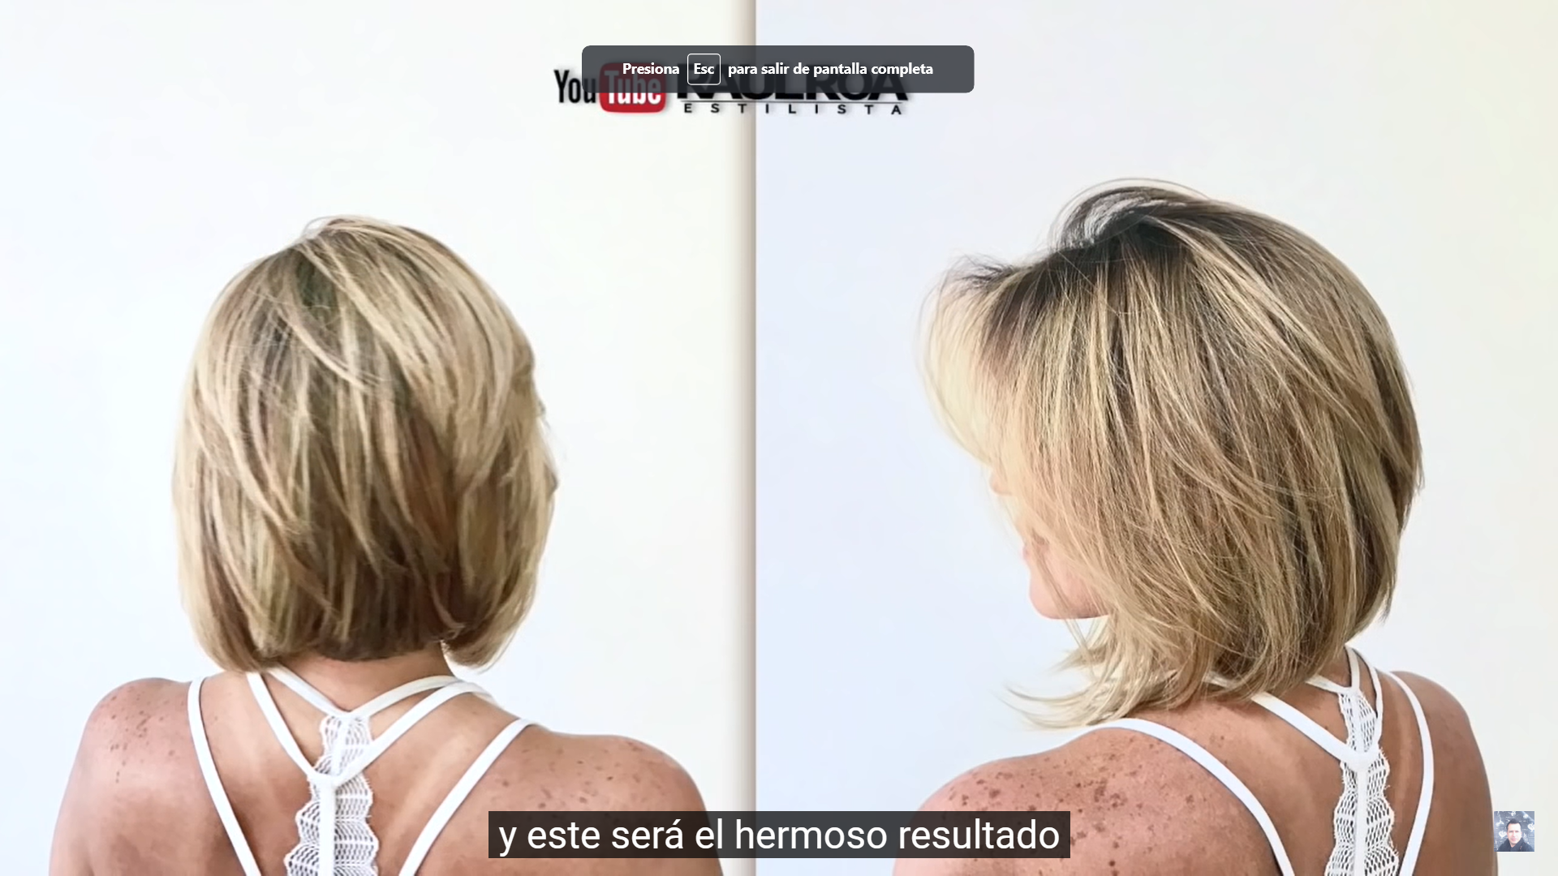

https://www.youtube.com/watch?v=DR_MVfGK7z4
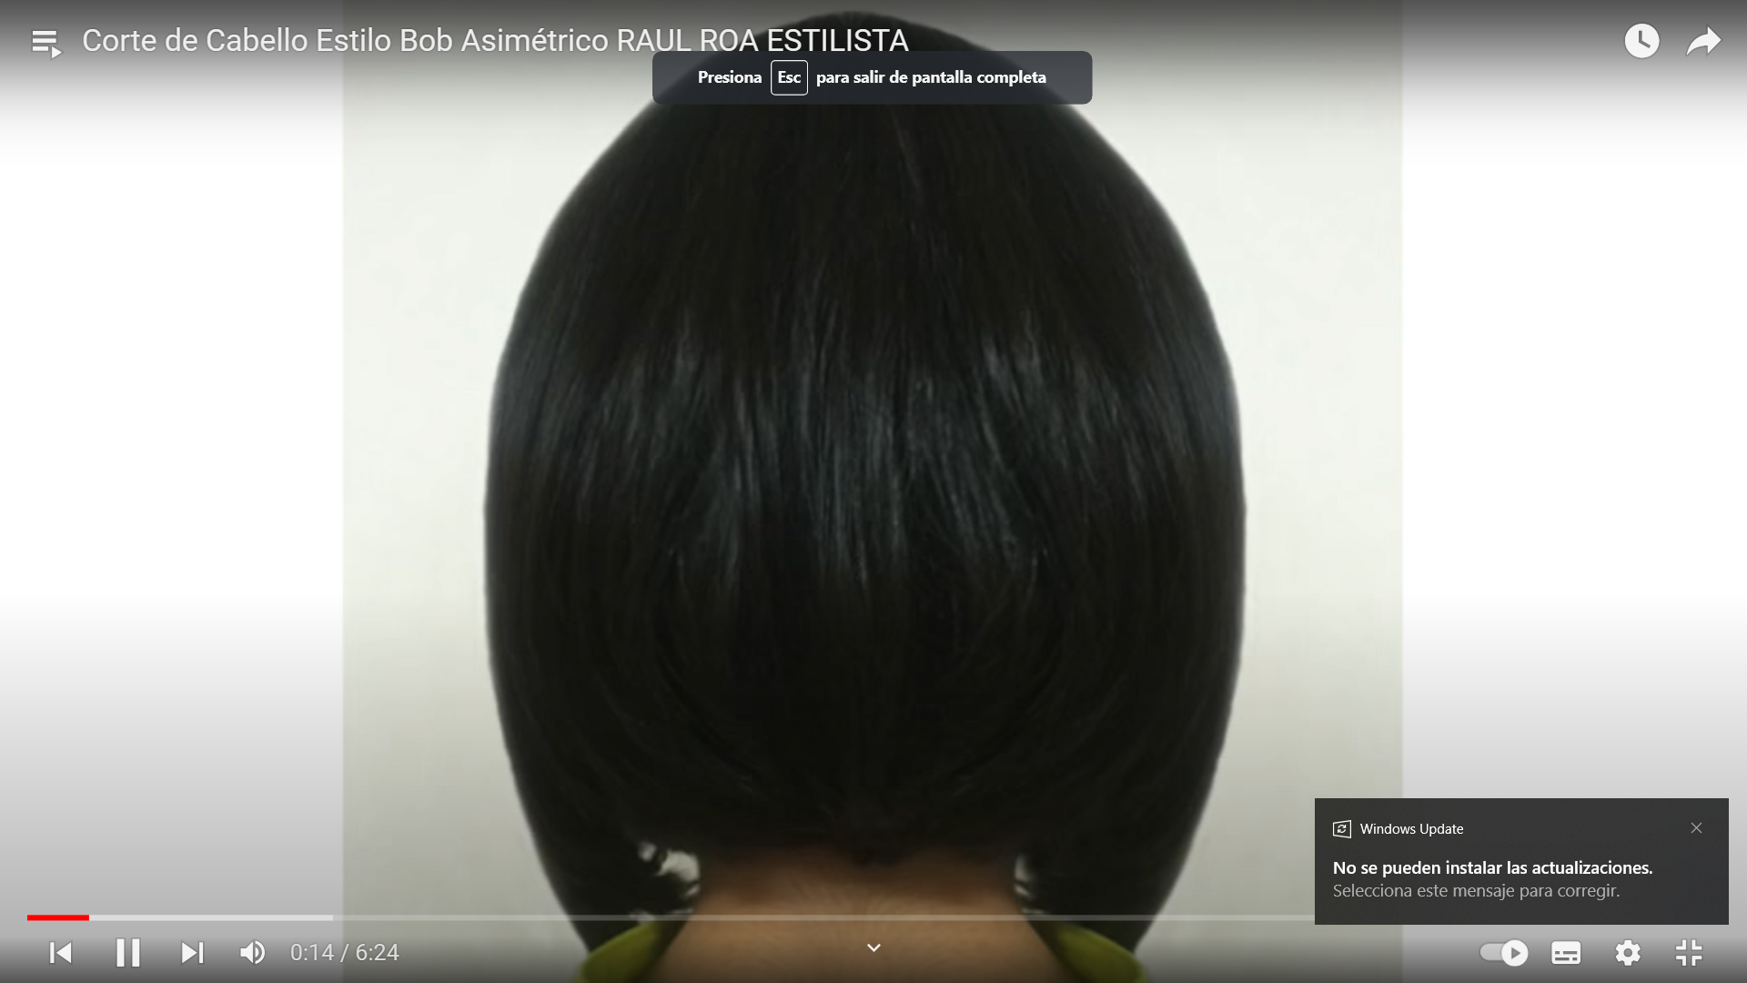
https://www.youtube.com/watch?v=qX2TQdY9O4s
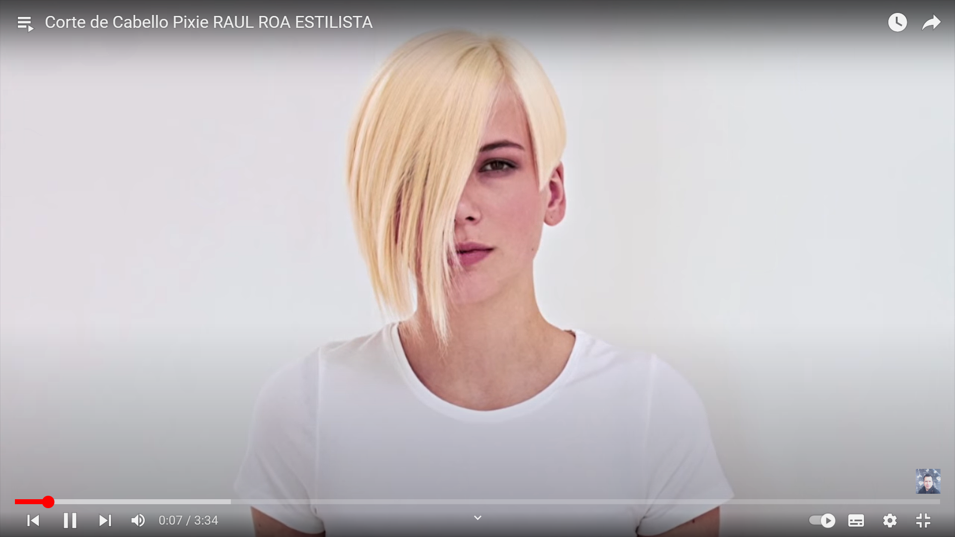

https://www.youtube.com/watch?v=iqf1iuL4ptU


https://www.youtube.com/watch?v=dp8EPeoze5c


https://www.youtube.com/watch?v=fEiw8THaM1A

https://www.youtube.com/watch?v=MNogPUzg6Zc&list=PLFIOj3BcDt7R6YABy4VUvtAt1Phsk840S
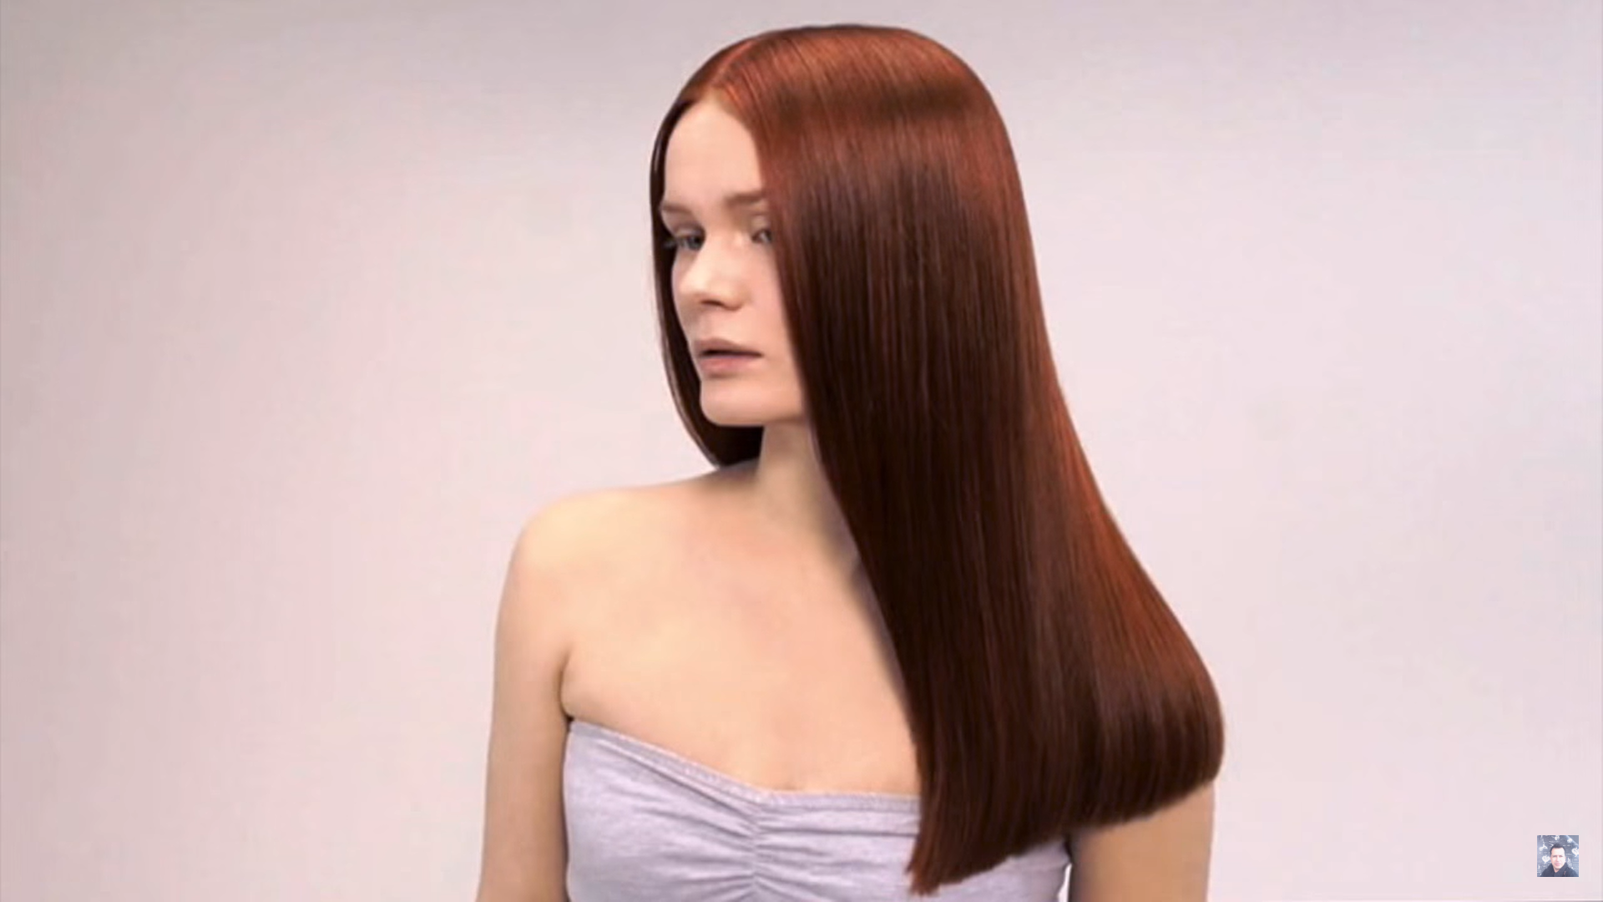

https://www.youtube.com/watch?v=riTtNemHm7A
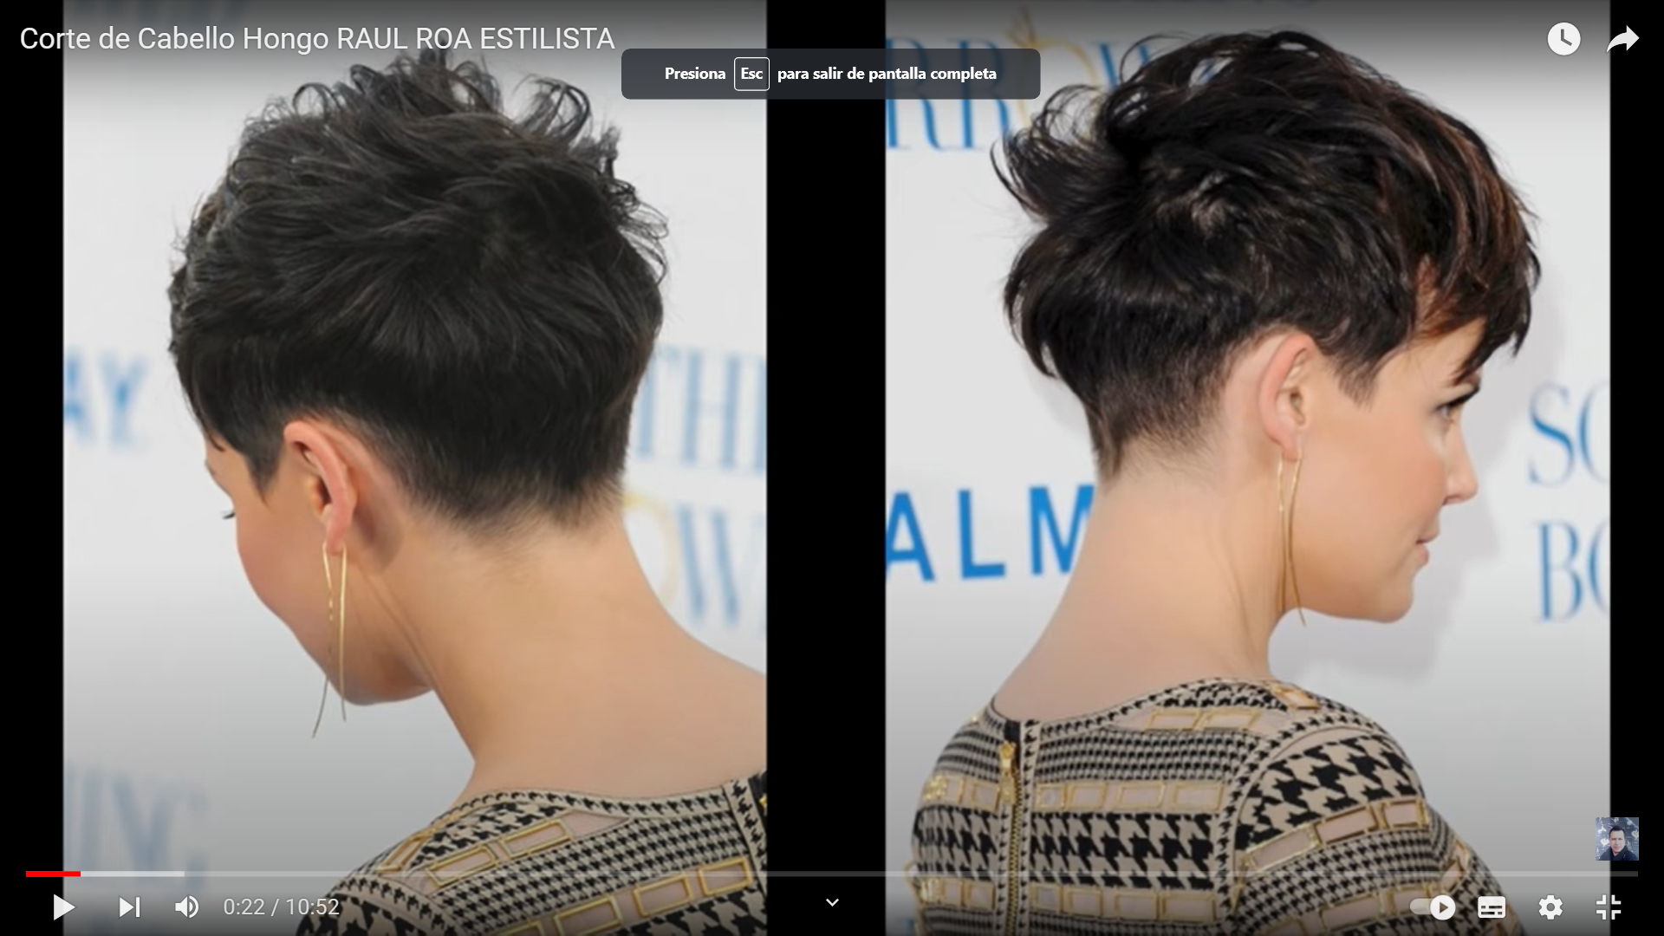

https://www.youtube.com/watch?v=5V3rCLmi9b0
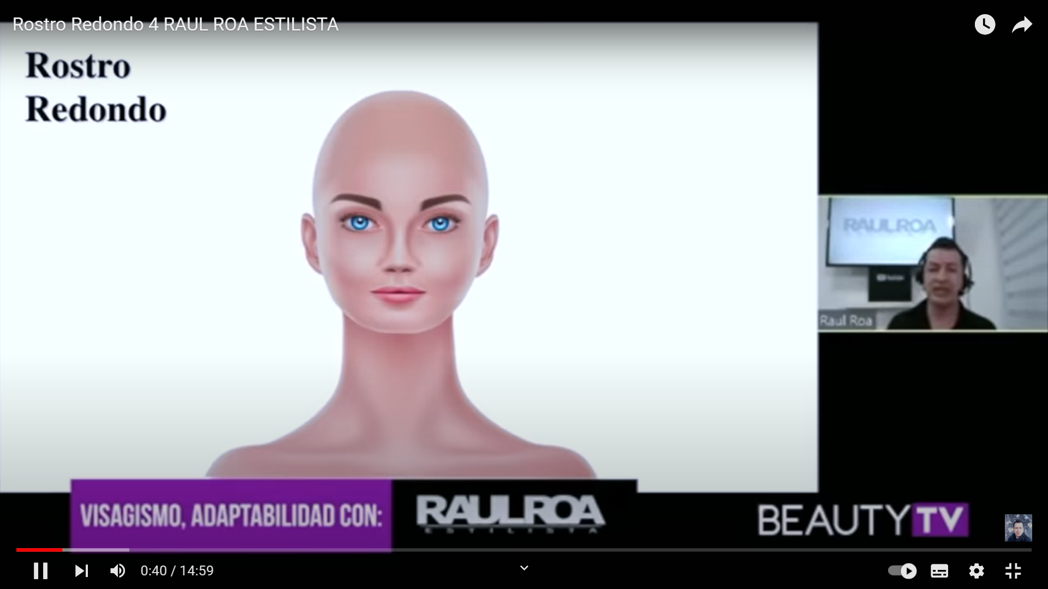

https://www.youtube.com/watch?v=riTtNemHm7A&list=RDCMUC8yyouZaOIRgq9aCqK3CiYg&start_radio=1&rv=riTtNemHm7A&t=36

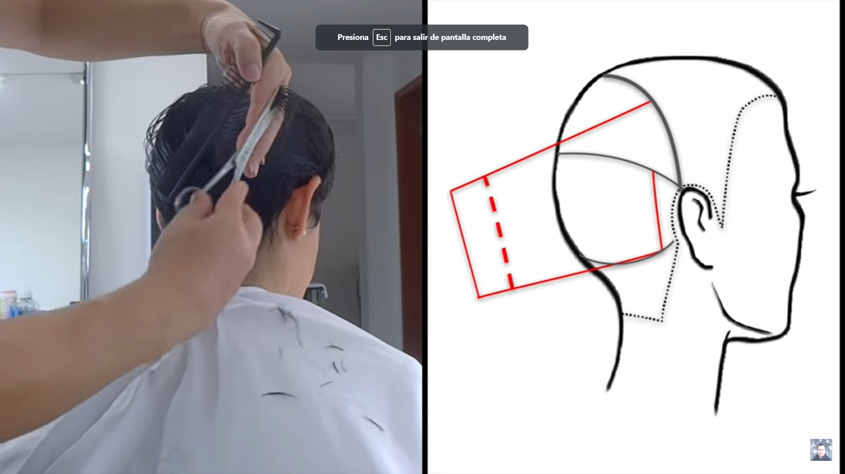

https://www.youtube.com/watch?v=Xp8yesOOwLM&list=RDCMUC8yyouZaOIRgq9aCqK3CiYg&index=6

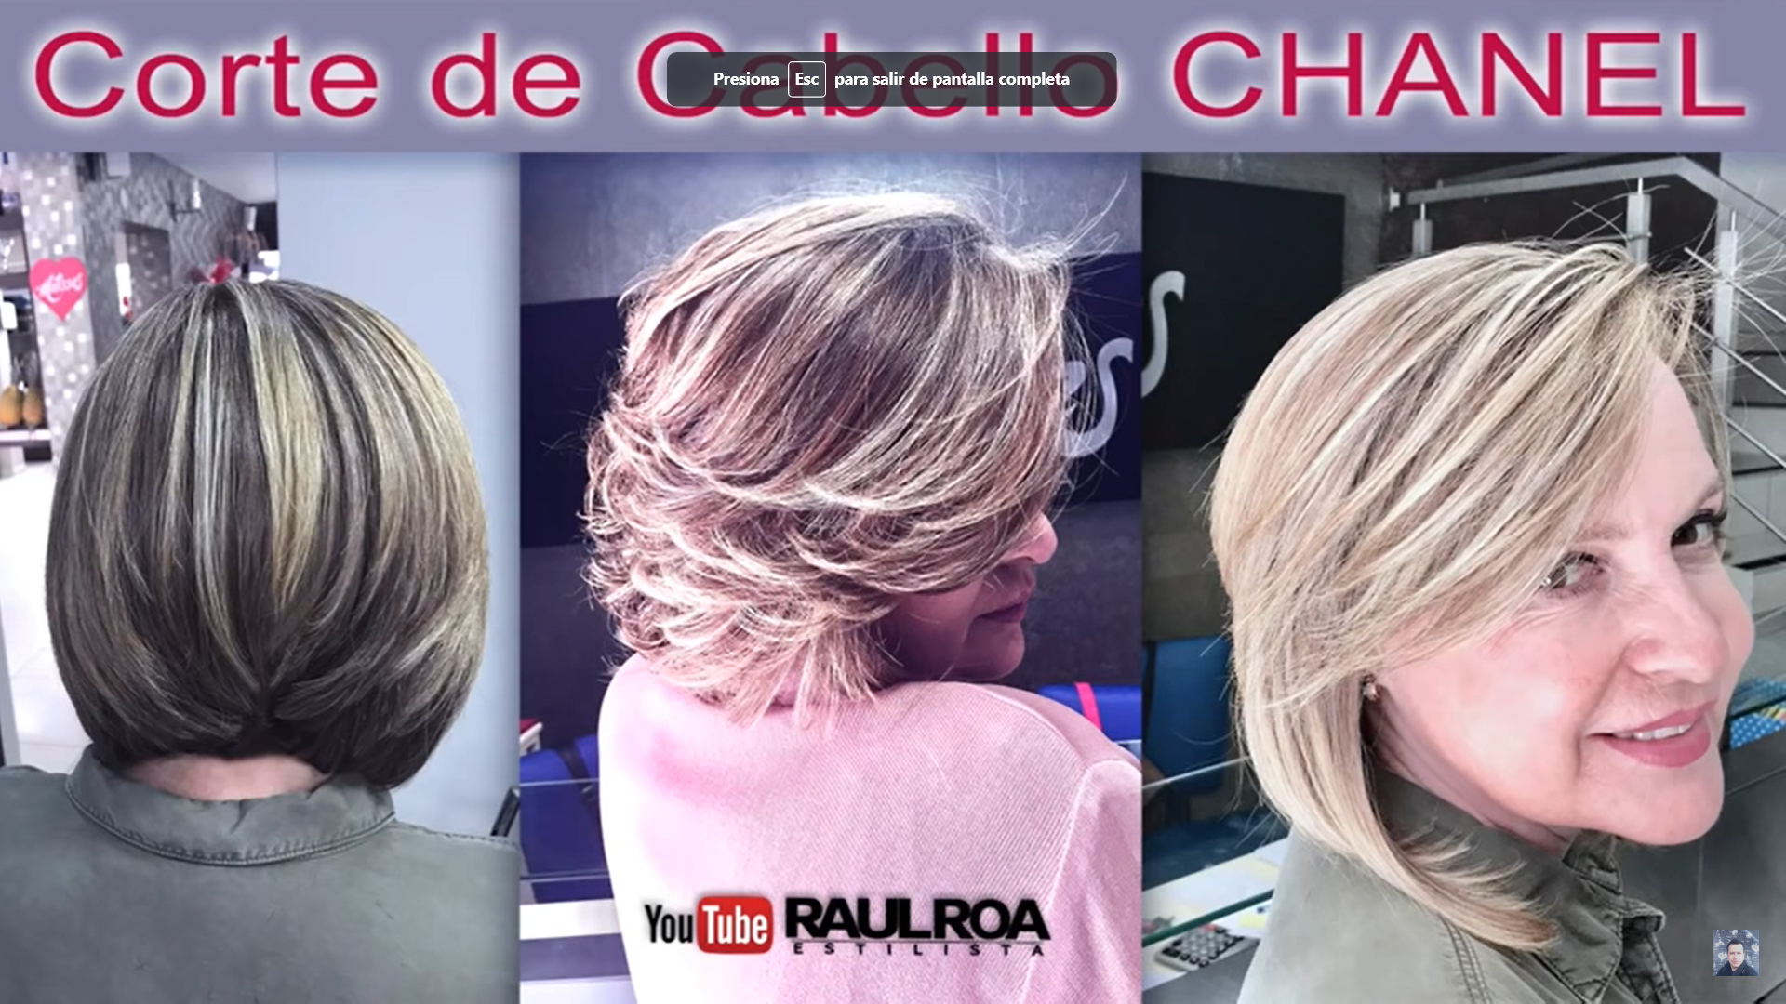

https://www.youtube.com/watch?v=vFC333x47fA

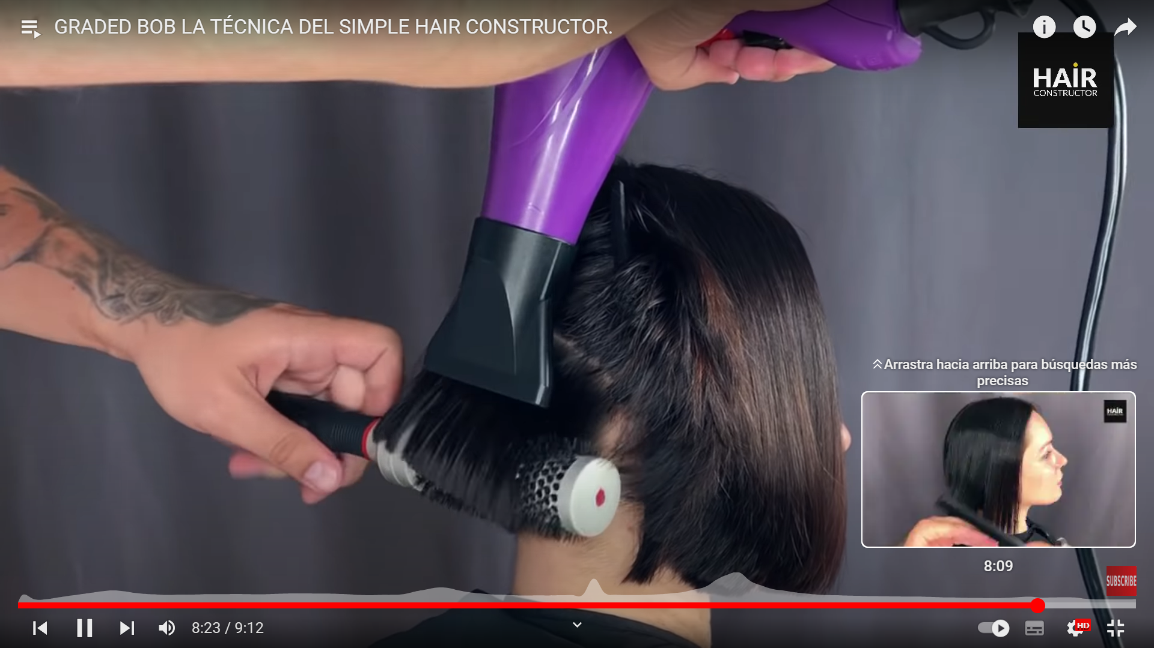

https://www.youtube.com/watch?v=zRe3jaSeXPo


https://www.youtube.com/watch?v=1UtM_p_8M48&list=TLPQMTQxMTIwMjMkyST1NawNog&index=9


https://www.youtube.com/watch?v=0F88FPlqoLI&t=49s
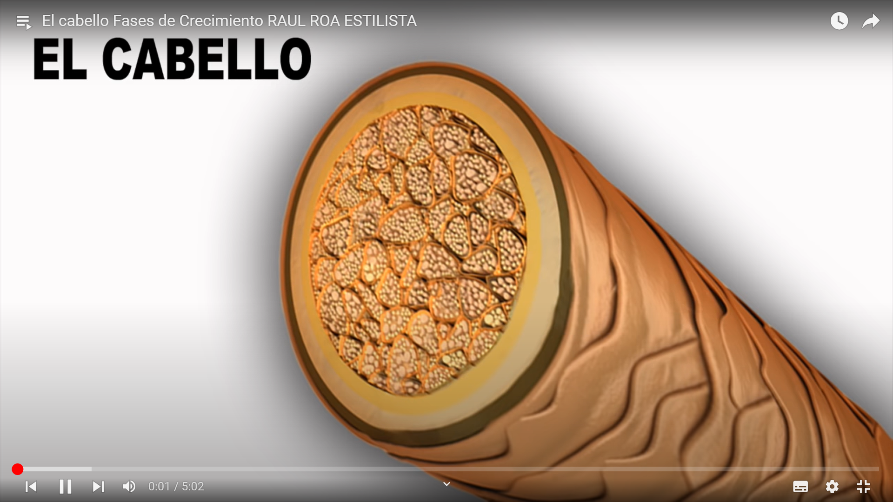

https://www.youtube.com/watch?v=1UtM_p_8M48&t=107s
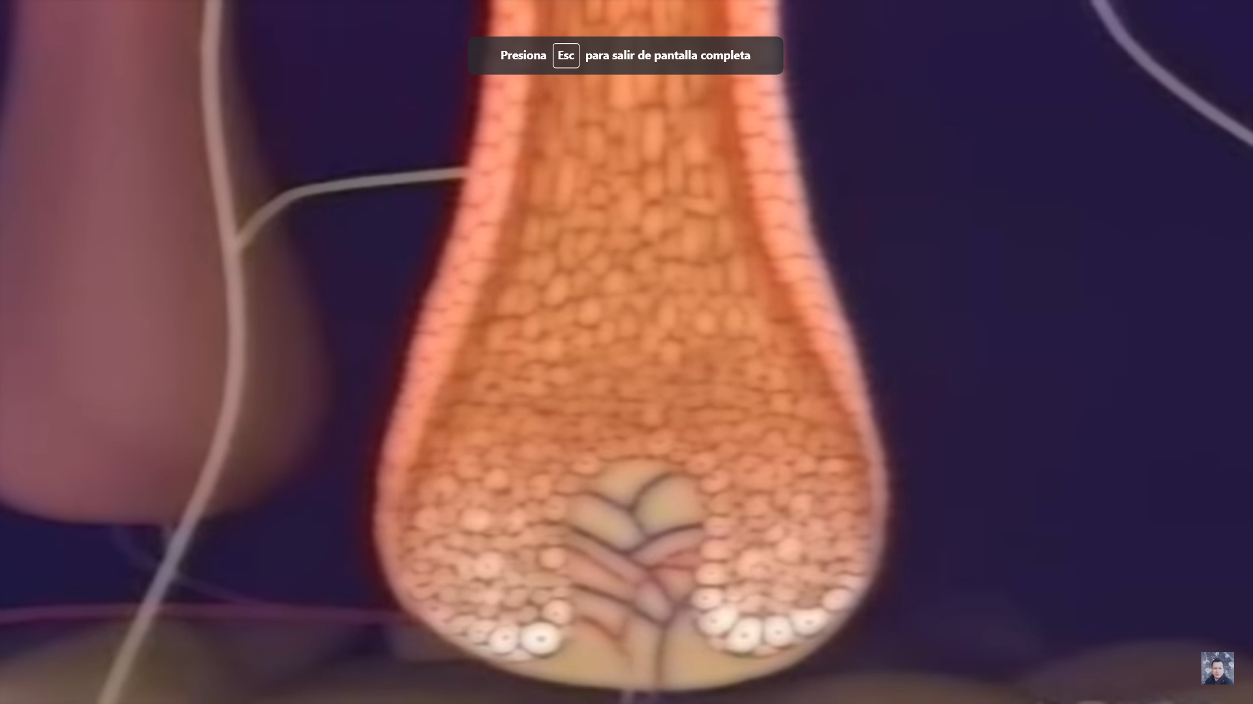

https://www.youtube.com/watch?v=1YsUhyWsi20
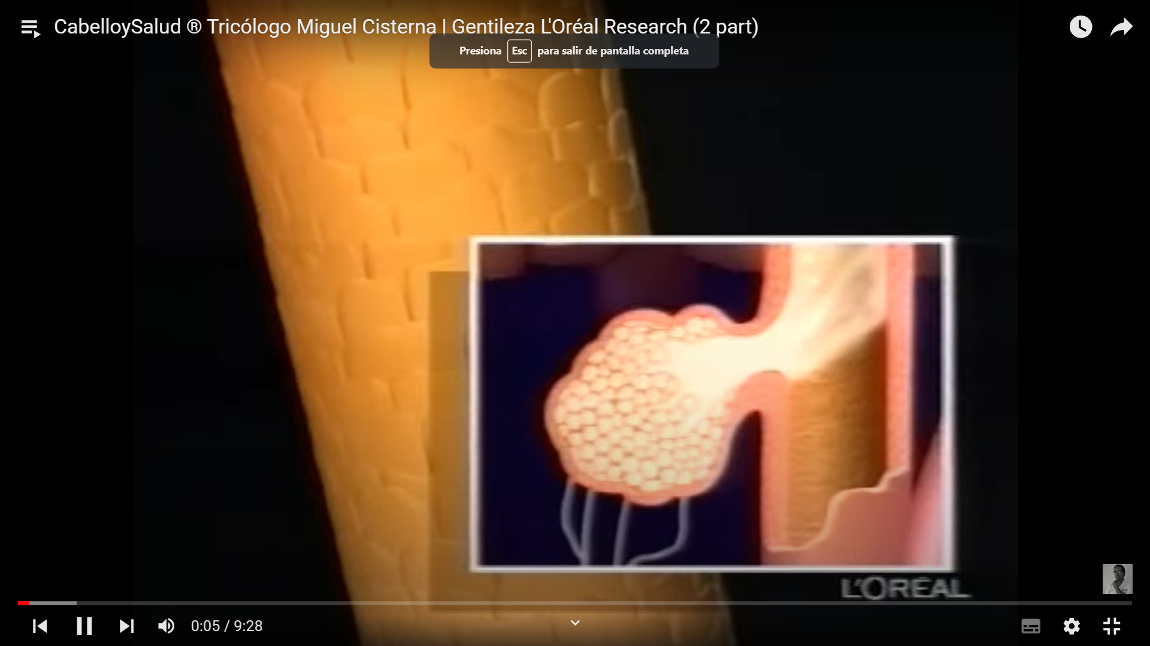

https://www.youtube.com/watch?v=K9z5A6rD3NM


https://www.youtube.com/watch?v=qmUGZT53O7A
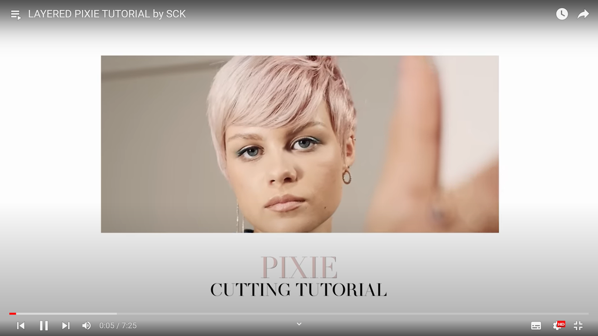

https://www.youtube.com/watch?v=0IeD2oMLlT0

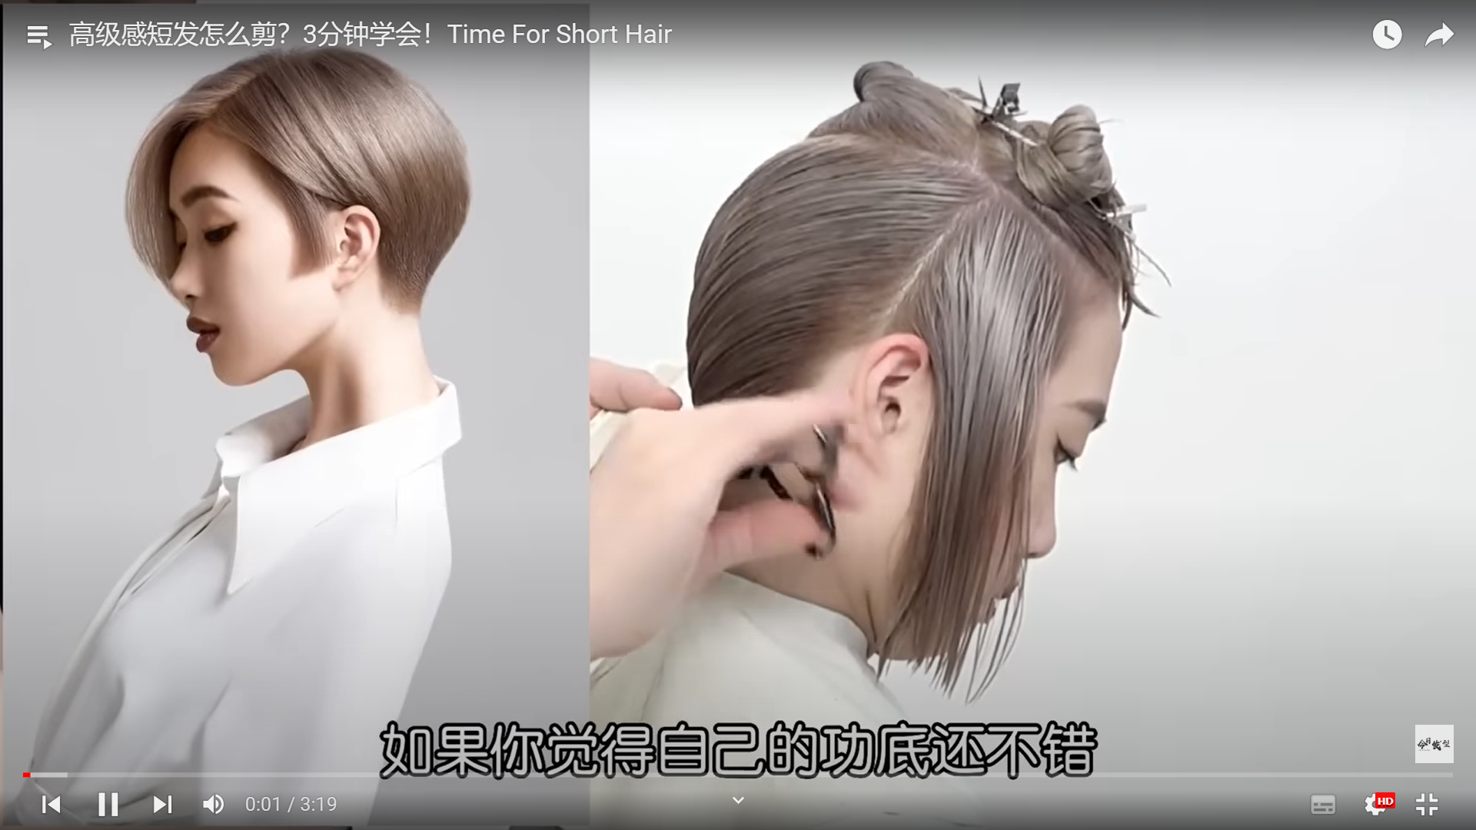
https://www.youtube.com/watch?v=2JnZMvBJsYQ



https://www.youtube.com/watch?v=nBBSHrusqfo


https://www.youtube.com/watch?v=JujbQLHmT5s
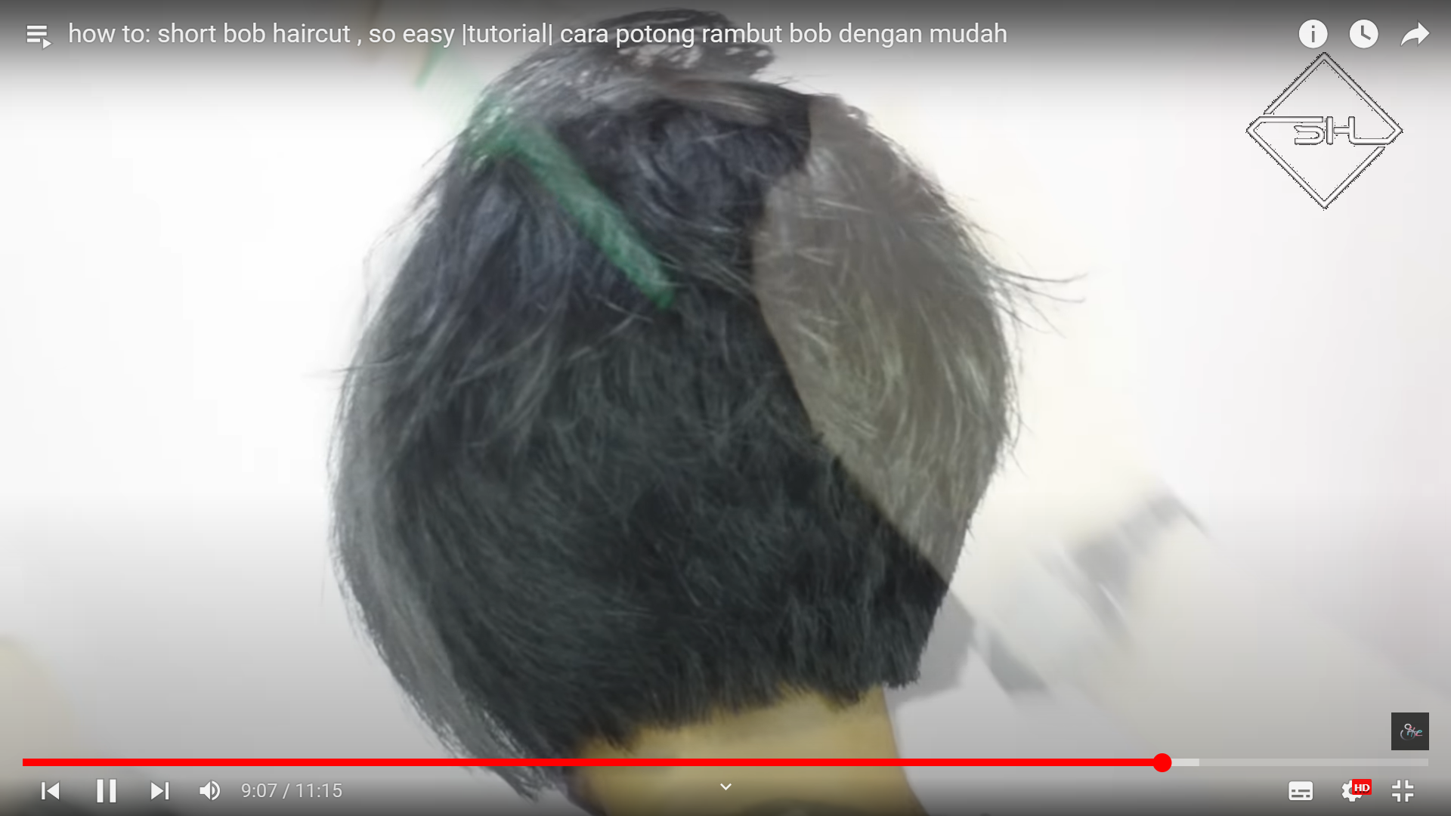

https://www.youtube.com/watch?v=uZL0V6LMv2o
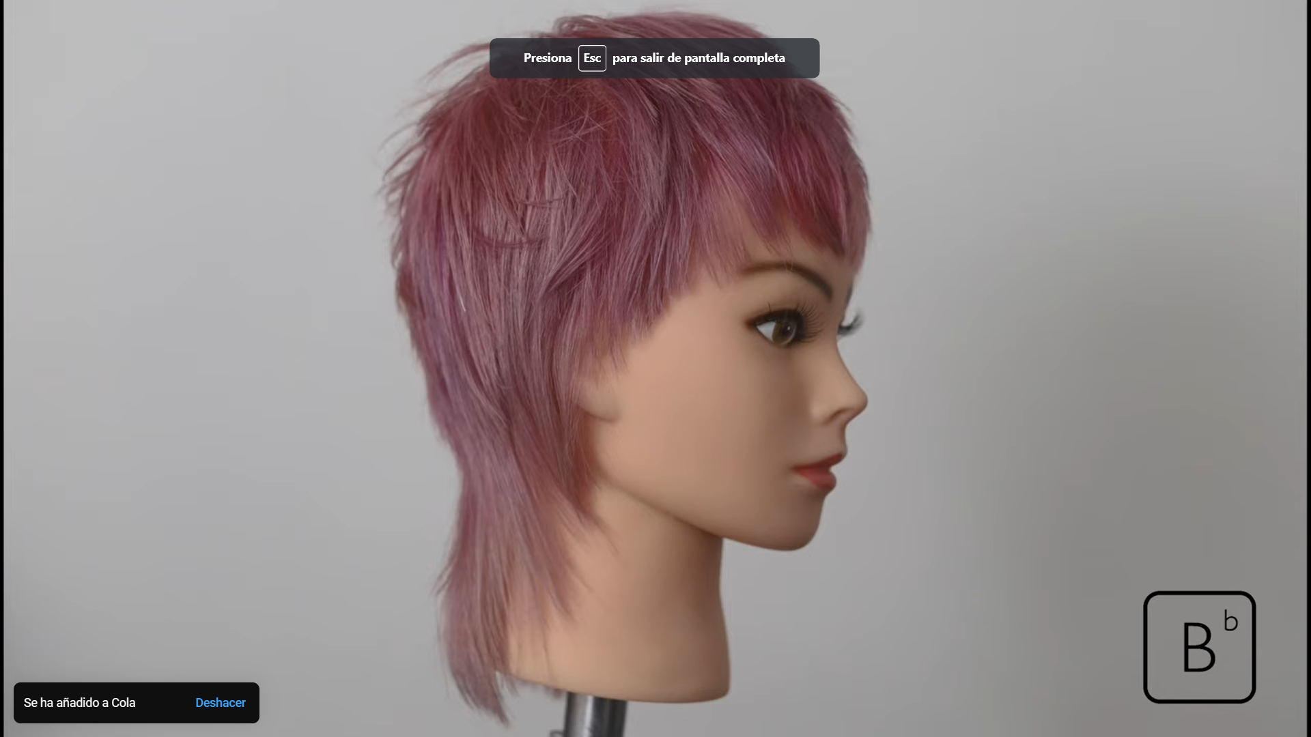

https://www.youtube.com/watch?v=DXioyg7DB-s
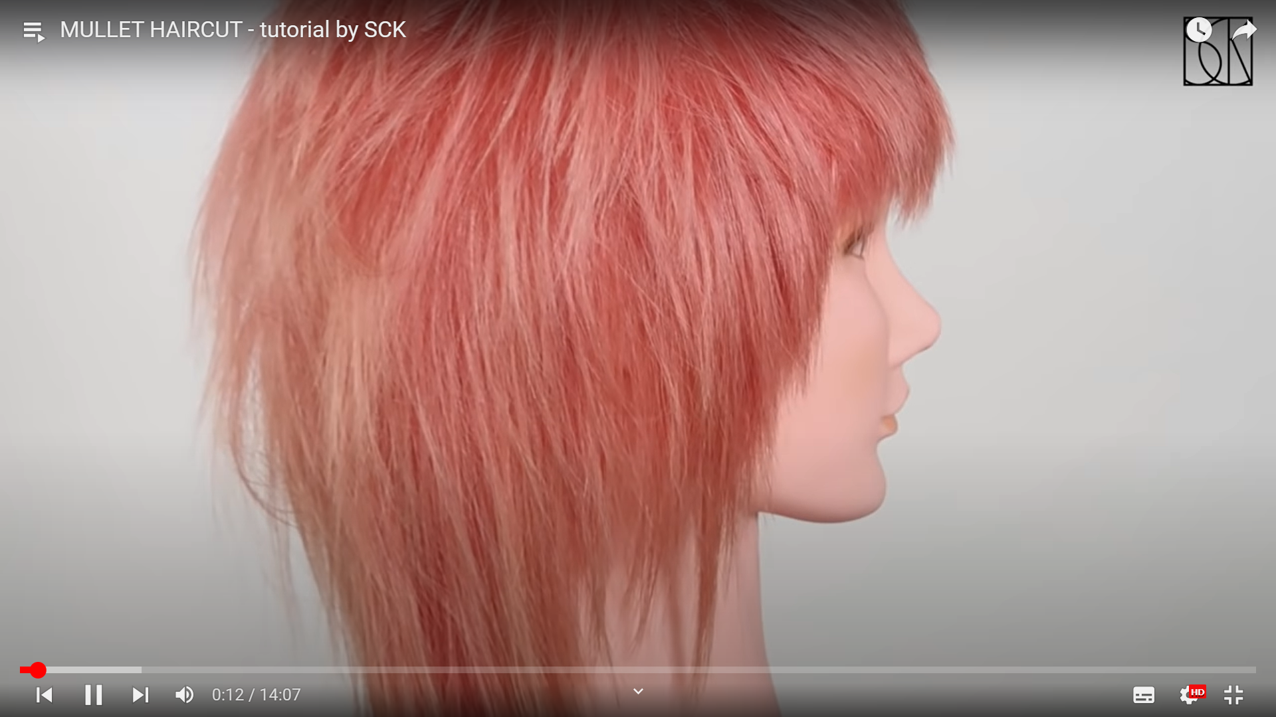

https://www.youtube.com/watch?v=2RsLa2tPbTI


https://www.youtube.com/watch?v=KYVtJCVfBk4
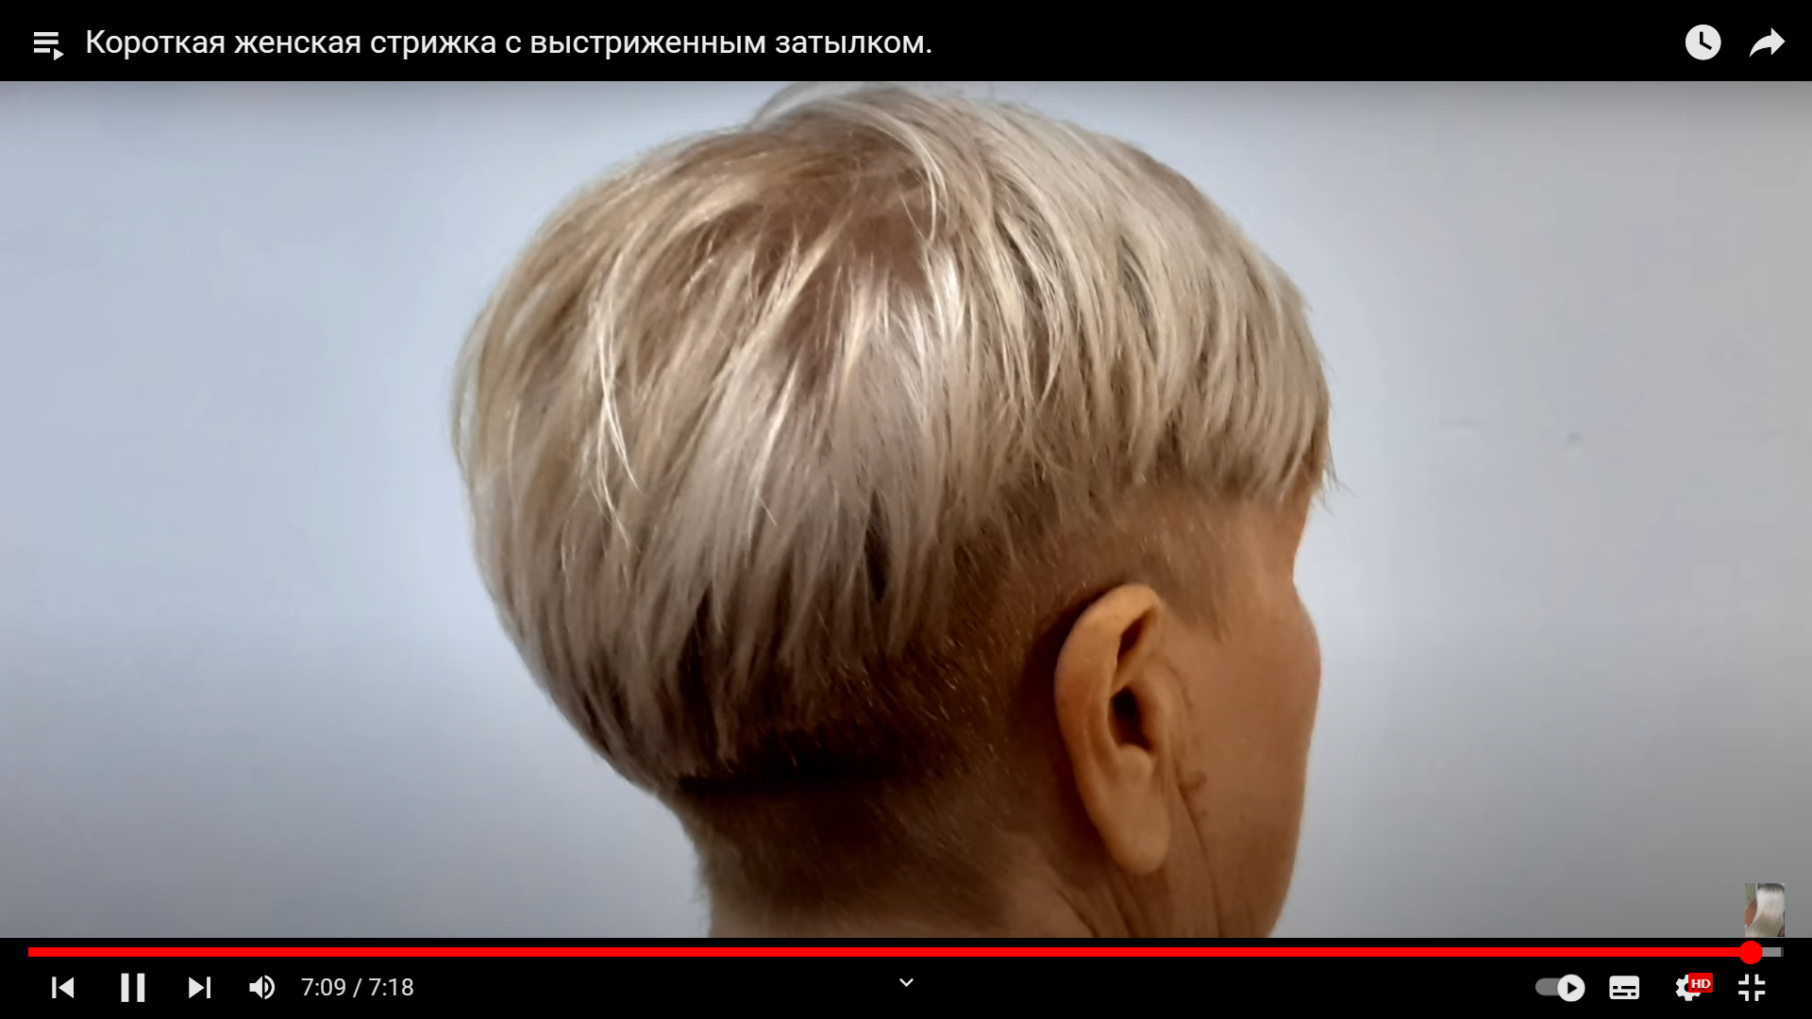

https://www.youtube.com/watch?v=QuhzR5sB378
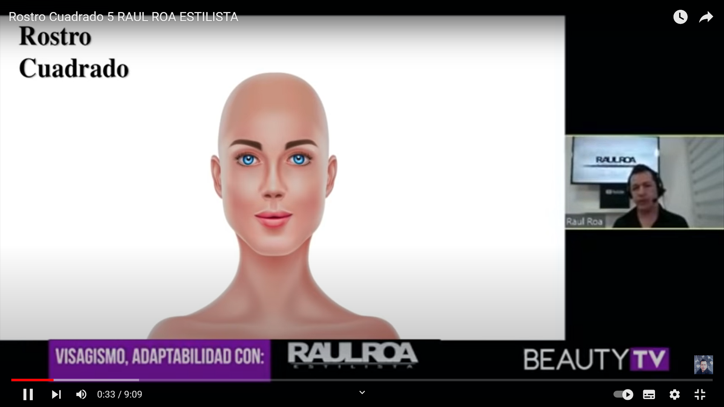

https://www.youtube.com/watch?v=dw43_iWbLEY
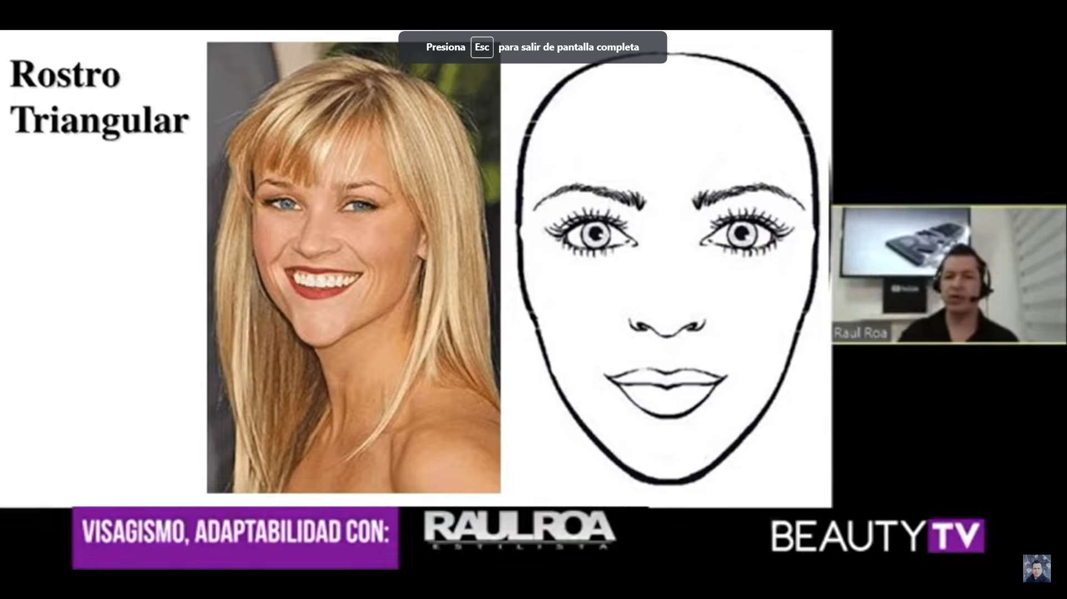

https://www.youtube.com/watch?v=GvG3hsM_tMA
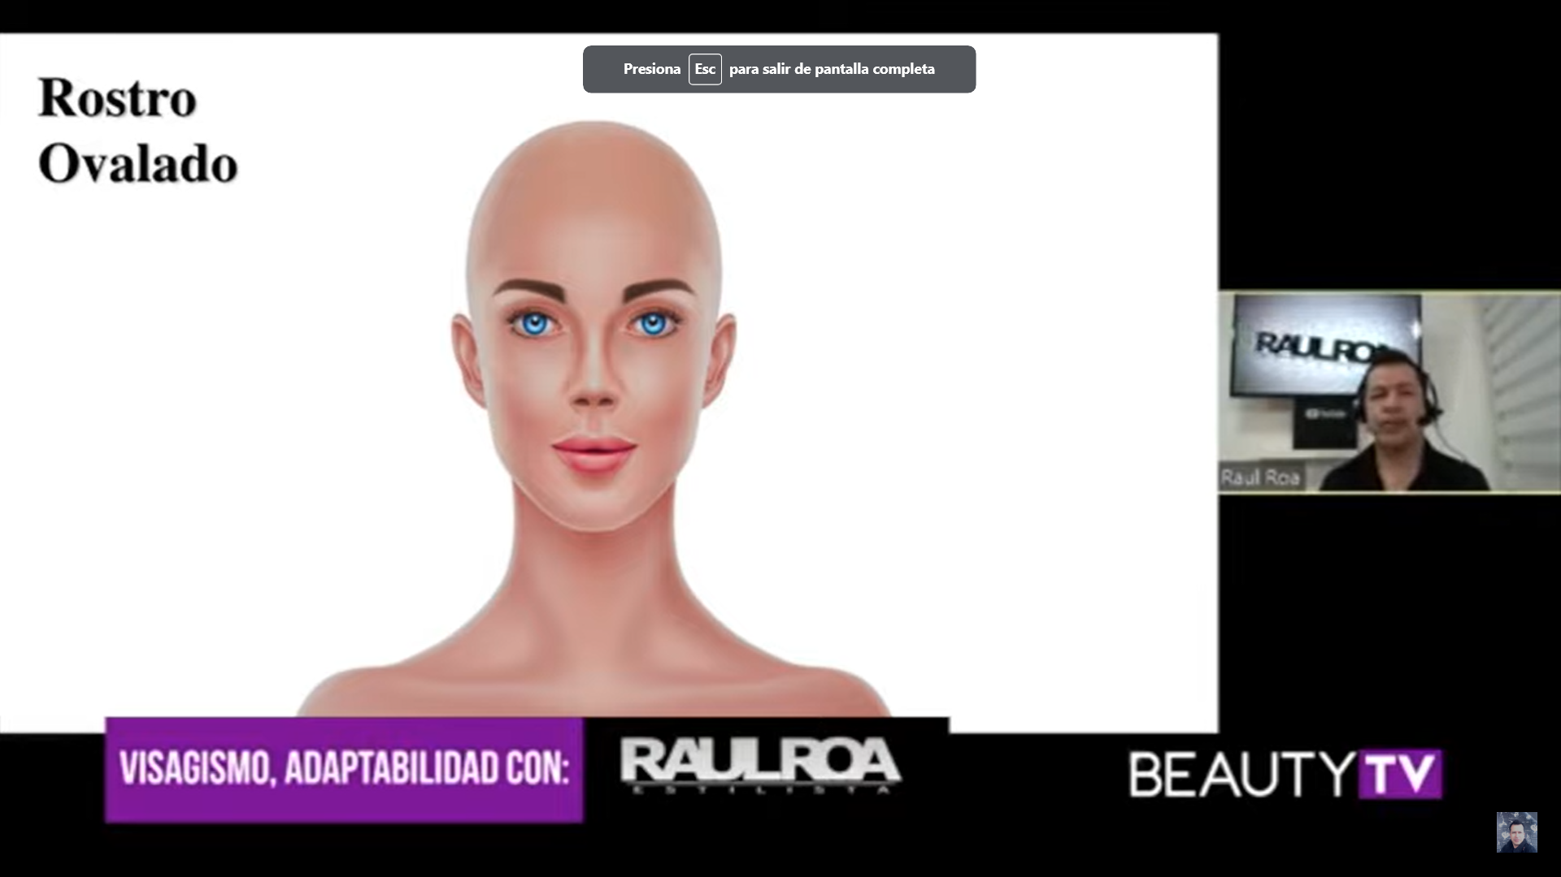

https://www.youtube.com/watch?v=003pEdoeV8A
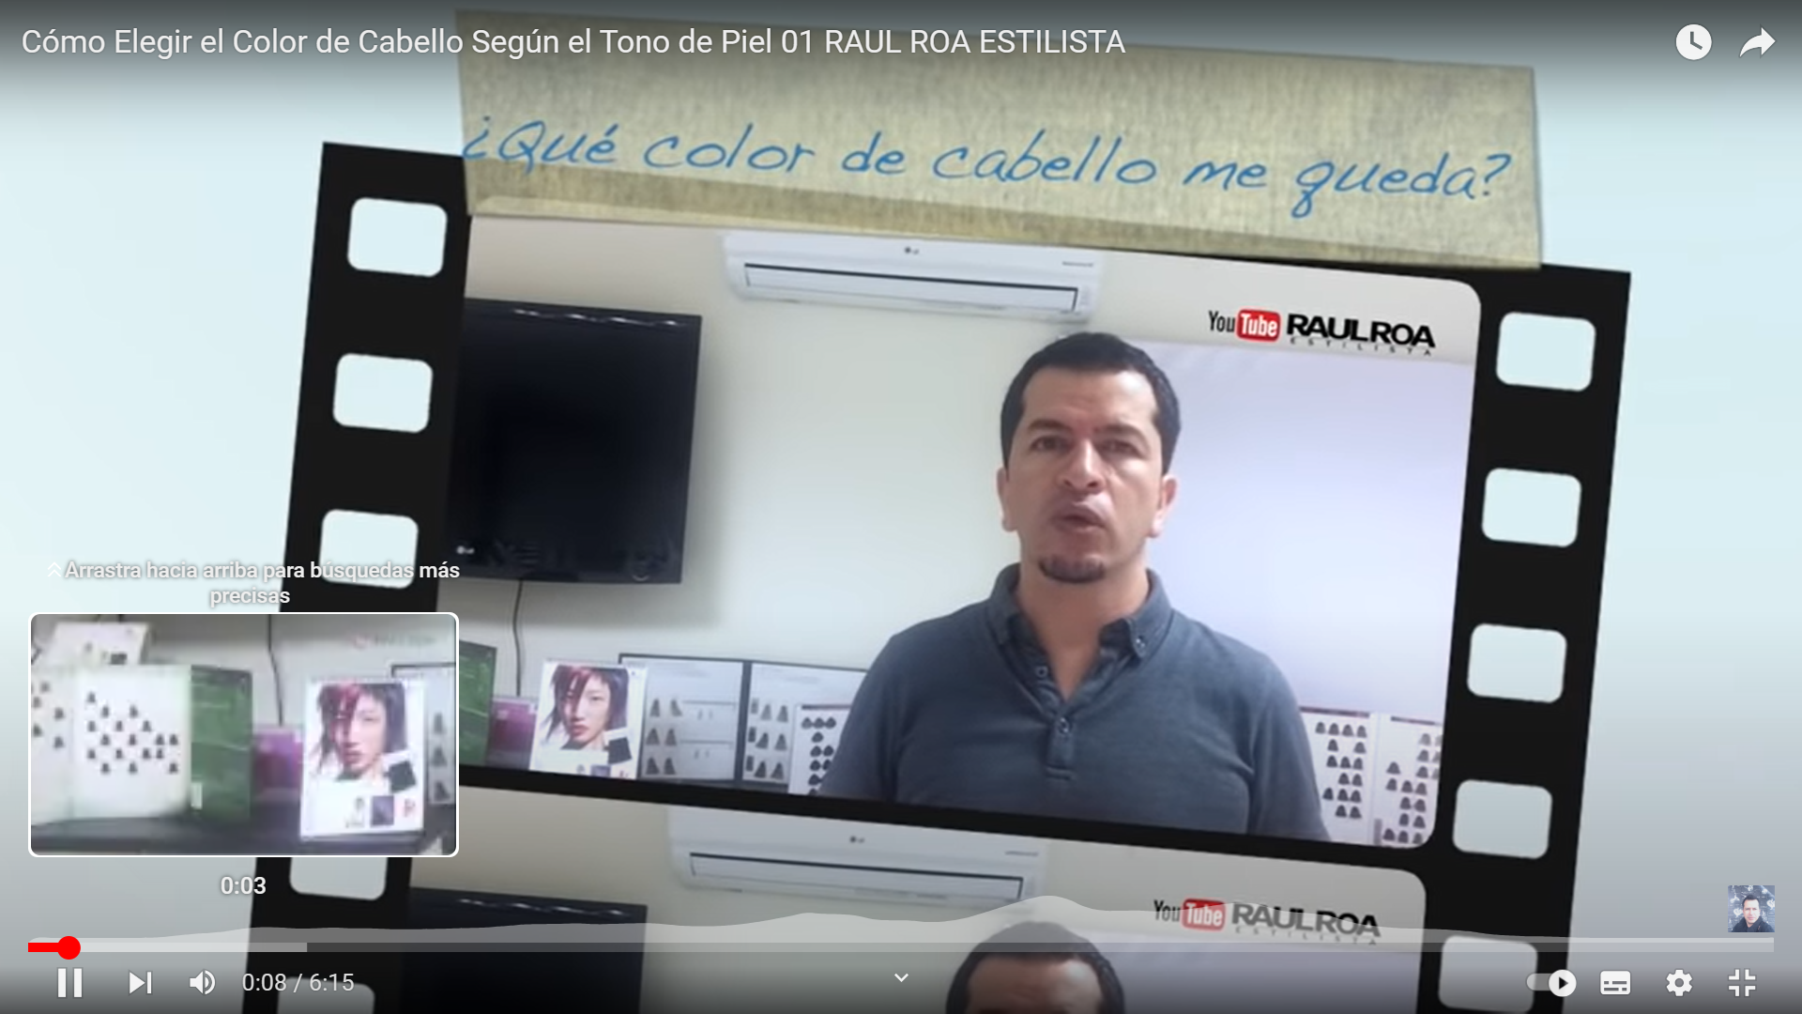

https://www.youtube.com/watch?v=t8iSBKJEMNQ
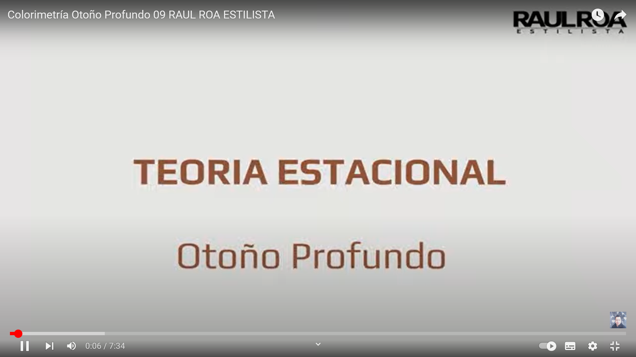

https://www.youtube.com/watch?v=knA-WDAoPxc
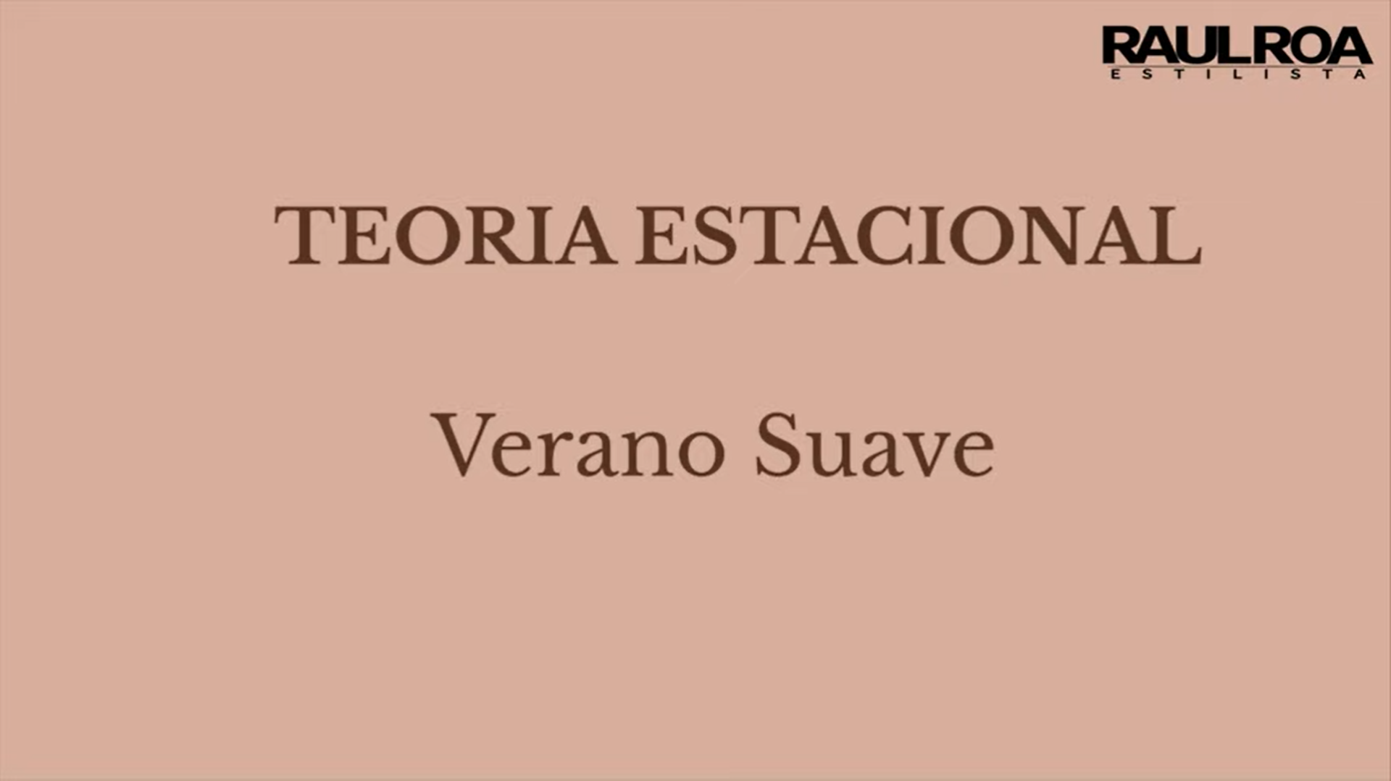
https://www.youtube.com/watch?v=2ks55NE3Veo
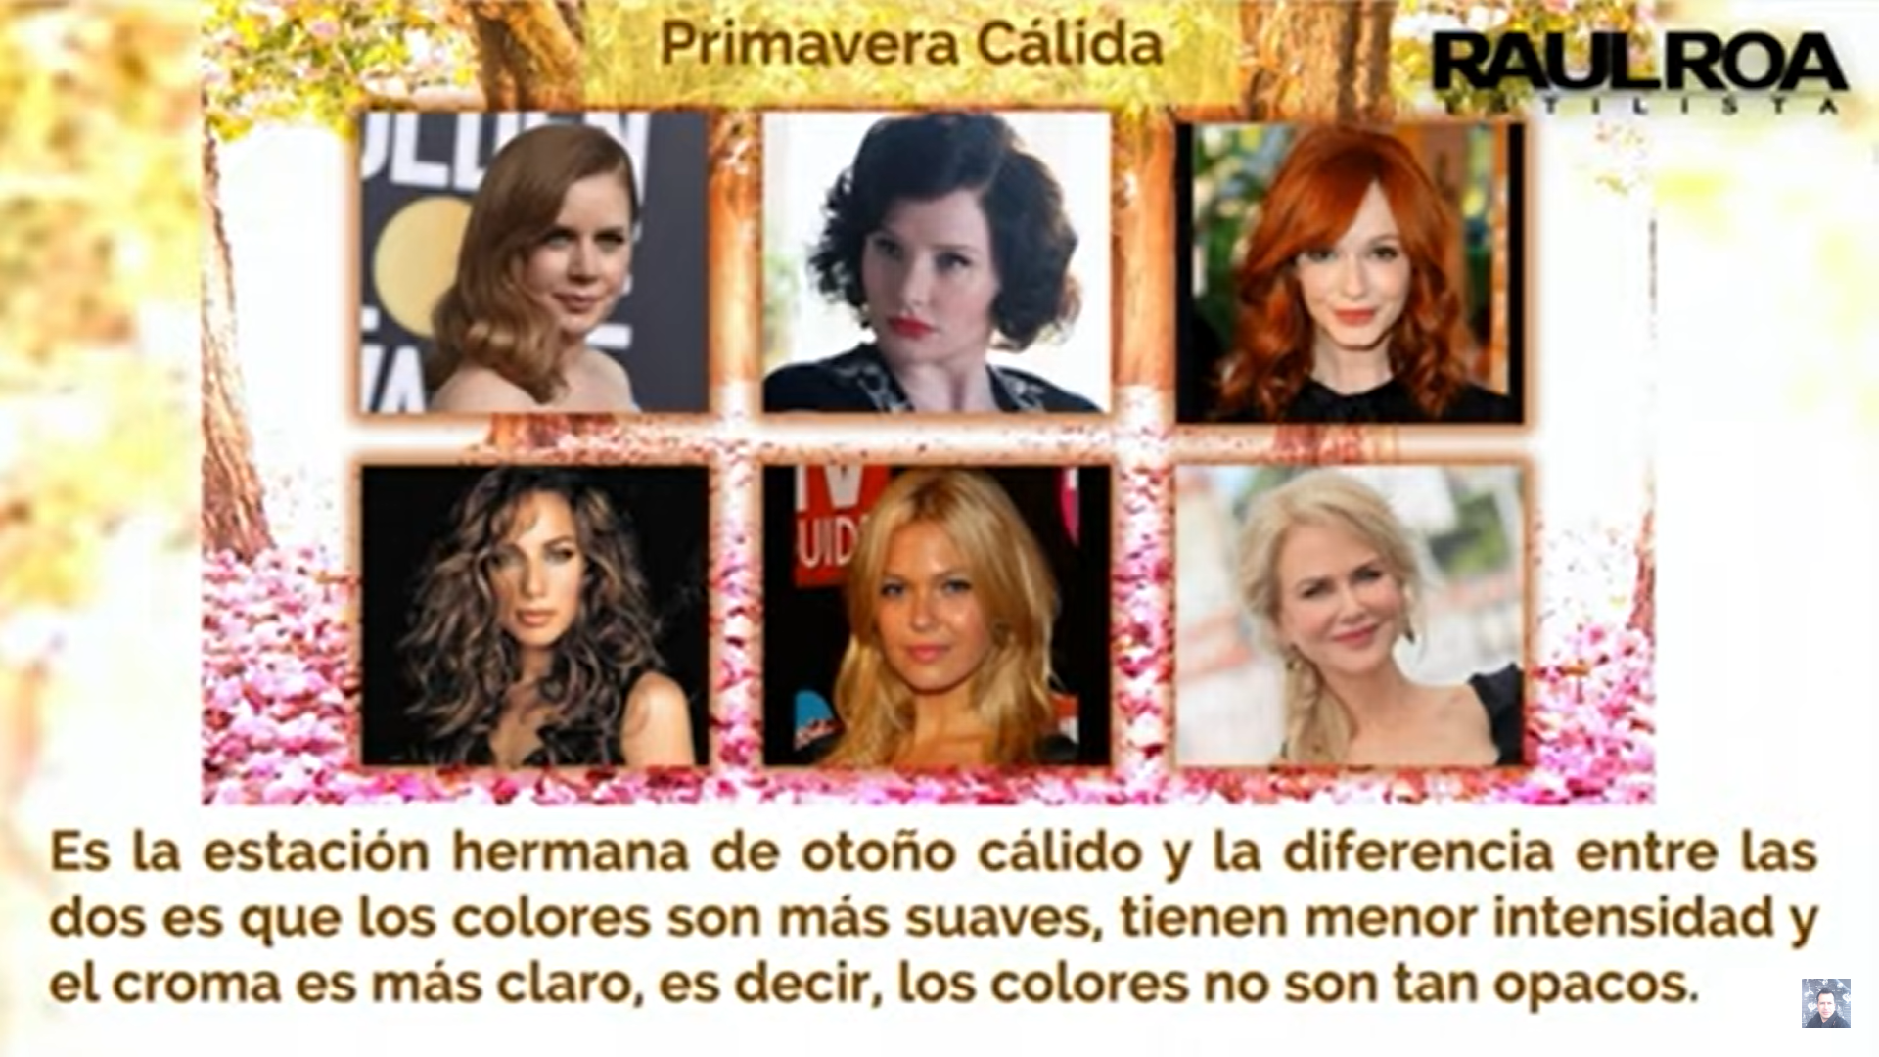
https://www.youtube.com/watch?v=5Xy_ZH0Nj1M
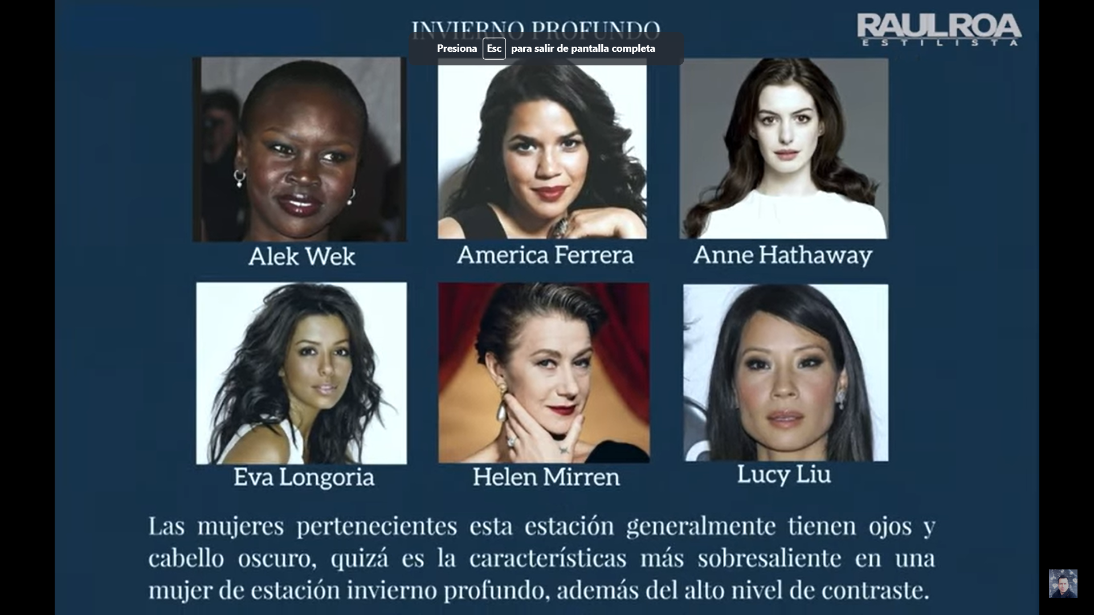
https://www.youtube.com/watch?v=eNDjsAOnlV0
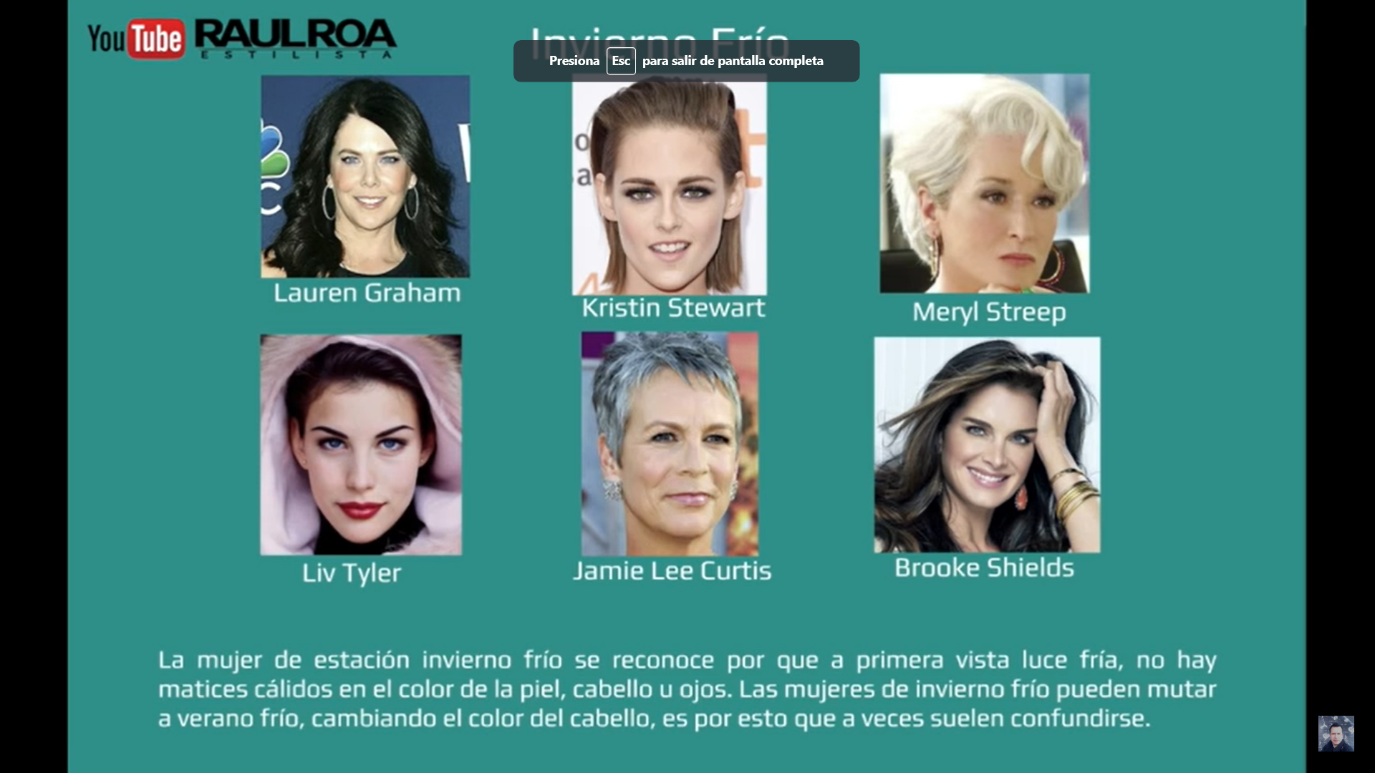
https://www.youtube.com/watch?v=N6Wyvk-GSGU


https://www.youtube.com/watch?v=f-ATx2pYbV8
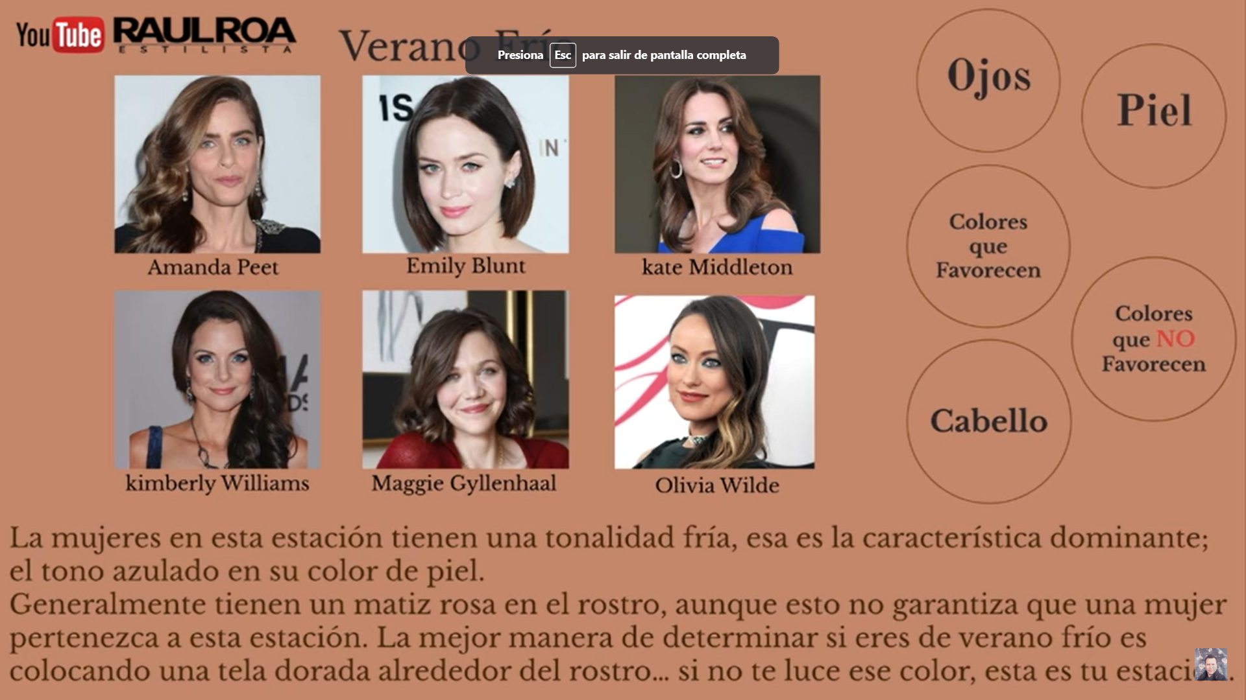
https://www.youtube.com/watch?v=0FhXlBpoosE
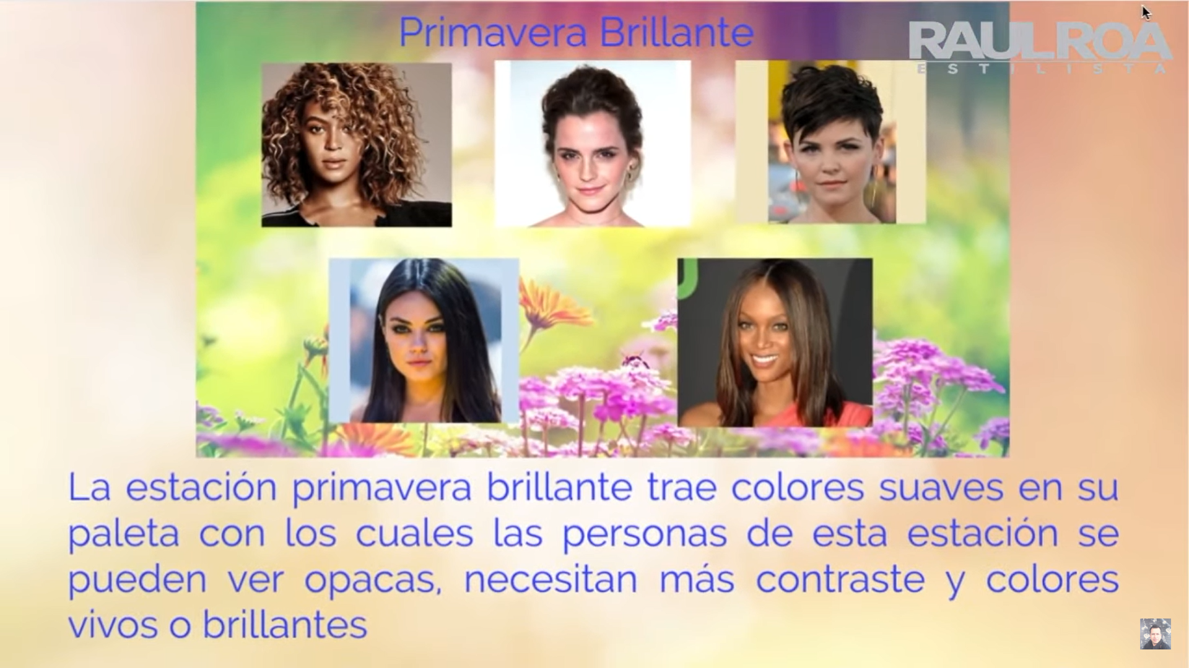
https://www.youtube.com/watch?v=RYMkUpmFFJc


https://www.youtube.com/watch?v=9092GyNnTNY

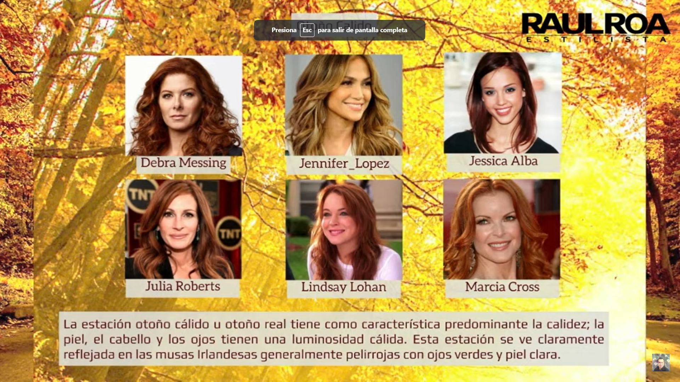

https://www.youtube.com/watch?v=2GJg3WpBoDU

https://www.youtube.com/watch?v=gOOlpSvhYzY
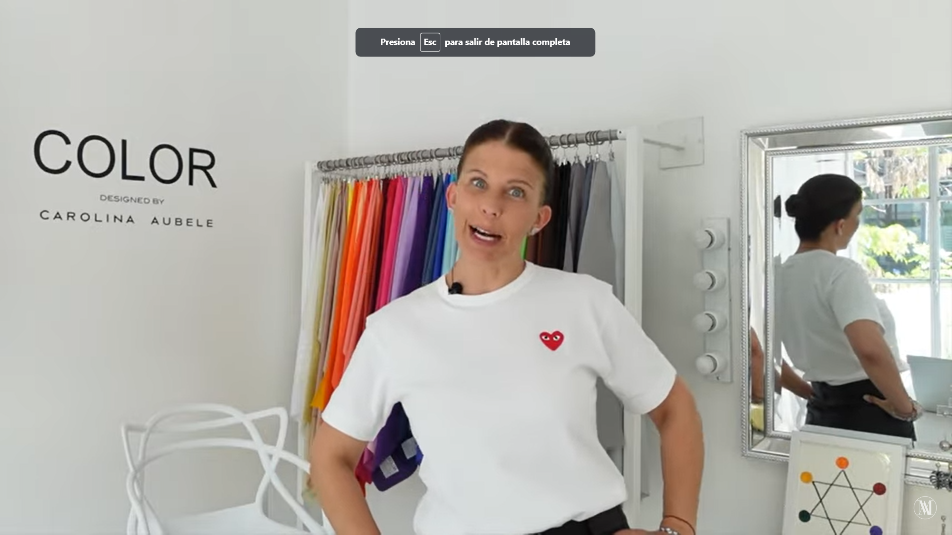

https://www.youtube.com/watch?v=uekdoCxbJ4A
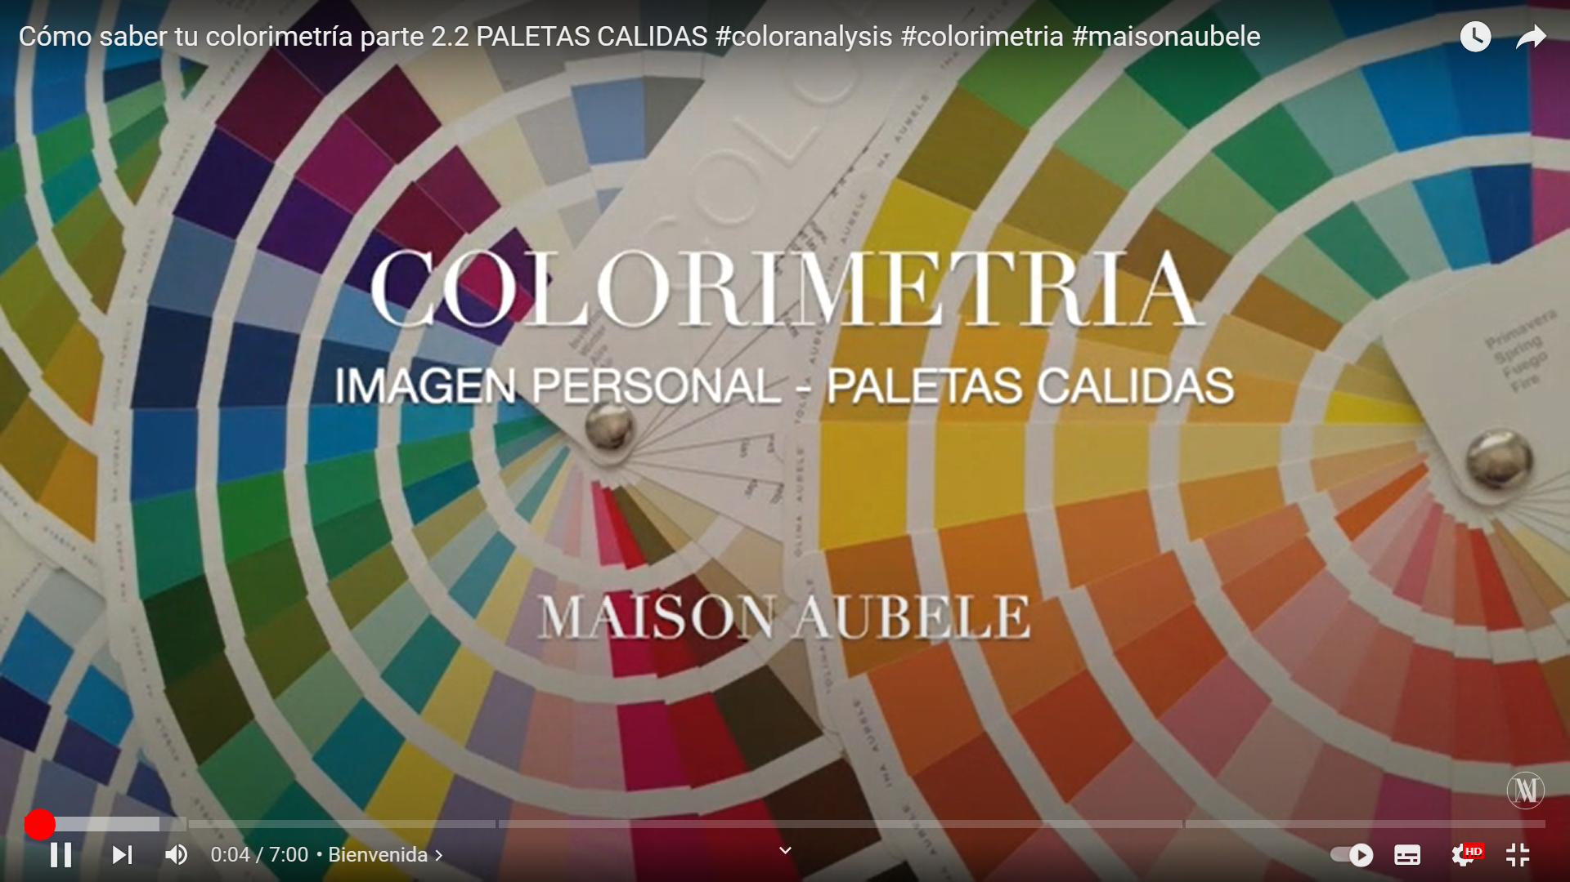

https://www.youtube.com/watch?v=LKhLigcK8HM
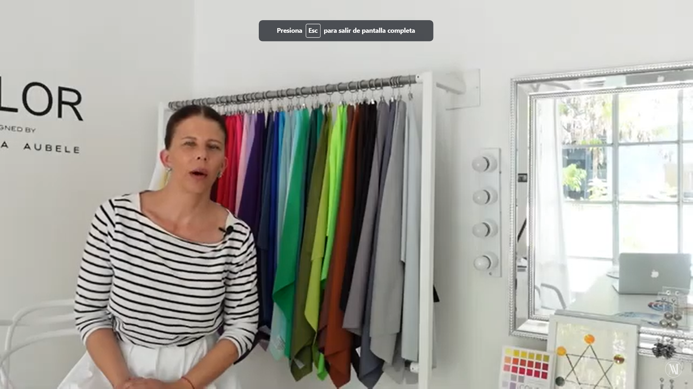
https://www.youtube.com/watch?v=m3oXLOEVE2Q
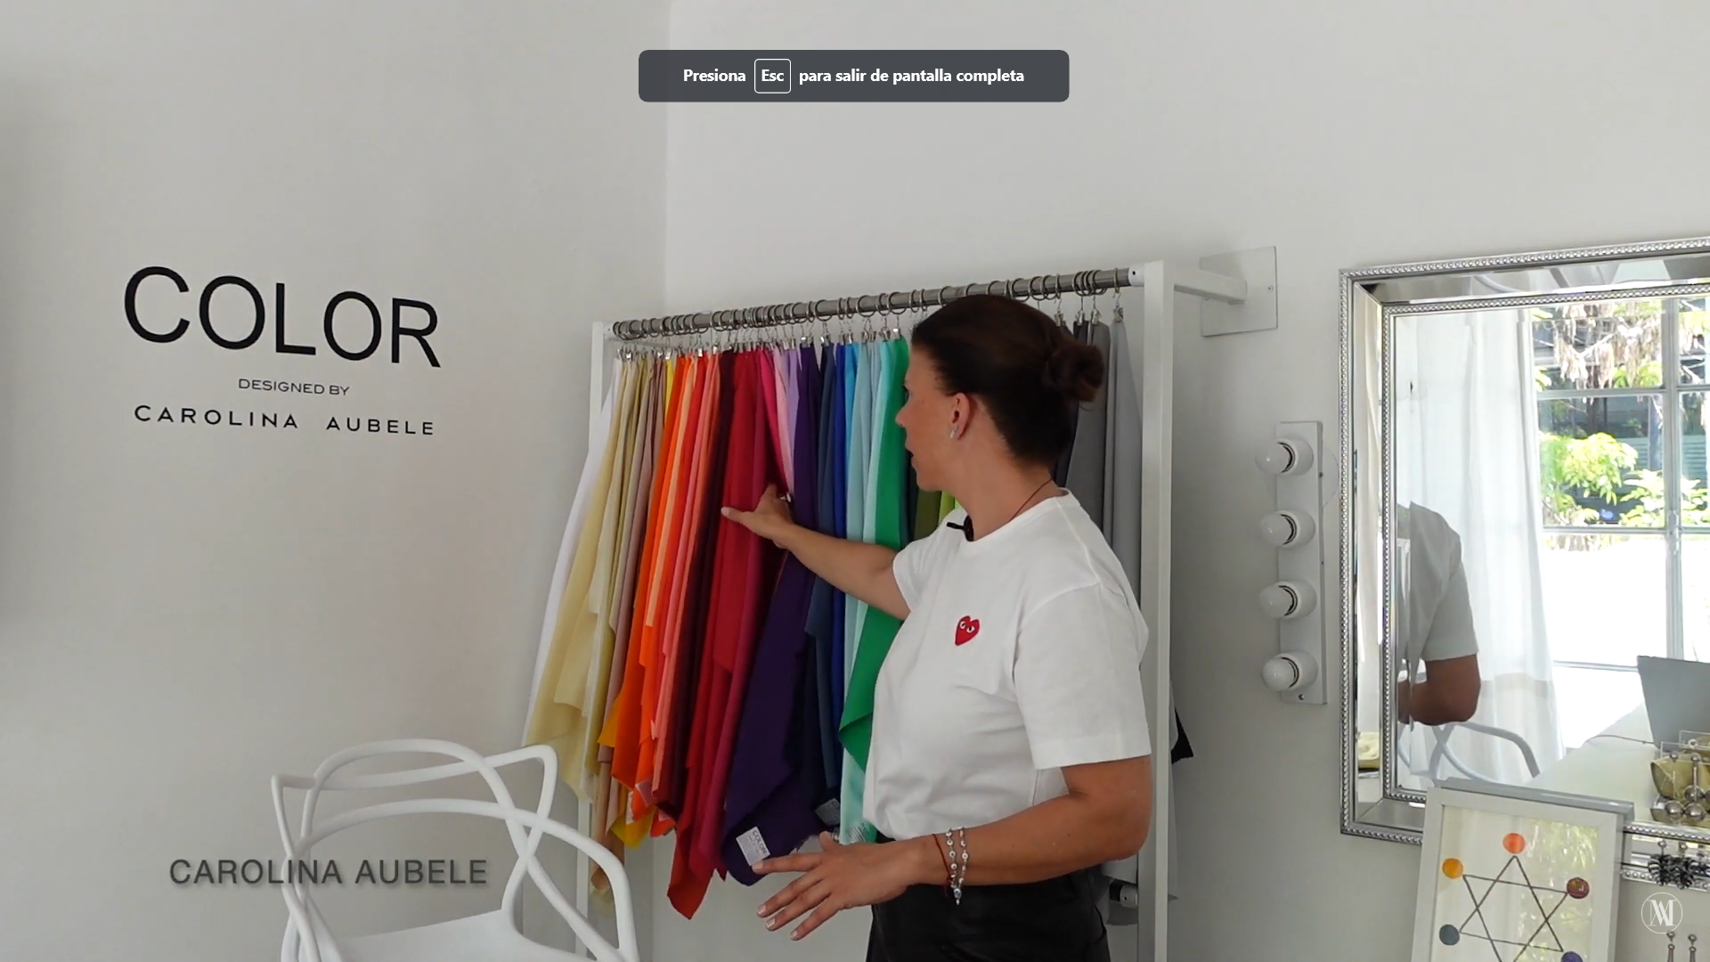

https://www.youtube.com/watch?v=x0U-amDwxKA



https://www.youtube.com/watch?v=OTuA-FyF2D4

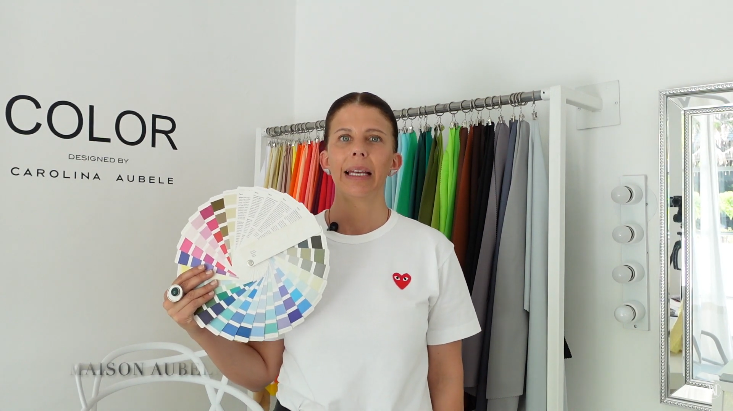

https://www.youtube.com/watch?v=_K7Evm6kyn0

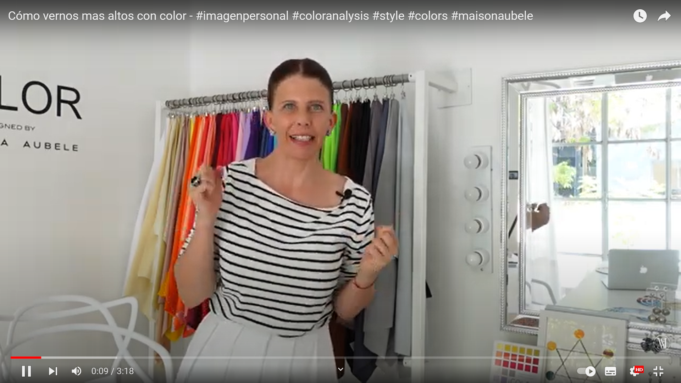
https://www.youtube.com/watch?v=qHtQsE5HiIs

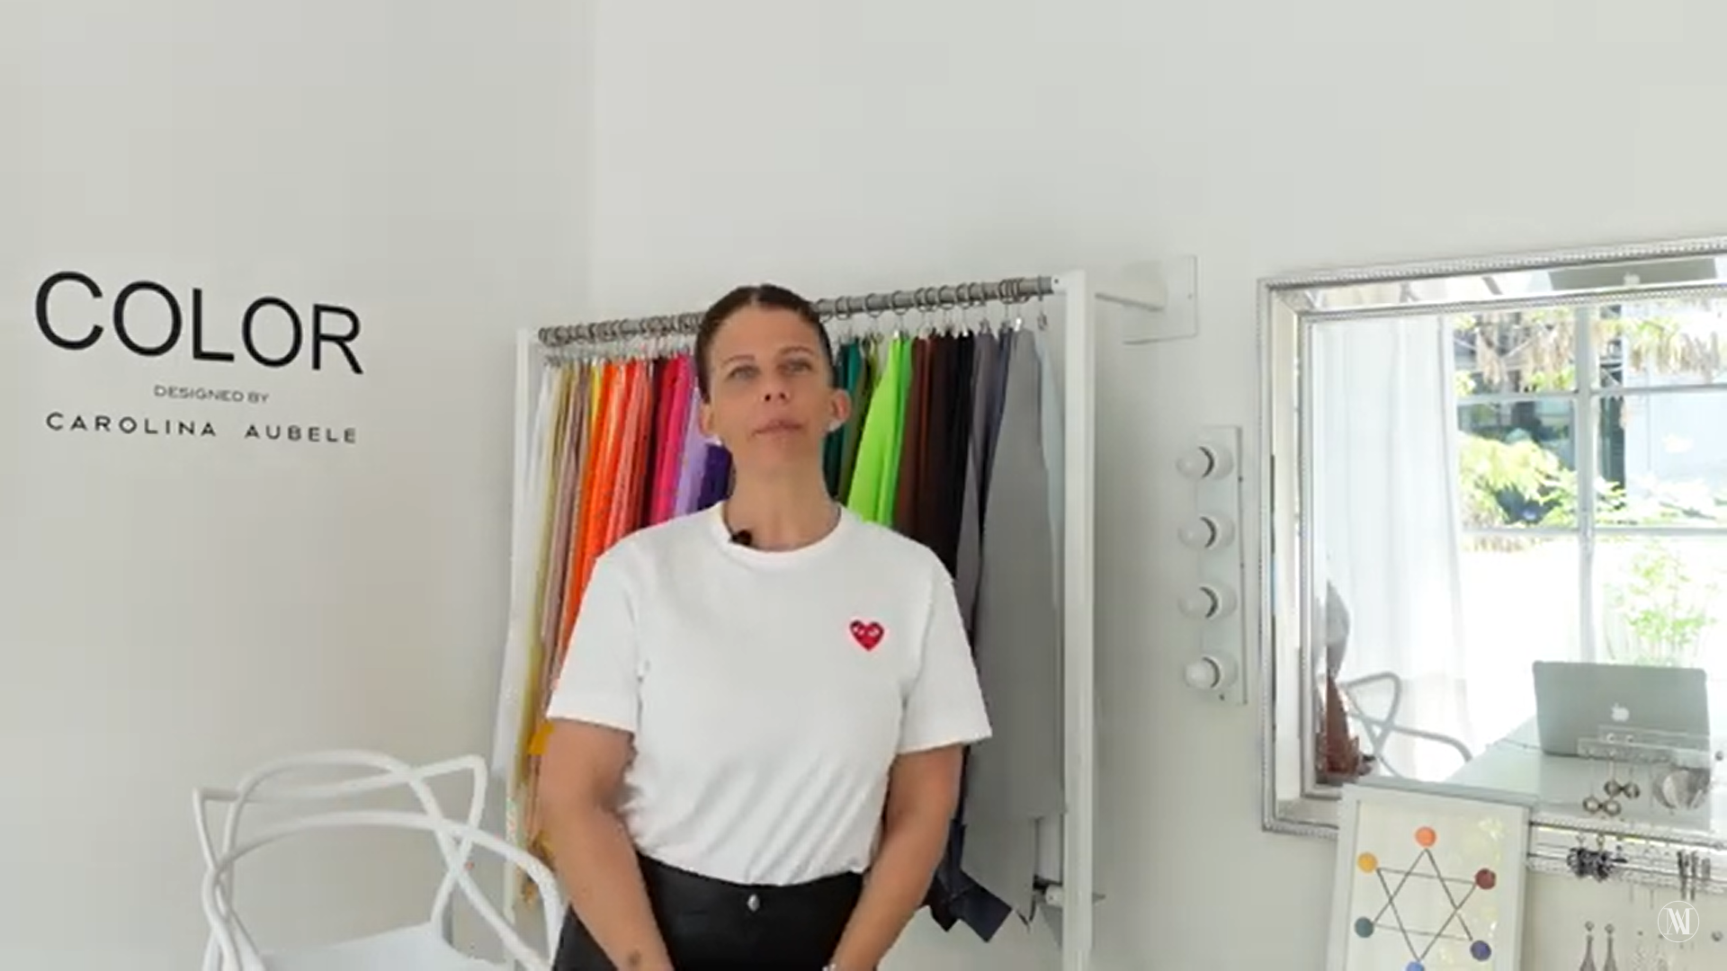
https://www.youtube.com/watch?v=Aqm7X1ClOFg


https://www.youtube.com/watch?v=RyRTWPz4mjc

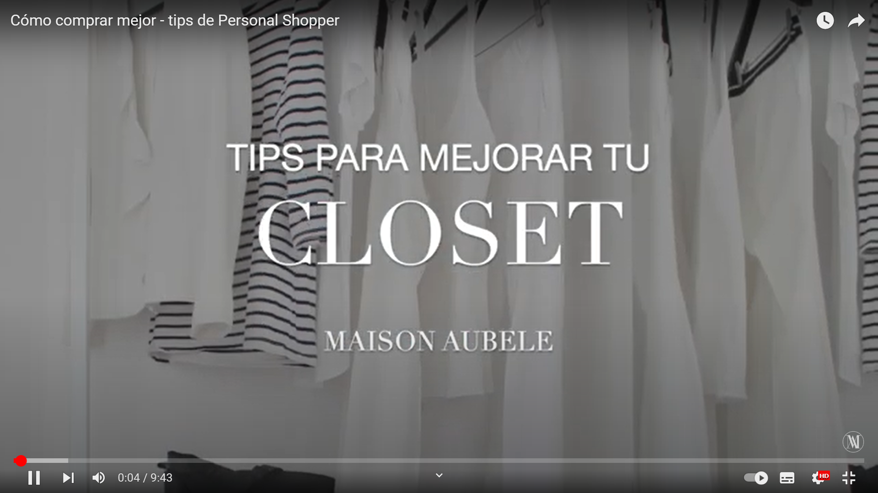

https://www.youtube.com/watch?v=Zqzx0WDvBwQ



https://www.youtube.com/watch?v=3Gryk9AHeYc&list=RDCMUC0ndcnnfL-R_EZSHNhyyicw&index=2


https://www.youtube.com/watch?v=p6CRyEy9ZJg

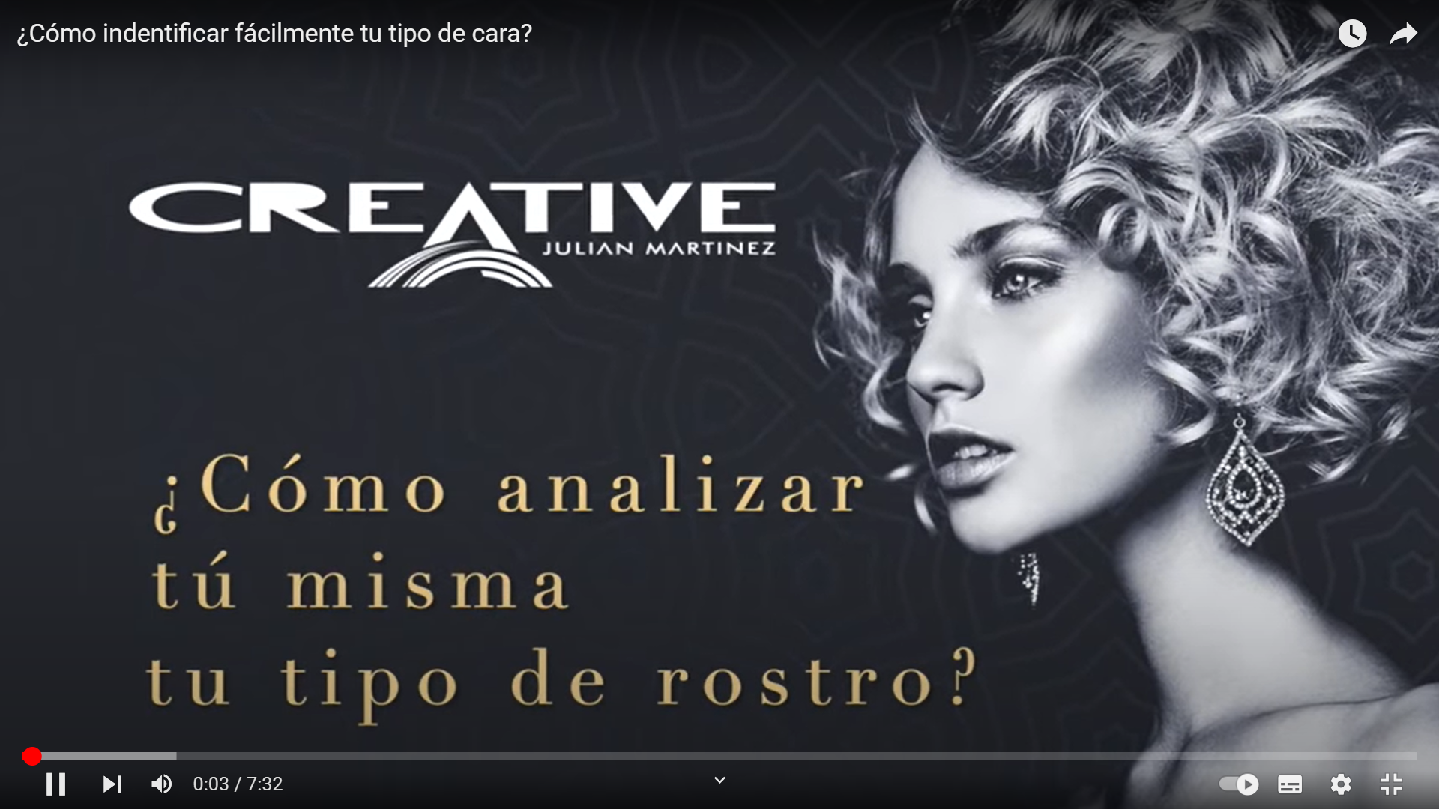

https://www.com/watch?v=mp6gstgYYsM
https://www.youtube.com/watch?v=mp6gstgYYsM&t=320s

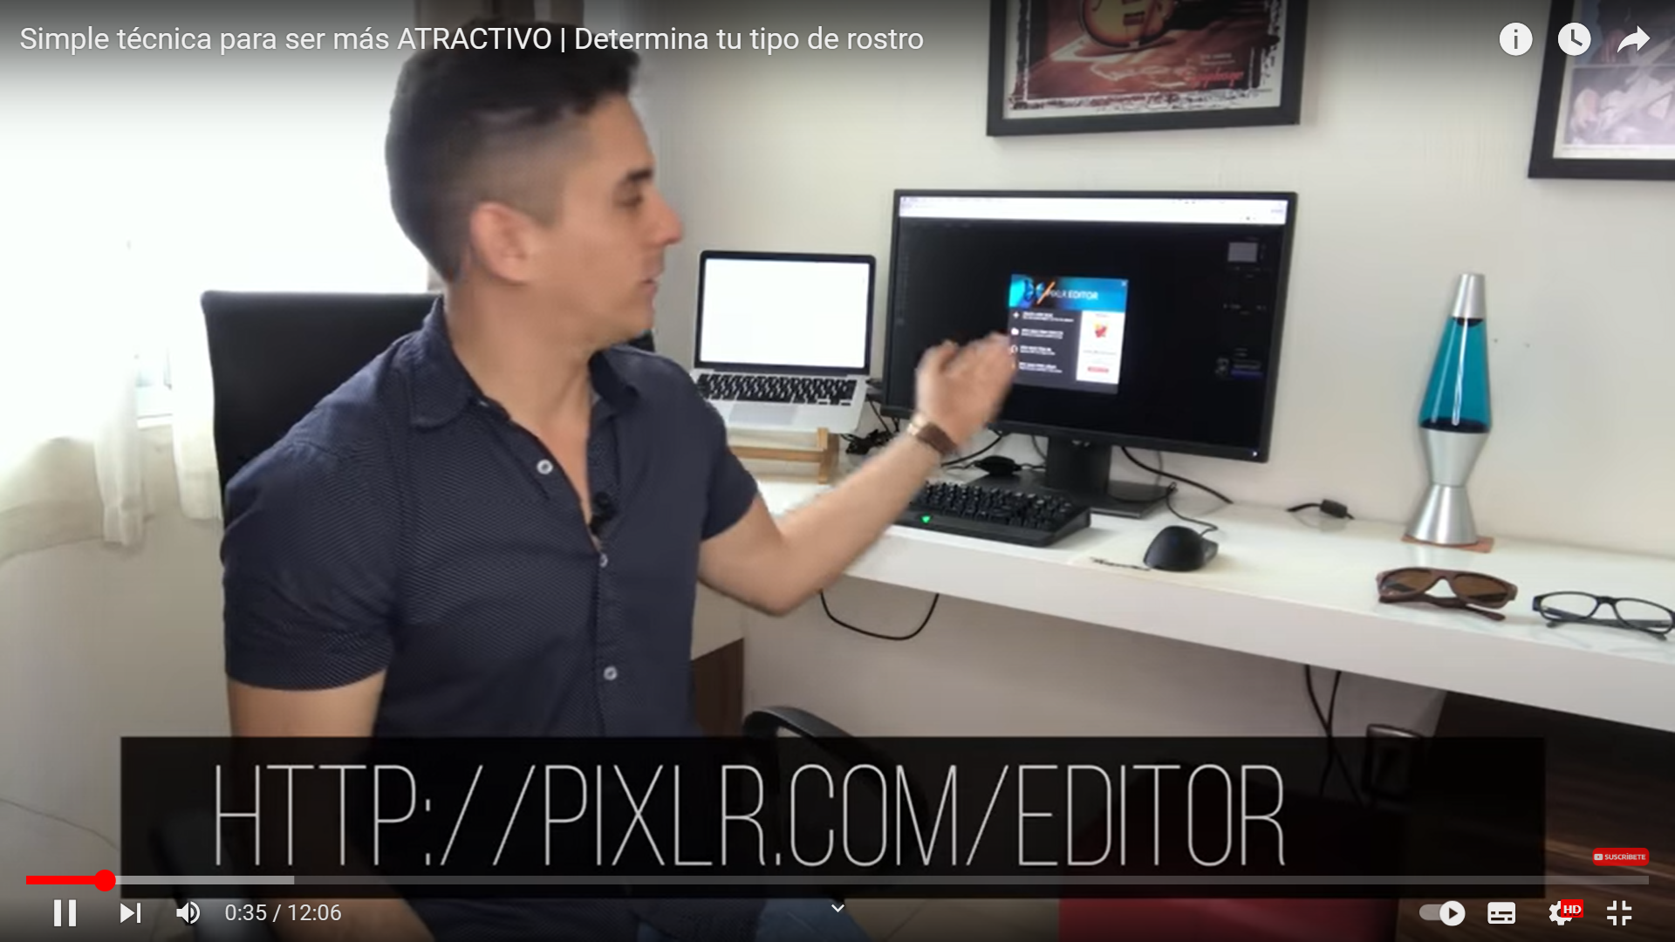

Como medir tu rostro.
https://www.youtube.com/watch?v=Jcrrcq0yi1k
