Grange High School
Filton Road
Bristol
BS17 4DE

French Tourist Information Office
Paris
France
23rd June
Dear Sir or Madam,

We are students at a high school in Bristol. We have four French lessons a week.
In our French lessons we learn about France. Our favourite city in France is Paris. We like Paris because it is an exciting city and there are lots of famous places.

Please send us some photographs of famous places in France for our classroom.

Yours faithfully,

Class 2

1. True or false? Correct the false ones
1 They have four French lessons on Monday.
2 They like Paris.
3 They want books about Paris.
4 They want photos of France.
5 The photos are for their classroom.

2. a) Look at the information about Class 2. Complete the chart with your information.

 | Class 2 | Your class
school in | Bristol | ¹ __________
tourist office | Paris | ² __________
language lessons a week | 4 | ³ __________
favourite city | Paris | ⁴ __________

b) Complete this formal letter to the British Tourist Information Office. Use your information above.

Dear Sir or Madam,
We are students at a high school in __________________________ . We have ____________________________ English lessons a __________________________ .
In our _______________________ lessons we learn about _____________________ .
Our favourite city in _________________ is _________________________ We like ___________________________ because ___________________________________________________________ ____________________________________________________________

Please send us ______________________ photographs of ______________________ places in _________________________ for our classroom.

Yours faithfully,
______________

3. Read the text and say if the statements are true or false.

Helena Nixon works in a computer telephone centre. She starts work at 11.00 pm and finishes at 6.00 am. She gets home at 6.30 am. She lives in a block of flats in a big city. Her children go to school at 8.00. Mrs Nixon goes to bed at 8.15 and sleeps for seven hours. She wakes up at about 3.00 and reads the newspaper in bed before she gets up.
There are a lot of neighbours around and everyone is nice. Children can play outside with their friends.

1 Mrs Nixon hasn’t got a family.
2 Mrs Nixon starts work at 8.00 am.
3 She lives in a village.
4 Her neighbours are kind.
- The children play outside.

4. Read the text and choose the correct answer.
1 The text is about … .
a pop stars b sorts of music
2 Pop Idol is …

Pop Idol
Pop Idol is a TV programme that looks for new pop singers. Millions of people watch the programme at home including children, parents and grandparents. The audience telephone to vote for their favourite singer.
One of the winners is Will Young. Will Young is 23, he has got curly brown hair and blue eyes. His number one song is Evergreen. Will’s family lives in the south of England but Will says, ‘Now I am famous, I’m never at home!
I am very busy. I see my fans and do concerts in lots of countries. I love it!’

- Choose the correct option.

1 Pop Idol looks for new … .
a drummers b singers
2 … watch Pop Idol.
a Children b Families
3 People … to choose their favourite singer.
a write b telephone
4 Will Young’s song is … .
a Evergreen b Pop Idol
5 Will … his new life.
a doesn’t like b likes
6 Will … in other countries.
a doesn’t sing b sings

- Read this interview and choose the correct answer.

1 Michael is a wild life … .
a hunter b photographer c artist
2 He follows the … of the lions.
a tracks b smell c sound
3 He carries a … .
a gun b knife c camera

int: Welcome to ‘A Day in the Life of …’ and tonight Michael Coleman is with us.
He’s a wild life photographer and he lives in Africa. Michael, what do you do in Africa?
michael: Imagine this. I follow some lion tracks along a river bed. I know that the tracks are fresh and that the lions are close. I suddenly see six lions. There is a mother with two cubs in the group. This is a dangerous situation. If a female lion (lioness) feels that her babies are in danger, she attacks the enemy. Slowly, I climb up a tree. Imagine me, my camera and all those lions! I am lucky to be alive!

- Punctuate the following paragraph adding capital letters, commas and full stops.

lions eat almost anything if they are hungry including carrion they usually hunt deer but also eat buffalos giraffes and even crocodiles they hunt at night and drink water but they can go for long periods without water in deserts and arid areas

Hi Chloe!
Thanks for your message. It’s great that you can come to the disco. Yes, please bring your friend Eric with you, I want to meet him.
The Pink Disco is easy to find. It’s at 45 Fleet Lane and it’s about five minutes walk from the shopping centre. There’s a big supermarket on the corner of Fleet Lane and next to the supermarket is a hotel. The disco is behind the hotel – between a car park and a restaurant.
See you on Saturday!
Claire

- True or false?
1 Chloe is Claire’s friend.
2 Chloe knows where the disco is.
3 Chloe doesn’t want to meet Eric.
4 The disco is near the hotel.
5 The disco is next to a car park.
6 There is a car park in Fleet Lane.

- Read the text and write the names of the four activities you can do in the areas on the map.
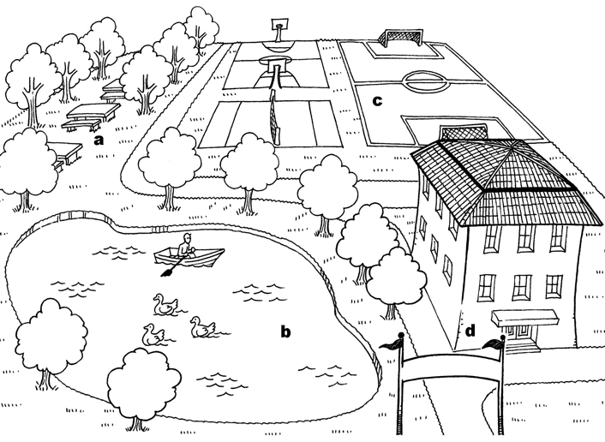
a picnic c
b _____________ d _____________

I often go to the park with my friends to play sports or have a picnic. It’s a good park and you can do lots of things. There are areas for different activities. For example, you can play football in the sports area, but you mustn’t play in the other areas. You can take your food into the picnic area, but you must put the rubbish in the bin when you finish. There is a lake where you can go canoeing, but you must be careful.
When the weather is sunny and warm we spend all day in the park at the weekends and there are lots of people doing different things, but when it’s cold or raining nobody goes, except to the tennis courts, which are inside. I don’t go often because I can’t play tennis, but sometimes I watch my friends play.
I like our park very much and I’m lucky because I live very near it.

- Now read the text again and answer these questions.
1 Where can you play football?
In the sports area.
2 Can you play football in other areas?

3 What must you do when you finish your picnic?

4 What must you do when you go canoeing?

5 What’s the weather like when there are lots of people in the park?

6 What sport can you play when it’s raining?

7 Why can you play it?

8 Why is the boy lucky?

- Read the text and decide if Tom:

A likes his job
b loves his job
c hates his job
d doesn’t like his job

Tom N’Boto works in one of the many national parks in Kenya. Tom tells us about what he does at the start of his working day.
Interviewer: Tom, what time do you start work?
Tom: Well, I start work very early. At half past five in the morning.
Interviewer: That is early. Why don’t you start later?
Tom: Because our main job is to look after the animals, and many of them get up when the sun comes up, so we do too.
Interviewer: Do you have a problem with getting up so early?
Tom: No, not at all. It’s great to see all the animals coming to drink at the lake. It’s a beautiful sight. I never get tired of it. I’m very happy every day when I see them all.

- Read the text again and answer the questions.

1 What country does Tom live in?
He lives in Kenya.
2 Where does Tom work?

3 What time does Tom start work?

4 What is the main part of Tom’s job?

5 When do many of the animals get up?

6 Does Tom have a problem with getting up early?

7 What do the animals do at the lake?

8 What does Tom feel when he sees the animals?

- Write a description of yourself:

PARAGRAPH 1: name, surname, age, birthday, address, brothers and sisters, languages you speak…
PARAGRAPH 2: appearance and personality
PARAGRAPH 3: school, free time, etc.

- Describe your dad’ s routine on Saturdays. What does he do? Write different paragraphs:
1st: in the morning
2nd: in the afternoon
3rd: in the evening

15. Write a description of a room:
- Room
- Location
- size
- Items in the room

- Describe a photo:

- Place

- People: who they are, what they are doing, what they’re wearing

