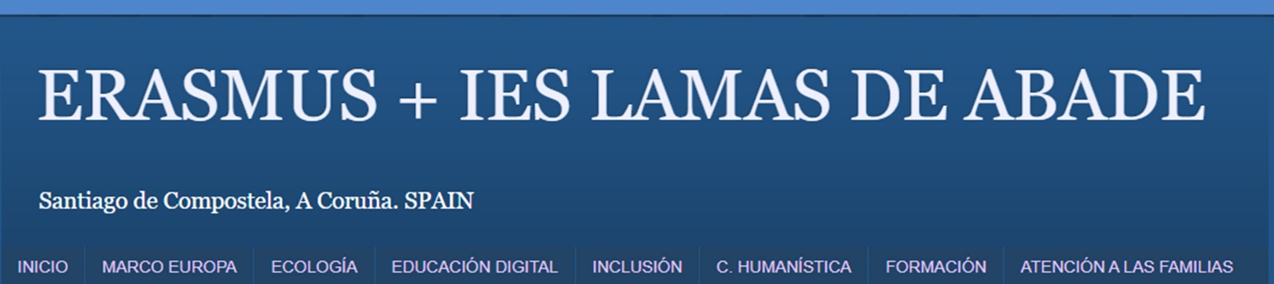
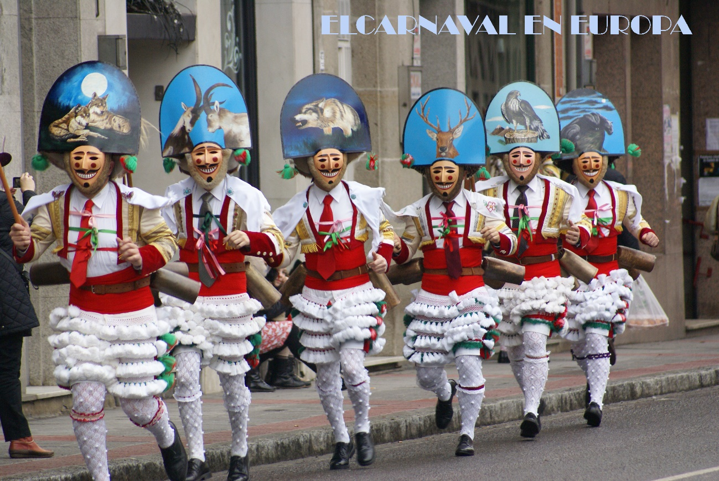

You can already enrol in the Cultural Exchange about CARNIVAL E + !
E+ would like to learn about traditional festivals similar to our Carnival, such as MARDI GRAS in the USA, and organize a cultural immersion in each of our host countries.
The Project consists of making, before February 10th, an exchange template with the host student. It has to be in English and once carried out by both students, our school students must send it through mail to: soana1973@yahoo.es, indicating the following subject line: CULTURAL EXCHANGE ABOUT CARNIVAL ERASMUS+. The template must be like the one attached here.
The aim of this activity is that each Galician student sends to their exchange students a review about any of the different types of traditional Galician Carnival and the foreign students also send us a review about similar traditions in their countries, such as Užgavėnės (Lithuania), the Czech Carnival from Hlinsko (Unesco Heritage), or Lole, in the village Agnita in Transylvania, or some others that are unknown to us.
THIS ACTIVITY IS MANDATORY FOR ALL THE PARTICIPANTS.

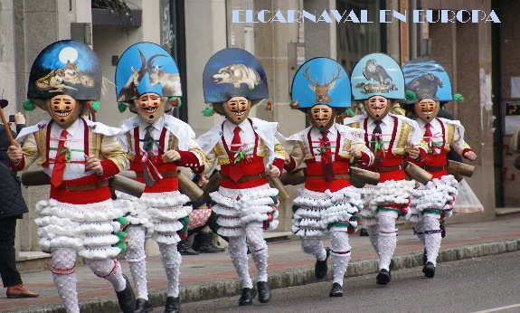

To be filled in by the Galician student:
NAME OF THE GALICIAN CARNIVAL AND LOCATION:

DESCRIPTION (three lines in English):

PHOTO (insert a photo)

To be filled in by the host student:
NAME OF THE CARNIVAL IN THEIR COUNTRY AND LOCATION:
DESCRIPTION (three lines in English):

PHOTO (insert photo)

