DISINFECTION AND SANITATION IN A SALON, SPA AND NAIL SHOP. Beautyhealthtravel (video)
- SANITATION:
- What do you have to clean?

- What do you have to remove?

- Does this process kill all the pathogens?

- DISINFECTION:
- How can you destroy microorganisms?

- What is EPA registered disinfectant used for?

- STERILIZATION:
- What happens during the sterilization process?

- Examples of microbes:

- What do salons use for sterilization?

- Describe the dry heat sterilizer:

- When is it used a dry heat sterilizer?

- IMPORTANCE OF SANITATION AND DISINFECTION:
- Why is it important? Write 4 reasons

- Which ones are the steps for proper sanitation and disinfection?

- What does OSHA stand for?

- Which one is OSHA main purpose?

- Which common salon areas require attention?

- PERSONAL HYGIENE PRACTICES:
- Mention the most important:

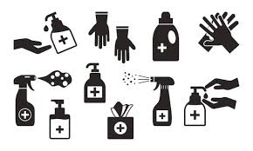
- RECORD KEEPING AND COMPLIANCE:
- What should you do?

