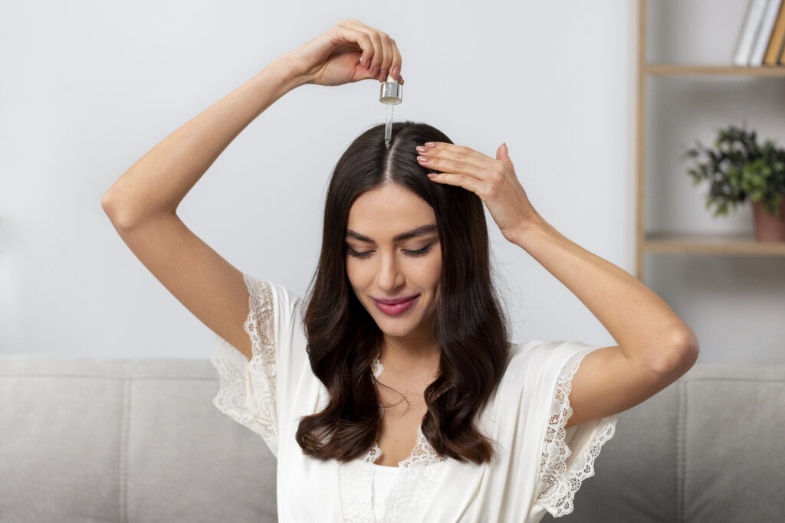
Hair Treatment List: Find the Perfect Solution for Your Hair Needs
Looking for the best hair treatment list? Explore expert-recommended solutions for hair fall, dryness, frizz & more.
Your hair deserves a best care, but with so many treatments available, finding the right one for you may feel overwhelming. Whether you are struggling with frizz, dryness, or hair loss, there is a treatment designed to restore and rejuvenate your looks. In this guide, we will detect a comprehensive list of hair remedies to help achieve healthy, shinier, and more manageable hair
Understanding the importance of hair care can be your first step towards long -lasting results. Consistent treatment to your specific requirements not only improves appearance, but also supports overall scalp and hair health.

Common Hair Problems and Why Treatments Are Essential
Before diving in treatment, identify some common hair issues:
Frizz and dryness: overexposure to heat, lack of moisture and chemicals.
Hair loss and thin: often associated with stress, hormonal imbalance, or poor nutrition.
Dandruff: as a result of products build-up, oil, or skin conditions.
Lack of glow and texture: a sign of damage or poor hair health.
Each of these problems requires a solution, and the right treatment can work wonders.

Comprehensive Hair Treatment List

1. Moisture Treatments
Suitable for: dried and brittle hair.
Benefits: Hydrate and smooth hair, prevents breakdown.
Key option: Hydration mask, leave-in conditioner.
Recommended even after heat style or color treatment.

2. Keratin Treatments
Suitable for: frizzy and curly hair.
Benefits: Gets smooth and adds glow when taming frizz.
Duration: Results last up to 3 months.
Ideal for those who want manageable, low maintenance styles.

3. Protein Treatments
Suitable for: weak and damaged hair.
Benefits: Restore strength, reduces breakage, and repair hair.
Application Time: Quick, with different result duration.
Great for people with chemically treated or more styled hairs.

4. Hair Botox
Suitable for all hair types.
Benefits: Reduces frizz, enhances shine, and reduces repair damage.
Duration: up to 4 months.
Non-invasive, formaldehyde-free solution for smooth texture.

5. Hot Oil Treatments
Suitable for: dried, brittle hair.
Benefits: Increases hydration, reduces hair loss, and adds glow.
Key oils: coconut, argan, and castor oil.
The best applied for deep penetration in the hair shaft.

6. Deep Conditioning Treatments
Suitable for: Colorful or chemically treated hair.
Benefits: Improves the texture and hydrates deeply.
Duration: Results last up to 3 weeks.
Helps to maintain color vibrancy and reduces split ends.

7. Scalp Treatments
Suitable for: Dandruff, itching and hair loss.
Benefits: detoxes the scalp and stimulates blood flow.
Option: Salon exfoliation or at overnight home treatments .
Oil or serum can be combined for the best results.

8. Hair Glossing Treatments
Suitable for: Dull or lackluster hair.
Benefits: Adds a radiant shine and increases color.
Duration: Temporary, ideal or special occasions.
Available in clear or tinted versions to suit hair goals.

9. Low-Level Laser Therapy
Suitable for: hair loss and thinning.
Benefits: Stimulates hair growth with advanced technology.
Effectiveness: For visual results consistent sessions are required.
Safe and non-invasive solution for alopecia.

10. Detox Treatments
Suitable for: Product Buildup or Oily Scalps.
Benefits: Reset the hair and scalp for optimal health.
Application: Special shampoo or salon can be done with services.
The best for those individuals who use regular styling products.

DIY vs. Salon Hair Treatments
Professional treatment: Ideal for long -lasting results and advanced solutions such as keratin or laser therapy.
DIY option: Affordable and convenient for regular maintenance (eg, hot oil or deep conditioning treatment).
Decision Tip: choose based on your hair needs, budget and time constraints.
Salon visits offer customization and higher strength products, while DIY can be great for maintenance.

How to Choose the Right Hair Treatment
Identify your hair concerns: What is your biggest issue – dryness, damage, or dandruff?
Assess your budget and time: some remedies, such as protein therapy, are quick, while others require more commitment.
Consult a professional: For serious issues, a stylist or trichologist may recommend the best solution.
Note how your hair responds post treatment and adjusts accordingly.

Aftercare Tips for Long-Lasting Results
Use sulfate-free shampoo and conditioner.
Avoid excessive heat style.
Follow your stylist’s recommendations for maintenance.
Include nutritious oil and masks in your routine.
Consider protective hairstyles and regular trims.

