5 DERMATOLOGIST TIPS FOR HEALTHY SKIN
A video from the American Academy of Dermatology

1.Can you answer these questions?

- What are the key tips from board-certified dermatologists for achieving healthier skin?
- How can one protect their skin from the sun?
- What is the recommended order for applying skincare products?
- What should one look for when choosing skincare products?
- Why is it important to avoid touching one's face throughout the day?
- What should one look for when checking their skin for potential skin cancer?
- Why is it important to partner with a board-certified dermatologist for maintaining healthy skin?

2. Watch again and complete these sentences

Follow dermatologists' tips for _______________(1)
Protect skin from sun to prevent _______________(2)
Seek shade and wear _______________(3)
Apply sunscreen with _______________(4)
Apply skincare products in _______________(5)
Avoid touching face to prevent transferring _______________(6)
Check skin regularly for suspicious spots or _______________(7)
Partner with a board-certified dermatologist for more information on ____________(8).

3. Prepare a leaflet with different tips to have a healthier skin. This leaflet is aimed at students and teachers from this school
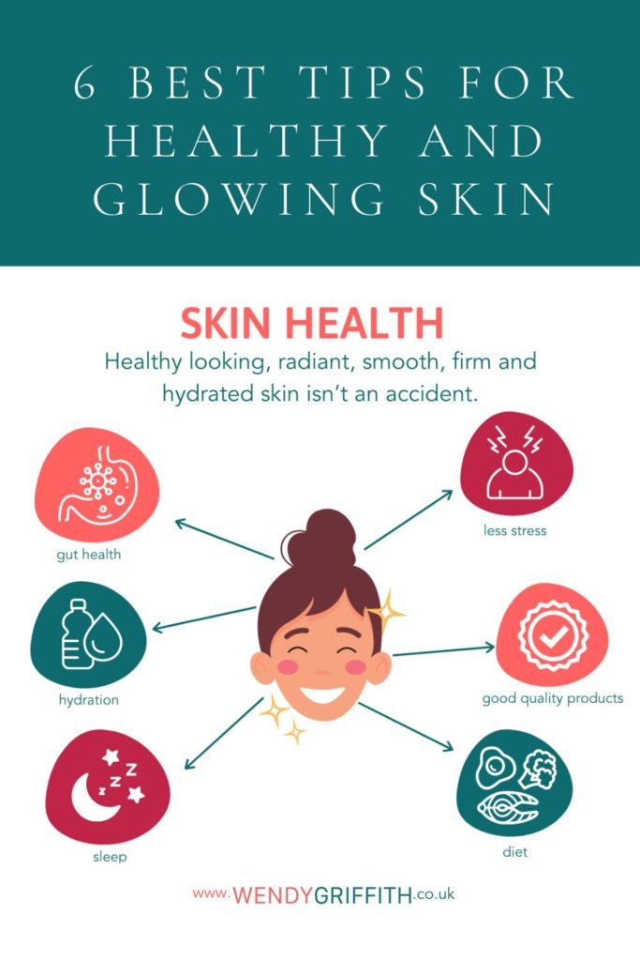

The key tips from board-certified dermatologists for achieving healthier skin include protecting the skin from the sun, following a proper skincare routine, and checking the skin regularly for any suspicious changes.
2
To protect the skin from the sun, one should seek shade when outdoors, wear sun-protective clothing, and apply broad-spectrum, water-resistant sunscreen with SPF 30 or higher.
3
The recommended order for applying skincare products is: 1) wash the face with a gentle cleanser, 2) apply any topical medications or treatments, 3) apply moisturiser and/or sunscreen, and 4) apply any desired makeup.
4
When choosing skincare products, one should look for products that are alcohol and fragrance-free, as they are less likely to irritate the skin, and products that address their specific skin concerns.
5
Avoiding touching the face throughout the day is important to prevent transferring dirt, germs, and oils from the hands to the skin, which can lead to skin problems.
6
When checking the skin for potential skin cancer, one should look for any suspicious spots or moles that itch, change colour, or bleed.
7
Partnering with a board-certified dermatologist is important for maintaining healthy skin as they can provide expert advice and treatment for any skin concerns.
Possible Answers:
1
healthier skin
2
cancer and aging
3
protective clothing
4
SPF 30 or higher
5
specific order
6
dirt and oils
7
moles
8
skin health

