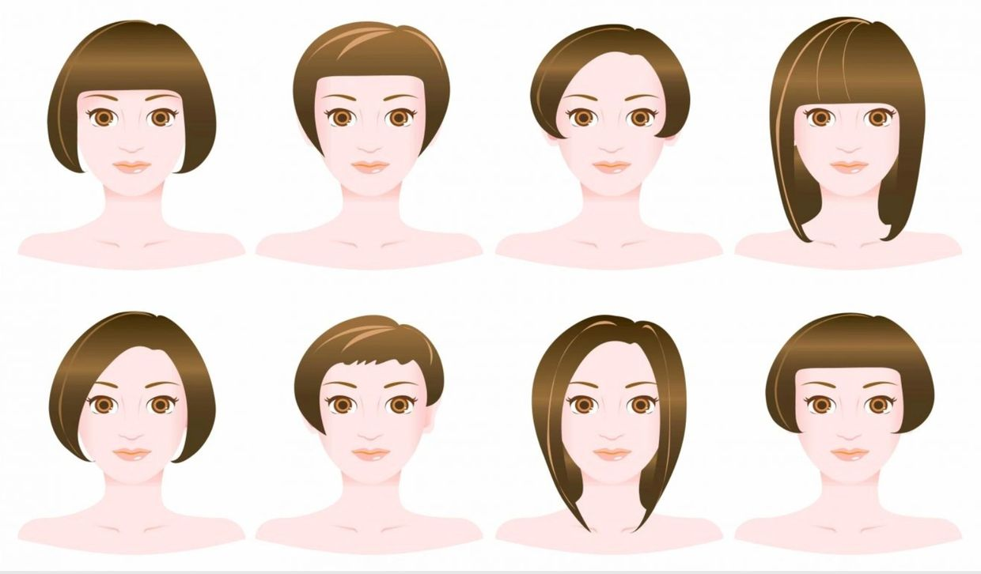
Finding the perfect harmony between image, hair and lifestyle is the best way to show who we really are. It’s paramount to devise a look based on your physical features and true desires.

So many people go to the hair salon asking for a hair color or haircut that is similar to that of a friend or someone famous. The issue with that is that we all have different facial features, dimensions and the haircut turns out not to have the same effect as the one desired. This is why choosing a haircut based on your very own facial traits is important.

Physical traits and physiological (skin undertone) are taken into consideration prior to suggesting any haircut, style or color. The lifestyle and routine are also analyzed. After all the information is acquired, we are able to determine what changes will bring more harmony to your overall look and style. All these steps are taken in order to obtain a final result that aligns with the client’s physical image and with what that clients really wants to portray.
For example, long hair can help to elongate the face, creating texture with curls or waves can help to soften angular features. Hairstyles can be used to enhance a person's facial features, elongate the neck, and draw attention to the eyes. It all depends on each person’s own needs and facial features and desired looks.

Here are the primary face shapes and their characteristics:
1. Oval: Balanced proportions with a slightly longer than wide shape. The forehead is slightly wider than the chin.
2. Round: Equal width and height with soft, rounded edges.
3. Square: Strong, angular jawline with equal width across the forehead, cheekbones, and jawline.
4. Heart: Wider forehead with a narrow, pointed chin.
5. Rectangle (or Oblong): Longer than it is wide with a long straight cheek line.
6. Diamond: Narrow forehead and jawline with the cheekbones being the widest part.

Hairstyles for Oval Face Shapes
Characteristics: Oval faces are versatile and balanced, allowing for a wide variety of hairstyles.
Recommended Hairstyles:
1. Long Layers: Enhance the natural symmetry with long layers that add movement and dimension.
2. Bobs: Both short and long bobs work well, especially if they are styled with waves or curls to soften the look.
3. Side-Parted Styles: A deep side part can add volume and break up the length of the face.

Hairstyles for Round Face Shapes
Characteristics: Round faces have a youthful appearance but can appear wider if not styled correctly.
Recommended Hairstyles:
1. Long and Layered: Long, layered hair elongates the face and adds a slimming effect.
2. Side-Swept Bangs: These create angles and draw attention away from the roundness.
3. Voluminous Updos: Adding height on top elongates the face.
Hairstyles for Square Face Shapes
Characteristics: Square faces have strong jawlines and broad foreheads, giving them a powerful and striking look.
Recommended Hairstyles:
1. Soft, Wispy Layers: Layers that start at the jawline can soften the strong features.
2. Side Parts: Off-center parts break up the symmetry and create a softer appearance.
3. Wavy Styles: Soft waves or curls add volume and movement, softening the angularity.
Hairstyles for Heart Face Shapes
Characteristics: Heart-shaped faces feature a broader forehead and a narrow, often pointed chin.
Recommended Hairstyles:
1. Chin-Length Bobs: These balance the wider forehead and narrower chin.
2. Side-Swept Bangs: These draw attention away from the forehead and add balance.
3. Soft Waves: Waves around the cheekbones add fullness and balance the face.
Hairstyles for Rectangle Face Shapes
Characteristics: Rectangle faces are longer than they are wide, with a long straight cheek line.
Recommended Hairstyles:
1. Soft Layers: Layers that start around the cheekbones add width and balance the length.
2. Curtain Bangs: These break up the length and draw attention to the eyes.
3. Volume at the Sides: Hairstyles with volume at the sides add width and balance the face.
Hairstyles for Diamond Face Shapes
Characteristics: Diamond faces have narrow foreheads and jawlines, with the cheekbones being the widest part.
Recommended Hairstyles:
1. Chin-Length Bobs: These add width at the chin and balance the cheekbones.
2. Side-Swept Bangs: These soften the angles and draw attention to the eyes.
3. Volume on Top: Adding volume on top balances the narrow forehead and jawline.
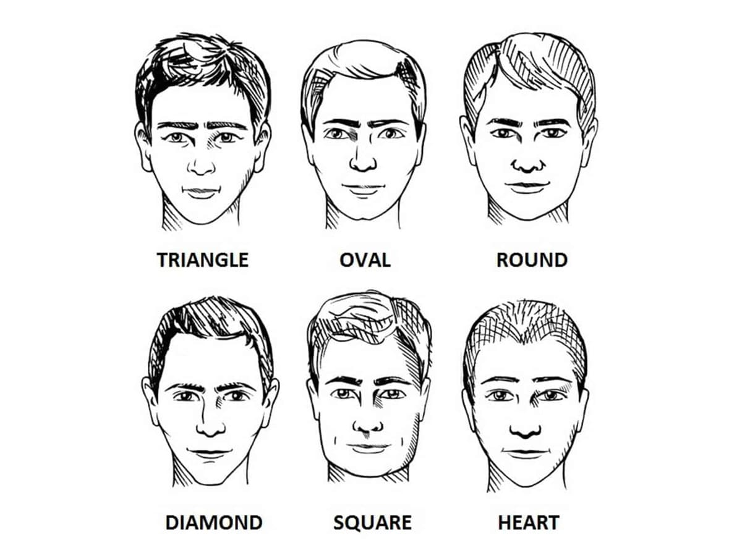
The seven most common face shapes for men |

Oblong Face Shape
Oblong Face Shape Characteristics:
- Longer than it is wide, with a balanced jawline, cheekbones and chin.
- Forehead is often high, and the overall impression can be one of a long face.
Flattering Styles:
- Side Part – A classic option that adds volume to the hairline and fringe.
- Textured Fringe – A textured fringe that falls across the forehead adds dynamism to the cut.
- Crew Cut – For those wanting to keep the hair on top short.

Square Shaped Face
Square Face Shape Characteristics:
- Broad forehead and jawline with a sharp jaw angle.
- Almost equal width across the forehead, cheekbones and jaw.
Flattering Styles:
- Asymmetrical Styles – Angled fringes and side partings help to throw off the balance and detract from the square shape of the head
- Short, Back and Sides – A classic for a reason. Keeping the sides short and top long gives the illusion of height.

Oval Face Shape
Oval Face Shape Characteristics:
- Balanced proportions – The face is longer than it is wide, but not exaggerated.
- The widest part of the face is at the cheekbones, gently slopping towards the jawline.
Flattering Styles:
- Pretty much anything
- Pompadours – Add some nice volume to the front of the hair
- Messy Textured Cuts – This face shape is perfect for experimentation so you can get away with looking a bit more unkempt.

Round Face Shape
Round Face Shape Characteristics:
- Full cheeks and a curved jawline.
- Short face length compared to width.
Flattering Styles:
- Pompadour – This hairstyle will elongate the face, giving you the illusion of height to balance the wider lower jawline.
- Textured Crop – A short style that adds texture to the top, giving you the illusion of height. For a more extreme variation, ask for a skin fade on the side and play around with the best length for the fringe.
Cillian Murphy’s diamond face shape is highly versatile |

Diamond
Diamond Face Shape Characteristics:
- Narrow forehead when compared to the cheekbones.
- Sharply pointed chin that is narrower than the forehead.
Flattering Styles:
- Messy Top – This style adds volume and texture on top, softening the jawline.
- High Fade with Fringe—This extreme cut adds more width to the top of the hair and accentuates your cheekbones.
Kumail Nanjiani’s wide jawline is typical of a triangular face shape, although his cheekbones are still quite pronounced

Triangular Face Shape
Triangular Face Shape Characteristics:
- Wider jawline with narrow cheekbones and forehead
- Prominent chin
Flattering Styles:
- Layers – Opting for a style that has layered sections will draw attention away from the jawline.
- Length – Longer-hair gives some shape and balance to the face shape.
A pointed chin like Ryan Gosling’s is indicative of a heart face shape

Heart Shaped Face
Heart Face Shape Characteristics:
- Wider forehead and cheekbones compared to the jawline.
- Pointed chin is the narrowest part of the face.
Flattering Styles:
- Forward-Facing Textured Fringe – Minimises the width of the forehead.
- Medium-Length Curly Hair – Works to add volume and width around the jawline, creating the illusion of balance.

