Types of crime and offenders
Check the following pictures and read the definitions.
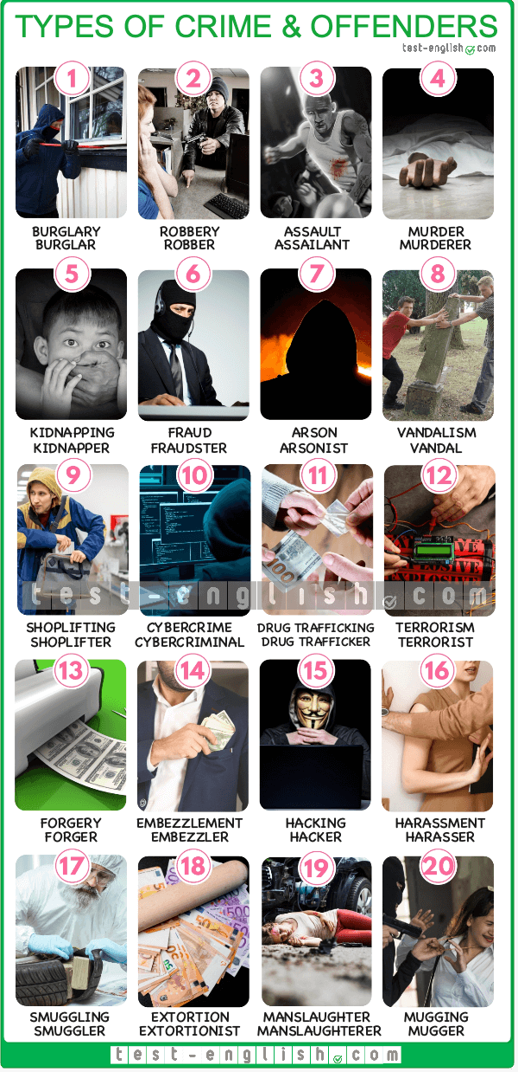
1 Burglary: A burglar is a person who breaks into a home or building without permission and steals from it.
2 Robbery: A robber is a person who steals from a place using threats or violence.
3 Assault: An assailant is a person who physically attacks someone.
4 Murder: A murderer is a person who intentionally kills someone.
5 Kidnapping: A kidnapper is a person who takes someone by force and demands money for their safe return.
6 Fraud: A fraudster is a person who lies or tricks others to obtain money.
7 Arson: An arsonist is a person who sets fire to a home or building.
8 Vandalism: A vandal is a person who intentionally destroys or damages public or private property.
9 Shoplifting: A shoplifter is a person who steals goods from a store.
10 Cybercrime: A cybercriminal is a person who commits crimes over the internet.
11 Drug Trafficking: A drug trafficker is a person who sells, imports, and transports illegal drugs.
12 Terrorism: A terrorist is a person who uses threats and violence to create fear.
13 Forgery: A forger is a person who reproduces documents, money, or signatures to deceive others.
14 Embezzlement: An embezzler is a person who steals money that has been put in their care.
15 Hacking: A hacker is a person who breaks into a private computer system to obtain information.
16 Harassment: A harasser is a person who abuses or annoys someone, causing them emotional or physical suffering.
17 Smuggling: A smuggler is a person who moves things out of a country illegally.
18 Extortion: An extortionist is a person who threatens others in order to obtain money.
19 Manslaughter: A manslaughterer is a person who kills someone unintentionally or without having planned to do it.
20 Mugging: A mugger is a person who attacks someone in a public place and steals from them.

Exercise 1
Match each sentence with a type of crime.

1 Two men attacked a jogger and stole his wallet and his watch.

2 A dentist killed his wife using poison.

3 Two men were caught trying to bring illegal diamonds into the country.

4 A woman was caught trying to buy a car with someone else’s credit card.

5 A student set fire to his school after failing his exams.

6 Sam broke into an apartment and stole a television and a laptop.

7 A young girl was caught stealing a chocolate bar from a shop.

8 Two teenage bullies were sending threatening messages to a classmate on social media.

9 Two men forced the president’s son into a car and then demanded $1 million for his safe return.

10 A man held a gun to a bank teller’s head and told him to give him all the money in the safe.

Types of crime and offenders – B1+ English Vocabulary - Test-English

Exercise 2
Complete each sentence with a type of offender.

1 The_____________________ created realistic banknotes at home and tried to use them to buy jewellery.
2 A ____________________________ smashed all the windows of a parked car.
3 The _________________________ attacked a man as he was leaving a pub, leaving him with six broken ribs.
4 A _________________________ was charged with importing marijuana and selling it in his local area.
5The _______________________ broke into a bank's computer system to access its clients' private information.
6The _______________________threatened the shop owners with violence unless they paid him.
7The _______________________was driving home after drinking and killed a pedestrian.
8The _______________________kept calling up a colleague and verball y abusing her, causing her mental distress.
9The _______________________illegally diverted money from the company's accounts for years.
10The _____________________ carried out a series of bombings in the city, instilling fear in the hearts of its residents.

