Company History - Linguahouse

1. Focus on vocabulary

Part A
Complete the definitions using the vocabulary below:
charities | costs | law | less | natural | organisation | sport
- climbing (n): a ______ where you go up rocks or mountains
- charity (n): an ______ which collects money for people who need help
- environment (n): the ______ world that we live in
- court (n): a place where it is decided if people have broken the ______ or not
- reduce (v): make something ______
- trust (n): an organisation that uses money that people give to help ______
- profit (n): money that is made in business after paying the ______ of running the business

Part B
Complete the following sentences with a different part of speech from the same word family as the words below:
charity | climbing | environment | profit | reduce | trust
- Our company has been very ______ this year and we've made much more money than we did last year.
- My brother works for an ______ organisation in India that cleans up the rivers and sea.
- My boss lets me use his office when he is out. He is very ______ with his employees.
- My friend just started a ______ organisation to help people who don't have enough food in the area.
- The store had a ______ on prices, making the clothes more affordable.
- Next weekend, my friends and I are going to ______ a mountain in the north of the country.

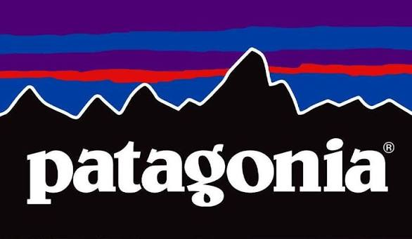
2. Focus on verbs
Choose the best verb to complete gaps 1–8 in the article:

Patagonia – A History of the Company
Yvon Chouinard (1) ______ selling clothes and equipment for climbing in 1957 through his company, Chouinard Equipment. He (2) ______ the company by himself until 1965 when he (3) ______ with Tom Frost. Together, they (4) ______ more products and (5) ______ them.
In 1985, Patagonia Inc. started giving 1% of its total sales to charities which helped the environment. In 2017 Patagonia Inc. (6) ______ the United States Government and President Donald Trump to court because they were trying to reduce protected land of the Bears Ears National Monument by 85%. Patagonia (7) ______ it would keep fighting to the end. In September 2022, Yvon Chouinard (8) ______ that he would give his ownership of Patagonia Inc. to a trust to make sure profits from the company will be used to fight climate change and protect land around the world.
- a. began | b. made | c. bought
- a. said | b. ran | c. took
- a. announced | b. took | c. partnered
- a. began | b. ran | c. made
- a. improved | b. started | c. made
- a. began | b. took | c. ran
- a. said | b. made | c. partnered
- a. took | b. announced| c. partnered

3. Reading comprehension
Decide if the following statements are True or False:
- Chouinard Equipment sold clothing and shoes for football.
- Yvon Chouinard started working with Tom Frost in 1957.
- Tom Frost and Yvon Chouinard created more products together and made the ones they already had better.
- Patagonia started giving money to take care of the environment in the 1980s.
- President Donald Trump was trying to make the amount of protected land in the United States much smaller.
- The company is going to stop helping Bears Ears National Monument soon.
- Yvon Chouinard does not own Patagonia Inc. any more.

4. Listening for details
Which of the following verbs in the past simple do you hear in the information?
[ ] started  [ ] began  [ ] sold  [ ] had  [ ] took | [ ] bought  [ ] brought  [ ] made  [ ] partnered

5. Listening comprehension
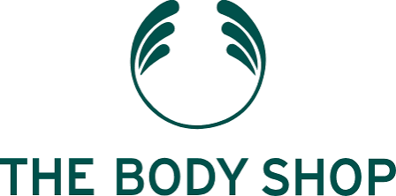
Choose the correct answer for the following questions:
- In which year did The Body Shop start?
a. 1976
b. 1967
c. 1965
- Where did the first shop open?
a. London, UK
b. Bristol, UK
c. Brighton, UK
- How many products did Anita Roddick have at the beginning?
a. 15
b. 25
c. 35
- When did Anita Roddick start her second shop?
a. 1976
b. 1977
c. 1978
- How much of her business did she sell to buy the second shop?
a. 30%
b. 40%
c. 50%
- How many shops were there in 1984?
a. 137
b. 138
c. 87
- When did L'Oréal buy The Body Shop?
a. March 2006
b. April 2007
c. March 2008
- How much money did Anita Roddick and her husband make from the sale of the company?
a. Less than £650 million
b. Over £650 million
c. Over £650 billion
- Which country was the company from that bought The Body Shop from L'Oréal in 2017?
a. Belgium
b. Botswana
c. Brazil

6. Talking point
In pairs, discuss the following questions:
- Have you shopped in either Patagonia or The Body Shop? If so, what did you think about their products?
- Which company do you think is the most interesting: The Body Shop or Patagonia? Why?
- Which are your favourite shops? Who owns those companies?
- When did your favourite companies start?
- When did the company you work for start?
- What products does your company make?
- Who started your company?

7. Extended task / Homework

Task 1
Complete the following sentences about your company:
- The company I work for started in ______. (year)
- The person/people who started my company was/were ______. (person/people)
- My company makes ______. (products)
- My company has ______ offices/shops. (number)
- Last year, my company made ______ in profit. (amount of money)

Task 2
Now write 3 sentences about your company. Use the past simple form of at least 3 of the verbs in the box:
improve | start | partner | announce | begin | run | make | take | say | bring | buy | sell

