Unit 2 - This is Halloween

1. Do the crossword puzzle.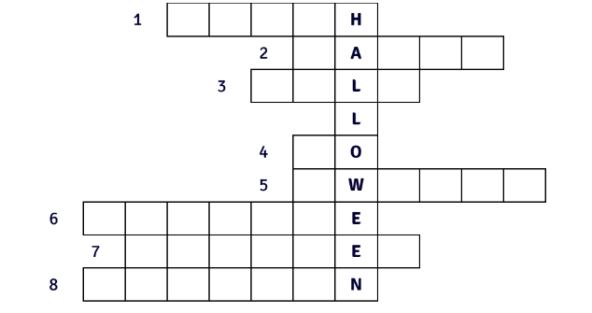
- 🧙She can do magic and often rides a broom.
- 🎉A group of friends comes together to eat, drink and have fun.
- 🎬You watch this at the cinema or at home.
- 🚶You can _______ to the cinema with your friends.
- 🍬Children love eating these.
- 🎭You wear this to look like another person or character.
- 📖You can tell these to your friends.
- 🎃It's an orange vegetable popular in the autumn.

2. Use the words from the puzzle in ex. 1. to complete the sentences. Use all of the nouns in their plural form.
A. Children carve ____________________ and put candles inside them in art lessons at school.
B. Most people give out ____________________ to children, so shops sell a lot of them.
C. Some people like to go to the forest with friends, sit around a fire and tell spooky ____________________
D. People enjoy watching scary ____________________, so many cinemas show classics like Dracula or Psycho.
E. Adults rarely wear ____________________ for Halloween.
F. Young adults often throw Halloween ____________________ with decorations and music.
G. Children dress up as ____________________ or ghosts and ____________________ trick-or-treating from house to house.

3. Complete the words with the missing letters. Then, replace the underlined words and phrases with your own ideas.
A. The most popular c _ _ t _ m _ s people wear for Halloween are of witches and pirates.
B. Children like to _ _ e _ s up as superheroes for Halloween.
C. I would _ _ _ e _ _ t my favourite sweets, which are gummy bears.
D. If I wanted to c _ _ _ e a pumpkin, I would make a funny face.
E. People like telling s _ _ o _ _ stories about ghosts.
F. Children often go trick-or- _ _ _ _ _ ing with their parents.
G. You can _ _ r _ _ a party at home.

4. Watch a video [https://youtu.be/eNTs3RrBxfl] (to 03:02) from a TV show called Friends and say what the people are doing. Use at least four phrases from ex. 2.

5. Choose what you would prefer to do on Halloween. Explain your choices.
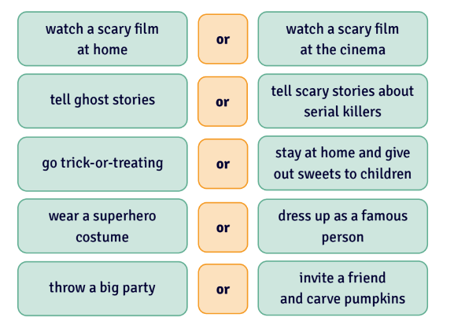

6. Write down an example for each of the categories below.
EXAMPLE: place: tropical island
A. place: __________________________________________________
B. thing: __________________________________________________
C. famous person: __________________________________________________
D. two animals: __________________________________________________
E. food: __________________________________________________
F. job: __________________________________________________
G. something people are often afraid of: ____________________________________________

7. Complete the story with the words you came up with in ex. 8.
I want to throw the scariest Halloween party ever!
I will throw a party in (A) ________________________. For decorations, I will carve pumpkins and put (B) ________________________ inside them.
I will dress up as (C) ________________________ and I will ask my friends to wear (D) ________________________ and ________________________ costumes.
When children go trick-or-treating, I will give out (E) ________________________ all instead of sweets.
We will watch a scary film about (F) ________________________ who got lost in a forest. We will also dance to songs about (G) ________________________.

8. Work in pairs. Student A, choose a card with a phrase. Do one of the tasks (A-C) so that Student B can guess the phrase. Then, swap roles and continue until you have used all the cards.
A. Explain it but don't use any words from the phrase.
B. Act it out in 15 seconds.
C. Draw it in 30 seconds.

9. Discuss the questions.
- How popular is Halloween in your country?
- Are the sentences in ex. 2 true about Halloween where you live?
- What other things do people do for Halloween in your country?
- Do people celebrate Halloween or similar holidays in other countries? What do they do?
- Have you seen any films about Halloween? What happens in them?

