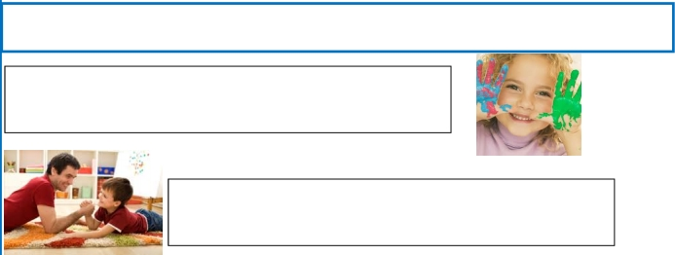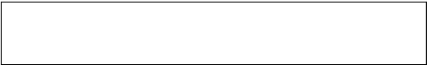
Repaso Segundo Trimestre.

Nombre: ________________________________

Verbo To be. Escribe el verbo to be y tradúcelo

AFFIRMATIVE
___I am______
_____________
_____________
_____________
_____________
_____________
_____________
______________
NEGATIVE
I´m not
_____________
_____________
_____________
_____________
_____________
_____________
______________
INTERROGATIVE
Am I?
_____________
_____________
_____________
_____________
_____________
_____________
______________

Complete with to be (am , is , are) and translate.

She _________ Ann.

He _________ my father

We_________ friends.

