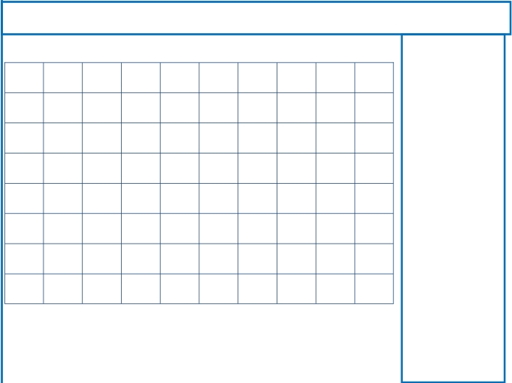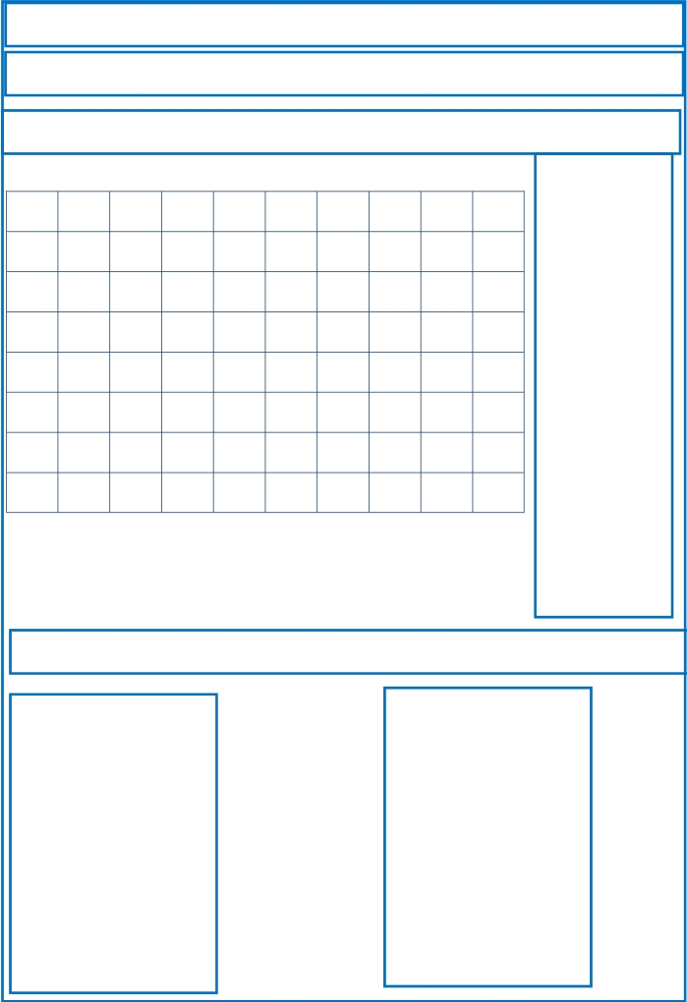
Repaso Segundo Trimestre.

Nombre: ________________________________

Find the words

ONE (1)

M
G
D
E
D
T
G
T
S
R
E
I
J
H
R
E
E
O
A
G
M
R
N
N
F
O
U
H
Z
E
I
S
S
E
N
T
A
E
N
U
E
D
T
R
S
H
E
F
V
A
U
P
O
E
A
I
E
D
L
M
N
R
E
V
N
H
N
N
E
E
W
E
S
I
X
T
W
O
E
A

TWO (2)

THREE (3)

FOUR (4)

FIVE (5)

SIX (6)

SEVEN (7)

EIGHT (8)

NINE (9)

TEN (10)

Write the numbers

1

2

3

4

5

6

7

8

9

10

