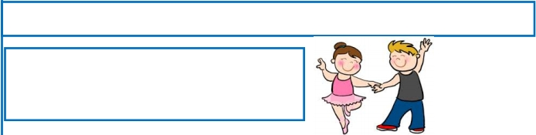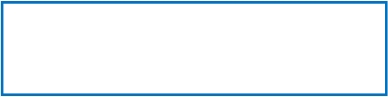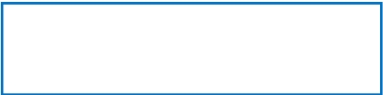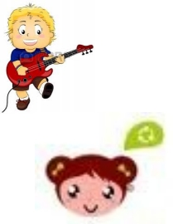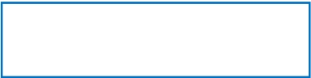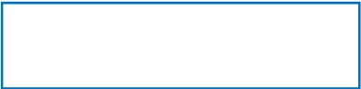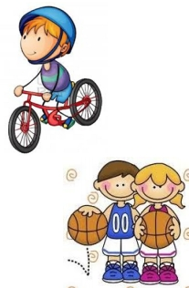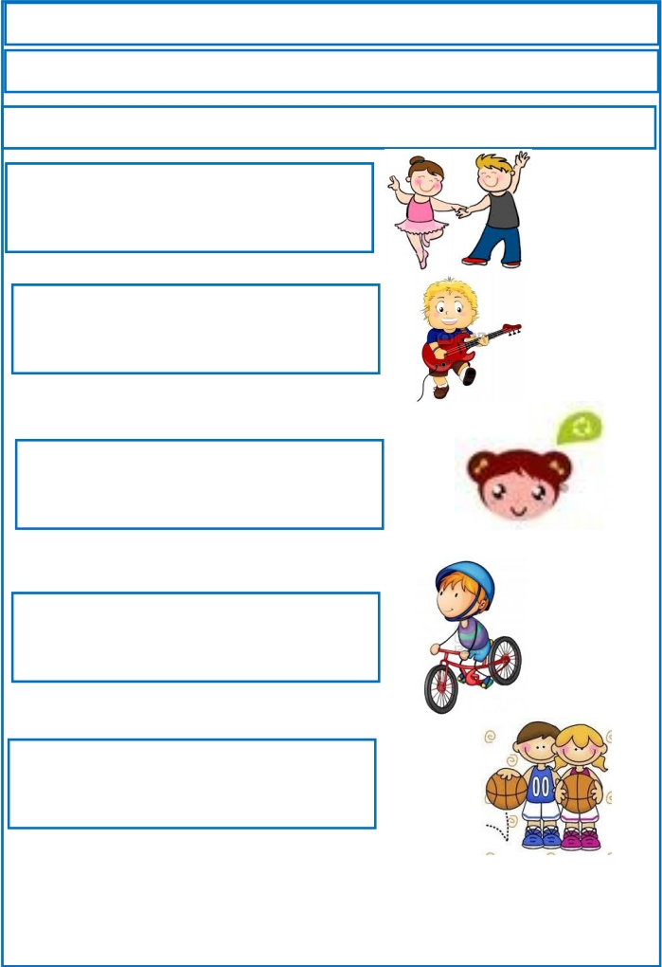
Repaso Segundo Trimestre.

Nombre: ________________________________

Escribe las preguntas.

They can dance.

Can they dance?

He can play guitar.

________________________________________

She can speak spanish.

________________________________________

He can ride a bicycle.

________________________________________

They can play basketball.

________________________________________

