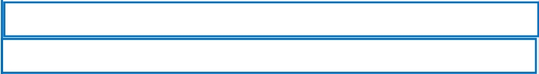Inglés. 3º Primaria
Repaso Segundo Trimestre.

Nombre: ________________________________
PRESENT CONTINUOUS ( Mirando polo exemplo completa cas palabras en rojo)

Fill in the blanks with am –is or are
6. I ________ doing my home-

1.

2.

3.

4.

5.
Ann ___is___ reading a book.

My sister _______ playing te-

nis.

We _________ listening to

music.

My brother _______ sleeping.

They ________ studying.
works.

7. You ________ speaking.

8. They _________cleaning the

house.

9. Tom _________ going to the

cinema.

10. My mother __________

running

Fill in the blank, using the present continuous (Completa co presente continuo como nos exemplos e mirando pola teoría da outra paxina)

1.

2.

3.

4.

5.

6.

7.

8.
Sarah _____is waching______________________________ (watch) a film.

I ___________________________________ (study) for my english exam.

We ___________________________________ (play) guitar.

My brother ___________________________ (read) the newspaper.

They __________________________________ (go) to the cinema.

Peter ________________________________ (clean) the house.

My sister _____________________________ (speak) with her friend.

We _____________________________________ (eat) an apple.

