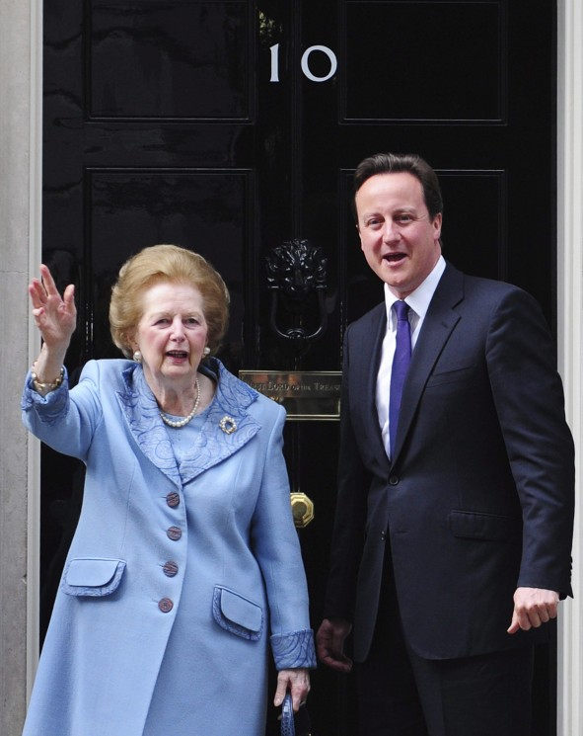
MARGARET THATCHER
- Complete name and peerage.
- Date and place of birth.
- What was her father´s job?
- How many brothers or sisters did she have?
- What religion was she brought up as?
- Who did she marry and when?
- Why wasn´t she a candidate in the 1955 general election?
- Political party she belonged to.
- Highest status she reached and dates.
- What was her nickname and who gave it to her.
- What was the name given to her policies?
- What is special about her being a woman?
- Name two of her jobs before becoming a politician.
- Where did she live from 1979 to 1990?
- What did her political philosophy and economic policies emphasise?
- When did the Falklands War take place?
- What was her position towards homosexuality and abortion?
- Why was she called “milk snatcher”?
- What was her position towards the welfare state?
- What famous actor helped her to suppress her Lincolnshire accent?
- What day did she become Prime Minister?
- As PM, who did she meet weekly? What for?
- What was her relationship with the University of Oxford like?
- Which strike brought the biggest confrontation between the trade unions and her government?
- Which tax made her terribly unpopular?
- Name some of the industries she privatized.
- Who was Bobby Sands?
- What happened in the morning on 12 October 1984 in Brighton?
- What is the name of the US president she was close to?
- What country did UK fight against in the Falklands War? Who won it?
- What was her position towards German reunification?
- Who replaced her as PM and leader of her party?
- When, where and how did she die?
- What were the reactions to her death?
- What can you say about her funeral?

