1 Look at the online catalogue for sports equipment. Then circle the correct answers.
* ** *** **** *****
good very good
Ball (small) €20 ****
Ball (big) €30 ****
Water bottle (small) €8 *****
Water bottle (big) €10 *****
Table tennis table €200 *****
Tennis racket €35 *****
1. The small water bottle is cheaper than / more expensive than / the most expensive the big water bottle.
2. The big ball is not as expensive as / not as cheap as / as expensive as the tennis racket.
3. The table tennis table is cheaper than / more expensive than / the most expensive item in the catalogue.
4. The cheap ball is bigger than / smaller than / as big as the other ball.
5. The balls are as good as / better than / not as good as the table tennis tables.
6. The small water bottle is cheaper than / as cheap as / the cheapest item in the catalogue.
2 Write sentences about the pictures using the words below. Use the comparative or superlative form of the adjectives or (not) as … as.
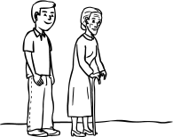 the man / be / old / the woman
1
The man isn’t as old as the woman.
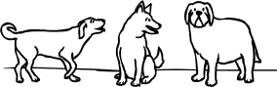 Spot / fat / dog
2
Spot
Blackie
Rufus

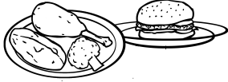 meal B / healthy / meal A
3
Meal B
Meal A

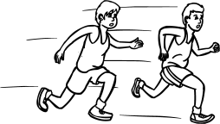 Paul / fast / Harry
4
Harry
Paul

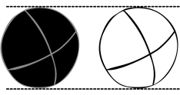 the white ball / big / the black ball
5

3 Look at the chart and complete the sentences with one of the adjectives in brackets. Use the comparative or superlative form or as … as / not as … as. There may be more than one possible answer. (6 x 1 = 6 points)
Skateboards | Price | Year | Length
Top Skate | €49.99 | 2009 | 79 cm
High Roller | €54.99 | 2008 | 79 cm
Speed King | €54.99 | 2007 | 80 cm
Gold Star | €99.99 | 2008 | 76 cm
1. Top Skate is ………………………… skateboard. (cheap / long)
2. Gold Star is ………………………… Speed King. (long / expensive)
3. High Roller is ………………………… Top Skate. (cheap / long)
4. Speed King is ………………………… skateboard. (new / old)
5. Speed King is ………………………… High Roller. (short / expensive)
6. Gold Star is ………………………… skateboard. (old / expensive)

