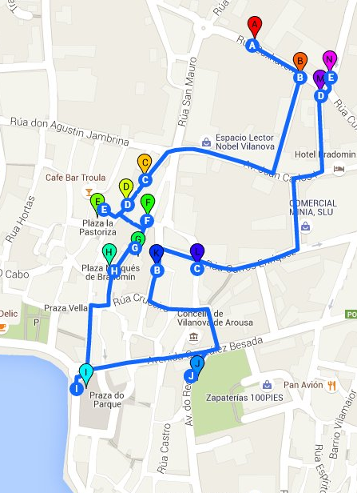

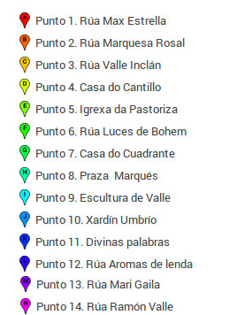


IES Faro das Lúas
Vilanova de Arousa


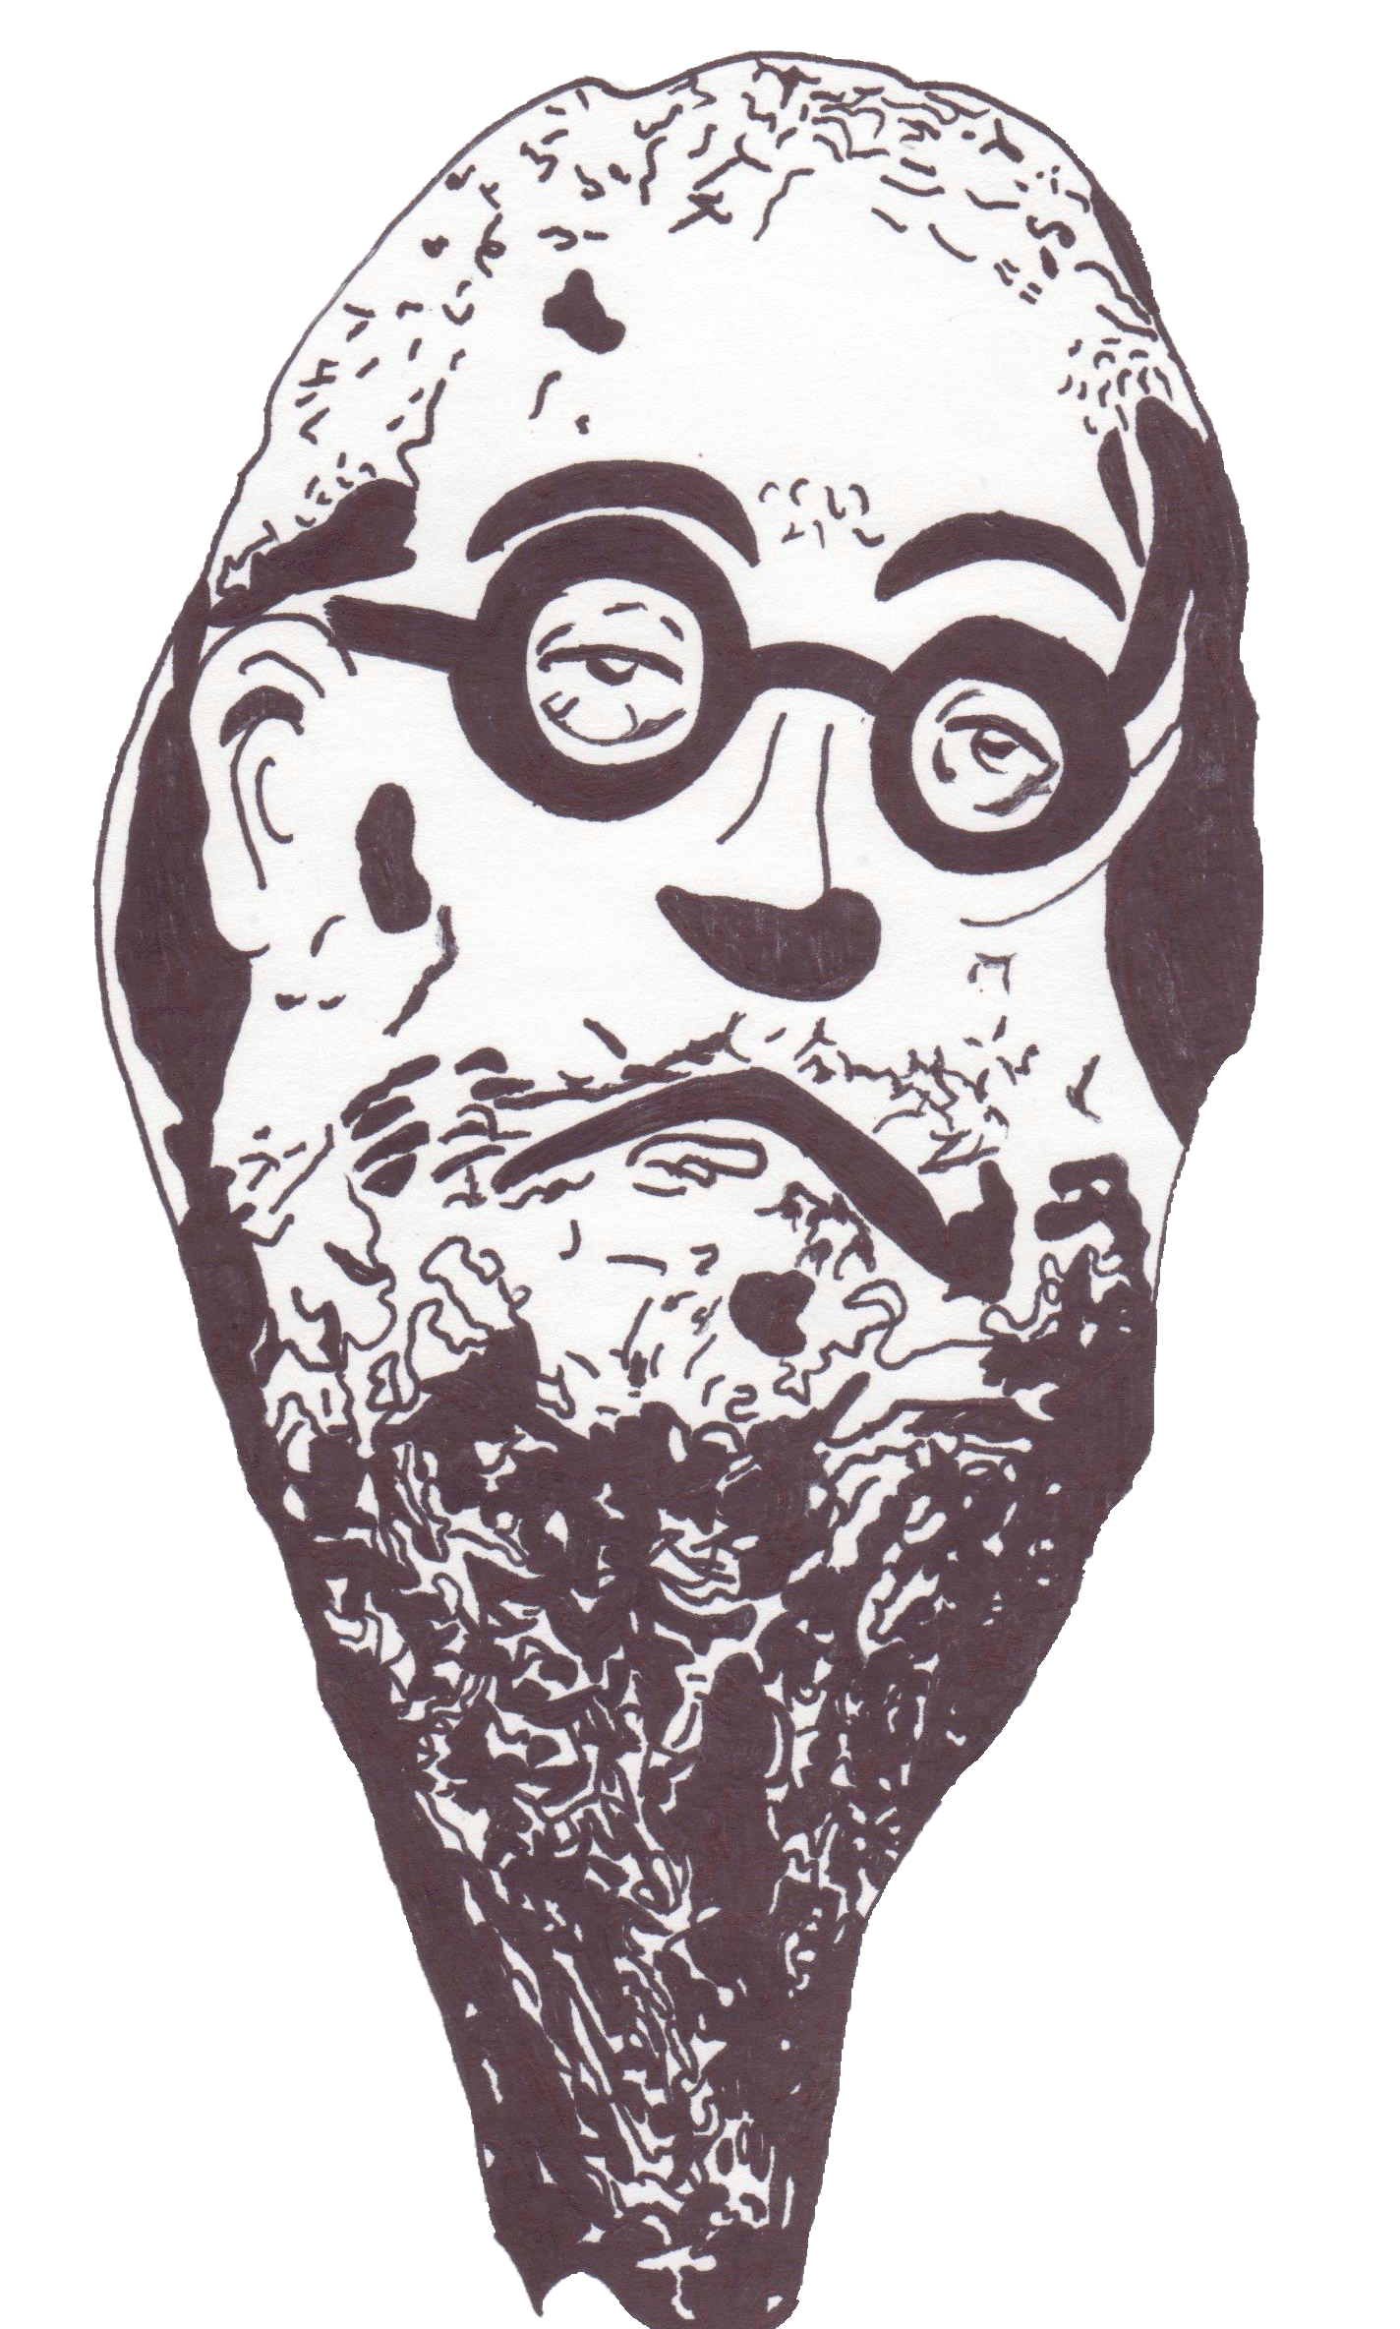
A TRIP TO VALLE-INCLÁN

Vilanova de Arousa
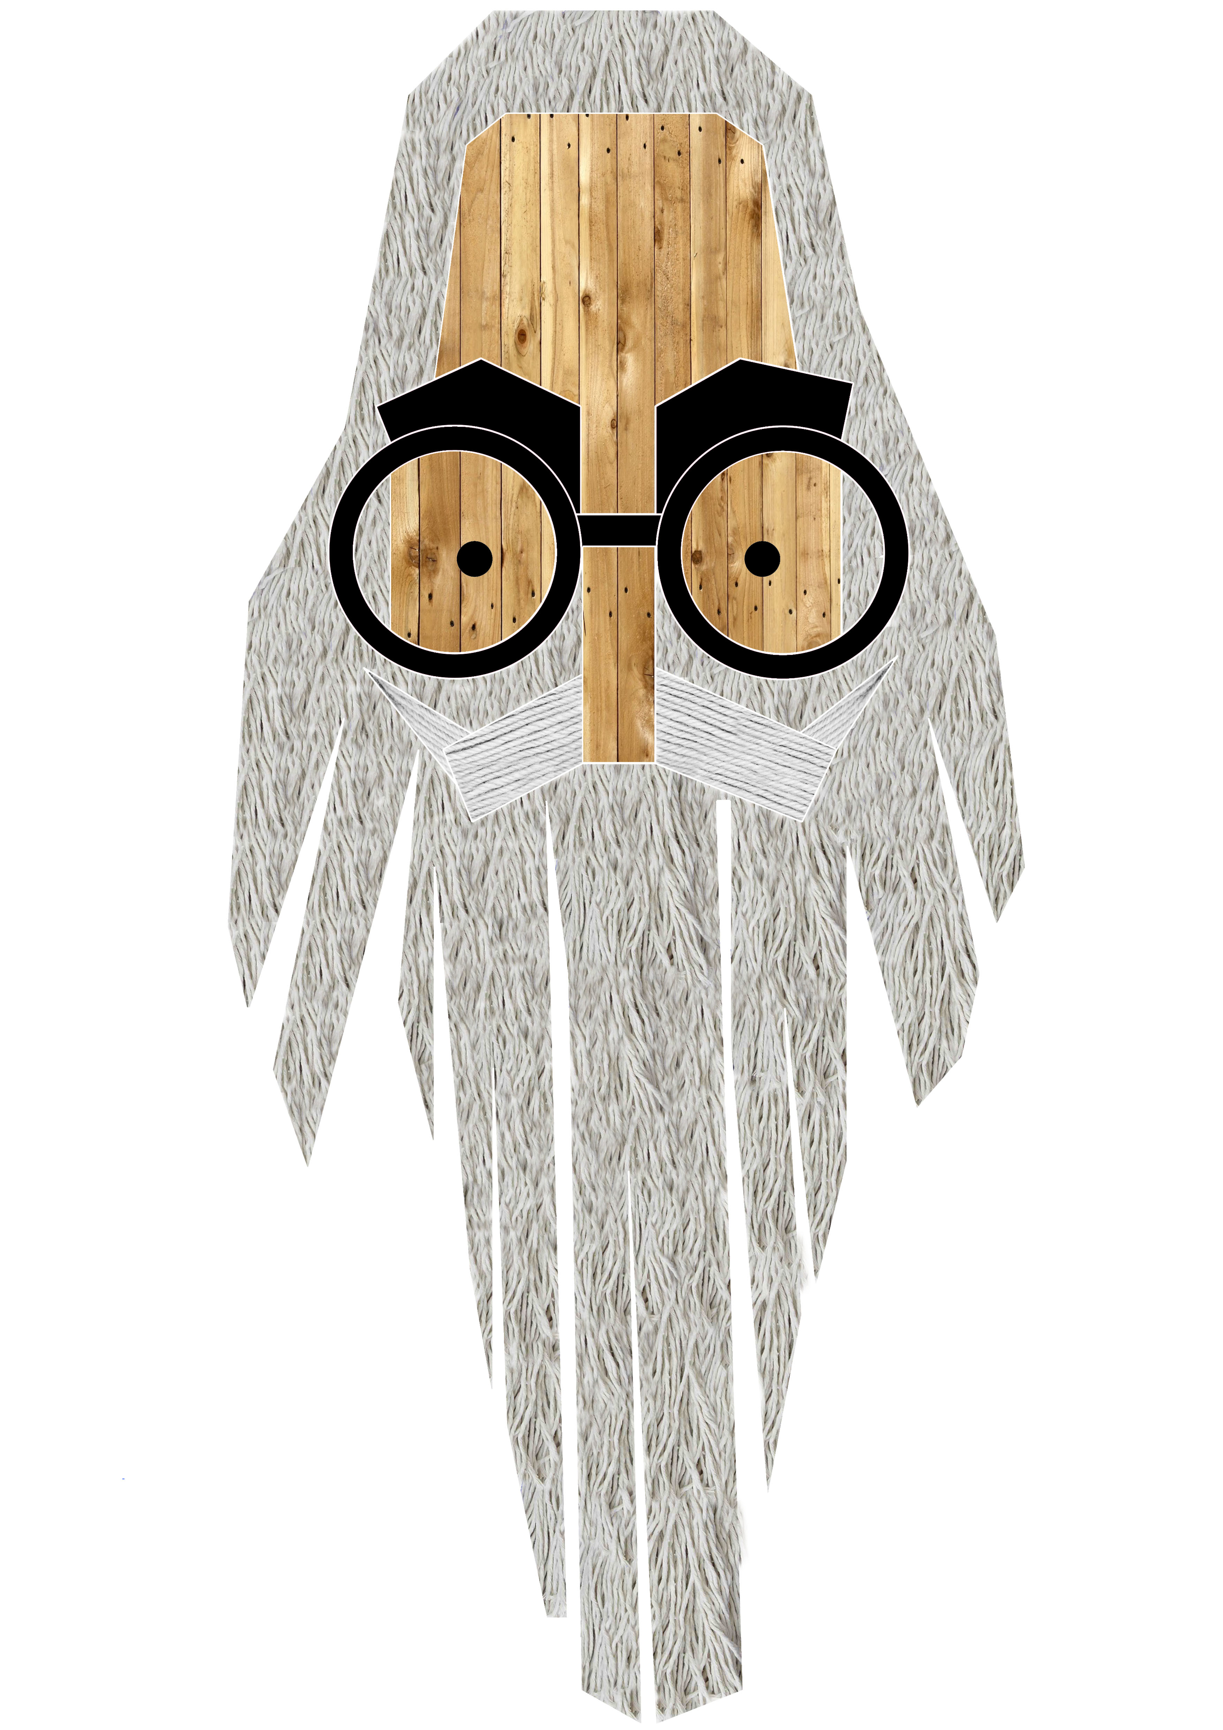
1. -Rúa Max Estrella. He is the protagonist of Luces de Bohemia, a frustrated blind poet who is extremely poor. The play reflects his last night walking around Madrid. In spite of his blindness, he is the only character who can see the truth and is aware of his mediocrity.

2. - Rúa Marquesa Rosalinda.
This play, performed for the first time in 1912, tells the story of Rosalinda, who, to her husband's despair, is seduced by Arlequín.

3.-Rúa Valle Inclán.
Ramón María del Valle Inclán (1866-1936) was born in Vilanova de Arousa, where he spent his childhood and youth. He published his first book, Femenina, in 1895, and started to study Law in Santiago, where he met Murguía and A. Brañas, leaders of the Regionalist movement he became a member of.

4.- Casa do Cantillo.
It's located in the former San Mauro Street (now Valle Inclán Street from 1924),and is dated from mid-18th Century. The writer lived here with his parents.

5.- Igrexa da Pastoriza.
Valle-Inclán was baptised here in 1866.

6.-Rúa Luces de bohemia.
Esperpento published in 1924, which makes use of sarcasm and satire to describe a grotesque reality and a decadent society.

7.-Casa do Cuadrante.
It was the residence of the writer's maternal grandparents from 1846 onwards.

8.- Praza do Marqués de Bradomín.
O Marqués de Bradomín (adaptation of Sonata de otoño) was performed as a play in 1906.

9.-Praza do parque.
Here we find a sculpture of Valle surrounded by his most famous characters: Verdemar Prince (from the children's farce A cabeza do dragón), Bradomín Marquis, Max Estrella and don Latino, Lucero (also known as Séptimo Miau) and Mari Gaila.

10.-Xardín umbrío.
This book gives its name to the main park of Vilanova. In its prologue, Valle states that when he was a child, Micaela, a Galana, and old of his grandmother's maids, told him “saints stories, tales of lost souls, goblins and thieves. Now I tell you those ones she once told me(...)

11.-Divinas palabras.
It's a play published in 1919 which reflects cruel situations in the mood of a tragicomedy.

12.- Rúa Aromas de lenda.
It´s a poetic work of modernist aesthetics published in 1907.

13.- Rúa Mari Gaila.
She is the protagonist of Divinas palabras (1919), a shy and religiuos woman, but with a strong personality.

14.-Rúa Ramón Valle Bermúdez.
Ramón Valle Bermúdez married to Dolores de la Peña y Montenegro and , in 1866, Ramón María del Valle Inclán was born.

