Past Perfect - Positive and Negative
1) When I arrived at the cinema, the film (start).

2) She (live) in China before she went to Thailand.

3) After they (eat) the shellfish, they began to feel sick.
5) Julie didn't arrive until after I (leave).

6) When we (finish) dinner, we went out.

7) The garden was dead because it (be) dry all summer.
8) He (meet) her somewhere before.
9) We were late for the plane because we (forget) our passports.
10) She told me she (study) a lot before the exam.
11) The grass was yellow because it (not/rain) all summer.
12) The lights went off because we (not/pay) the electricity bill.
13) The children (not/do) their homework, so they were in trouble.
14) They (not/eat) so we went to a restaurant.
15) We couldn't go into the concert because we (not/bring) our tickets.
16) She said that she (not/visit) the UK before.
17) Julie and Anne (not/meet) before the party.
18) I (not/have) breakfast when he arrived.
19) He (not/use) email before, so I showed him how to use it.
20) You (not/study) for the test, so you were nervous.
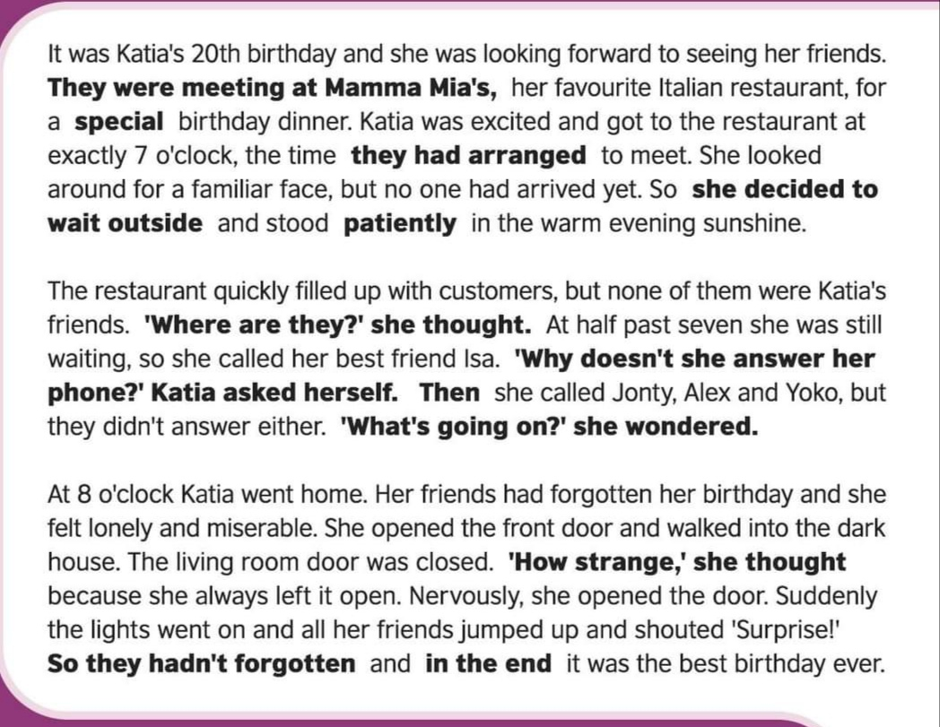
- Where had Katia and her friends arranged to meet ? Why ?
- What happened when she arrived at Mamma Mia´s ?
- What did she decide to do ?
- What was the weather like?
- How did she feel when she arrived home? Why ?
- What happened when she opened the door of the living room ?

COMPLETE THIS STORY . Use PAST PERFECT
Poor man…! What happened to him?
When HE arrived home, HE realized HE had been burgled!
The burglars …
had broken …………………………………………………………………………….
had smashed ………………………………………………………………………….
had scattered ………………………………………………………………..………on the floor
had locked ……………………………………………………………………………..
had eaten…………………………………………………………………………...
had (drink)………………………………………………………………………………
had (sleep) …………………………………………………………………………..…
had (smoke) …………………………………………………………………………..
had (use) ……………………………………………………………………………..…
had (write)…………………………………………………………………………..….
had (steal)…………………………………………………………………………….…

Poor Robert,
he will have to install an alarm system as soon as possible!

