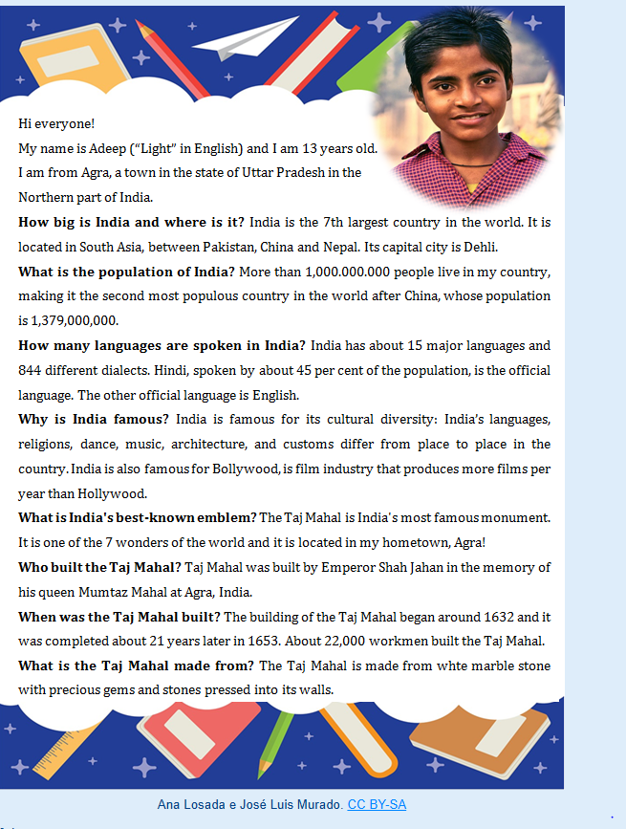
Say if the following statements are True or False. Correct the false ones.

1. Agra is the capital of India.
True False

2. More people live in China than in India.
True False

3. English is one of the official languages in India
True False

4. India makes fewer films that the United States
True False

5. The Taj Mahal is located in Adeep's hometown
True False

6. The Taj Mahal was built in the 16th century
True False

7. The Taj Mahal is made from expensive materials
True False

