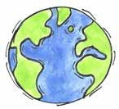
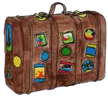
Country Fact Sheet

Map
Capital City: Population:
Terrain: Climate:
Natural Resources: Type of Government: Language:
Major Religions: Currency:

Where is it?
Flag
Can you describe it?
Holidays and Traditions Famous Landmarks
What are the most important traditions and holidays?
Landmark is a building or an object that helps you identify a location

Famous people Foods
What are the most typical dishes?
Why are they famous?

Layers of Learning

FUNNY FACTS:

