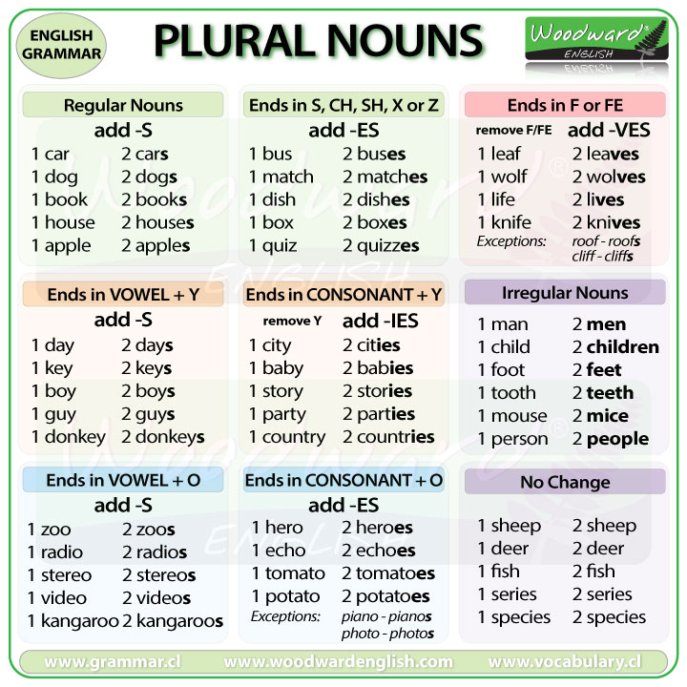
photo |  |  | glass
pen |  |  | car
thief |  |  | baby
kiss |  |  | lady
knife |  |  | tooth
life |  |  | calf
key |  |  | ox
potato |  |  | toy
cow |  |  | house
trolley |  |  | toe
star |  |  | apple
book |  |  | woman
desk |  |  | toffee
boy |  |  | fish
child |  |  | party
foot |  |  | man
strawberry |  |  | monkey
wolf |  |  | brush
phone |  |  | bear
family |  |  | day

