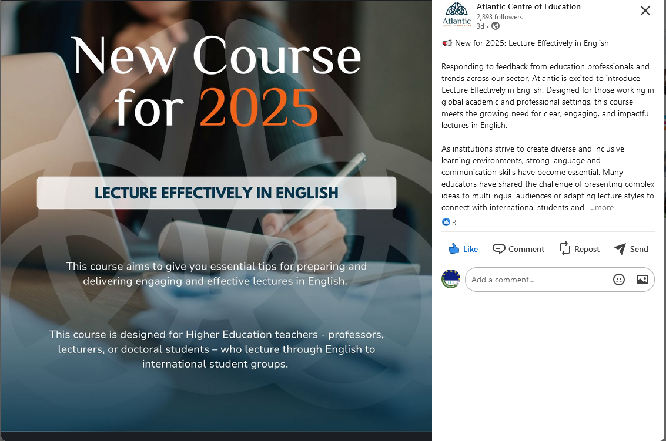

We would be delighted to welcome staff from IES As Fontiñas to take part in our training courses which have been designed specifically for Erasmus funded Higher Education staff. These courses consist of 5 training days. The fee also includes a full-day excursion on the Sunday before the course, to one of the many areas of interest here on the Atlantic West coast of Ireland.

You'll find the full range of our courses for Higher Ed staff on our website HERE but some of your teachers may also be interested in courses designed for secondary teachers which you can find HERE

Some courses, such as English for the Educational Workplace and English for Professional Communication are suitable for administrative staff working in the higher education sector. For teachers we offer courses such as CLIL, Job Shadowing for English Language Teachers, and Social and Emotional Learning - and in 2025 we will be introducing New Approaches to Teaching: Universal Design Learning

Also very popular with staff who simply wish to improve and develop their English language skills is our English Language Development course which is available at 5 levels from A2 to C1. This course is available to start on any Monday throughout the year.
This year we've also had lots of participants joining our new English Language and Irish Culture course which combines English language tuition with Irish culture topics such as history, literature and music.

For 2024 Course Dates please see our HE Courses Calendar 2024 and our Teacher Courses Calendar 2024
We are currently finalising our 2025 Dates and they will be available on our website before the end of June, and I'll send you the 2025 Calendar as soon as it's ready.

You'll find more information such as course outlines and sample timetables in the Course Fact Sheets which are in the links above.
The cost of a course is €525 and, as I mentioned this includes a full day tour and programme of afternoon activities.

Participants can book their own accommodation in Galway or they can avail of Atlantic Language accommodation. We offer a certain number of rooms in student residences which are located within easy reach of the school. We provide standard single rooms with shared bathroom, comfort single rooms with private bathroom, or twin/ double rooms to be shared with another person. These are 2 - 6 bedroomed apartments which share fully equipped kitchens, dining and living areas, and you can find more information on our website. We are also happy to recommend local hotels and B&Bs.

A full outline of course and accommodation prices can be found HERE.

It's very easy to reserve a place on a course. If a teacher or staff member is interested all they have to do is complete and submit our Erasmus Registration Form. Once we have the details our Registrations Team will get back with a Confirmation of Booking, Letter of Invitation, and invoice. Payment is usually made within 8 weeks of booking. However, this is flexible. If after 8 weeks, staff are still waiting for approval for their grant or to receive funding, we will hold the booking until funding is confirmed.

I have copied here a link to our Atlantic Language Erasmus Guide which offers lots of useful information about taking part in a staff mobility course at Atlantic Language.

I'll also arrange to send you a poster and brochure which you can display in your college. I hope all the above information makes sense. If you have any questions or if you need further information, please don't hesitate to get in touch.

We would be very excited to develop and grow our relationship with IES As Fontiñas which has become quite familiar to us through our wonderful interns!

