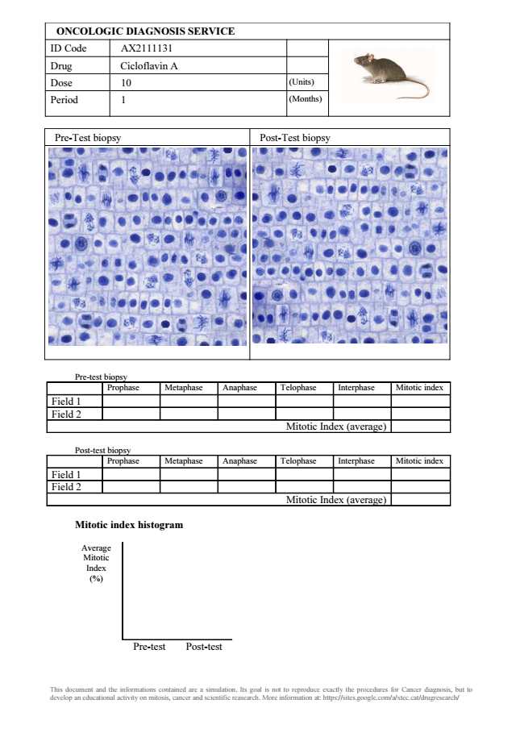
ONCOLOGIC DIAGNOSIS SERVICE ID Code AX2111131 Drug Cicloflavin A Dose 10 (Units)
Period 1 (Months)
Pre-Test biopsy Post-Test biopsy
Pre-test biopsy
Prophase Metaphase Anaphase Telophase Interphase Mitotic index Field 1 Field 2
Mitotic Index (average)
Post-test biopsy
Prophase Metaphase Anaphase Telophase Interphase Mitotic index Field 1 Field 2
Mitotic Index (average)
Mitotic index histogram
Average Mitotic Index (%)
Pre-test Post-test
This document and the informations contained are a simulation. Its goal is not to reproduce exactly the procedures for Cancer diagnosis, but to develop an educational activity on mitosis, cancer and scientific reasearch. More information at: https://sites.google.com/a/xtec.cat/drugresearch/

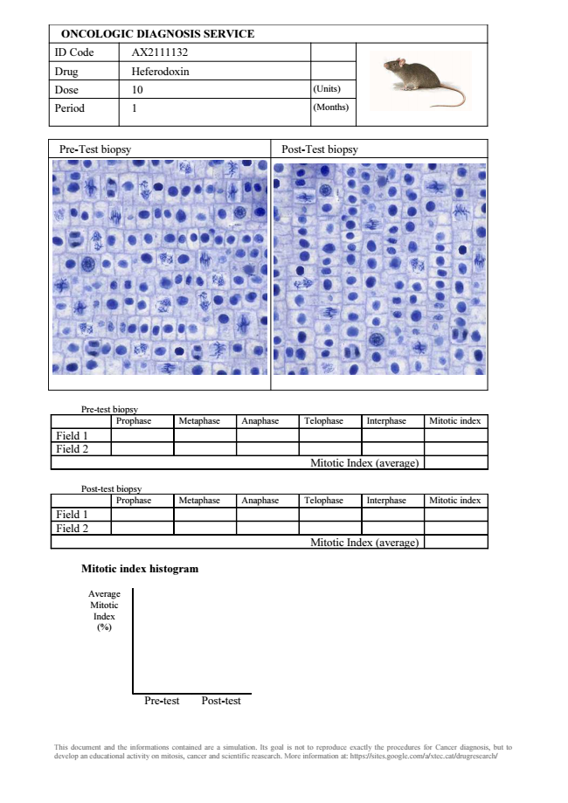
ONCOLOGIC DIAGNOSIS SERVICE ID Code AX2111132 Drug Heferodoxin Dose 10 (Units)
Period 1 (Months)
Pre-Test biopsy Post-Test biopsy
Pre-test biopsy
Prophase Metaphase Anaphase Telophase Interphase Mitotic index Field 1 Field 2
Mitotic Index (average)
Post-test biopsy
Prophase Metaphase Anaphase Telophase Interphase Mitotic index Field 1 Field 2
Mitotic Index (average)
Mitotic index histogram
Average Mitotic Index (%)
Pre-test Post-test
This document and the informations contained are a simulation. Its goal is not to reproduce exactly the procedures for Cancer diagnosis, but to develop an educational activity on mitosis, cancer and scientific reasearch. More information at: https://sites.google.com/a/xtec.cat/drugresearch/

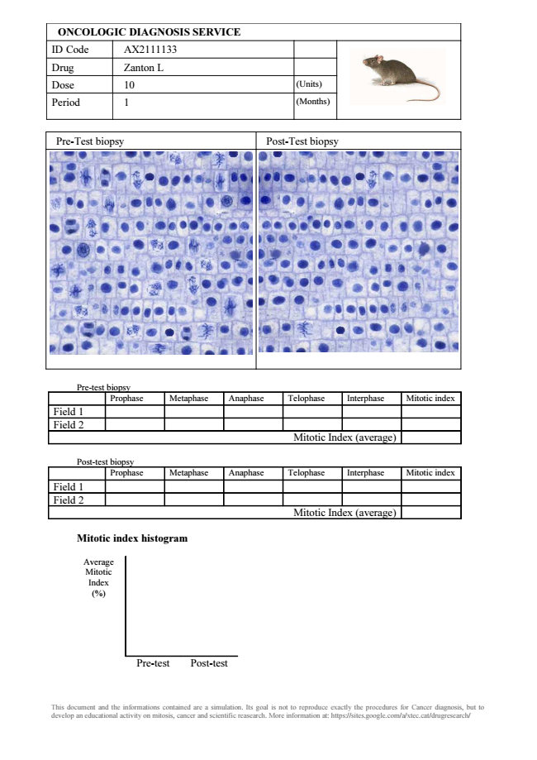
ONCOLOGIC DIAGNOSIS SERVICE ID Code AX2111133 Drug Zanton L Dose 10 (Units)
Period 1 (Months)
Pre-Test biopsy Post-Test biopsy
Pre-test biopsy
Prophase Metaphase Anaphase Telophase Interphase Mitotic index Field 1 Field 2
Mitotic Index (average)
Post-test biopsy
Prophase Metaphase Anaphase Telophase Interphase Mitotic index Field 1 Field 2
Mitotic Index (average)
Mitotic index histogram
Average Mitotic Index (%)
Pre-test Post-test
This document and the informations contained are a simulation. Its goal is not to reproduce exactly the procedures for Cancer diagnosis, but to develop an educational activity on mitosis, cancer and scientific reasearch. More information at: https://sites.google.com/a/xtec.cat/drugresearch/

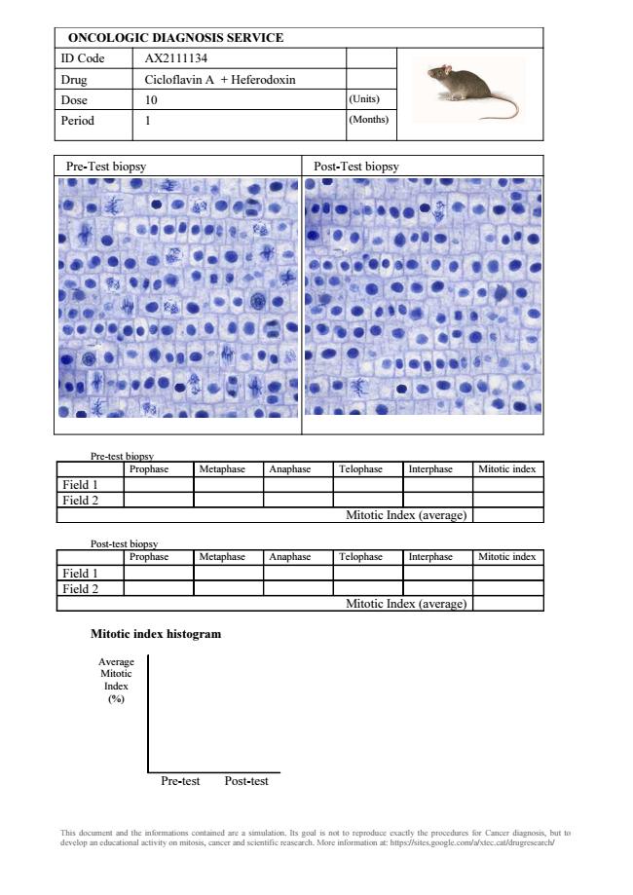
ONCOLOGIC DIAGNOSIS SERVICE ID Code AX2111134 Drug Cicloflavin A + Heferodoxin Dose 10 (Units)
Period 1 (Months)
Pre-Test biopsy Post-Test biopsy
Pre-test biopsy
Prophase Metaphase Anaphase Telophase Interphase Mitotic index Field 1 Field 2
Mitotic Index (average)
Post-test biopsy
Prophase Metaphase Anaphase Telophase Interphase Mitotic index Field 1 Field 2
Mitotic Index (average)
Mitotic index histogram
Average Mitotic Index (%)
Pre-test Post-test
This document and the informations contained are a simulation. Its goal is not to reproduce exactly the procedures for Cancer diagnosis, but to develop an educational activity on mitosis, cancer and scientific reasearch. More information at: https://sites.google.com/a/xtec.cat/drugresearch/

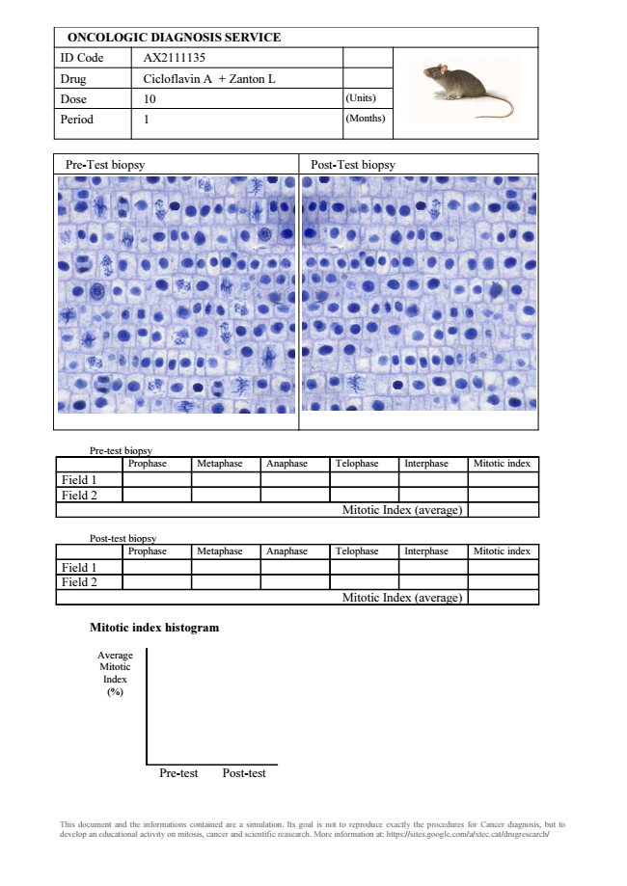
ONCOLOGIC DIAGNOSIS SERVICE ID Code AX2111135 Drug Cicloflavin A + Zanton L Dose 10 (Units)
Period 1 (Months)
Pre-Test biopsy Post-Test biopsy
Pre-test biopsy
Prophase Metaphase Anaphase Telophase Interphase Mitotic index Field 1 Field 2
Mitotic Index (average)
Post-test biopsy
Prophase Metaphase Anaphase Telophase Interphase Mitotic index Field 1 Field 2
Mitotic Index (average)
Mitotic index histogram
Average Mitotic Index (%)
Pre-test Post-test
This document and the informations contained are a simulation. Its goal is not to reproduce exactly the procedures for Cancer diagnosis, but to develop an educational activity on mitosis, cancer and scientific reasearch. More information at: https://sites.google.com/a/xtec.cat/drugresearch/

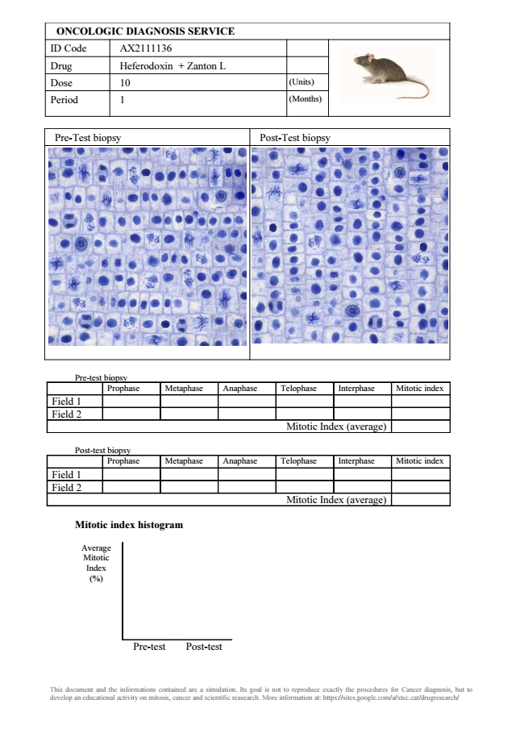
ONCOLOGIC DIAGNOSIS SERVICE ID Code AX2111136 Drug Heferodoxin + Zanton L Dose 10 (Units)
Period 1 (Months)
Pre-Test biopsy Post-Test biopsy
Pre-test biopsy
Prophase Metaphase Anaphase Telophase Interphase Mitotic index Field 1 Field 2
Mitotic Index (average)
Post-test biopsy
Prophase Metaphase Anaphase Telophase Interphase Mitotic index Field 1 Field 2
Mitotic Index (average)
Mitotic index histogram
Average Mitotic Index (%)
Pre-test Post-test
This document and the informations contained are a simulation. Its goal is not to reproduce exactly the procedures for Cancer diagnosis, but to develop an educational activity on mitosis, cancer and scientific reasearch. More information at: https://sites.google.com/a/xtec.cat/drugresearch/

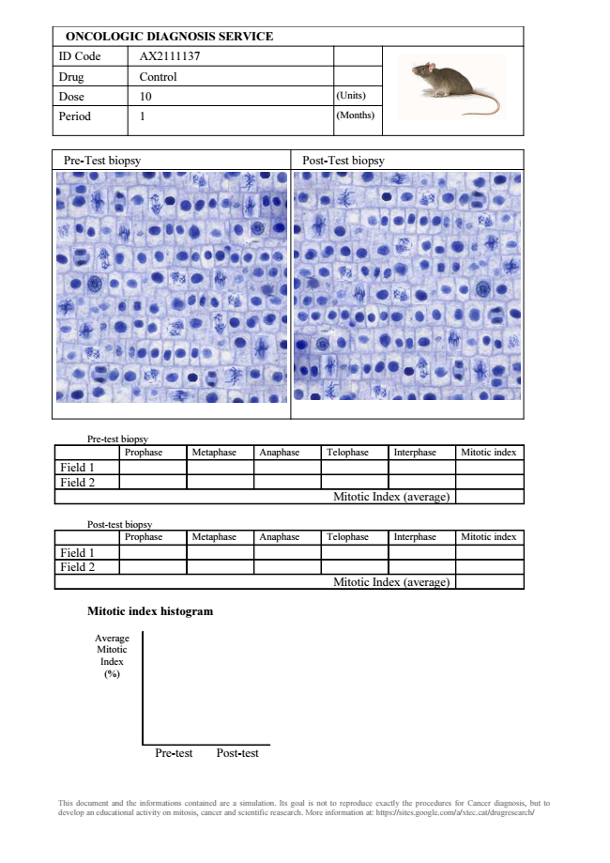
ONCOLOGIC DIAGNOSIS SERVICE ID Code AX2111137 Drug Control Dose 10 (Units)
Period 1 (Months)
Pre-Test biopsy Post-Test biopsy
Pre-test biopsy
Prophase Metaphase Anaphase Telophase Interphase Mitotic index Field 1 Field 2
Mitotic Index (average)
Post-test biopsy
Prophase Metaphase Anaphase Telophase Interphase Mitotic index Field 1 Field 2
Mitotic Index (average)
Mitotic index histogram
Average Mitotic Index (%)
Pre-test Post-test
This document and the informations contained are a simulation. Its goal is not to reproduce exactly the procedures for Cancer diagnosis, but to develop an educational activity on mitosis, cancer and scientific reasearch. More information at: https://sites.google.com/a/xtec.cat/drugresearch/

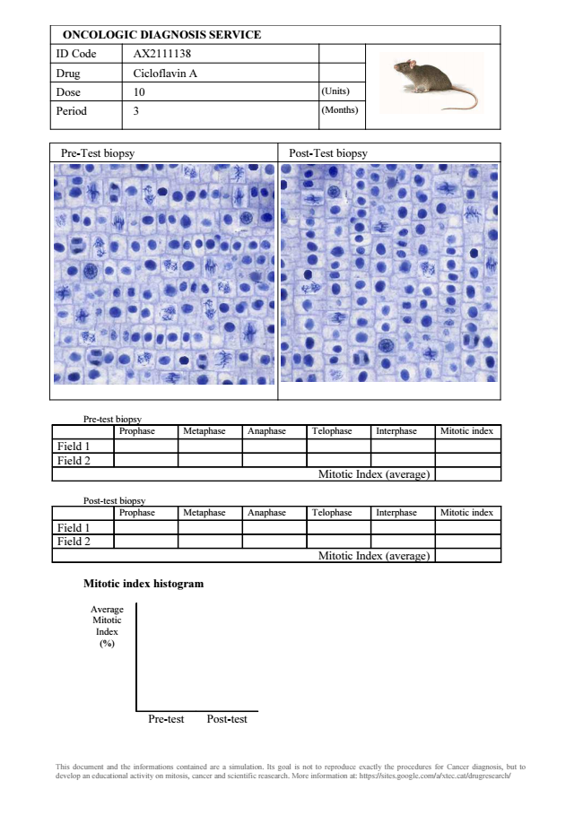
ONCOLOGIC DIAGNOSIS SERVICE ID Code AX2111138 Drug Cicloflavin A Dose 10 (Units)
Period 3 (Months)
Pre-Test biopsy Post-Test biopsy
Pre-test biopsy
Prophase Metaphase Anaphase Telophase Interphase Mitotic index Field 1 Field 2
Mitotic Index (average)
Post-test biopsy
Prophase Metaphase Anaphase Telophase Interphase Mitotic index Field 1 Field 2
Mitotic Index (average)
Mitotic index histogram
Average Mitotic Index (%)
Pre-test Post-test
This document and the informations contained are a simulation. Its goal is not to reproduce exactly the procedures for Cancer diagnosis, but to develop an educational activity on mitosis, cancer and scientific reasearch. More information at: https://sites.google.com/a/xtec.cat/drugresearch/

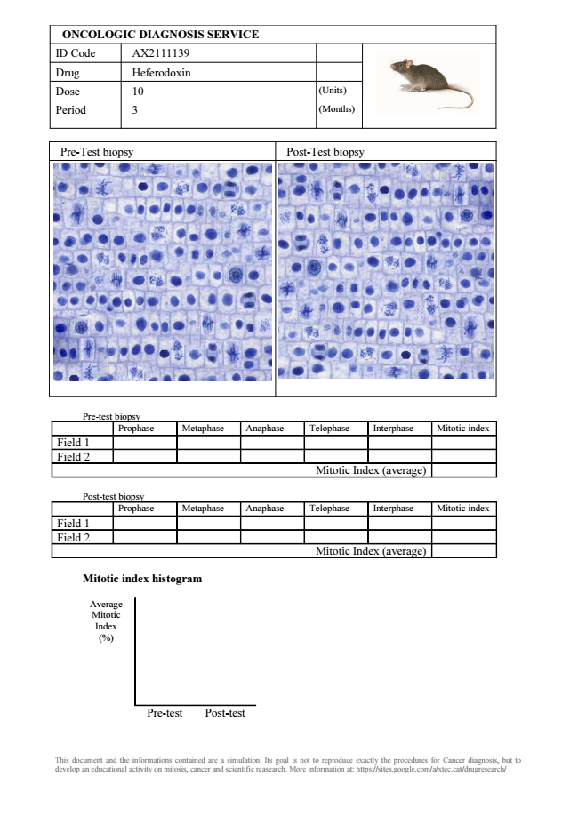
ONCOLOGIC DIAGNOSIS SERVICE ID Code AX2111139 Drug Heferodoxin Dose 10 (Units)
Period 3 (Months)
Pre-Test biopsy Post-Test biopsy
Pre-test biopsy
Prophase Metaphase Anaphase Telophase Interphase Mitotic index Field 1 Field 2
Mitotic Index (average)
Post-test biopsy
Prophase Metaphase Anaphase Telophase Interphase Mitotic index Field 1 Field 2
Mitotic Index (average)
Mitotic index histogram
Average Mitotic Index (%)
Pre-test Post-test
This document and the informations contained are a simulation. Its goal is not to reproduce exactly the procedures for Cancer diagnosis, but to develop an educational activity on mitosis, cancer and scientific reasearch. More information at: https://sites.google.com/a/xtec.cat/drugresearch/

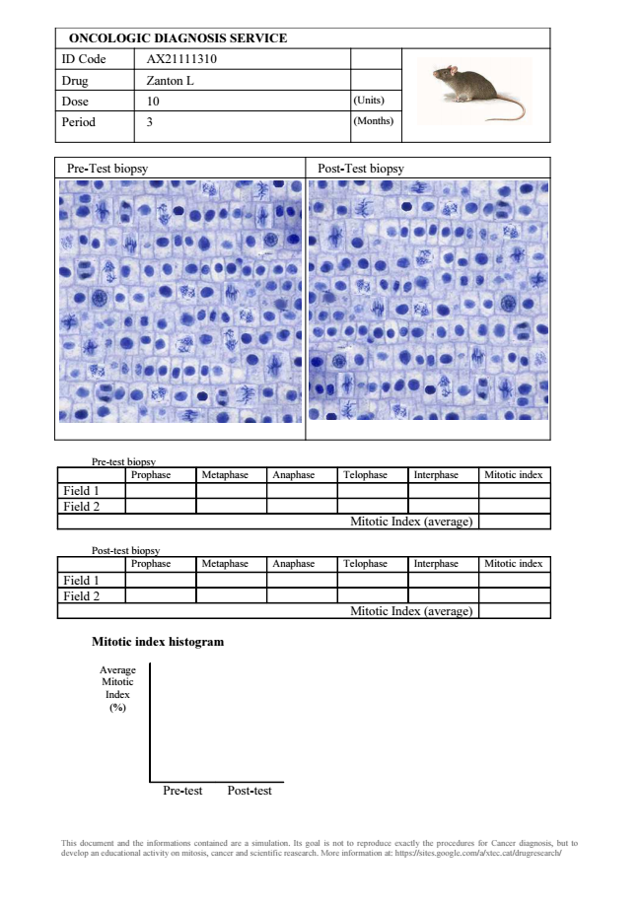
ONCOLOGIC DIAGNOSIS SERVICE ID Code AX21111310 Drug Zanton L Dose 10 (Units)
Period 3 (Months)
Pre-Test biopsy Post-Test biopsy
Pre-test biopsy
Prophase Metaphase Anaphase Telophase Interphase Mitotic index Field 1 Field 2
Mitotic Index (average)
Post-test biopsy
Prophase Metaphase Anaphase Telophase Interphase Mitotic index Field 1 Field 2
Mitotic Index (average)
Mitotic index histogram
Average Mitotic Index (%)
Pre-test Post-test
This document and the informations contained are a simulation. Its goal is not to reproduce exactly the procedures for Cancer diagnosis, but to develop an educational activity on mitosis, cancer and scientific reasearch. More information at: https://sites.google.com/a/xtec.cat/drugresearch/

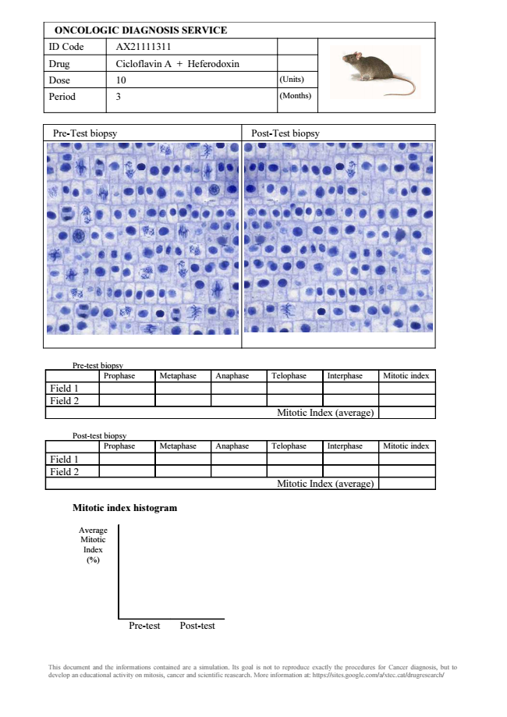
ONCOLOGIC DIAGNOSIS SERVICE ID Code AX21111311 Drug Cicloflavin A + Heferodoxin Dose 10 (Units)
Period 3 (Months)
Pre-Test biopsy Post-Test biopsy
Pre-test biopsy
Prophase Metaphase Anaphase Telophase Interphase Mitotic index Field 1 Field 2
Mitotic Index (average)
Post-test biopsy
Prophase Metaphase Anaphase Telophase Interphase Mitotic index Field 1 Field 2
Mitotic Index (average)
Mitotic index histogram
Average Mitotic Index (%)
Pre-test Post-test
This document and the informations contained are a simulation. Its goal is not to reproduce exactly the procedures for Cancer diagnosis, but to develop an educational activity on mitosis, cancer and scientific reasearch. More information at: https://sites.google.com/a/xtec.cat/drugresearch/

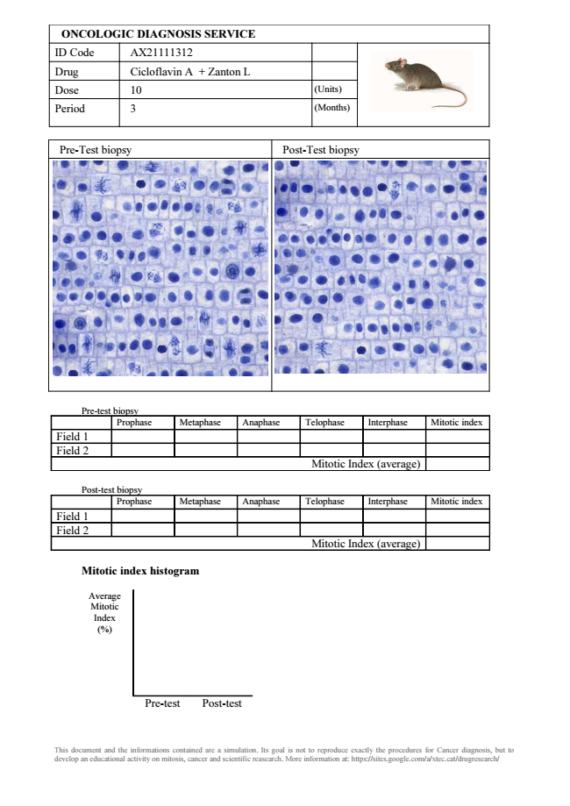
ONCOLOGIC DIAGNOSIS SERVICE ID Code AX21111312 Drug Cicloflavin A + Zanton L Dose 10 (Units)
Period 3 (Months)
Pre-Test biopsy Post-Test biopsy
Pre-test biopsy
Prophase Metaphase Anaphase Telophase Interphase Mitotic index Field 1 Field 2
Mitotic Index (average)
Post-test biopsy
Prophase Metaphase Anaphase Telophase Interphase Mitotic index Field 1 Field 2
Mitotic Index (average)
Mitotic index histogram
Average Mitotic Index (%)
Pre-test Post-test
This document and the informations contained are a simulation. Its goal is not to reproduce exactly the procedures for Cancer diagnosis, but to develop an educational activity on mitosis, cancer and scientific reasearch. More information at: https://sites.google.com/a/xtec.cat/drugresearch/

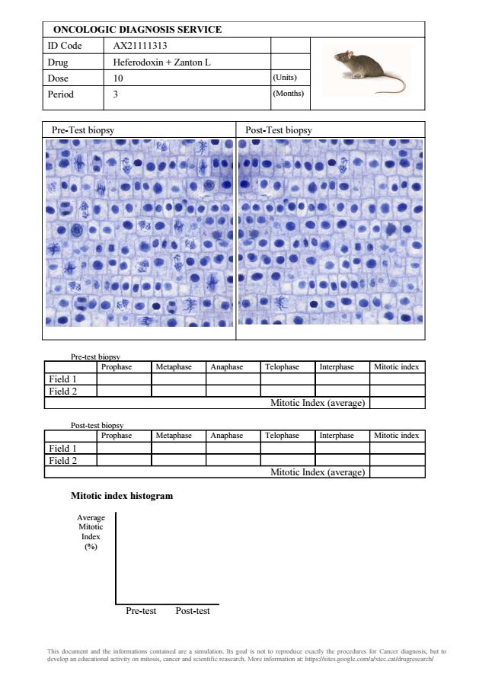
ONCOLOGIC DIAGNOSIS SERVICE ID Code AX21111313 Drug Heferodoxin + Zanton L Dose 10 (Units)
Period 3 (Months)
Pre-Test biopsy Post-Test biopsy
Pre-test biopsy
Prophase Metaphase Anaphase Telophase Interphase Mitotic index Field 1 Field 2
Mitotic Index (average)
Post-test biopsy
Prophase Metaphase Anaphase Telophase Interphase Mitotic index Field 1 Field 2
Mitotic Index (average)
Mitotic index histogram
Average Mitotic Index (%)
Pre-test Post-test
This document and the informations contained are a simulation. Its goal is not to reproduce exactly the procedures for Cancer diagnosis, but to develop an educational activity on mitosis, cancer and scientific reasearch. More information at: https://sites.google.com/a/xtec.cat/drugresearch/

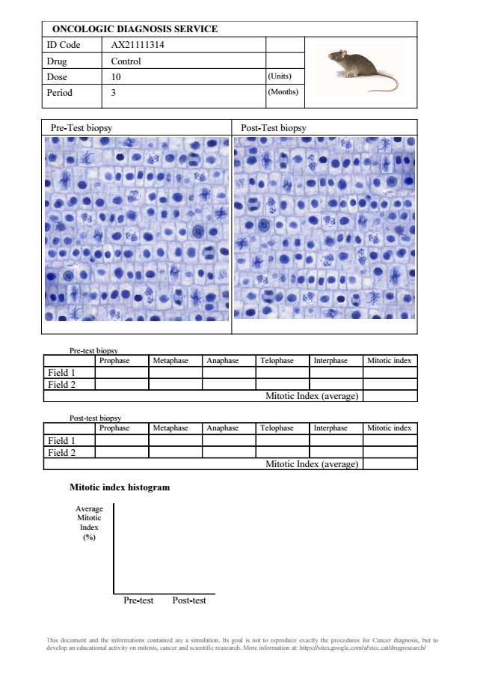
ONCOLOGIC DIAGNOSIS SERVICE ID Code AX21111314 Drug Control Dose 10 (Units)
Period 3 (Months)
Pre-Test biopsy Post-Test biopsy
Pre-test biopsy
Prophase Metaphase Anaphase Telophase Interphase Mitotic index Field 1 Field 2
Mitotic Index (average)
Post-test biopsy
Prophase Metaphase Anaphase Telophase Interphase Mitotic index Field 1 Field 2
Mitotic Index (average)
Mitotic index histogram
Average Mitotic Index (%)
Pre-test Post-test
This document and the informations contained are a simulation. Its goal is not to reproduce exactly the procedures for Cancer diagnosis, but to develop an educational activity on mitosis, cancer and scientific reasearch. More information at: https://sites.google.com/a/xtec.cat/drugresearch/

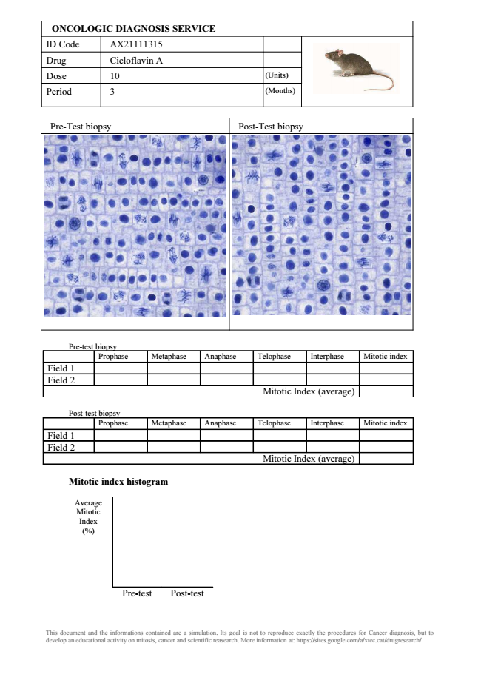
ONCOLOGIC DIAGNOSIS SERVICE ID Code AX21111315 Drug Cicloflavin A Dose 10 (Units)
Period 3 (Months)
Pre-Test biopsy Post-Test biopsy
Pre-test biopsy
Prophase Metaphase Anaphase Telophase Interphase Mitotic index Field 1 Field 2
Mitotic Index (average)
Post-test biopsy
Prophase Metaphase Anaphase Telophase Interphase Mitotic index Field 1 Field 2
Mitotic Index (average)
Mitotic index histogram
Average Mitotic Index (%)
Pre-test Post-test
This document and the informations contained are a simulation. Its goal is not to reproduce exactly the procedures for Cancer diagnosis, but to develop an educational activity on mitosis, cancer and scientific reasearch. More information at: https://sites.google.com/a/xtec.cat/drugresearch/

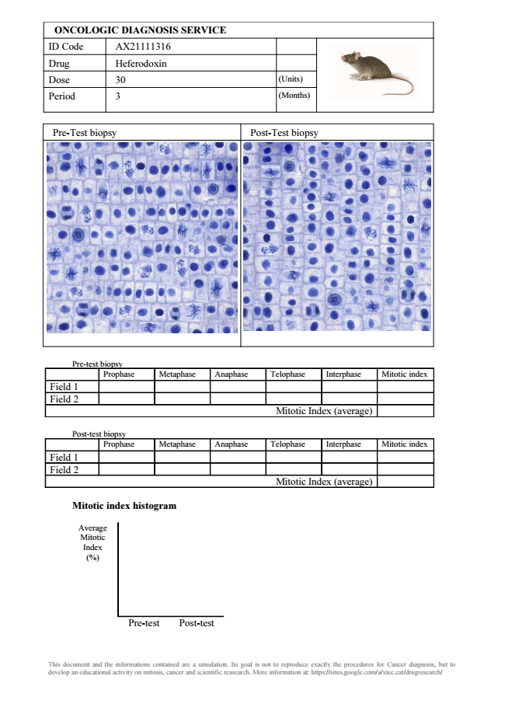
ONCOLOGIC DIAGNOSIS SERVICE ID Code AX21111316 Drug Heferodoxin Dose 30 (Units)
Period 3 (Months)
Pre-Test biopsy Post-Test biopsy
Pre-test biopsy
Prophase Metaphase Anaphase Telophase Interphase Mitotic index Field 1 Field 2
Mitotic Index (average)
Post-test biopsy
Prophase Metaphase Anaphase Telophase Interphase Mitotic index Field 1 Field 2
Mitotic Index (average)
Mitotic index histogram
Average Mitotic Index (%)
Pre-test Post-test
This document and the informations contained are a simulation. Its goal is not to reproduce exactly the procedures for Cancer diagnosis, but to develop an educational activity on mitosis, cancer and scientific reasearch. More information at: https://sites.google.com/a/xtec.cat/drugresearch/

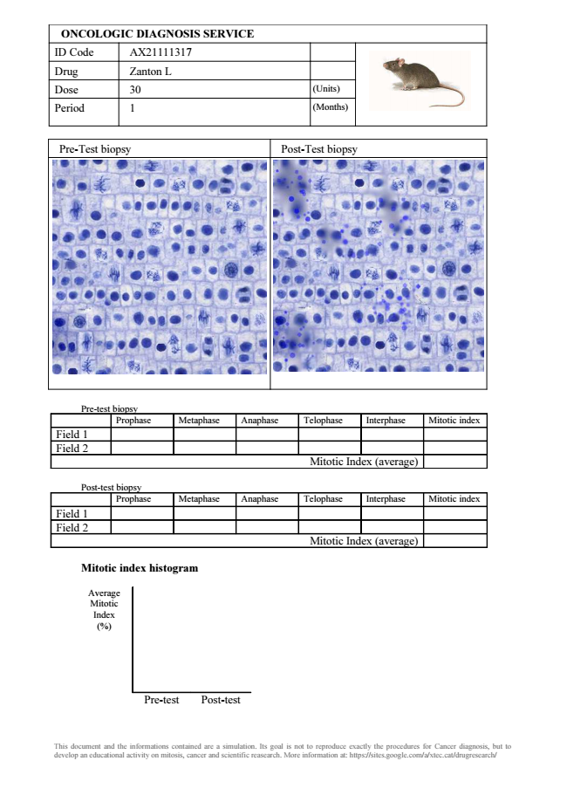
ONCOLOGIC DIAGNOSIS SERVICE ID Code AX21111317 Drug Zanton L Dose 30 (Units)
Period 1 (Months)
Pre-Test biopsy Post-Test biopsy
Pre-test biopsy
Prophase Metaphase Anaphase Telophase Interphase Mitotic index Field 1 Field 2
Mitotic Index (average)
Post-test biopsy
Prophase Metaphase Anaphase Telophase Interphase Mitotic index Field 1 Field 2
Mitotic Index (average)
Mitotic index histogram
Average Mitotic Index (%)
Pre-test Post-test
This document and the informations contained are a simulation. Its goal is not to reproduce exactly the procedures for Cancer diagnosis, but to develop an educational activity on mitosis, cancer and scientific reasearch. More information at: https://sites.google.com/a/xtec.cat/drugresearch/

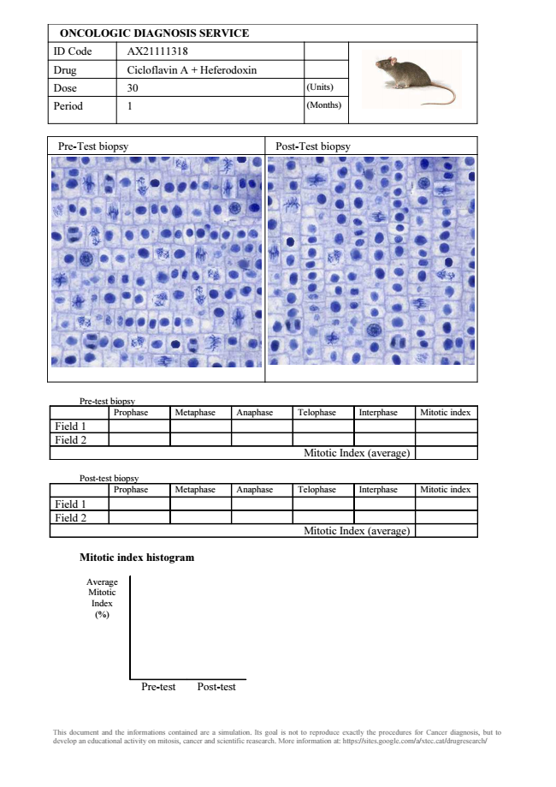
ONCOLOGIC DIAGNOSIS SERVICE ID Code AX21111318 Drug Cicloflavin A + Heferodoxin Dose 30 (Units)
Period 1 (Months)
Pre-Test biopsy Post-Test biopsy
Pre-test biopsy
Prophase Metaphase Anaphase Telophase Interphase Mitotic index Field 1 Field 2
Mitotic Index (average)
Post-test biopsy
Prophase Metaphase Anaphase Telophase Interphase Mitotic index Field 1 Field 2
Mitotic Index (average)
Mitotic index histogram
Average Mitotic Index (%)
Pre-test Post-test
This document and the informations contained are a simulation. Its goal is not to reproduce exactly the procedures for Cancer diagnosis, but to develop an educational activity on mitosis, cancer and scientific reasearch. More information at: https://sites.google.com/a/xtec.cat/drugresearch/

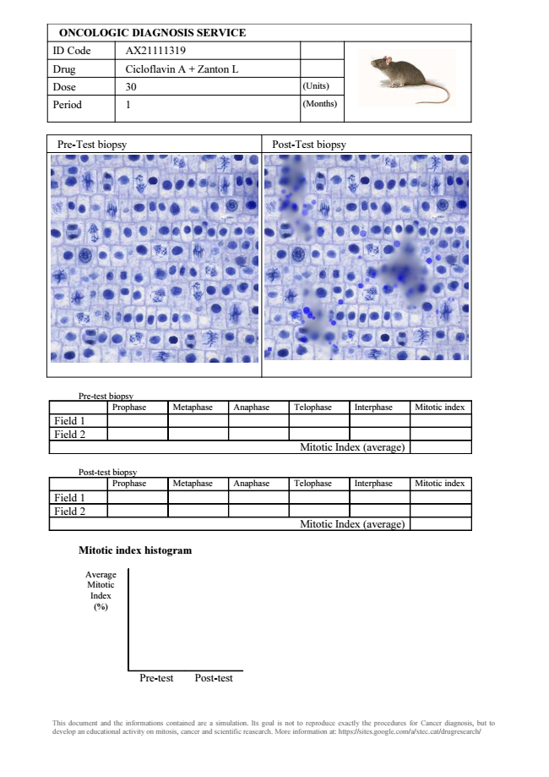
ONCOLOGIC DIAGNOSIS SERVICE ID Code AX21111319 Drug Cicloflavin A + Zanton L Dose 30 (Units)
Period 1 (Months)
Pre-Test biopsy Post-Test biopsy
Pre-test biopsy
Prophase Metaphase Anaphase Telophase Interphase Mitotic index Field 1 Field 2
Mitotic Index (average)
Post-test biopsy
Prophase Metaphase Anaphase Telophase Interphase Mitotic index Field 1 Field 2
Mitotic Index (average)
Mitotic index histogram
Average Mitotic Index (%)
Pre-test Post-test
This document and the informations contained are a simulation. Its goal is not to reproduce exactly the procedures for Cancer diagnosis, but to develop an educational activity on mitosis, cancer and scientific reasearch. More information at: https://sites.google.com/a/xtec.cat/drugresearch/

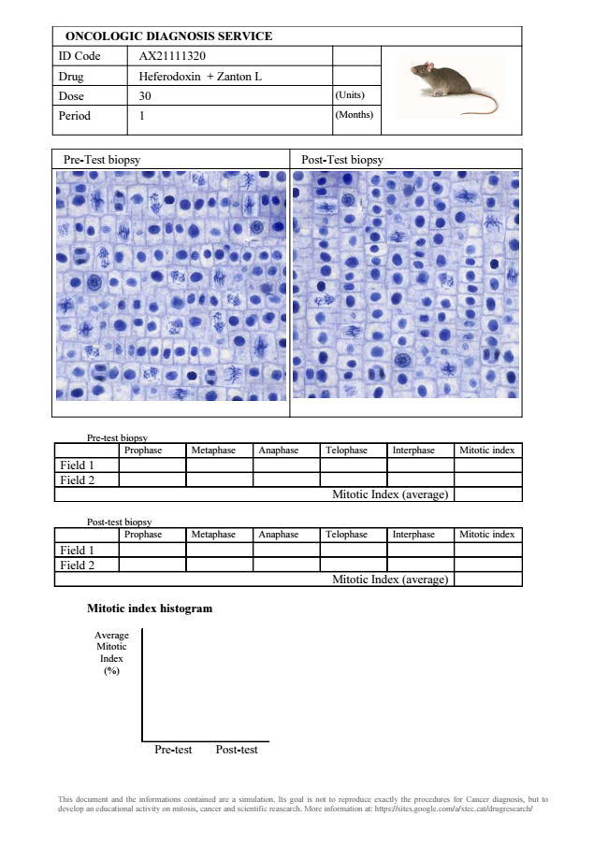
ONCOLOGIC DIAGNOSIS SERVICE ID Code AX21111320 Drug Heferodoxin + Zanton L Dose 30 (Units)
Period 1 (Months)
Pre-Test biopsy Post-Test biopsy
Pre-test biopsy
Prophase Metaphase Anaphase Telophase Interphase Mitotic index Field 1 Field 2
Mitotic Index (average)
Post-test biopsy
Prophase Metaphase Anaphase Telophase Interphase Mitotic index Field 1 Field 2
Mitotic Index (average)
Mitotic index histogram
Average Mitotic Index (%)
Pre-test Post-test
This document and the informations contained are a simulation. Its goal is not to reproduce exactly the procedures for Cancer diagnosis, but to develop an educational activity on mitosis, cancer and scientific reasearch. More information at: https://sites.google.com/a/xtec.cat/drugresearch/

