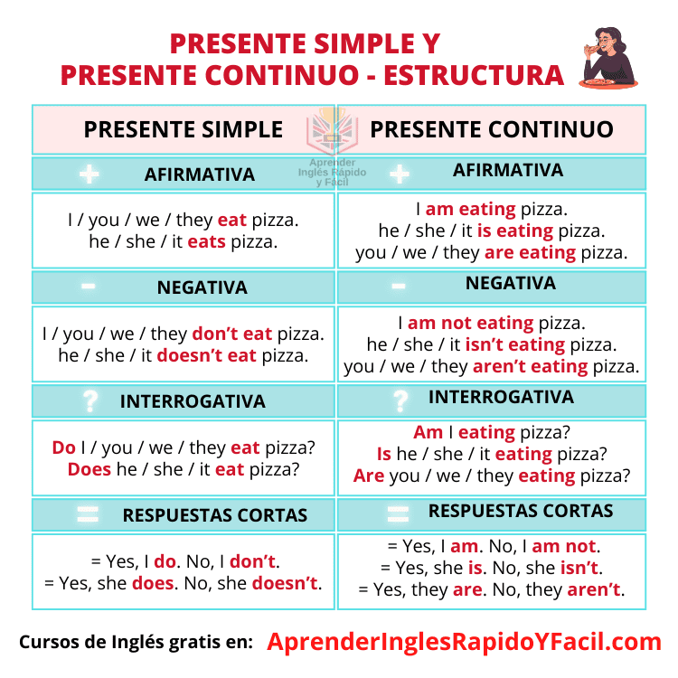
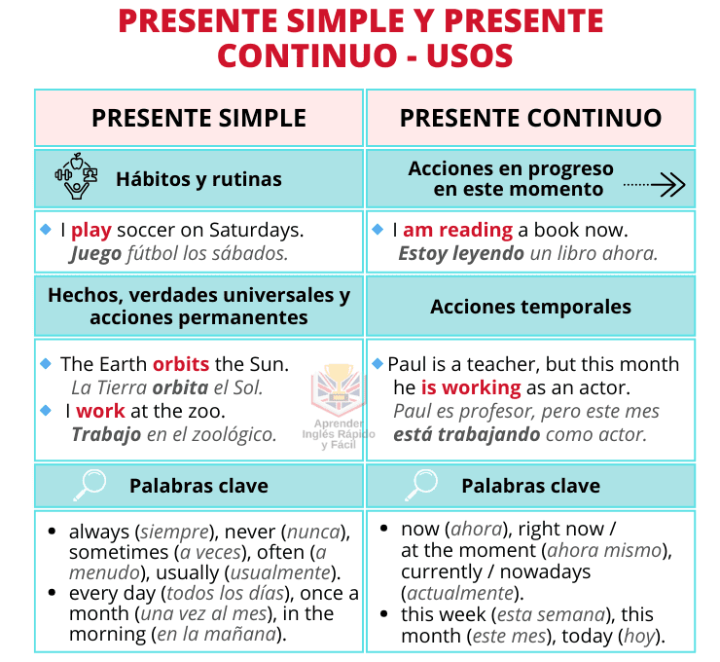
Exercises

Present Simple or Present ProgressiveContinuous
1. They normally _____________________ lunch at two. (have)
2. Are _____________________ in Paris this week? (you work)
3. You _____________________ new clothes every Saturday! (buy)
4. I played football at school but now I _____________________ swimming (prefer)
5. I _____________________ no idea what the book is about. Can you tell me what it’s about? (have)
6. John _____________________ a difficult time at the university this year (have)
7. My father _____________________ everything about cars, but nothing about bicycles. (know)
8. The moon _____________________ round the earth. (go)
9. Do _____________________ those men at the door? – They _______________ at us very
strangely (you see, look)
10. We _____________________ that the contents of this letter should be changed.(feel)
11. They _____________________ lunch at the moment. – You shouldn’t disturb them. (have)
12. The watch _____________________ to my grandmother. (belong)
13. I _____________________ what you _____________________ me but I don’t agree with you (hear,
tell)
14. This medicine _____________________ a new substance (contain)
15. These days we _____________________ tests at school. (always have)
16. Why _____________________ my coat? – Oh, I’m sorry. It _____________________ like mine!
(you wear, look)
17. This cake _____________________ strange. What’s in it? (smell)
18. Hi Jake. – What _____________________ at the moment? – I _____________________ the
sunshine at the beach. (you do, enjoy)
19. Where __________________________ from? (new neighbours, come)
20. What _____________________ for a living? - He is a government official but he quit his job a few
weeks ago. – And what _____________________ now? – At the moment he
_____________________ for a new job. (your Dad do, he do, look)

