EXERCICIOS TEORÍA 3ª AVALIACIÓN

1. Inclúe neste teclado: nomes notas (teclas brancas e negras), nomes notas en inglés, tonos e semitonos.

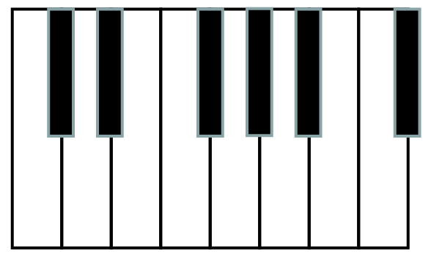

2. Pon nomes a estas notas:

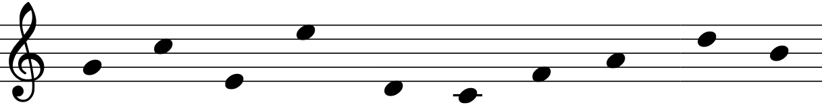
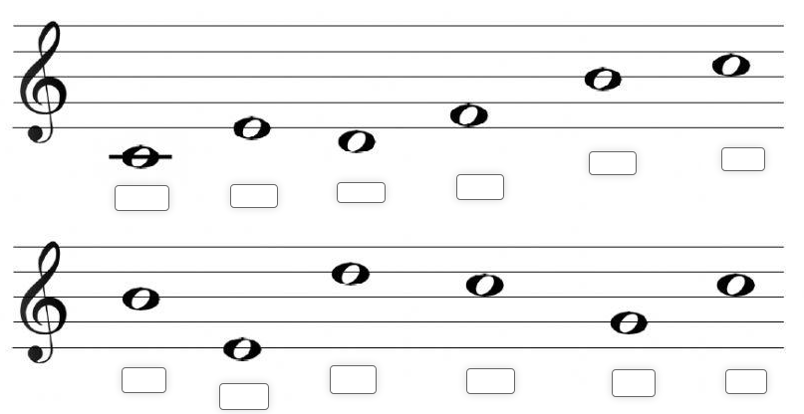

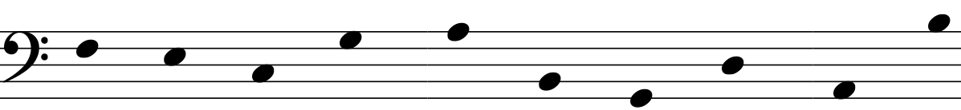

3. Escribe o nome das notas:
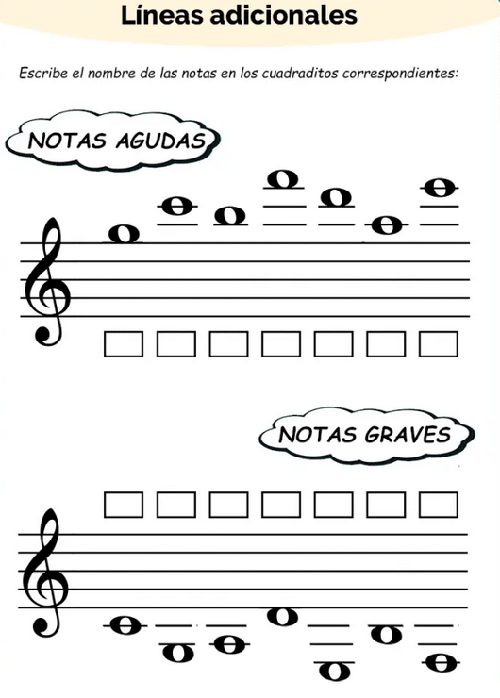

4. Exercicios intervalos con notas naturais. Pon o nome das notas, o tipo de intervalo e os tonos e
semitonos de cada intervalo:

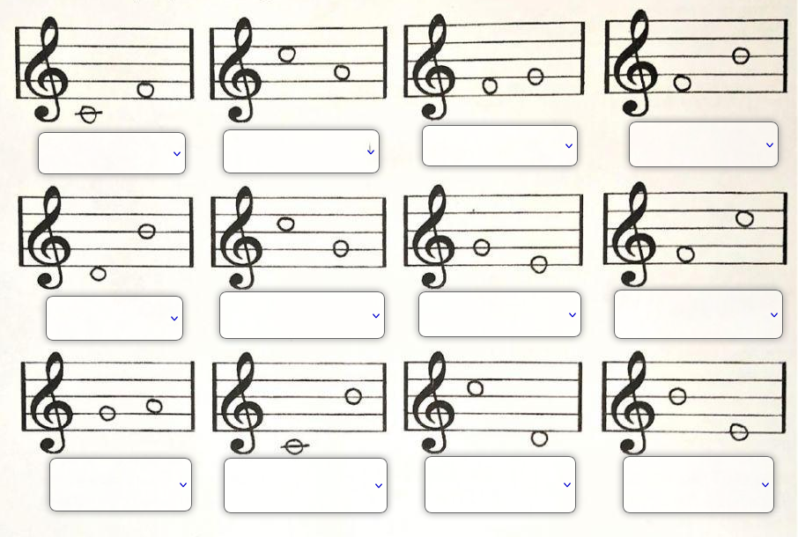

5. Ton ou semitón ?. Indica tamén os nomes das notas.
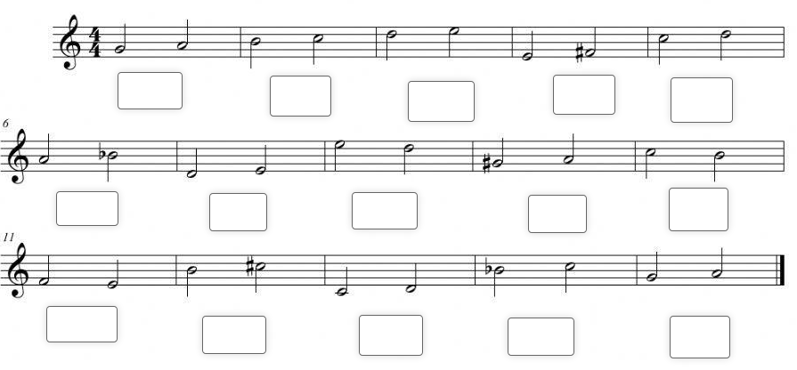
6. Intervalos de 3ª M e m. (3ª M: 2 tons . 3ªm: 1 ton e 1 semitón.). Pon sempre o nome das notas.
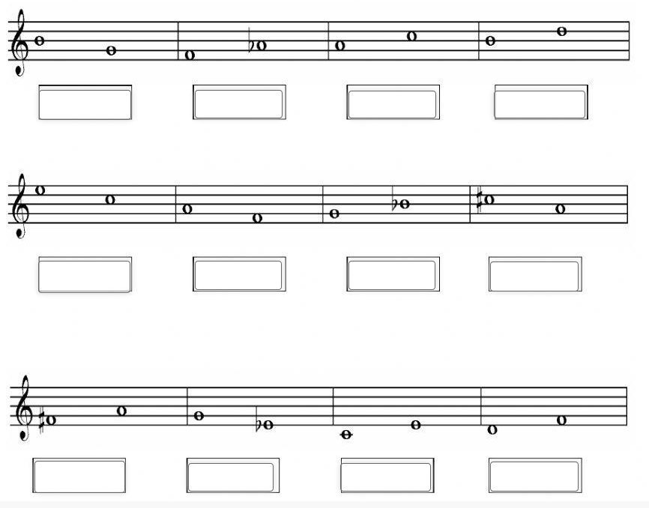

7. En CLAVE DE FA Escribe a escala de Do M indicando graos, tons e semitons.

________________________________________________________________________________________________________________________________________________________________________________________________________________________________________________________________________________________________________________________________________________________________________________________________________________

8. Escribe a escala de Sol M indicando graos, tons e semitons. Utiliza sostenidos.

________________________________________________________________________________________________________________________________________________________________________________________________________________________________________________________________________________________________________________________________________________________________________________________________________________

9. Escribe a escala de Fa M indicando graos, tons e semitons. Utiliza bemoles.

________________________________________________________________________________________________________________________________________________________________________________________________________________________________________________________________________________________________________________________________________________________________________________________________________________

10.
-Escribe un intervalo melódico descendente de sexta.
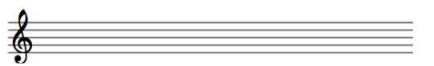

-Escribe un intervalo armónico de quinta.

-Escribe un intervalo armónico de oitava.

11. Sinala os tons e os semitons desta escala de Re maior.
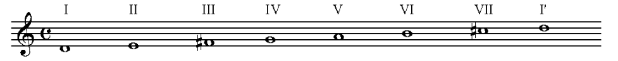

Escalas menores. Exercicios:

12. Escribe: a escala de La m natural, o acorde de tónica e o de dominante.

________________________________________________________________________________________________________________________________________________________________________________________________________________________________________________________________________________________________________________________________________________________________________________________________________________

13. Escribe: a escala de La m harmónica, o acorde de tónica e o de dominante.

________________________________________________________________________________________________________________________________________________________________________________________________________________________________________________________________________________________________________________________________________________________________________________________________________________

14. Escribe: a escala de La m melódica, o acorde de tónica e o de dominante.

________________________________________________________________________________________________________________________________________________________________________________________________________________________________________________________________________________________________________________________________________________________________________________________________________________

15. Escribe: a escala de Mi m natural, o acorde de tónica e o de dominante.

________________________________________________________________________________________________________________________________________________________________________________________________________________________________________________________________________________________________________________________________________________________________________________________________________________

16. Escribe: a escala de Mi m harmónica, o acorde de tónica e o de dominante.
________________________________________________________________________________________________________________________________________________________________________________________________________________________________________________________________________________________________________________________________________________________________________________________________________________

17. Escribe: a escala de Mi m melódica, o acorde de tónica e o de dominante.

________________________________________________________________________________________________________________________________________________________________________________________________________________________________________________________________________________________________________________________________________________________________________________________________________________
18. Escribe: a escala de Re m natural, o acorde de tónica e o de dominante.
_______________________________________________________________________________________________________________________________________________________________________________________________________________________________________________________________________________________________________________________________________________________________________________________________________________

19. Escribe: a escala de Re m harmónica, o acorde de tónica e o de dominante.

________________________________________________________________________________________________________________________________________________________________________________________________________________________________________________________________________________________________________________________________________________________________________________________________________________

20. Escribe: a escala de Re m melódica, o acorde de tónica e o de dominante.

________________________________________________________________________________________________________________________________________________________________________________________________________________________________________________________________________________________________________________________________________________________________________________________________________________

21. Escribe: a escala de Si m natural, o acorde de tónica e o de dominante.
________________________________________________________________________________________________________________________________________________________________________________________________________________________________________________________________________________________________________________________________________________________________________________________________________________

22. Escribe: a escala de Si m harmónica, o acorde de tónica e o de dominante.

________________________________________________________________________________________________________________________________________________________________________________________________________________________________________________________________________________________________________________________________________________________________________________________________________________

23. Escribe: a escala de Si m melódica, o acorde de tónica e o de dominante.

________________________________________________________________________________________________________________________________________________________________________________________________________________________________________________________________________________________________________________________________________________________________________________________________________________

24. Escribe: a escala de Sol m natural, o acorde de tónica e o de dominante.

________________________________________________________________________________________________________________________________________________________________________________________________________________________________________________________________________________________________________________________________________________________________________________________________________________

25. Escribe: a escala de Sol m harmónica, o acorde de tónica e o de dominante.

________________________________________________________________________________________________________________________________________________________________________________________________________________________________________________________________________________________________________________________________________________________________________________________________________________

26. Escribe: a escala de Sol m melódica, o acorde de tónica e o de dominante.

________________________________________________________________________________________________________________________________________________________________________________________________________________________________________________________________________________________________________________________________________________________________________________________________________________

27. Dí que escalas menores son e o seu tipo:

27.1. Sinala debaixo da escala os tonos e semitonos.
Escala: Tipo:

27.2. Sinala debaixo da escala os tonos e semitonos.
Escala: Tipo:

27.3. Sinala debaixo da escala os tonos e semitonos.
Escala: Tipo:

28. Constrúe os seguintes acordes (lembra que non podes modificar a nota dada):


