Maybe she will return tonight. – She ........................return tonight.
Don't stand up! - You...................stand up!
I'm sure they will finish it in a minute. – They ...................finish it in a minute.
There is no need to answer the letter. - You...................answer the letter.
Please, do it for me. -...................you do it for me?
I'd like to see your children. -...................I see your children?
I am not good at football. - I...................play football.
Do your homework! - You...................do your homework.
Let's take a taxi. - We...................take taxi.
Don't park your car on bends. It is illegal. – You ...................park your car on bends.
Perhaps she will agree with it. Who knows? - She...................agree with it.
I want you to tidy the classroom. - You...................tidy the classroom.
I need your help. It's too much work for me. - You...................help me.
Look at that baloon. It's over there. -...................you see the balloon?
Don't worry about dinner. I'll make it. - You...................worry about dinner.
It is not necessary to be there. - We...................be there.
Why don't you stay with us? No problem! - You...................stay with us.
Excuse me! ...................you speak French?
Alan isn't coming tonight. He...................come tomorrow, I hope.
There's a lot of work to do in the house. You...................help me!
You...................call him anymore. I have already called him.
She is over there. ...................you see her?
I................... borrow your pen, please?
Teachers...................beat children. It's forbidden.
I can hear some voices. Someone...................be in the house.
We...................eat sweets! We are on a diet.
You...................buy it on Sunday if you want. The shops are open.
You ...................drive me to the station. I can walk.
We want to be the best. We...................practise!
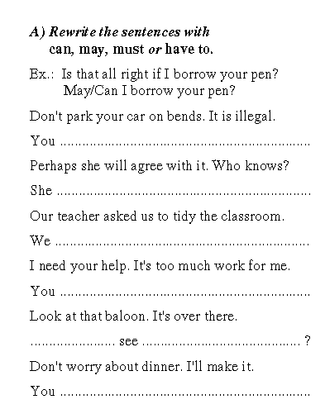
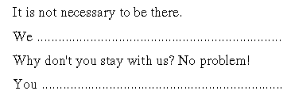
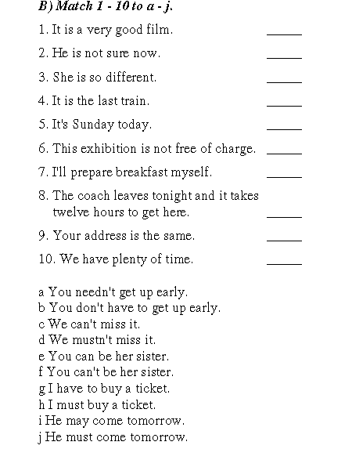

Exercise 3