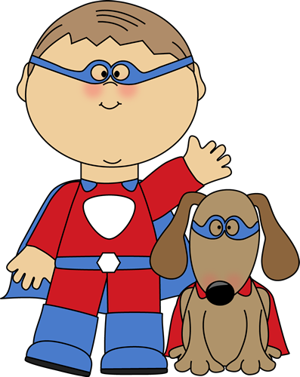

- Supermarkets ______________ (open) at 8 o’clock and
__________________(close) at 9.
- Yesterday I _______________(buy) a T-shirt and cargo shorts.
- They ____________________(have) dinner when the tornado _________________(strike).
- By next summer Jayden _________________ (complete) the
beginner’s computer course.
- I _________________(lie) on the beach in Ibiza this time next week. Lucky me!
- Every morning Jackson ____________ (turn) on his computer and _______________ (check) his Facebook for updates and news.
- Sophia and Isabella _______________ (not/finish) their power point presentation on African animals yet.
- Tonight Evan ______________________(play) a game of singles with his best friend, Christopher.
- This summer I _________________(read) 10 classic novels for school.
- Ethan and Noah ________________(already/wait) for 2 hours, when the bus finally ________________ (arrive).
- What _________________ (you/do) this weekend? I think I _____________ (start) a new jigsaw puzzle.
- Mia looks very pale. It looks like she ________________________(faint).
- My cousins, Logan and Jackson, _____________________(live) in Barcelona since 2006.
- My Uncle Landon ________________________ (work) in Dublin from 2002-2008.
- My mother and father _______________________(paint) the kitchen all morning.
- Right now Cameron ______________________ (play) his favorite computer game.
- What _____________________ (you/do) at the moment? Oh, nothing.
- This is the first time I ____________________ (ever/try) snails.



19. Fortunately Abigail _______________ just/ (put up) her umbrella when it ______________(start) to pour. Or she would have been soaked.
20. Last night my family and I __________________(watch) an interesting
documentary on Ancient Greece.
21. Andrew _____________________(never/be) on a safari before and he is so excited.
22. Tomorrow morning I ____________________(see) my dentist for my yearly checkup.
23. Real Madrid _______________________________ (play) against Barcelona tonight.
24. Our school ___________________(usually/have) breaks in the morning and afternoon.
25. That girl with the red hair _______________________(talk) on the phone right now.
26. Natalie _________________________(sleep ) over Chloe’s house last Saturday night.
27. I ______________________(not/often go) to the cinema these days. _______ you ________ (go) to the cinema once a month?
28. Guess what I _________________ (wear) to the party last night? A vampire costume.
29. By next June, they _____________________________(graduate) from high school.
30. What __________________(you/do) while the ground _________________(shake) during the earthquake?
31. We ______________ (drive) on Main Street when a dog __________ (run) in front of our car.
32. Our flight _________________(leave) at 9 in the morning.
33. Bad weather ____________ (delay) our flight to Madagascar last summer.
34. School ____________(start) in September and ________________ (finish) in June.
25. Where __________________ (go) this summer? I ________________(go) on a trek in the Himalayas.

