WE ARE STILL USING HIS EXPRESSIONS...
Can you guess these Shakespeare's expressions?
a) 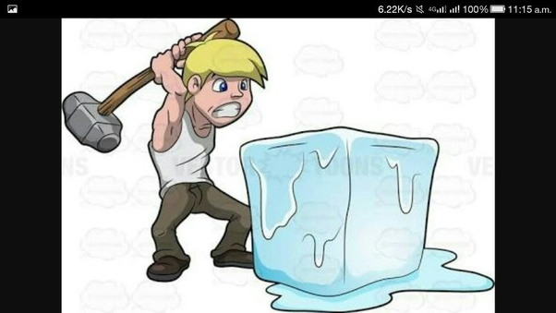
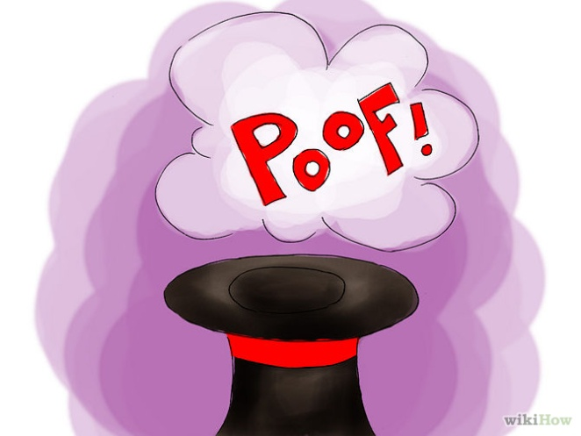
b)

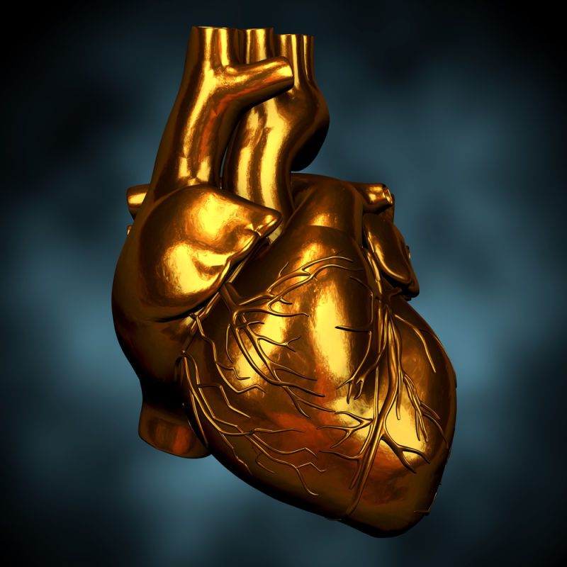
c)


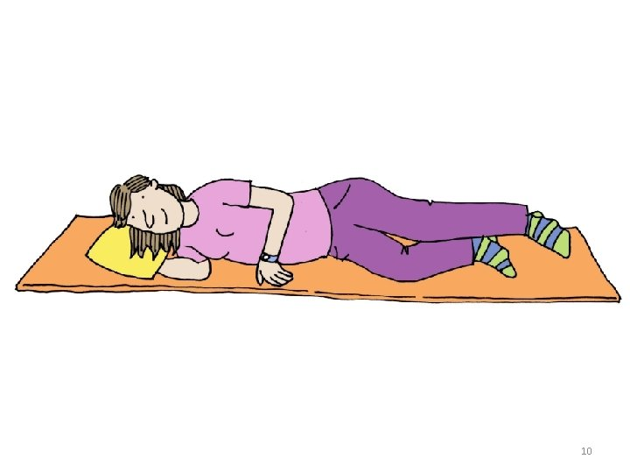
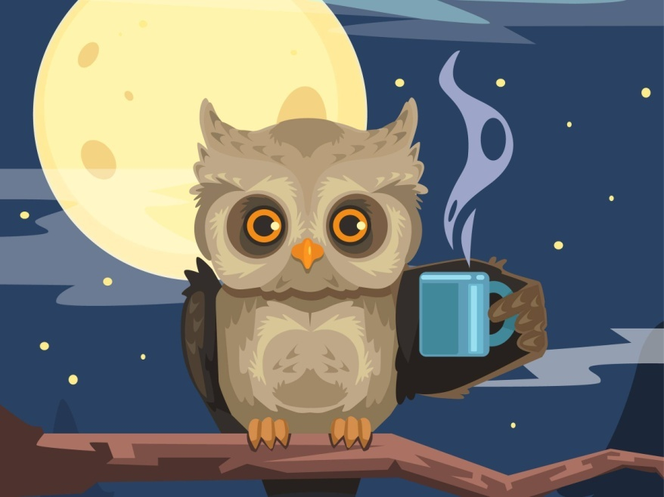
d)
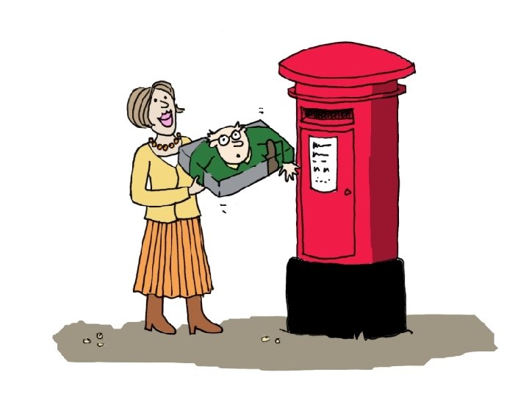
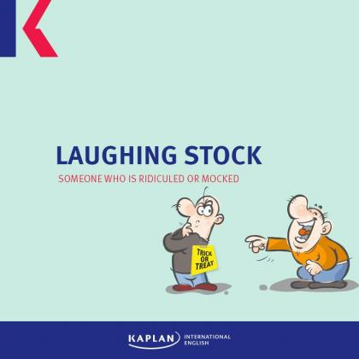
What do you say when :
- You are playing a video game and it finishes.....
-What do you say when in a match both teams don't have the same opportunities .................
- What do you say when something is very funny and you can stop laughing ............
- What do you think this expression means : She is an adolescent and eat us out of house and home
- A wink of sleep ......
- That t-shirt is very old . It has seen better days! Yes , but I like it .
- The dentist's drill sound sets my teeth on edge
- What adjective you use when someone has no feelings for instance a criminal that kills without any remorse ..................

Come what may For goodness sake !
What's done is done !!
