STARTER UNIT AND UNIT 1 REVISION

FALSE FRIENDS

actual: real, efectivo (y no actual, que se dice current)
actually: en realidad (y no actualmente, que se dice nowadays, at present)
to apologise: pedir disculpas (y no apología, que se dice defence)
to approve: estar de acuerdo, aceptar, aprobar una decisión (y no aprobar un examen, que se dice to pass an exam)
attendance: asistencia (y no atención, que se dice attention)
billion: mil millones (y no billón, que se dice trillion)
can: lata o el verbo poder (y no cana, que se dice white hair)
career: carrera profesional, ocupación luego del estudio (y no carrera referida al curso universitario, que se dice degree)
carpet: alfombra (y no carpeta, que se dice folder)
casualty: víctima o herido (y no casualidad, que se dice coincidence)
commodity: mercancía o materia prima (y no comodidad, que se dice comfort)
costume: traje, disfraz (y no costumbre, que se dice custom, habit)
curse: maldición (y no curso, que se dice course)
deception: engaño (y no decepción, que se dice disappointment)
disgust: asco, repugnancia (y no disgusto, que se dice annoyance, quarrel, trouble o to be upset)
diversion: desviación (y no diversión, alegría, que se dice fun)
dramatic: drástico, espectacular
estate: propiedad, bien inmueble, patrimonio (y no estado, que se dice state)
eventually: finalmente, "tarde o temprano" (y no eventualmente que se dice by chance, possibly)
exit: salida (y no éxito, que se dice success)
extravagant: derrochador, excesivo (y no extravagante, que se dice outrageous, odd)
fabric: tela (y no fábrica, que se dice factory)
facilities: instalaciones (y no facilidades, que se dice credit terms)
hardly: apenas, difícilmente (y no duramente, que se dice strongly)
by heart: de memoria (y no de corazón, que se dice from one's heart)
idiom: modismo, locución (y no idioma, que se dice language)
to improve: mejorar (y no improvisar, que se dice to improvise)
influenza: gripe (y no influencia, que se dice influence)
ingenuity: ingenio (y no ingenuidad, que se dice naivety)
inhabitant: habitante (y no inhabitado, que se dice uninhabited)
injury: herida (y no injuria, que se dice insult)
to intend: tener la intención de (y no intentar, que se dice to try)
intoxicated: ebrio (y no intoxicado, que se dice with food poisoning)
involve: involucrar (y no envolver, que se dice wrap)
lecture: conferencia (y no lectura, que se dice reading)
lentil: lenteja (y no lentilla, que se dice contact lens)
man: hombre (y no mano, que se dice hand)
mayor: alcalde (y no mayor, que se dice bigger)
occurrence: aparición (y no ocurrencia, que se dice absurd idea)
office: oficina (y no oficio, que se dice trade o job)
once: una vez (y no once, que se dice eleven)
ordinary: común (y no ordinario, que se dice vulgar)
pan: cacerola, cazuela (y no pan, que se dice bread)
parade: desfile (y no pared, que se dice wall)
pendant: colgante de un collar (y no pendiente, que se dice earring)
petrol: gasolina o nafta (y no petróleo, que se dice oil, petroleum)
pie: pastel (y no pie, que se dice foot)
place: lugar (y no plaza, que se dice square)
plate: plato o lámina (y no plata, el metal, que se dice silver)
policy: política (y no policía, que se dice police)
to presume: suponer (y no presumir o mostrarse orgulloso, que se dice to show off)
to rape: violar (y no rapar, que se dice to shave o to crop)
relatives: parientes (y no relativos, que se dice relative (adjective))
to remove: quitar, eliminar (y no remover, que se dice to stir)
rope: cuerda, soga (y no ropa, que se dice clothes)
scenery: paisaje, vista o bien, decorados en un teatro (y no escenario, que se dice stage)
sensible: sensato (y no sensible, que se dice sensitive)
sensitive: sensible (y no sensitivo, que se dice related to the senses)
soap: jabón (y no sopa, que se dice soup)
suburb: barrio rico periférico de la ciudad (y no suburbio de casas pobres, que se dice slum)
success: éxito (y no suceso, que se dice event)
sunrise: amanecer, salida del sol (y no sonrisa, que se dice smile)
to supply: suministrar, proveer (y no suplicar, que se dice to beg, to implore)
to support: apoyar (y no soportar, que se dice to put up with)
sympathetic: comprensivo (y no simpático, que se dice nice, likeable)
sympathy: compasión, comprensión, pésame (y no simpatía, que se dice friendliness, affection)
terrific: fenomenal, genial (y no terrorífico, que se dice terrifying)
tramp: vagabundo (y no trampa, que se dice trap)
ultimately: en última instancia, a la larga (y no últimamente, que se dice lately, recently)
vase: jarrón (y no vaso, que se dice glass o cup)
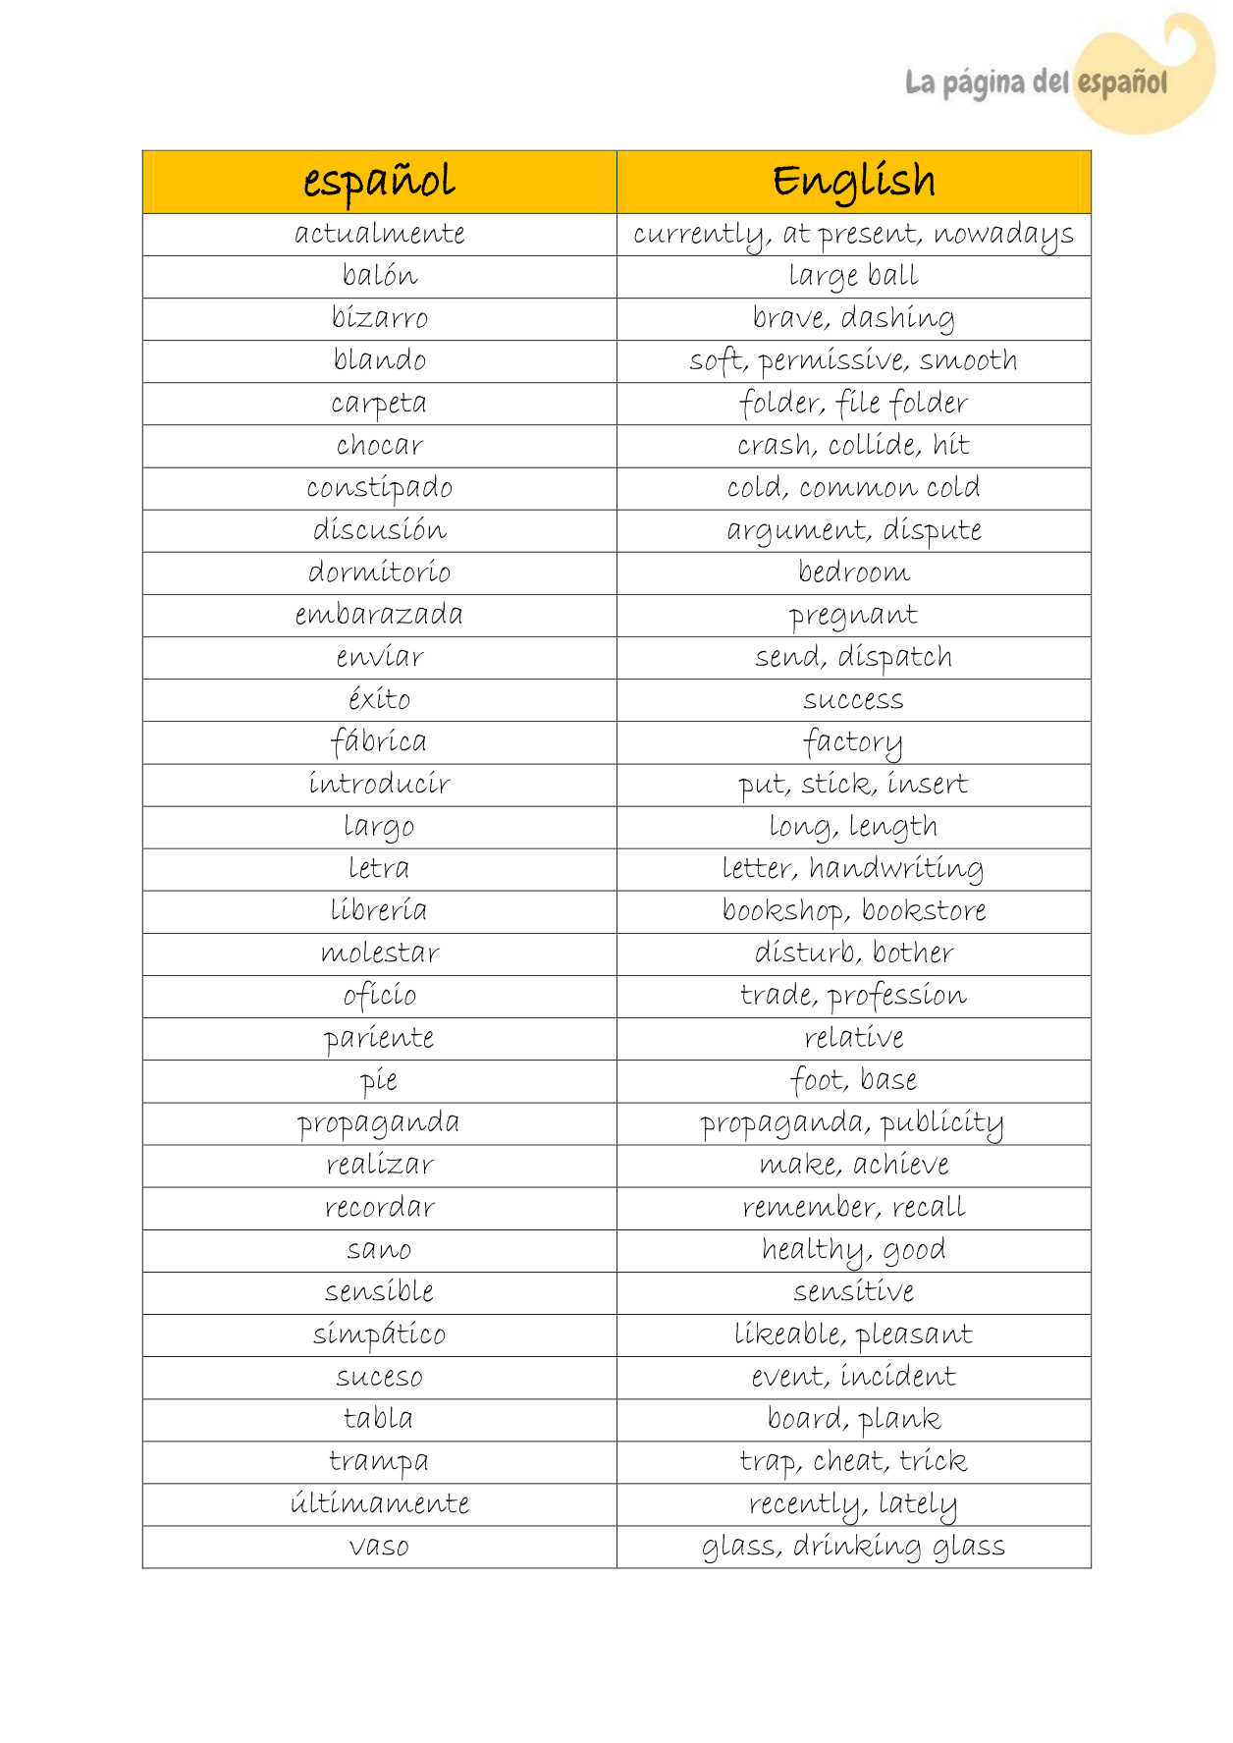

REPORTED SPEECH EXERCISES

STATEMENTS
.. Change the following statements into the reported speech.

a. “I have something to show you”, I said to her.
_________________________________________________________________________________
b. “I’m going away tomorrow”, he said.
_________________________________________________________________________________
c. “I’ve been in London for a month but I haven’t had time to visit the Tower”, said Rupert.
_________________________________________________________________________________
d. “I’ll come with you as soon as I’m ready”, she replied.
_________________________________________________________________________________
e. “We have a lift but very often it doesn’t work”, they said.
_________________________________________________________________________________
f. “I must go to the dentist tomorrow”, he said.
_________________________________________________________________________________
g. “I found an old Roman coin in the garden yesterday and I am going to take it to the museum this
afternoon”, he said.

a. “I’ll see you tomorrow”, she said.
_________________________________________________________________________________
b. “I saw her today”, he said.
_________________________________________________________________________________
c. “I don’t like this film”, she said.
_________________________________________________________________________________
d. She said, “We went swimming today.”
_________________________________________________________________________________
e. “I met her about three months ago”, he said.
_________________________________________________________________________________
f. “I’ll see Mary on Sunday”, she said.
_________________________________________________________________________________
g. “Pete and Sue are getting married tomorrow”, she said.
_________________________________________________________________________________
h. “Stephen’s bringing some records to the party tomorrow”, she said.
_________________________________________________________________________________
i. “I really like this furniture”, she said.
_________________________________________________________________________________
j. “My parents are arriving tomorrow”, she said.
_________________________________________________________________________________
k. “We visited her this morning” they said.
_________________________________________________________________________________
l. “We’ll see her next summer” they said.
_________________________________________________________________________________
m. “They were here three months ago”, he said.
_________________________________________________________________________________
n. “I’m meeting them at four o’clock today”, he said.
_________________________________________________________________________________
o. “I can see you tomorrow”, she said.

QUESTIONS
7. Report the police-officer’s questions to the shop owner.

a
8. Write these sentences as reported questions using the words given.
a. “What’s your name?”, he asked. (wanted to know)
_________________________________________________________________________________
b. “Do you like Marlon Brandon?”, she asked.
_________________________________________________________________________________
c. “How old are you?”, she said. (asked)
_________________________________________________________________________________
d. “When does the train leave?”, I asked.
_________________________________________________________________________________
e. “Are you enjoying yourself?”, he asked.
_________________________________________________________________________________
f. “How are you?”, he said. (asked)
_________________________________________________________________________________
g. “Does your father work here?”, she asked.
_________________________________________________________________________________
h. “Do you live near your father?”, he asked.
_________________________________________________________________________________
i. “Who did you see at the meeting?”, my mother asked.
_________________________________________________________________________________
j. “Why did you take my wallet?”, he asked.
_________________________________________________________________________________
k. “How did you get to school?”, she asked.
_________________________________________________________________________________
l. “Are you a foreigner?”, she asked.
_________________________________________________________________________________
m. “Where do you live?”, the boy asked.
_________________________________________________________________________________
n. “Have you met Danny before?”, he asked.
_________________________________________________________________________________
o. “Are you hungry?”, he asked.
_________________________________________________________________________________
p. “Why wasn’t Judy at the party?”, she asked.
_________________________________________________________________________________
q. “Why didn’t you telephone?”, my father asked.
_________________________________________________________________________________
r. “Did you borrow my dictionary?”, he asked.
_________________________________________________________________________________
s. “Why are you so late?”, the teacher asked.
_________________________________________________________________________________
t. “Have you finished your exams?”, she asked.
_________________________________________________________________________________
u. “Did you invite Judy and Mitch?”, he asked.
_________________________________________________________________________________
v. “Does your brother live in London?”, she asked.
_________________________________________________________________________________
w. “Why didn’t the police report the crime?”, the judge asked.
_________________________________________________________________________________
x. “Do you know who broke the window?”, he asked.
_________________________________________________________________________________

y. “Why you won’t let me in?”, he shouted.

COMMANDS, REQUESTS AND ADVICE

9. Rewrite these sentences in reported speech.

a. “Make some coffee, Bob”, Carol said.(ask)
_________________________________________________________________________________
b. “You must do the homework soon, Jane”, she said.(tell)
_________________________________________________________________________________
c. “Remember to buy a map, Ann” he said.(remind)
_________________________________________________________________________________
d. “You should see a doctor, Mrs Clark”, he said.(advise)
_________________________________________________________________________________
e. “Keep all the windows closed, Bill” they said.(warn)
_________________________________________________________________________________
f. “Go home, Paul”, Francis said.(tell)
_________________________________________________________________________________
g. “Please stay for supper, Bob”, he said.(try to persuade)
_________________________________________________________________________________
10. Report the following sentences.
a. “Don’t try to be funny.”
_________________________________________________________________________________
b. “Wait here till I come.”
_________________________________________________________________________________
c. “Go to bed and don’t get up till you’re called.”
_________________________________________________________________________________
d. “Be a good girl and sit quietly for five minutes.”
_________________________________________________________________________________
e. “Watch the milk and don’t let it boil over.”
_________________________________________________________________________________
f. “Don’t take your coat off.”
_________________________________________________________________________________
g. “Don’t forget to thank Mrs Jones when you’re saying good bye to her.”
_________________________________________________________________________________
h. “Stop that dog.”

SAY AND TELL

12. Use the correct form of SAY and TELL in these sentences.

a. She _______________________ me she didn’t agree.
b. He _______________________ , “Have we met before?”
c. I _______________________ them I wasn’t happy with their work.
d. She smiled and _______________________ to me, “I’m very pleased to meet you.”
e. She _______________________ me a story about her parents.
f. He _______________________, “Are you feeling OK?”
g. I didn’t hear. What did he _______________________?
h. Could you _______________________ me the time, please?
i. They _______________________ me they were going to a meeting.
j. I _______________________ the police my address.
k. I _______________________ I wanted to buy a magazine.
l. He _______________________ he wasn’t interested in politics.
m. Could you _______________________ me your name again?
n. Do you think he is _______________________ the truth?
o. Would you _______________________ him to come early tomorrow?
p. If he _______________________ that again there’ll be trouble.
q. I _______________________ them it was dangerous to swim here.
r. Did you _______________________ anything to him about your problem at work?
s. _______________________ me what happened.
t. I think he is _______________________ lies.
u. The policeman _______________________ the man was lying.
v. Philip _______________________ it would probably rain tomorrow.
w. Susan _______________________, “Let’s go out for dinner tonight.”
x. Jim _______________________ me about the party last night.
y. Our teacher _______________________ he was pleased with our work.
z. Stop _______________________ lies!

OFFERS AND SUGGESTIONS

13. Rewrite the sentences with the gerund or the infinitive and the in reported speech.
a. “I’ll bring my CDs to the party.”
He promised to bring his CDs to the party.
b. “Let’s go to the cinema tonight, shall we?
She suggested _____________________________________________________________________
c. “Yes, I stole the wallet.”
He admitted ______________________________________________________________________
d. “Be careful! The water is boiling.”
She warned us _____________________________________________________________________
e. “You must apologise to your teacher.”
My father insisted (on) ______________________________________________________________
f. “All right! I’ll share the expenses with you.”
My friend agreed __________________________

REPORTING VERBS STRUCTURES

Verb+ object  + infinitive | Verb+ infinitive | Verb + “that” |  | Verb+ gerung |  | Verb+ object+  preposition+ gerund | Verb+  preposition  +gerund
Advise  Encourage  Invite  Remind  Warn  tell  Ask  Forbid  Request  Instruct  Ask  Beg  promise | Agree  Decide  Offer  promise  Refuse  Threaten  Beg  decide |  | Agree  Claim  Decide  Demand  Guarantee  Request  Swear  Admit  Deny  Explain  Insist  Suggest* |  | Admit  Advise  Confess  Deny  Suggest  Recom  mend  Regret | Accuse sbdy of  Congratulate sbdy on  Blame sbdy for  Dissuade sbdy from  Forgive sbdy from  Warn sbdy against/about | Apologise for  Insist on
Example:  Jack encouraged me to look for a new job | Example:  She offered to give him a lift to work |  | Examples:  She agreed that we needed to reconsider our plans  John suggested that we all have / had a drink to celebrate his birthday |  | Example  He denied having anything to do with her | Example:  Xabier accused the boys of cheating on the exam | Example:  She insisted on doing the washing up

EXERCISES

1)Fill the gaps using the verbs in the box. Use each verb once only.
Advise hope promise warn suggest beg insist remind threaten deny invite refuse
1 | "I didn't do it," she said.
 | She ________________ doing it.
2 | "Have lunch with me," she said.
 | She ________________ me to have lunch with her.
3 | "Why don't you buy one?" said Tom.
 | Tom ________________ I buy one.
4 | "I promise I'll take you to Prague," said Mary.
 | Mary ________________ to take me to Prague.
5 | "I hope Andy phones tonight," said Clare.
 | Clare ________________ Andy would phone that night.
6 | "Please, please don't tell anyone!" he said.
 | He ________________ me not to tell anyone.
7 | "I won't do it," he said.
 | He ________________ to do it.
8 | "You should have lessons," she said.
 | She ________________ me to have lessons.
9 | "We really must go with you," they said.
 | They ________________ on going with me.
10 | "Don't forget to phone Granny," said Mum.
 | Mum ________________ me to phone Granny.
11 | "If you wear my T-shirt again, I'll pinch you very hard," said Maggy.
 | Maggie ________________ to pinch me very hard if I wore her T-shirt again.
12 | "Don't fly kites near electric overhead cables," said my father.
 | My father ________________ me not to fly kites near electric overhead cables.

2) WRITE THESE SENTENCES IN ANOTHER WAY USING THE WORDS AT THE END OF THE LINE.
(Reporting verbs - past simple)
- “I know you can do it . Take the exam again”, he said to John
He encouraged……..
- “The accident was all my fault”.
He / admit
- “Shall we have a quiet evening at home?”
He / suggest
- “There’s no way I’m going on holiday with mum and dad”.
He / refuse
- “Oh please! Let me go to Sharon’s party, mum”.
She / beg
- “No, it wasn’t me. I didn’t eat the last chocolate biscuit”.
She / deny
- “Those bags look very heavy. Can I give you a hand?.
She / offer / him
- “Could you tell me the way to the city centre?”.
She / want to know
- “Now don’t forget to lock all the doors and windows”
He / remind /her
- “Would you like to come for lunch on Sunday?”.
She / invite /me
- “Don’t cross the road here. It’s dangerous”.
She / warn / them
- “That’s very kind of you. What a lovely present!”.
- She / thank / her
12. “If I were you, I’d be very careful what you say to her”.
She / advise / them
13. “I’ll definitely get my hair cut this week”.
She / promise
- “I’m so sorry I forgot about our appointment”.
He / apologise
- “What about going for a meal to that new Chinese restaurant?”
He / suggest
- “Does anyone know who this car belongs to?”
He / want to know
- “If I were you, I’d spend a year abroad before university”.
He / advise / her
- “We can’t go yet. I want to see every picture in the gallery before leaving”.
I / insist
19.”Careful! Don’t touch those plates. They’re very hot”.
He /warn / them
20. “It’s disgusting! I’m not going to eat any more”.He / refuse

3) TRANSFORM THE FOLLOWING SENTENCES FROM DIRECT SPEECH INTO REPORTED SPEECH. INSTEAD OF SAY OR TELL USE SUITABLE REPORTING VERBS FROM THE BOX.

deny suggest promise doubt invite
warn advise threaten refuse persuade
admit complain offer remind announce

e.g. ‘You really should give up smoking, Roger,’ said Chris.
Chris advised Roger to give up smoking.

‘How about going to the Lake District for the weekend?’ said Marta

‘I’m not sure if I can come to the party,’ said Raymond.

‘We’re getting married next year,’ said Marilyn.

‘Oh come on, Bill! Come for a swim with us!’ said Charlie (and Bill went)

‘I didn’t kill Terry Morton!’ said Sid.

‘Don’t forget to pay the phone bill, Norman,’ said Grace.

‘I really will clean the car tomorrow,’ said David.

‘The food is disgusting!’ said Walter.

‘Yes, it’s true: I have been rather careless,’ said Perry.

‘If you touch my bike again, I’ll punch you on the nose!’ said Roy.

‘Don’t touch these wires!’ said Antony.

‘I won’t lend you any money!’ said Maggie.

‘Shall I bring you a cup of tea?’ said Gordon.

‘Would you like to come round for lunch on Sunday?’ said Geraldine.

