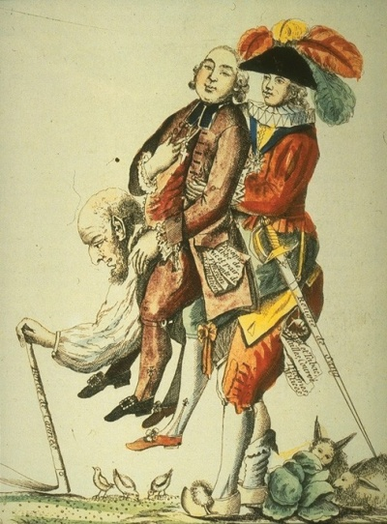
The French Revolution

TEXT 1
Cartoon of 1789
The Peasant, shown carrying the burden of maintaining the feudal lords and the clergy. The text reads: “One hopes this will end soon.”

TEXT 2
An Englishman's view of French peasants, 1787-1790
I was joined by a poor woman who complained of the times. Her husband had only a morsel of land, one cow and a poor horse. But they had to pay 20 kg of wheat and three chickens as feudal dues to one lord, and 60 kg of oats, one chicken and five pence to another, along with very heavy taxes to the king's tax collectors: “The taxes and feudal dues are crushing us.”
Arthur Young: Travels in France, 1792
TEXT 3
Yearly incomes compared
Archbishop of Paris Marquis de Mainvillette Prince de Conti
A Paris parish priest A typical village priest A master carpenter
50,000 livres
20,000 livres
14,000 livres
10,000 livres
750 livres
200 livres
The livre was replaced by the franc in 1795. In the 1780s, there were about 4 livres to £1.
TEXT 4
The People should have power, 1775
Man is born free. No man has any natural authority over others; force does not give anyone that right. The power to make laws belongs to the people and only to the people.
A pamphlet, banned by the French government in 1775, Jean Jacques Rousseau

TASKS:
- Look back at the information in the texts above. List the reasons why many people in France were critical of:
  - the nobility b) the King c) the clergy
- What might a French peasant have complained about in 1789?
- Look at text 1. Explain what the cartoonist meant. Remember to explain the significance of the three characters, as well as the text in it.
- How does the author of text 2 describe the life of peasants? (Give examples)
- Study texts 1 to 4. Do the texts explain why poor people in France resent the rich. Explain your answer.
- Rousseau (text 4) was an influential writer at this time. Along with other writers like Voltaire, he wanted France to have a more democratic form of government. Who would be most influenced by his words and why? Justify your answer.
- Why was text 4 banned in 1775? Which members of French society wanted to ban it?

Activity from CPI Tino Grandío CC BY-SA 2.0

