JOBS • 2025
Name .………………………………………………………………………………………… Group: ………………….
Task: Application letter
You have decided to apply for the festival job advertised. Write a covering email of between 120-150 words.
DRAFT your email:
- Write an introductory sentence to explain why you are writing.
- Paragraph 1: Give personal information including skills.
- Paragraph 2: Talk about any relevant experience you have.
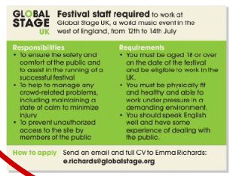
- Paragraph 3: Explain why you think you would be suitable for the job.
- Finish the email appropriately
- Use linkers and vocabulary related to jobs.

Please, write within the margins given

ASSESSMENT
Eficacia comunicativa
Adecuación
Organización e cohesión
Riqueza e corrección gramatical
Riqueza e corrección léxica

