Reading comprehension: Fashion styles

It seems that what you choose to wear each day isn’t necessarily random. The clothes we wear may say a lot about our personality and that can be fascinating. Now, have a look at 6 different fashion styles and the implications of what your choice of clothing says about you.

1. Clean and simple
This type of woman is classic and has a no-frills approach to both her life and of course her clothing. They tend to wear a simple fitted t-shirt and jeans and focus more on fit than frilly style. Sometimes people call them tomboys since they like to keep things clean and simple. Instead of bright colors, they prefer neutrals like white, black, gray, and beige. Their simple modern style doesn’t mean that they are not stylish—they can be the life of the party and also people tend to follow since they are low on drama. They can be found in a t-shirt, shorts, and a pair of All Stars shoes.

Personality traits: kind, earnest, dependable, fun.

2. Feminine
Also known as girly, the feminine fashion style is full of lace, florals, hearts, and pastel colors like pink. This girl is a hopeless romantic who loves watching a good romantic comedy or reading a romance novel. She likes to dress like a lady and be treated like one. If you’re a girl who loves dresses, skirts, heels, and lovely fashions, you probably identify with the feminine clothing style.

Personality traits: Composure, thoughtfulness, an eye for art and beauty.

3. Sporty
Do you tend to wear your gym clothes even after you have finished exercising? Do you love the way your leggings fit your legs? Do you prefer sports shoes over other types of shoes on most days of the week? Then you’re definitely a sporty gal. Women who love the sporty style are active and on-the-go. They choose casual styles that can take them anywhere they go. If you like sporty clothing, chances are you are a big fan of physical activity.

Personality traits: confident, easy-going, optimistic, focused, leadership

4. Free spirit
You feel free like Thelma and Louise in the seat of a convertible with their hands in the air. If free-spirit is your style, you show how spontaneous you are in the clothes you choose to wear, which may not be trendy, but the outfits you come up with are different and fun! A free-spirit can bring back past fashion styles like wide-leg pants. Creative and thinking outside the box are two typical traits and even they can wear items that no-one would think go together, but on them…they totally work!

Personality traits: Bohemian, carefree, enthusiastic, a creative thinker.

5. Make a statement
If you belong to this group, then you like like bright colors, designer clothes, and you wear them confidently. You choose what you wear so that your clothes say: “Hey … I'm over here!” Your outfit reflects your inner confidence, which means that your clothes make a statement and that's reflected in your personality as well. You don’t mind being the center of attention…in fact, you love it!

Personality traits: charismatic, self-assured, artistic, well-spoken.

6. Trend-setter
You are a trend-setter if you follow the latest styles and go shopping for clothes regularly.You always look like a fahion model on the catwalk and your friends are always calling you to ask for fashion advice. You know what’s in and you are willing to be the first one to try out a new trend.

Personality traits: connected, intelligent, helpful, a good friend.

Text created by Aldao, S, Calvo N and Rosales, S. Clothes and personality. CC BY-SA

Reading comprehension exercise

Have a look at this poster and then write the number of the picture that goes with each fashion style.

Text - Picture
1. Clean and simple: Picture ___
2. Feminine: Picture ___
3. Sporty: Picture ___
4. Free spirit: Picture ___
5. Make a statement: Picture ___
6. Trend-setter: Picture ___

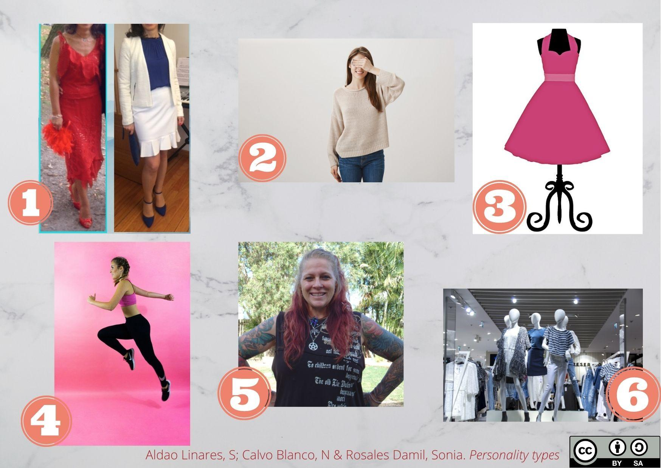

Text – Picture KEY

1. Clean and simple: Picture 2
2. Feminine: Picture 3
3. Sporty: Picture 4
4. Free spirit: Picture 5
5. Make a statement: Picture 1
6. Trend-setter: Picture 6

