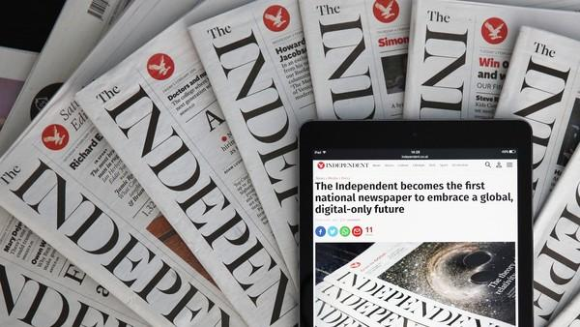
WATCH VIDEO 1
Complete the text with ONE TO FOUR words.
1. The Independent was born with the vision of being______________________________, but above all independent from the political lobbies.
2. Indeed, this paper has published startling front covers and was the first _________________________________ tabloid.
3. Now they are the first to give up on print and the editor says that painful as it is, they are happy to go where the readers are and __________________________________ future.
4. After selling The I, its sister paper, today’s announcement about The Independent was __________________________________,
5. According to the reporter, no one has managed to make money __________________as they used to ________________,
6. When it was set up, not only was The Independent a journalistic adventure but __________________________________ new technology,
7. The Independent’s founder asserts that all papers are losing __________________________________, which- in his own words is a double-whammy.
8. So this is goodbye to print but also to more than half of __________________________________,

WATCH VIDEO 2 : Kelvin MacKenzie
True or false? Be prepared to justify your answers.
- The Independent going out of print is a terrible loss.
- There is a wide enough offer of print newspapers.
- The Independent was one of the top print newspapers.
- This digital version will survive thanks to advertising.
- The Lady at the table agrees with Mr MacKenzie.

KEY TO ANSWERS:
VIDEO 1
1. BOLD, INNOVATIVE
2. BROADSHEET TO SWITCH TO
3. EMBRACE AN EXCITING DIGITAL /EMBRACE A (REALLY EXCITING) DIGITAL
4. HARDLY A SURPRISE
5. OUT OF DIGITAL/OUT OF PRINT
6. THE CUTTING-EDGE OF
7. CIRCULATION AND ADVERTISING INCOME.
8. 200 (TWO HUNDRED) OR SO STAFF
VIDEO 2 : Kelvin MacKenzie
- The Independent going out of print is a terrible loss. F (It’s not gonna be any sad loss, TBH)
- There is a wide enough offer of print newspapers. T (we have a fantastic array of print products)
- The Independent was of the top print newspapers. F (… The Independent has not been one of them (fantastic print products) for the last 10 or 15 years)
- This digital version will survive thanks to advertising. F ( there will be no users and therefore no advertisers)
- The Lady on the table agrees with Mr MacKenzie. F (Oh, I’m a bit more sympathetic, I suppose cause I used to work for The Independent...)



