CEFR COMPANION VOLUME
LAUNCHING CONFERENCE
BUILDING INCLUSIVE SOCIETIES
THROUGH ENRICHING PLURILINGUAL AND
PLURICULTURAL EDUCATION
“Promoting plurilingual and
pluricultural education”

www.coe.int/lang-cefr
Biographies
16-17 May 2018
Strasbourg
Palais de l’Europe
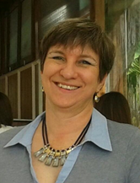
Maria-Teresa BERCERUELO-PINO has degrees in English Phylology and in Translation and Interpreting. Since 1988 she has been an English teacher at Escuelas Oficiales de Idiomas (the Spanish network of publicly funded schools dedicated to the specialised teaching of modern languages).
She has lectured and been a teacher trainer at various Escuelas Oficiales de Idiomas in diverse autonomous regions in Spain on issues such as curriculum development, methodology, assessment and evaluation, teacher training and new technologies.
She has been a member of the expert commissions in charge of the design and implementation of the common public assessment tests for Escuelas Oiciales de Idiomas in the autonomous region of Andalucía (B1 and B2 levels), and also in charge of the design and publication of the curriculum for C1 and C2 levels in this autonomous region.
As the Head of Studies at the Escuela Oficial de Idiomas de Granada, she was a leader and member of the team who was awarded the “Premio Marta Mata a la calidad de los centros educativos 2010” (the national prize on quality in education, granted by the Spanish Ministry of Education).
She has participated in the ECML Project “Encouraging the culture of evaluation among professionals (ECEP Workshop)”, which resulted in the publication of Pathways through Assessing, Learning and Teaching in the CEFR (http://www.ecml.at/publications).
At present she is working as an English teacher at Escuela Oficial de Idiomas de Granada.
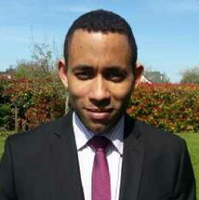
Jonas ERIN is an inspector general in the French Ministry of Education where he works in the fields of language education policy. He is currently coordinating an expert team on a four-year action-research project (2016-2019) of the European Center for Modern Languages (ECML – Council of Europe) called “EOL - Learning environments where modern languages flourish”. He was also involved as an external expert in the project PlurCur (Plurilingual whole school curricula) of the previous program of the ECML.
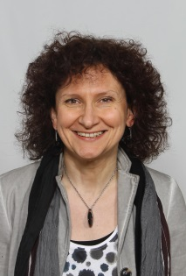
Daniela FASOGLIO is foreign language specialist at the Netherlands Institute for Curriculum Development. Her work expertise pertains above all secondary education. She has coordinated several projects, among which major CEFR implementation projects in Dutch secondary education and a quantitative study on the attained level in speaking and writing at the end of upper secondary education for English (speaking and writing), French and German (writing). Between 2010 and 2014 she worked at the development and implementation of a curriculum Chinese in pre-university education. In the last few years she was also concerned in the implementation of assessment for learning principles and techniques in the English classroom. Presently, she is actively involved in a thorough reform of the educational curricula in primary and secondary education in the Netherlands, more specifically in the substantive supervision of the activities pertaining the foreign language curricula. The national curricular reform is starting this year.
Vincent FOLNY has been working at CIEP for 11 years, the public operator for the ministry of National Education which is dedicated to the certification of the French language. At CIEP, he is in charge of monitoring and supervising CIEP’s test quality (from content, constructs and measurement perspectives). He also takes part in the establishment of language tests in Europe and worldwide.

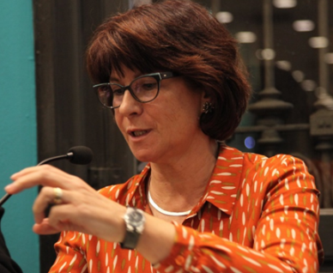
Maria GONZALEZ-DAVIES is an Associate Professor in the Department of Foreign Languages and Education at the Universitat Ramon Llull (Barcelona, Spain). She is the Head of the research group CILCEAL (Intercultural and Interlinguistic Competence In Languages Teaching and Learning). She previously worked as a teacher of English, Spanish and Catalan in Primary and Secondary Education. She taught English as a Foreign Language and Translation at the School of Modern Languages (EIM, University of Barcelona), where she co-directed the English Department and set up the Translation Section. She also worked at the University of Vic, where she was Head of the Translation Department. She is the author of articles and books that have been published internationally and co-edits the indexed journal The Interpreter and Translator Trainer (Routledge) with Dr. Dorothy Kelly.
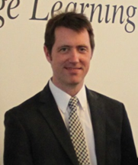
Tim GOODIER is Head of Academic Development for the Eurocentres Foundation, and coordinates Eurocentres’ ongoing NGO consultancy to the Council of Europe for language learning, which includes recent key contributions to the development of the CEFR Companion Volume with New Descriptors and the Collated representative samples of descriptors of language competences developed for young learners. He has senior oversight of quality and innovation at Eurocentres, and has worked on numerous international curriculum projects such as the launch of the 'my.Eurocentres' blended learning platform for English and French, and the design of transnational preparatory programmes for higher education. Tim is a member of the Eaquals board of trustees, and regularly contributes to Eaquals projects that aim to foster excellence in language education for all languages. His previous roles in education include teacher, examiner, course-developer, school inspector, and teacher-trainer.
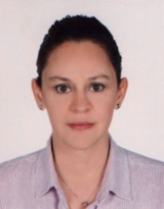
Elif KANTARCIOĞLU is the Director of the English Language Preparatory Program at Bilkent University, Ankara, Turkey. She completed her MA studies in ELT with a dissertation on test validation at Middle East Technical University, Ankara, Turkey; and her PhD on the role of CEFR linking in test validation at Roehampton University, London, UK. She has been involved in language assessment for about 20 years and her areas of interest are test design, validation, test analysis techniques, Rasch measurement techniques in particular, and standard setting. She has presented at a number of national and international conferences and co-authored papers and book chapters in the area of language assessment, particularly on CEFR linking and test validation. She has also been involved in a number of national and international projects as a consultant and project leader.
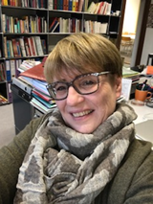
Rosanna MARGONIS-PASINETTI graduated from the University of Geneva and the Pedagogical Seminar of Lausanne (Switzerland), she’s been for many years a language teacher and a foreign language teacher trainer. She’s the current Head of the Foreign Languages Teacher Training Department at the University of Education in Lausanne and the person in charge of the Italian Teacher Training. Her scientific interests concern task-based language learning and teaching, multilingualism, interculturalism and language policies.

Brian NORTH is a researcher in language education. He has extensively collaborated with international organizations, particularly the Council of Europe, as a project coordinator and consultant. He spent most of his career at Eurocentres, the Swiss-based foundation with language schools in several countries, which has been an official NGO to the Council of Europe since 1968. In his PhD thesis he developed the levels and descriptors for the CEFR. He then co-authored the CEFR itself, the prototype European Language Portfolio, the Manual for relating examinations to the CEFR, and Eaquals’ CEFR Core Inventories for English and French and was Chair of Eaquals 2005–2010. He recently coordinated the 2013–17 project that produced the CEFR Companion Volume with New Descriptors.
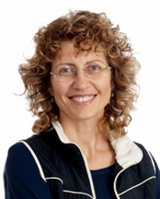
Enrica PICCARDO is Associate Professor at OISE – University of Toronto and at the Université Grenoble-Alpes France. She has extensive experience in language teaching, teacher training and second/foreign language education research. A CEFR specialist, she has been collaborating with European Institutions on international projects (the ECML in Graz –Austria – as project coordinator, and the Council of Europe as project member). Her monograph From Communicative to Action-oriented: a Research Pathways. (2014) available online is being used in teacher education in Canada and beyond. She is the principal investigator of two SSHRC funded research projects, QualiCEFR and Linguistic and Cultural Reinvented (LINCDIRE) and of a Council of Europe funded project QualiMatrix. Her research focuses on emotions and creativity in language education, assessment and its role in the curriculum, plurilingualism and teacher education. She has presented in many countries and published in different languages. Some recent articles include one in TESOL Quarterly (2013), a co-edited issue of The Canadian Modern Language Review (2015), an article in Frontiers in Psychology (2017) on Plurilingualism as a Catalyst for Creativity in Superdiverse Societies: A Systemic Analysis, and two book chapters The impact of the CEFR on Canada's linguistic plurality: a space for heritage languages? (2014) Cambridge University Press and Plurilingualism: vision, conceptualization and practices (2017) Springer.
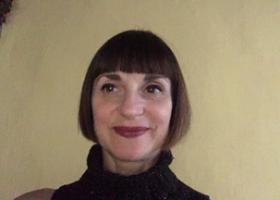
Nadia PRIONI is a teacher of English and European projects referee at an Italian Secondary School: “Liceo Statale Giorgio Spezia” (http://www.liceospezia.eu/) where I’ve been teaching for ten years now. I work with students aged 14-18 and piloted the new CEFR scales regarding literary appreciation with some of them. I am interested in European projects and education. I'm keen on literature, art and interior design. I love travelling and meeting new people.
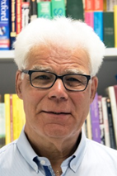
Prof. Dr. Bernd Rüschoff holds the chair in didactics and applied linguistics in the Institute for Anglophone Studies at the University of Duisburg-Essen. He has a special research focus technology enhanced learning systems, and has over the past decades participated in a number of national and international projects dealing with the development and assessment of digital tools and multi-media resources in language learning. In addition, his research addresses issues a wide range of issues in the field of applied linguistics, such as language & culture, bilingual education, corpus linguistics and data-driven learning, as well as the implementation of CEFR and competency-oriented principles in language learning.
He has been involved in a number of European Union projects and contributed to various Council of Europe activities, e.g. as a director of studies in Modern Languages ‘New Style’ workshops. He is a former president of EUROCALL and of GAL e.V. – the German Association of Applied Linguistics. He is also a former president of AILA, the International .Association for Applied Linguistics, and served on AILA’s Executive Board from 2005-2017 in various capacities. On behalf of AILA, he is a member of the Professional Network Forum, a think tank of the Council of Europe’s ECML (European Centre for Modern Languages).
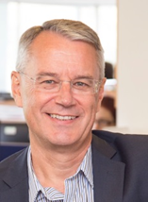
Dr Nick Saville is Director of Research & Thought Leadership at Cambridge Assessment English (University of Cambridge). He is the elected Secretary-General of the Association of Language Testers in Europe (ALTE) and has close involvement with other European initiatives, such as the Council of Europe’s Common European Framework of Reference for Languages (CEFR). He is a Trustee for The International Research Foundation for English Language Education (TIRF), and a Board member of Cambridge University’s Institute for Automated Learning and Assessment (ALTA).
Before joining Cambridge, he taught at the University of Cagliari (Italy) and worked in Japan. He has a PhD in Language Assessment focusing on test impact, an MA in TEFL and a BA in Linguistics. Nick presents regularly at international conferences and has published widely on issues related to language assessment. He co-edits English Profile Studies with Dr Fiona Barker and is joint editor of Studies in Language Testing (SiLT) with Prof Cyril Weir.

