CREDITS
MODULE 9 – ART FOR ART’S SAKE
Imaxe | Autor | Título | Ligazón | Licenza
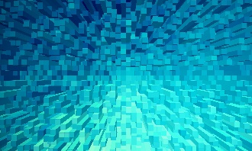 | Nadejda Bostanova | Fondo azul | https://pixabay.com/es/illustrations/de-fondo-blu-formas-extruir-1572602/ | CC0
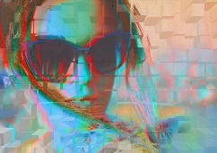 | Yatheesh Gowda | Glitch | https://pixabay.com/es/illustrations/falla-glitch-art-distorsi%C3%B3n-tv-2463370/ | CC0
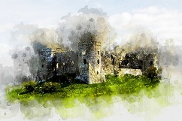 | Evren Ozde | Carew Castle | https://pixabay.com/es/illustrations/carew-castle-castillo-acuarela-3160880/ | Pixabay. Editorial Use.
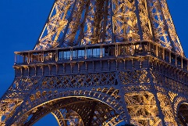 | Jorge Royan | Torre Eiffel | https://commons.wikimedia.org/wiki/File:Paris_-_Eiffel_Tower_in_the_evening_-_4210.jpg | CC BY
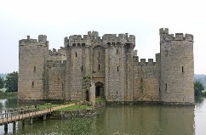 | Shutterbug75 | Battlements | https://pixabay.com/es/photos/almenas-gran-breta%C3%B1a-brit%C3%A1nico-1239279/ | CC0
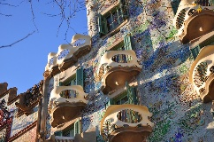 | pcsfish | High First | https://pixabay.com/es/photos/alto-primero-gaud%C3%AD-barcelona-5049246/ | CC0
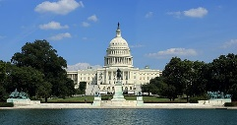 | Martin Falbisoner | Capitol | https://commons.wikimedia.org/wiki/File:US_Capitol_and_Grant_Memorial.JPG | CC BY-SA
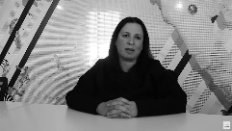 | WIA | Elena Manferdini | https://www.youtube.com/watch?v=KtGQgvj3IeM | CC BY
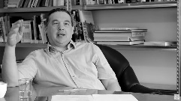 | WIA | Peter Trummer | https://www.youtube.com/watch?v=n1rdBnH55KE | CC BY
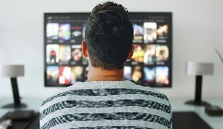 | Mohamed Hassan | Tv | https://pixabay.com/es/photos/tv-hombre-ver-habitaci%c3%b3n-oficina-3774381/ | CC0
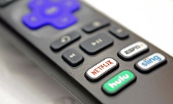 | mjimages | Remote | https://pixabay.com/es/photos/a-distancia-netflix-televisi%c3%b3n-6003839/ | CC0
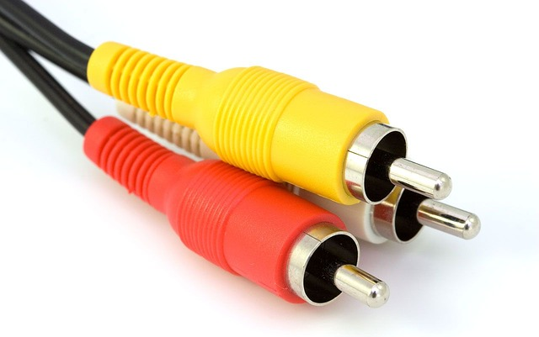 | Republica | Cables | https://pixabay.com/es/photos/cables-video-de-audio-compuestos-89043/ | CC0
 | Gerd Altmann | Screen | https://pixabay.com/es/illustrations/pantalla-tv-ver-la-televisi%C3%B3n-92134/ | CC0
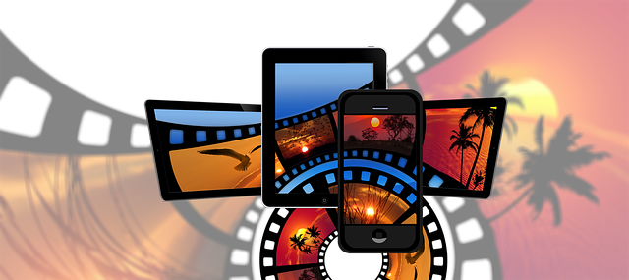 | Gerd Altmann | Film | https://pixabay.com/es/illustrations/pel%c3%adcula-tira-de-pel%c3%adcula-smartphone-2643100/ | CC0
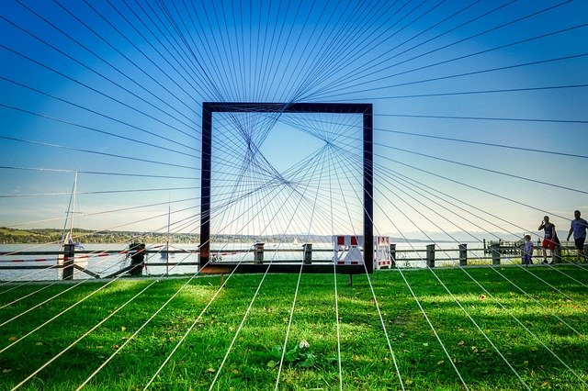 | Albrecht Fietz | By looking | https://pixabay.com/es/photos/mirando-objeto-de-arte-el-arte-4571672/ | CC0
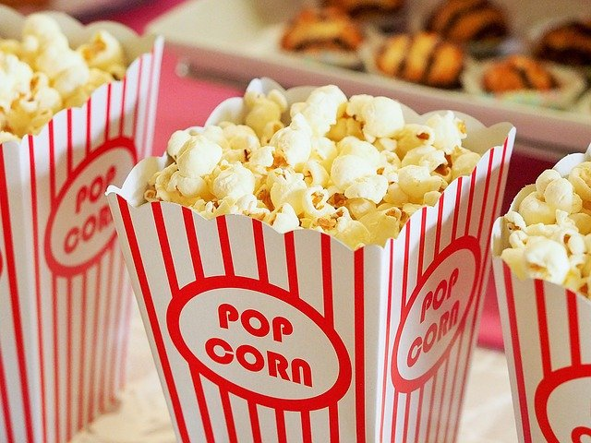 | Devon Breen | Popcorn | https://pixabay.com/es/photos/palomitas-de-ma%c3%adz-los-alimentos-1085072/ | CC0
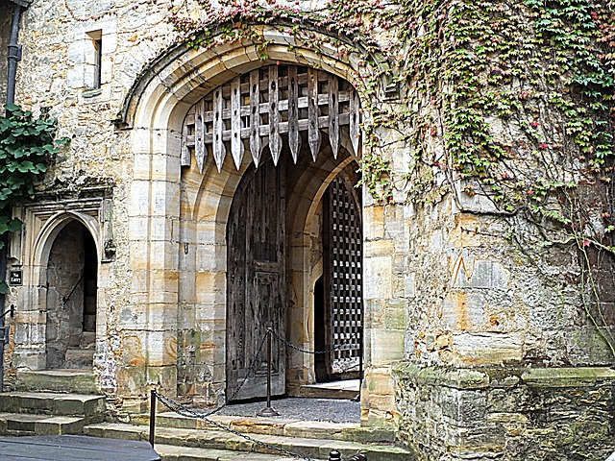 | Michael Drummond | Castle | https://pixabay.com/es/photos/castillo-guardar-hdr-rastrillo-936456/ | CC0
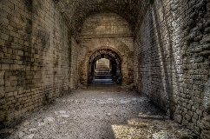 | Skitterphoto | Corridor | https://pixabay.com/es/photos/corredor-cueva-arena-romano-t%c3%banel-4415517/ | CC0
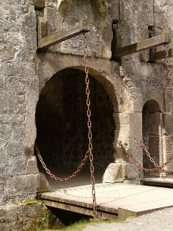 | Hans Braxmeier | Gate | https://pixabay.com/es/photos/port%c3%b3n-puerta-del-castillo-entrada-54189/ | CC0
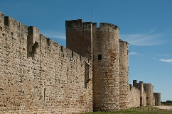 | Jaqueline Macou | Dead Treble | https://pixabay.com/es/photos/agudos-muertos-murallas-pared-1406158/ | CC0
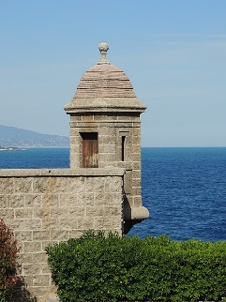 | Abxbay | Turret of Monaco | https://commons.wikimedia.org/wiki/File:Turret_of_Monaco.JPG | CC BY-SA
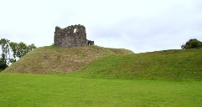 | Eric Jones | Clough Castle Motte and Bailey | https://commons.wikimedia.org/wiki/File:Clough_Castle_Motte_and_Bailey.jpg | CC BY-SA
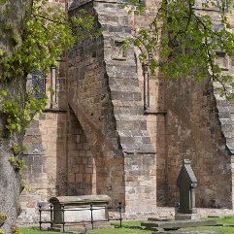 | Tom Parnell | Buttressed | https://commons.wikimedia.org/wiki/File:Buttressed_(5702611051).jpg | CC BY-SA
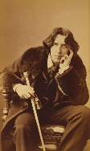 | Napoleon Sarony | Oscar Wilde | https://commons.wikimedia.org/wiki/File:Oscar_Wilde_portrait_by_Napoleon_Sarony_-_albumen.jpg | Public domain
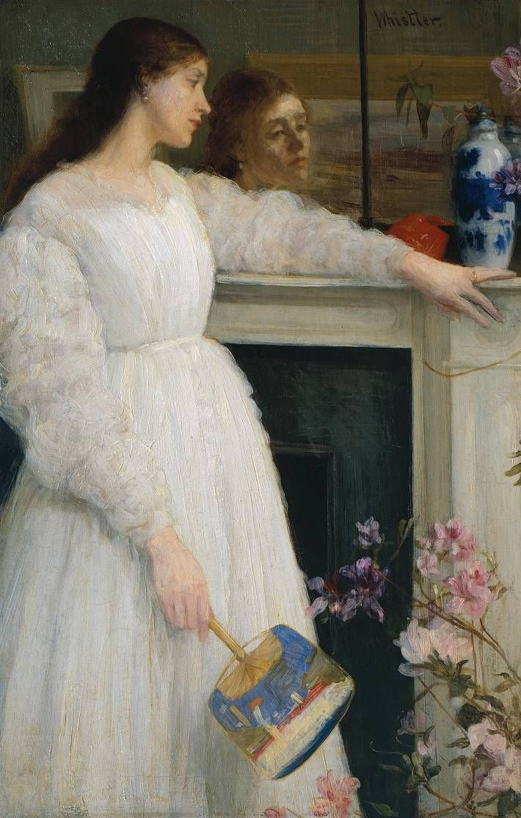 | James Whistler | Symphony in White no 2 (The Little White Girl) | https://en.wikipedia.org/wiki/Symphony_in_White,_No._2:_The_Little_White_Girl#/media/File:Whistler_James_Symphony_in_White_no_2_(The_Little_White_Girl)_1864.jpg | Public domain
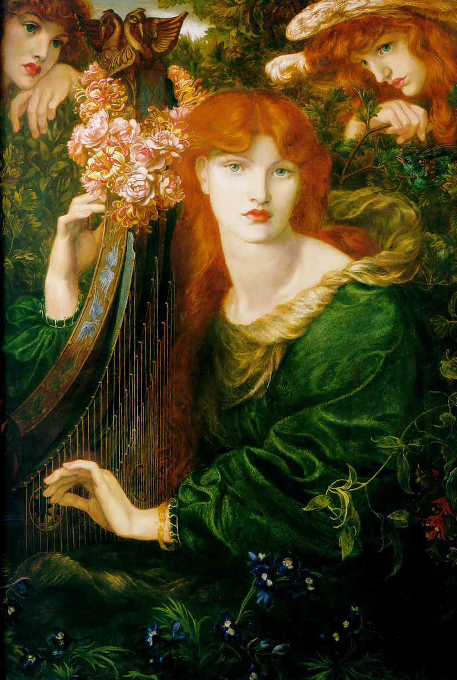 | Dante Gabriel Rosetti | La Ghirlandata | https://es.wikipedia.org/wiki/La_Ghirlandata#/media/Archivo:Rossetti,_Dante_Gabriel_-_La_Ghirlandata_-_1871-1874.jpg | Public domain
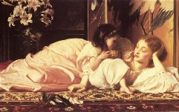 | Frederic Leighton | Mother and Child | https://www.wikiart.org/en/frederic-leighton/mother-and-child | Public domain
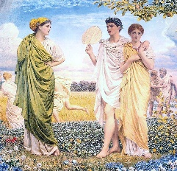 | Albert Moore | The Loves of the Winds and the Seasons | https://commons.wikimedia.org/wiki/File:Albert_Joseph_Moore_-_The_Loves_of_the_Winds_and_the_Seasons_1893.jpg | Public domain
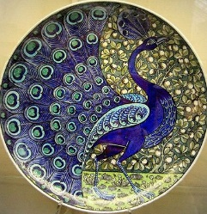 | William de Morgan | Charger | https://www.theartstory.org/movement/aesthetic-art/artworks/ | Public domain
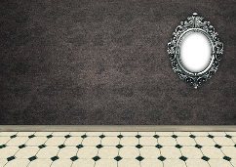 | Darkmoon Art | Room | https://pixabay.com/es/illustrations/habitaci%c3%b3n-vac%c3%ado-espacio-interior-2103285/ | CC0
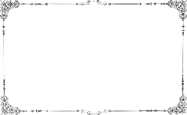 | Gordon Johnson | Frame | https://pixabay.com/es/vectors/marco-frontera-l%c3%adnea-arte-cl%c3%a1sico-5130680/ | CC0
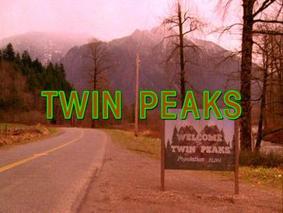 | Screenshot uploade by TAntony | Twin Peaks Opening Shot Credits | https://en.wikipedia.org/wiki/Twin_Peaks#/media/File:TwinPeaks_openingshotcredits.jpg | Fair use
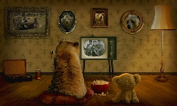 | Peter Fischer | Bear | https://pixabay.com/es/photos/soportar-osito-de-peluche-3145874/ | CC0
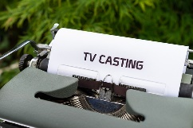 | Markus Winkler | Typewriter | https://pixabay.com/es/photos/m%c3%a1quina-de-escribir-papel-5521553/ | CC0
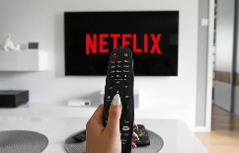 | Tumisu | TV | https://pixabay.com/es/photos/televisor-remoto-casa-netflix-5571609/ | CC0
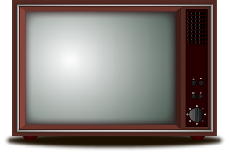 | Sdvigger | Vector | http://www.edu.xunta.gal/portal/sites/web/files/resolucion_plan_dixital.pdf | CC0
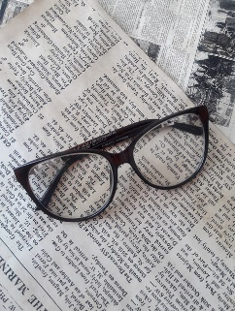 | Green Lana | Paper | https://pixabay.com/es/photos/papel-peri%c3%b3dico-libro-texto-3054758/ | CC0
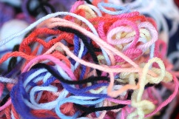 | Vicky Becker | Yarn | https://pixabay.com/es/photos/hilo-colores-mara%c3%b1a-986252/ | CC0
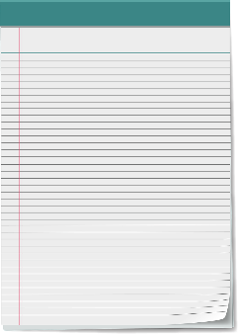 | Pixel Perfect | Vector Notepad | https://pixabay.com/es/photos/bloc-de-notas-de-vectores-bloc-2111645/ | CC0
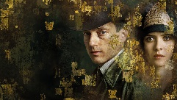 | Netflix | Babylon Berlin | https://tinyurl.com/hdva8383 | Fair use
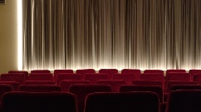 | Sabine Lange | Movie theater | https://pixabay.com/es/photos/cine-lienzo-al-vapor-cortina-2093264/ | CC0
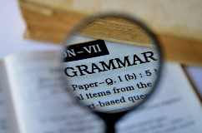 | PDPics | Grammar | https://pixabay.com/es/photos/gram%c3%a1tica-lupa-libro-diccionario-389907/ | CC0
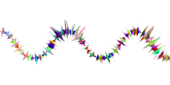 | Gordon Johnson | Music | https://pixabay.com/es/vectors/m%c3%basica-onda-sonido-resumen-arte-2756912/ | CC0
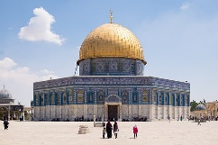 | Emilio García | The Dome of the Rock | https://en.wikipedia.org/wiki/Dome_of_the_Rock#/media/File:C%C3%BApula_de_la_Roca_(45298221951).jpg | CC BY-SA
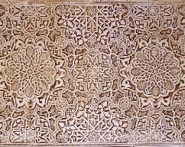 | gloverbh222 | Alhambra | https://pixabay.com/es/photos/alhambra-granada-espa%c3%b1a-ar%c3%a1bica-4968922/ | CC0
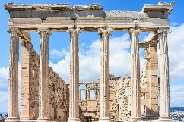 | Christo Anestiev | Acropolis | https://pixabay.com/es/photos/acr%c3%b3polis-atenas-grecia-antiguo-2725918/ | CC0
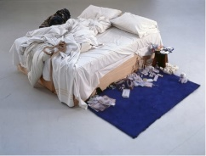 | Tracey Emin | My bed | https://thecreativeconversation.wordpress.com/2021/05/25/could-anyone-display-a-bed-like-that-and-call-it-art/ | Fair use
 | Gerd Altmann | People | https://pixabay.com/es/illustrations/hombres-gente-lotes-humano-silueta-695653/ | CC0
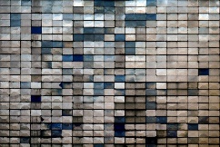 | Admiral Lebioda | Abstraction | https://pixabay.com/es/photos/abstracci%c3%b3n-losas-ritmo-factura-3779581/ | CC0
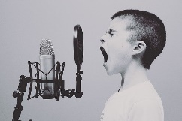 | Free-Photos | Microphone | https://pixabay.com/es/photos/micr%c3%b3fono-chico-estudio-gritando-1209816/ | CC0

