CREDITS
Imaxe | Autor | Título | Ligazón | Licenza
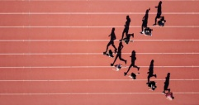 | Steven Lelham | Watchmaker’s junkyard | https://unsplash.com/photos/yBzrPGLjMQw | CC0
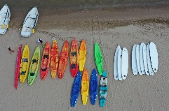 | docaz | kayak | https://pixabay.com/photos/kayak-surf-board-beach-water-boat-4389742/ | CC0
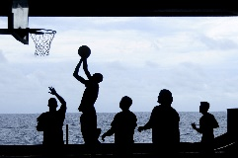 | Id: 12019 | Basketball | https://pixabay.com/es/photos/baloncesto-jugando-silueta-108622/ | CC0
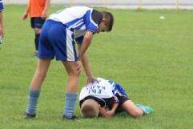 | 7721622 | futbol lesión dor | https://pixabay.com/es/photos/f%c3%batbol-lesi%c3%b3n-el-dolor-3689660/ | CC0
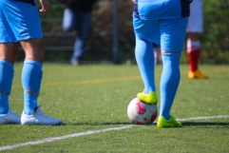 | Hebi B | football players kickof meadow | https://pixabay.com/photos/football-players-kick-off-meadow-730418/ | CC0
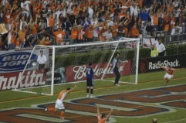 | Tom Haynes | Dynamo’s thrid goal | https://www.flickr.com/photos/92187130@N00/321292834 | CCBY20
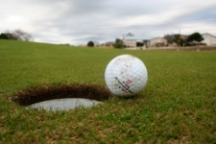 | Bill Erickson | Missed shot | https://www.flickr.com/photos/67471048@N00/328599394 | CCBY20
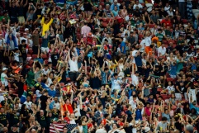 | Hamson Lu | Audience | https://unsplash.com/photos/WrNbw7UeNqI | CC0
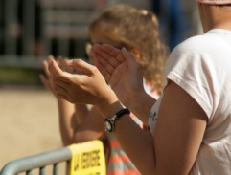 | Jacqueline Macou | spectators applaud | https://pixabay.com/photos/spectators-applaud-applause-1444043/ | CC0
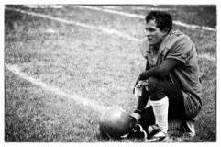 | Fábio Luciano Sorg | American football defeat | https://pixabay.com/photos/sport-american-football-defeat-1043190/ | CC0
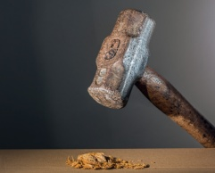 | Steve Buissine | Sledgehammer | https://pixabay.com/photos/hammer-sledgehammer-mallet-tool-682767/ | CC0
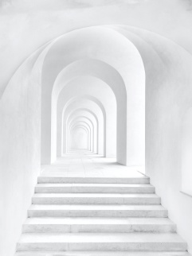 | Robin Schreiner | Prague castle | https://unsplash.com/photos/7y4858E8PfA | CC0
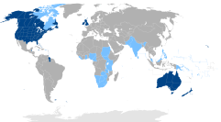 | Canuckguy | anglospeak map | https://en.wikipedia.org/wiki/English-speaking_world#/media/File:Anglospeak.png | CCBYSA4.0
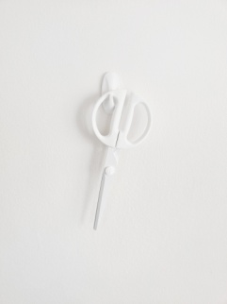 | Spencer | Tesouras brancas | https://unsplash.com/photos/rd1GIP-zCaI | CC0
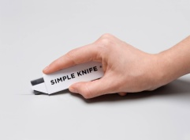 | Brands&People | man con cutter | https://unsplash.com/photos/Xx8ei5bkbek | CC0
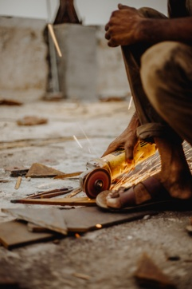 | Pratik Gupta | home con serra circular | https://unsplash.com/photos/CgCvft_lJJU | CC0
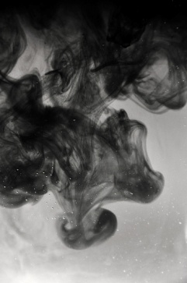 | Lieselot.dalle | Mistura | https://unsplash.com/photos/BvxTpTj0QlA | CC0
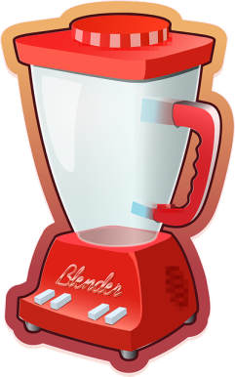 | OpenClipart- vectors | mexclador | https://pixabay.com/es/vectors/batidora-amoladora-mezclador-equipo-575445/ | CC0
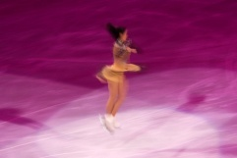 | Rod Long | Figure skating | https://unsplash.com/photos/1wDEvHfXdr4 | CC0
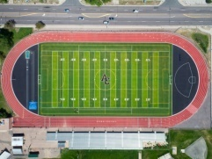 | Andres Coop | Aurora Central HS field | https://unsplash.com/photos/F8slmuD2YgM | CC0
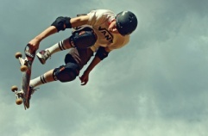 | gfkDSGN | Skateboard | https://pixabay.com/es/photos/patín-timón-protectores-protección-1091710/ | CC0
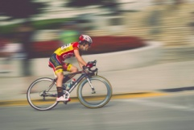 | Pexels | Desengoque movemento ciclismo | https://pixabay.com/es/photos/el-desenfoque-de-movimiento-ciclismo-1281675 | CC0
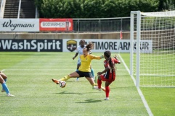 | Jeffrey F. Lin | Kailen blocks shot | https://unsplash.com/photos/LgnW6AnTBtc | CC0
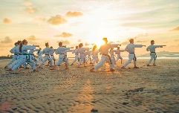 | Thao Le Hoang | Beach karate | www.hthaostudio.com | CC0
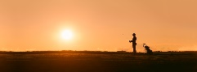 | Christoph Keil | Sunset golf | https://unsplash.com/photos/_VOQ9VwnbgE | CC0
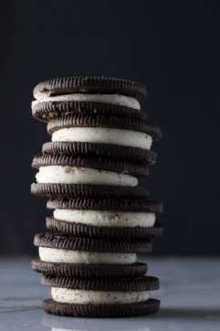 | Denise Johnson | stack of oreos | https://unsplash.com/photos/8qLRrFhZ3jA | CC0
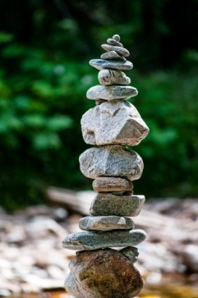 | Daryl Baird | Ross Cedars | https://unsplash.com/photos/qWkKXXIf1nc | CC0
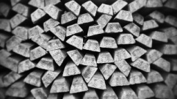 | tookapic | plata barras | https://pixabay.com/es/photos/bullion-plata-barras-932218/ | CC0
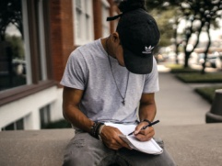 | Brad Neathery | sports writer | https://unsplash.com/s/photos/sports-writer | CC0
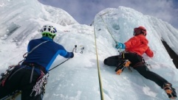 | Gipfelsturm69 | Escalada en xeo | https://pixabay.com/es/photos/escalada-en-hielo-hielo-subir-1247606/ | CC0
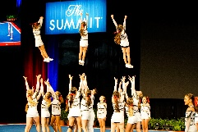 | Clayton Scelzi | The Summit cheerleading | https://unsplash.com/photos/ariF5InMHts | CC0
 | Amy Hirschi | Business and work | https://unsplash.com/photos/JaoVGh5aJ3E | CC0
 | Academy of Achievement | Academy of Achievement logo | https://en.wikipedia.org/wiki/Academy_of_Achievement | Uso lexítimo

